Current Monitoring Testbed

Kevin Weekly
EE290Q

Table of Contents
Objective 3
Related Work 3
Technical Scheme 3
Hardware Component 3
Firmware Component 3
PC Software Component 4
Configuration 4
Running Experiments 4
Current Results 4

Objective
The objective of this project is to measure real-world current consumption of a wireless sensor network deployment. At the heart of the project is an intelligent host board which provides power to Xbee-compatible motes and can configure experiments which will explore the current consumption of various configurations.

Related Work
There is not any novel theory involved in the project as it is mainly an implementation task. Therefore, we mainly refer to other similar testbeds such as:
- FlockLab (http://www.flocklab.ethz.ch/wiki/)
Description: http://www.tik.ee.ethz.ch/~walserc/tik/pub/BLMWWTY2009a.pdf
Observer nodes use Gumstix processor. Connected via ethernet. Can support different motes, although currently attached motes are TinyOS or Contiki motes.
- MoteLab (http://www.eecs.harvard.edu/~mdw/papers/motelab-spots05.pdf )
Emphasis on GUI. Backed by Ethernet for reprogramming & configuration. Modular server software. Mica2 motes only.
- MoteScope (http://smote.cs.berkeley.edu/motescope/)
UC Berkeley effort. Uses EPIC motes. Measures current consumption via cycle counting of the power regulator.

Technical Scheme

Hardware Component
The functionality of the hardware is described below:
- Intelligence : Provided by a PIC18F26J50, an 8-bit microcontroller with 64Kb Flash and 3.6Kb RAM. Built-in USB, 10-bit ADC, SPI and 32KHz oscillator.
Timing of events provided by either Timer1 or a built-in RTC attached to the 32KHz oscillator.
- Current Sensing : Two ranges are provided with two different devices, both using a 2.2Ohm sense resistor.
- High-Current circuit: Using ZXCT10009, gives 10.34V/A to AN2 input on the PIC. Maximum sense current, Isense, is 319mA. Resolution is 312uA/LSB.
- Low-Current circuit: Using MAX4172, measures the time it takes C12 to reach a certain voltage, Vth. Current into C12 is 0.022 * Isense.
Example: Vth = 2V. Isense=10uA. Current into C12 is 220nA. Charges in 90mS.
- Memory : Up to 8Mb of FLASH storage is available through two AT45DB041 chips. These can be used to store current samples, configurations, and firmware updates.
- Debugging : A standard Microchip ICSP header is added for in-circuit debugging. Additionally, two LEDs are provided for field debugging at-a-glance.
- Mote Support : The board is designed as two boards, a "motherboard" and "daughterboard".
The daughterboard could be used standalone to provide:
- To collect "real" data, two inexpensive sensors are provided (ambient light and temperature). These are connected to the XBee's ASSOC port to only consume current when the device is awake.
- A 3.3V regulator to regulate an external power source, like a battery..
The motherboard could be used standalone to provide:
- Connection to non-XB footprint mote boards, such as the OpenMote breakout board (same pinout as FTDI cable).
- A USB to Serial adapter.

Firmware Component
Programming of the PIC is supported by the Microchip provided MPLAB X IDE and the free version of MCC18. The firmware provides the following functionality:
- Drivers
  - xbee : Parses bytes to/from an Xbee module into C structures.
  - currentADC : Operates the ADC and Timer Capture peripherals to obtain high/low current readings.
  - rtc : Operates Timer1 and the 32KHz oscillator to provides UNIX timestamps with resolution of 2s.
- Services
  - usb2serial : Provides USB-to-serial port to the host computer using the standard Communications Device Class (CDC). Provides hooks for other parts of the code to sniff serial transactions (such as reading what X-CTU sends to the XBee) or inject bytes.
  - commands : Constructs and parses frames between the host computer and firmware via a custom device driver and libusb.
  - commands_adc/commands_xbee : Performs actions on commands sent by the host computer and responds accordingly.

PC Software Component

Configuration
A configuration application will be written in Java and interact with the PIC using libusb and a custom device interface. This application will be able to create configurations and configure experiments to run. The device must be connected to the computer for the functionality of this component to be accessable.

Running Experiments
Another application (although could be combined with above) will be used to actually run the experiments and visualize the results. The main difference is that this application doesn't use the custom device interface and instead collects information by communication w/ the mote and communicating via the mote to remote units wirelessly.

Current Results
As of now, the first revision of the hardware has been built and is being tested for its functionality. Two problems have been identified with the new board:
- The DAC module cannot be used with the comparator as intended, since only the non-inverting input can be switched to the DAC.
  - HW Fix: Swap RA0/C1INA and RA3/C1INB
  - SW Workaround: Use digital input buffer as a "comparator". Typically 2V threshold.
- Pin numbering on the ZXCT10009 is not the standard SOT-23
  - HW Fix: Fix the numbering in the footprint
  - HW Workaround: Re-solder the part upside-down and rotated

Firmware has also been written providing the ability to read current measurments, construct and parse commands over the custom usb interface, timing using the 32KHz oscillator, and provide the USB-to-serial interface. Major components left to do is drive the FLASH memory chips, store and use Xbee configurations, log measurments, configure experiments, and communicate using the mote (Xbee) to the coordinator.

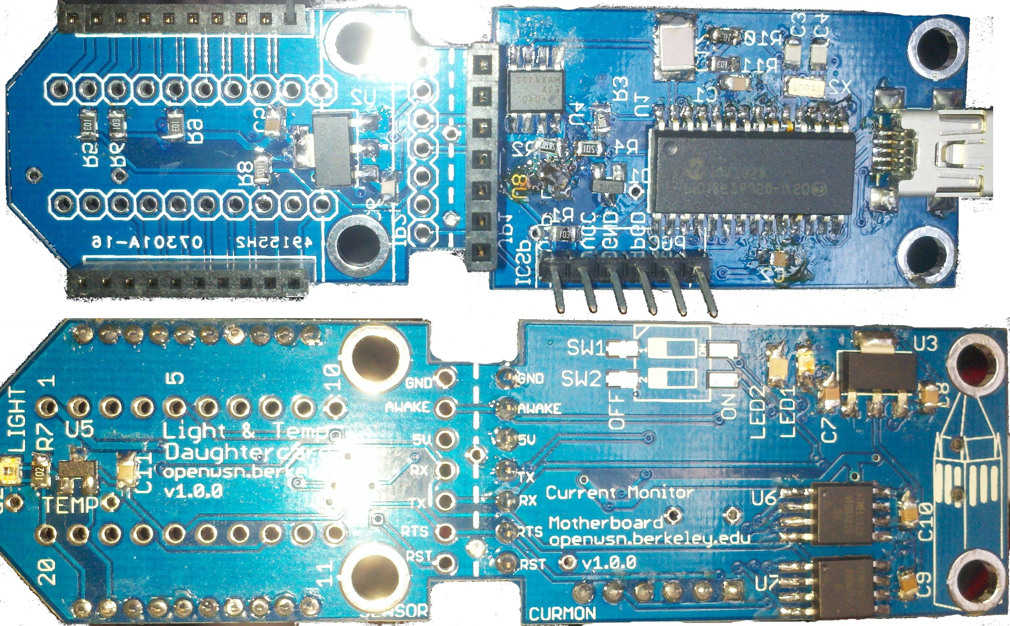Illustration 1: Current Monitor v1_0_0. Top: Front. Bottom: Back
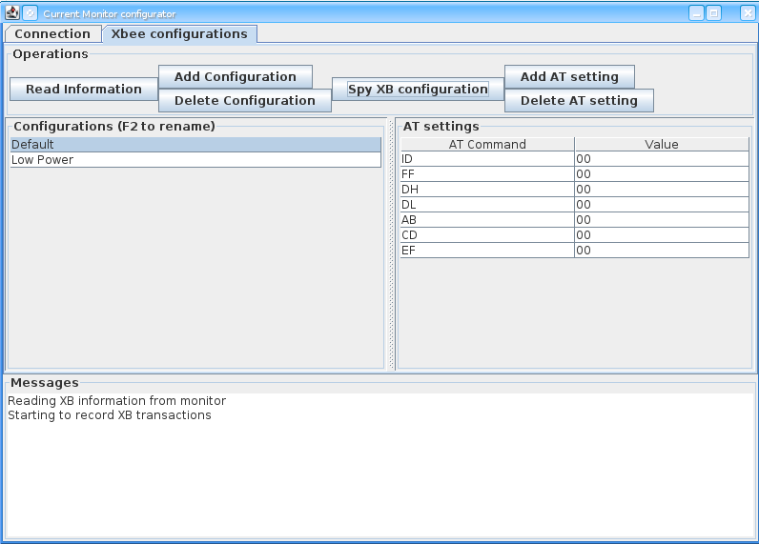Illustration 2: Current Monitor PC configuration Software

