Лабораторная №2
по предмету: математическая статистика
Основные характеристики выборок

Мухина Марина
А-13-11

2014

Задача 1

function f = matrixreal (k, n)
i = 1;
list = [];
listrand = realrand(beginlistravn(n*k));
while (i <= k)
list = [list; ravnrasp(-1, 2, getelem(listrand, (i-1)*n+1, i*n))];
#list = normonereal(1, 2, 10, getelem(listrand, (i-1)*n+1, i*n));
#list = Exponential(4, getelem(listrand, (i-1)*n+1, i*n));
#list = binomializreal(8, 0.3, getelem(listrand, (i-1)*n+1, i*n));
i++;
end
f = list;
endfunction

MatrixRealRavn = matrixreal(3, 10)
-0.958749 1.287385 0.135373 1.816416 0.522557 -0.030126 1.711316 0.981541 0.661302 -0.517162
0.544561 0.989506 -0.055556 1.000023 1.997884 -0.809595 -0.136466 -0.718075 0.626704 -0.403346
-0.698850 1.896473 -0.682598 0.433792 1.958699 -0.282969 0.467165 1.955105 0.040515 1.353649

listNorm =
1.314926 -0.014391 1.744120 -0.079788 1.521615 2.711257 2.255889 0.792147 -0.667327 2.133786

listExpo =
0.0034614 0.3593564 0.1188878 0.6984236 0.1770748 0.0976286 0.5852587 0.2700804 0.2017286 0.0438701

listBinom =
1 2 5 1 3 1 3 1 3 3

VarRyadRavn =
-0.958749 -0.517162 -0.030126 0.135373 0.522557 0.661302 0.981541 1.287385 1.711316 1.816416

VarRyadNorm =
-0.667327 -0.079788 -0.014391 0.792147 1.314926 1.521615 1.744120 2.133786 2.255889 2.711257

VarRyadExpo =
0.0034614 0.0438701 0.0976286 0.1188878 0.1770748 0.2017286 0.2700804 0.3593564 0.5852587 0.6984236

VarRyadBinom =
1 1 1 1 2 3 3 3 3 5

Задача 2

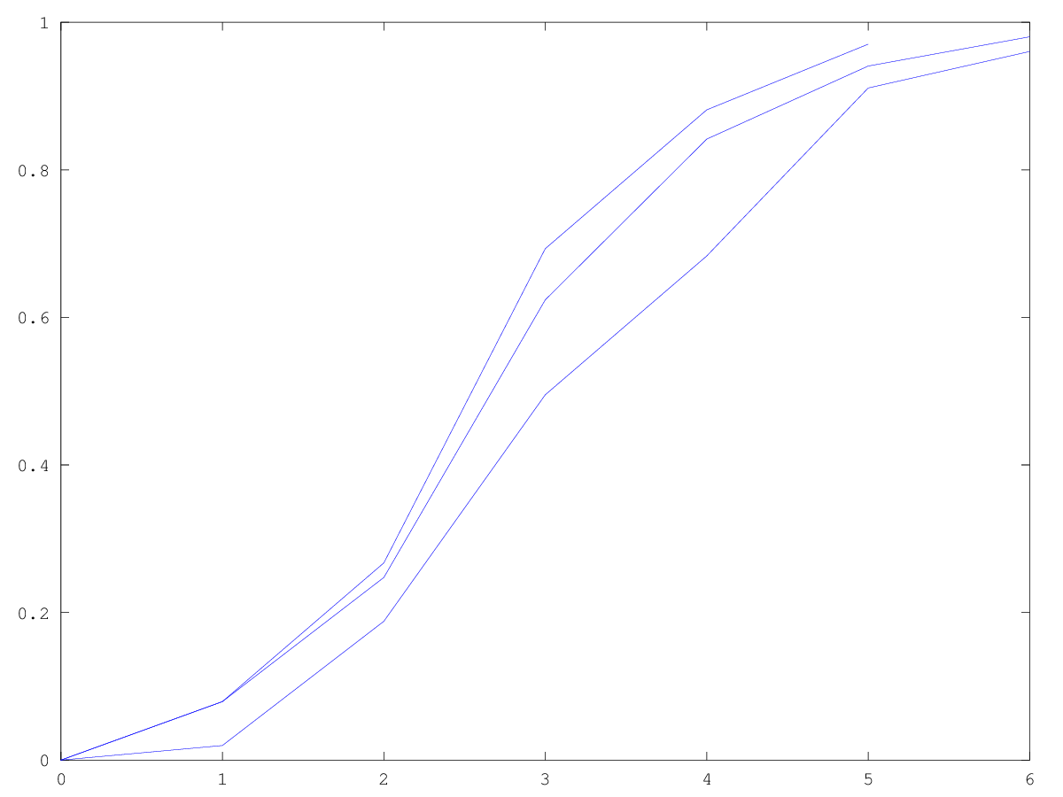
function f = empirraspmore(list)
i = 1;
listy = [];
listx = sort(list);
while (i <= length(list))
listy = [listy, empirrasp(listx(i), list)];
i++;
end;
plot(listx, listy)
endfunction

#l = ravnrasp(-1, 2, realrand(beginlistravn(300)));
#l = normonereal(1, 2, 300, 300);
#l = Exponential(4, 300);
l = binomializreal(8, 0.3, 300);
for i=1:3
empirraspmore(getelem(l,(((i-1)*100) + 1), i*100));
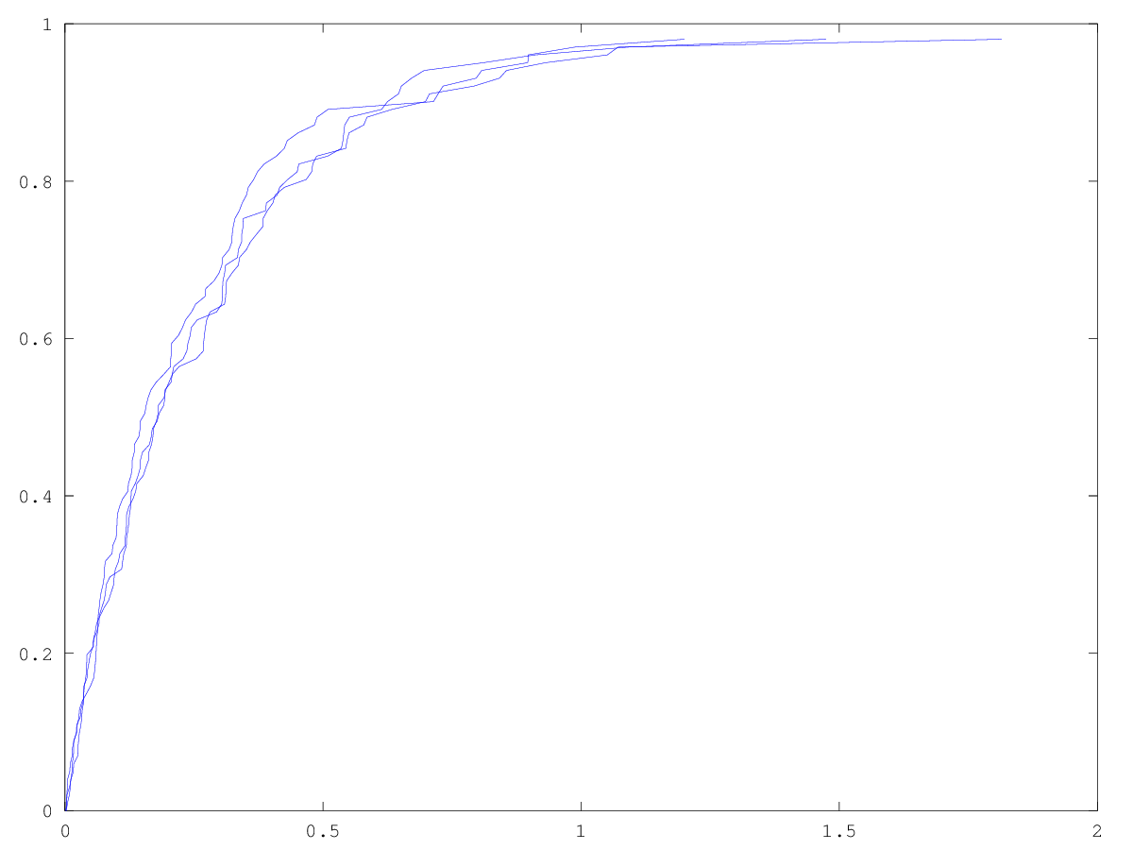
hold on;
end
print('empirbinom3.png','-dpng');
#l = ravnrasp(-1, 2, realrand(beginlistravn(30)));
#l = normonereal(1, 2, 30, 30);
l = Exponential(4, 30);
#l = binomializreal(8, 30, 30);
for i=1:3
empirraspmore(getelem(l,(((i-1)*10) + 1), i*10));
hold on;
end

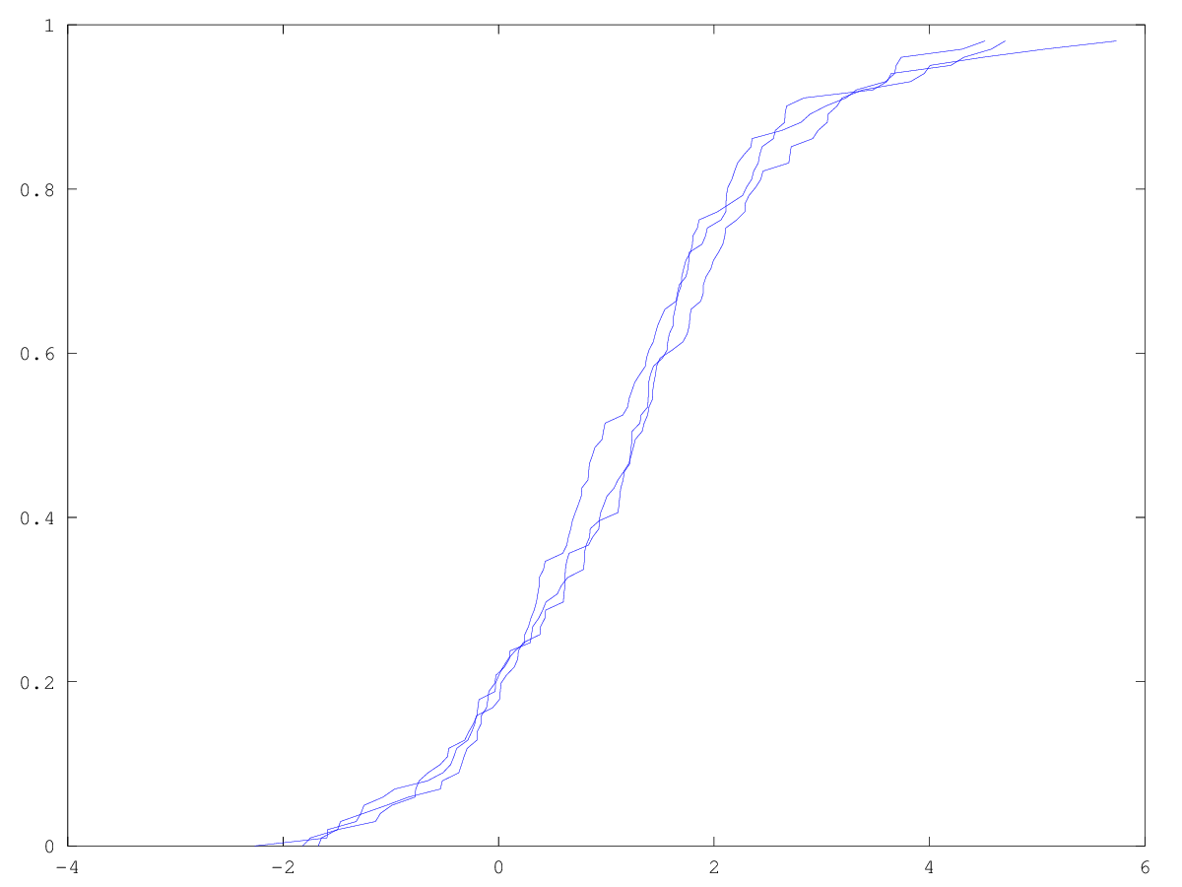

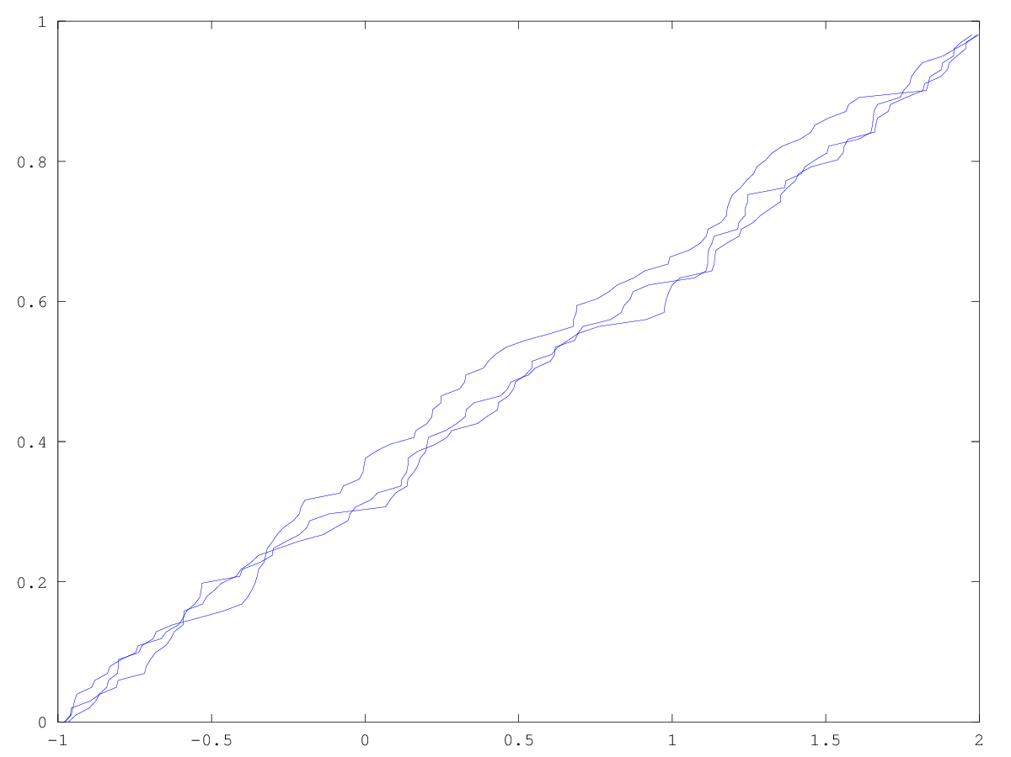

Задача 3

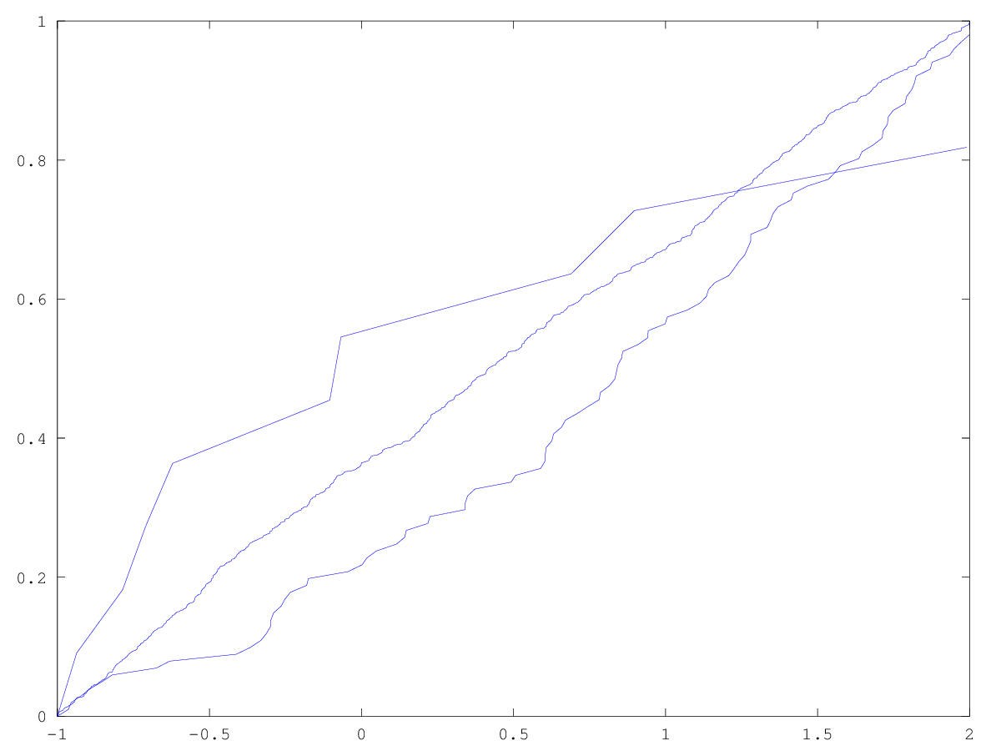
#l10 = ravnrasp(-1, 2, realrand(beginlistravn(10)));
#l100 = ravnrasp(-1, 2, realrand(beginlistravn(100)));
#l1000 = ravnrasp(-1, 2, realrand(beginlistravn(1000)));

#l10 = normonereal(1, 2, 10, 10);
#l100 = normonereal(1, 2, 100, 100);
#l1000 = normonereal(1, 2, 1000, 100);

l10 = Exponential(4, 10);
l100 = Exponential(4, 100);
l1000 = Exponential(4, 1000);

#l10 = binomializreal(8, 0.3, 10);
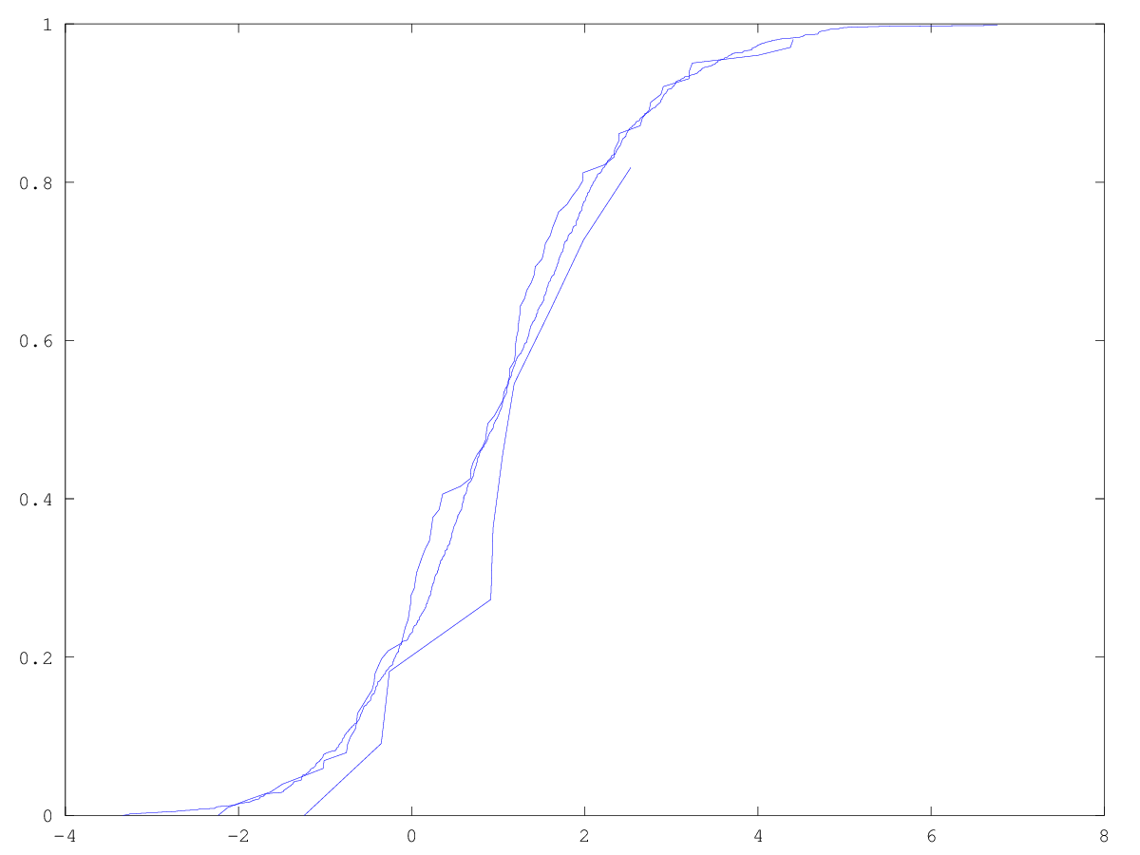
#l100 = binomializreal(8, 0.3, 100);
#l1000 = binomializreal(8, 0.3, 1000);
hold off;
empirraspmore(l10);
hold on;
empirraspmore(l100);
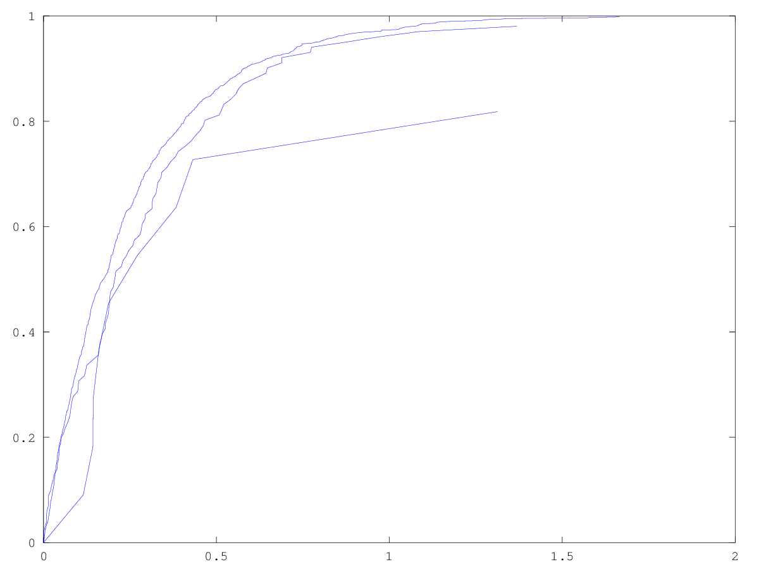
empirraspmore(l1000);
print('empir_rasp_exp.png','-dpng');

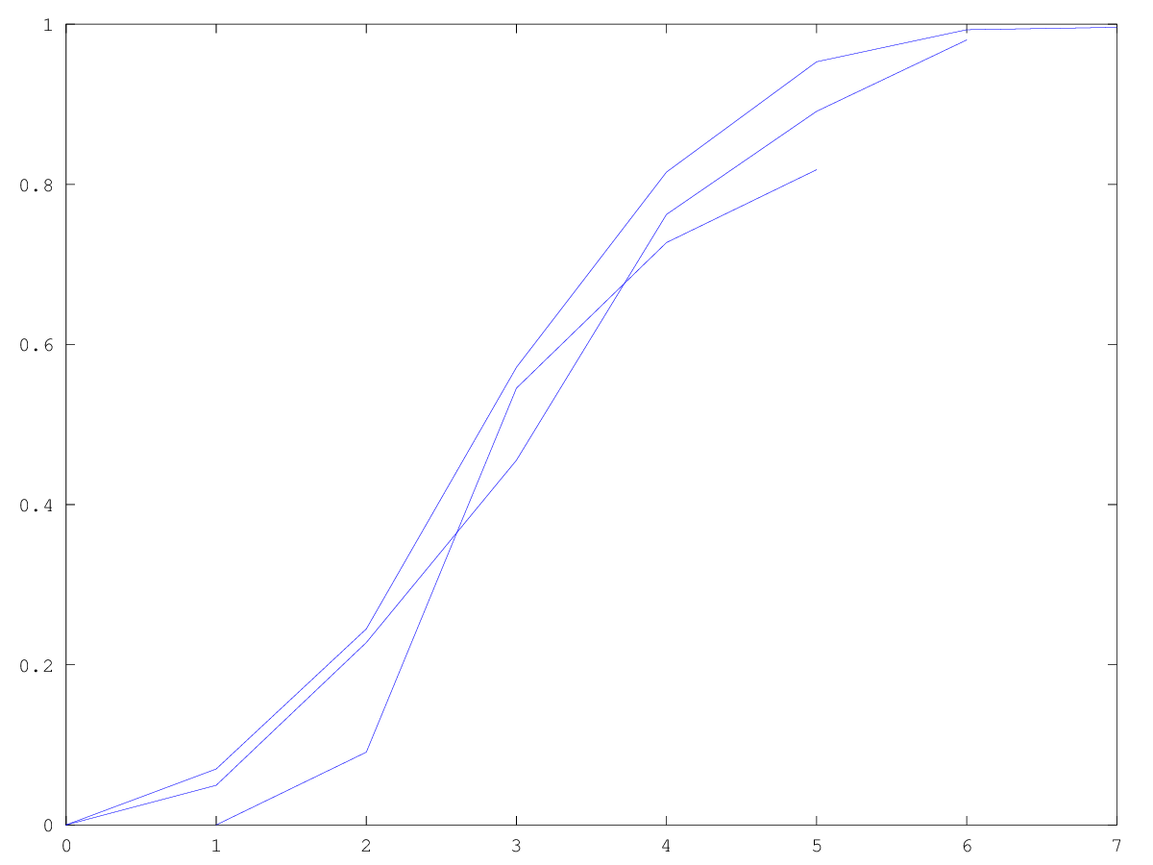
Задача 4
function f = frequency(listy, l)
listx = [];
listy = [listy, 1000000000];
for i=1:(length(listy)-1)
s = 0;
for j=1:length(l)
if (l(j) >= listy(i) && l(j) < listy(i+1))
s++;
end
end
listx = [listx, s];
end
f = listx/length(l);
endfunction

function f = gistreal(listx, l)
#l = ravnrasp(-1, 2, realrand(beginlistravn(length(listx))));
#l = normonereal(1, 2, length(listx), 10);
#l = Exponential(4,length(listx));
#l = binomializreal(10, 30, length(listx));
listy = frequency(listx, l);
hold off;
bar(listx, listy)
print('dist_exp.png', '-dpng');
# pause(3);
endfunction
l = Exponential(4,100);
lx = min(l):((max(l)-min(l))/100):max(l);
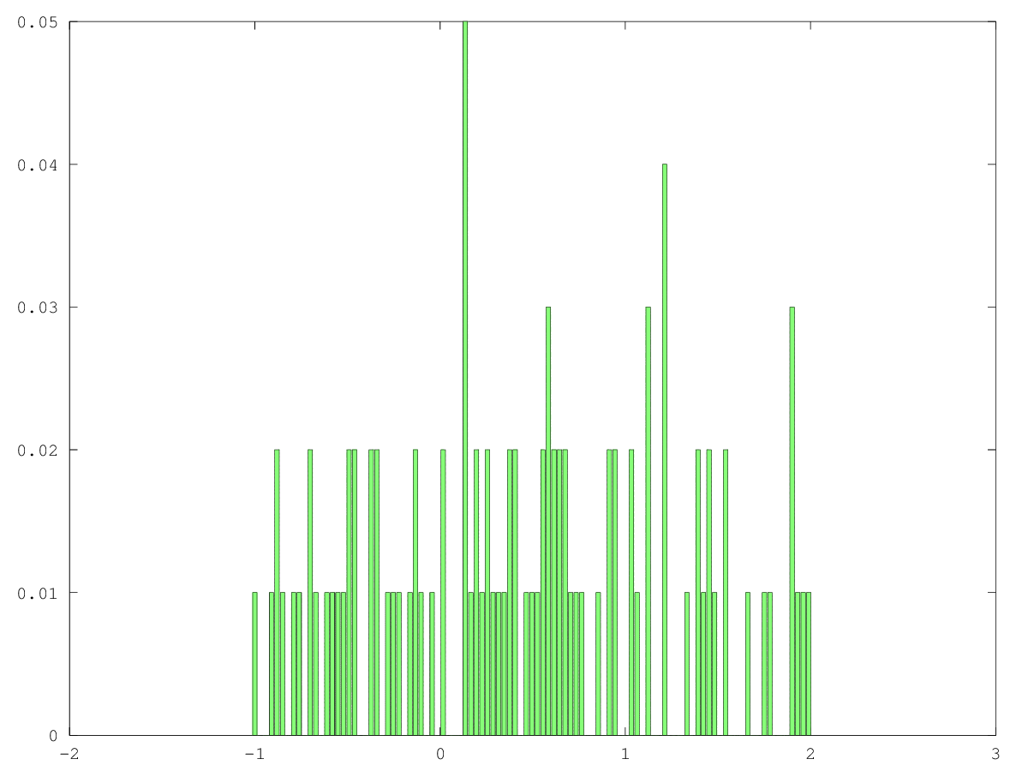
length(lx)
length(l)
#lx = -1:0.03:2;
#lx = 1:0.025:3.6;
#lx = -4:0.023:-1.65;
gistreal(lx, l)

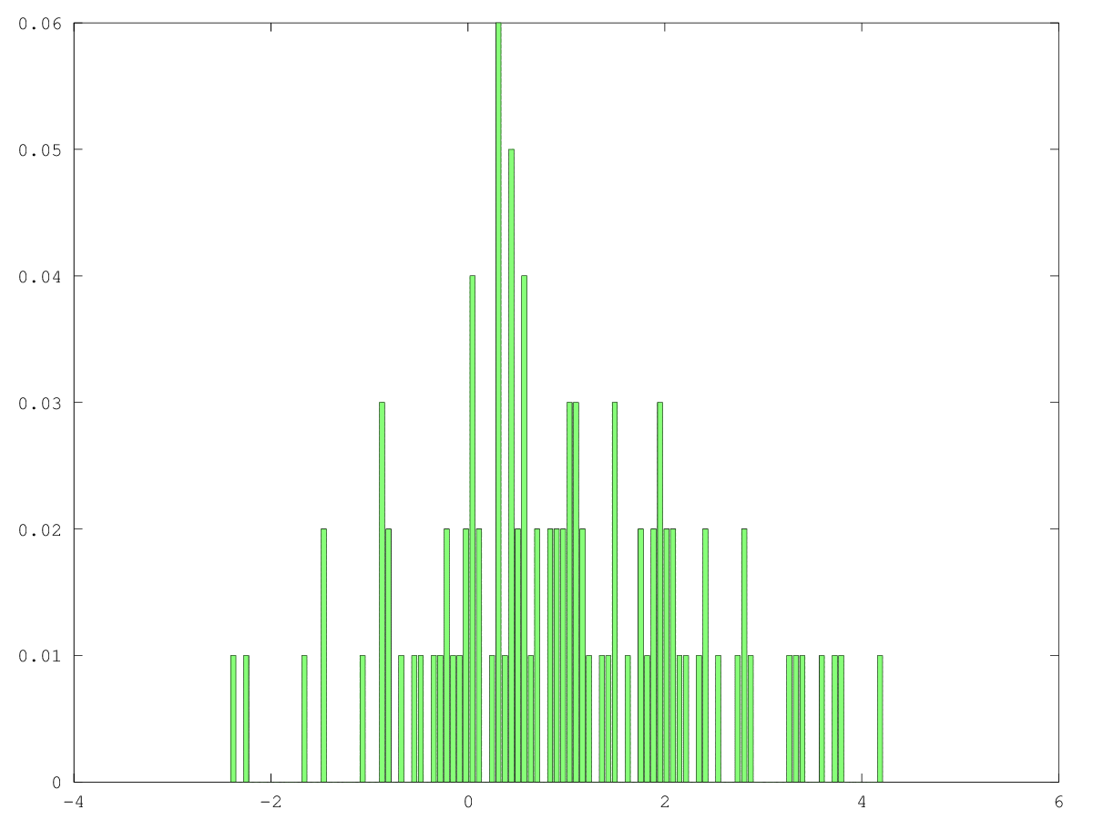
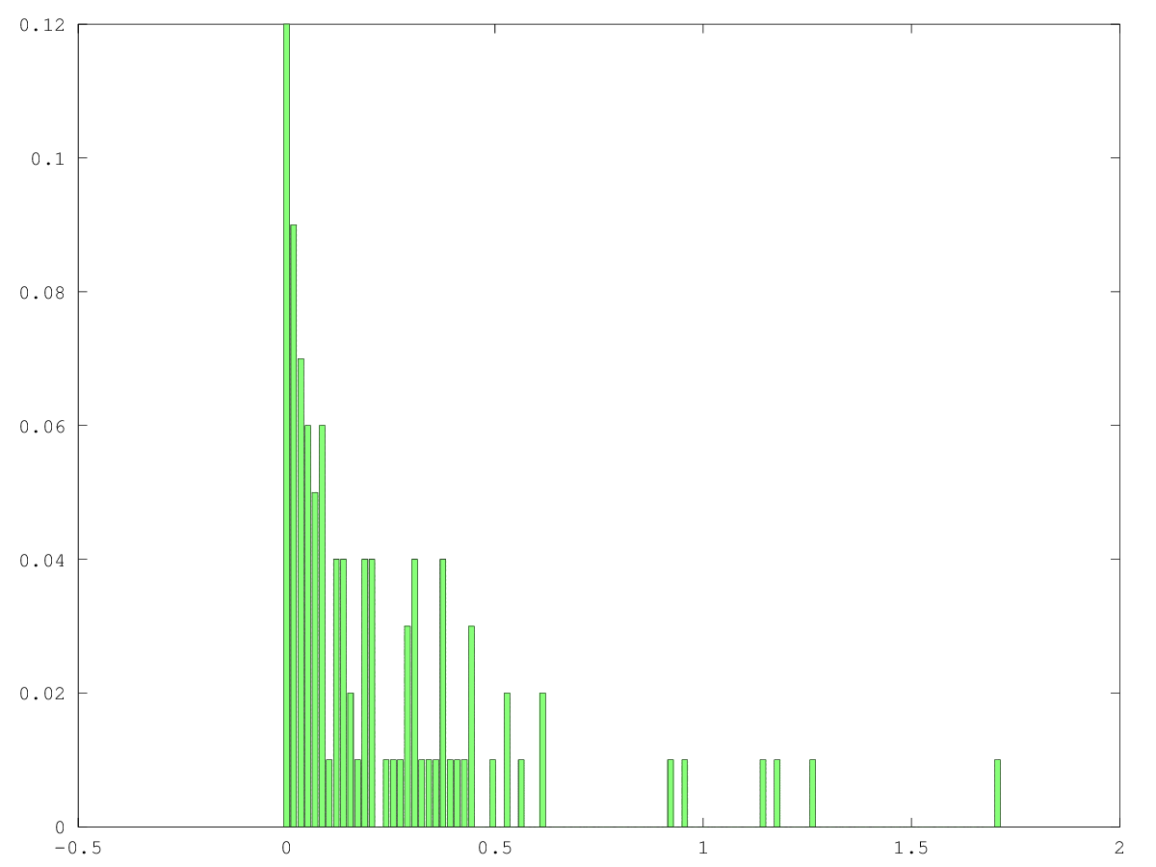

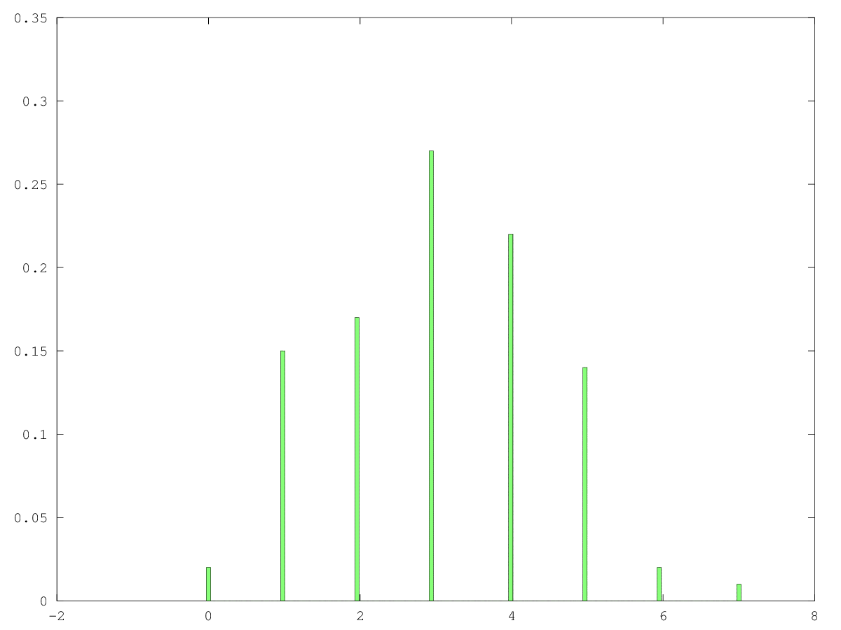
Задача 5

function f = samplemoment1(list)
f = sum(list) / length(list);
endfunction

function f = samplemoment(list, k)
scm = 0;
for i=1:(length(list))
scm = scm + (list(i))**k;
end
f = scm / length(list);
endfunction

function f = samplecentralmoment(list, k)
scm = 0;
sm = samplemoment1(list);
for i=1:(length(list))
scm = scm + (list(i) - sm)**k;
end
f = scm / length(list);
endfunction

function f = isprdisp(list)
scm = 0;
sm = samplemoment1(list);
for i=1:(length(list))
scm = scm + (list(i) - sm)**2;
end
f = scm / (length(list) - 1);
endfunction

IspravlDispersiaRavn = isprdisp(ravnrasp(-1, 2, realrand(beginlistravn(100))))
DispersiaRavn = ((2 - (-1))**2) / 12
IspravlDispersiaNorm = isprdisp(normonereal(1, 2, 10, 100))
DispersiaNorm = 2
IspravlDispersiaExp = isprdisp(Exponential(4, 100))
DispersiaExp = 4**(-2)

Moment2Ravn = samplemoment(ravnrasp(-1, 2, realrand(beginlistravn(100))), 2)
Moment2RavnT = (2**2 + 2*(-1) + 1) / 3
Moment2Norm = samplemoment(normonereal(1, 2, 10, 100), 2)
Moment2NormT = 2**2 * dvfactor(2-1)
Moment2Expo = samplemoment(Exponential(4, 100), 2)
Moment2ExpoT = 2 / 4**2

Moment1Ravn = samplemoment1(ravnrasp(-1, 2, realrand(beginlistravn(100))), 2)
Moment1RavnT = (2 + (-1)) / 2
Moment1Norm = samplemoment1(normonereal(1, 2, 10, 100), 2)
Moment1NormT = 0
Moment1Expo = samplemoment1(Exponential(4, 100), 2)
Moment1ExpoT = 1 / 4

CentralMoment3Ravn = samplecentralmoment(ravnrasp(-1, 2, realrand(beginlistravn(100))), 3)
CentralMoment3Norm = centralmomentnorm = samplecentralmoment(normonereal(1, 2, 10, 100), 3)
CentralMoment3Expo = samplecentralmoment(Exponential(4, 100), 3)

IspravlDispersiaRavn = 0.81372
DispersiaRavn = 0.75000
IspravlDispersiaNorm = 1.8024
DispersiaNorm = 2
IspravlDispersiaExp = 0.083878
DispersiaExp = 0.062500
Moment2Ravn = 1.0898
Moment2RavnT = 1
Moment2Norm = 3.7109
Moment2NormT = 4
Moment2Expo = 0.15673
Moment2ExpoT = 0.12500
Moment1Ravn = 0.53316
Moment1RavnT = 0.50000
Moment1Norm = 1.4452
Moment1NormT = 0
Moment1Expo = 0.27147
Moment1ExpoT = 0.25000
CentralMoment3Ravn = -0.027913
CentralMoment3Norm = 0.69836
CentralMoment3Expo = 0.054044

