Suraj Kumar

1NT19IS167

Inheritance in JAVA

1. Write a Java Program to demonstrate Hierarchical Inheritance and document the code.

**package** suraj;

**class** Animal {

**public** **void** showAnimal() {

System.***out***.println("This is Animal Class.");

}

}

**class** Cow **extends** Animal {

**public** **void** showCow() {

System.***out***.println("This is Cow Class.");

}

}

**class** Human **extends** Animal {

**public** **void** showHuman() {

System.***out***.println("This is Human Class.");

}

}

**class** Tiger **extends** Animal {

**public** **void** showTiger() {

System.***out***.println("This is Tiger Class.");

}

}

**public** **class** Inheritance {

**public** **static** **void** main(String[] args)

{

Cow obj_B = **new** Cow();

obj_B.showAnimal();

obj_B.showCow();

Human obj_C = **new** Human();

obj_C.showAnimal();

obj_C.showHuman();

Tiger obj_D = **new** Tiger();

obj_D.showAnimal();

obj_D.showTiger();

}

}

Output :

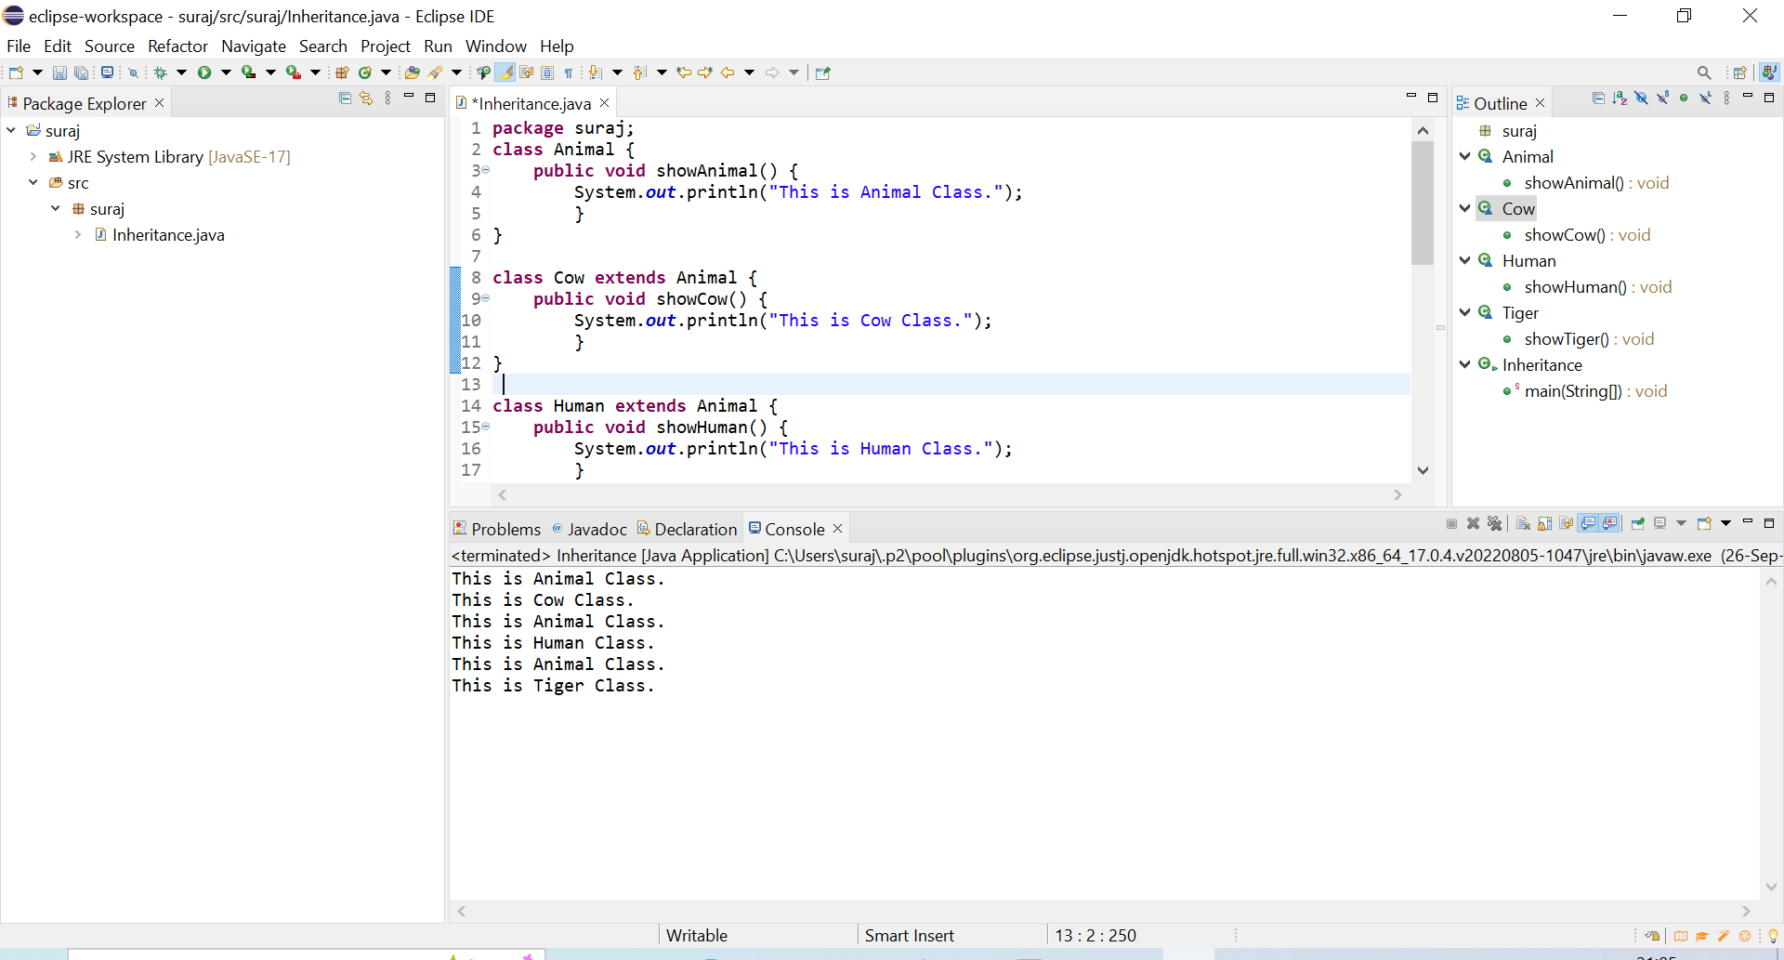

2.What is the usage of Static keyword and Private keyword in Java. Demonstrate a program for the same.

**package** suraj;

**class** StaticTest {

**private** **int** a, b;

**int** multiply(){

**return** a * b;

}

**static** **int** add(**int** a, **int** b){

**return** a + b;

}

**public** StaticTest(**int** a, **int** b) {

**this**.a = a;

**this**.b = b;

}

}

**public** **class** Static_And_Private_Keyword {

**public** **static** **void** main( String[] args ) {

StaticTest st = **new** StaticTest(5,10);

System.***out***.println(" 5 * 10 = " + st.multiply());

System.***out***.println(" 12 + 13 = " + StaticTest.*add*(12,13));

}

}

Output:

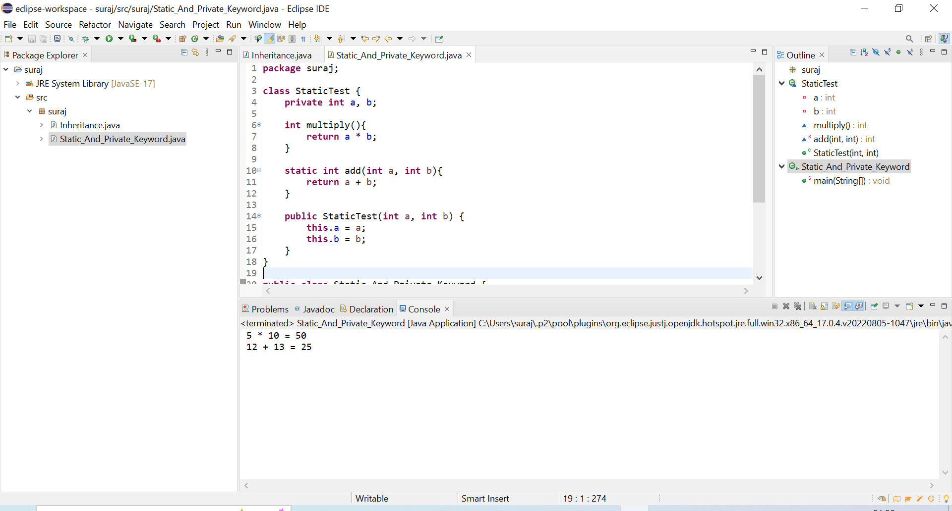

3. Illustrate the usage of Super Keyword for data member and member function access with a program.

Super keyword is used to call superclass methods, and to access the superclass constructor.

**package** suraj;

**class** Animal {

**public** **void** showAnimal() {

System.***out***.println("\nThis is Animal Class.");

}

}

**class** Cow **extends** Animal {

**public** **void** showCow() {

**super**.showAnimal();

System.***out***.println("This is Cow Class.");

}

}

**class** Human **extends** Animal {

**public** **void** showHuman() {

**super**.showAnimal();

System.***out***.println("This is Human Class.");

}

}

**class** Tiger **extends** Animal {

**public** **void** showTiger() {

**super**.showAnimal();

System.***out***.println("This is Tiger Class.");

}

}

**public** **class** Inheritance {

**public** **static** **void** main(String[] args)

{

Cow obj_B = **new** Cow();

obj_B.showCow();

Human obj_C = **new** Human();

obj_C.showHuman();

Tiger obj_D = **new** Tiger();

obj_D.showTiger();

}

}

Output :

