Suraj Kumar

1NT19IS167

Interfaces in JAVA

1. Write a Java Program to demonstrate Multiple Inheritance using 4 Interfaces

**package** suraj;

**interface** Sleep {

**void** sleep();

}

**interface** Cry {

**void** cry();

}

**interface** Eat {

**void** eat();

}

**interface** Play {

**void** play();

}

**class** Baby **implements** Sleep, Cry, Eat, Play {

**public** **void** sleep() {

System.***out***.println("Baby is Sleeping.\n");

}

**public** **void** cry() {

System.***out***.println("Baby is Cryling.\n");

}

**public** **void** eat() {

System.***out***.println("Baby is Eating.\n");

}

**public** **void** play() {

System.***out***.println("Baby is Playing.\n");

}

}

**public** **class** Multiple_Inheritance_4_interface {

**public** **static** **void** main(String args[]) {

Baby abc = **new** Baby();

abc.sleep();

abc.cry();

abc.eat();

abc.play();

}

}

Output :

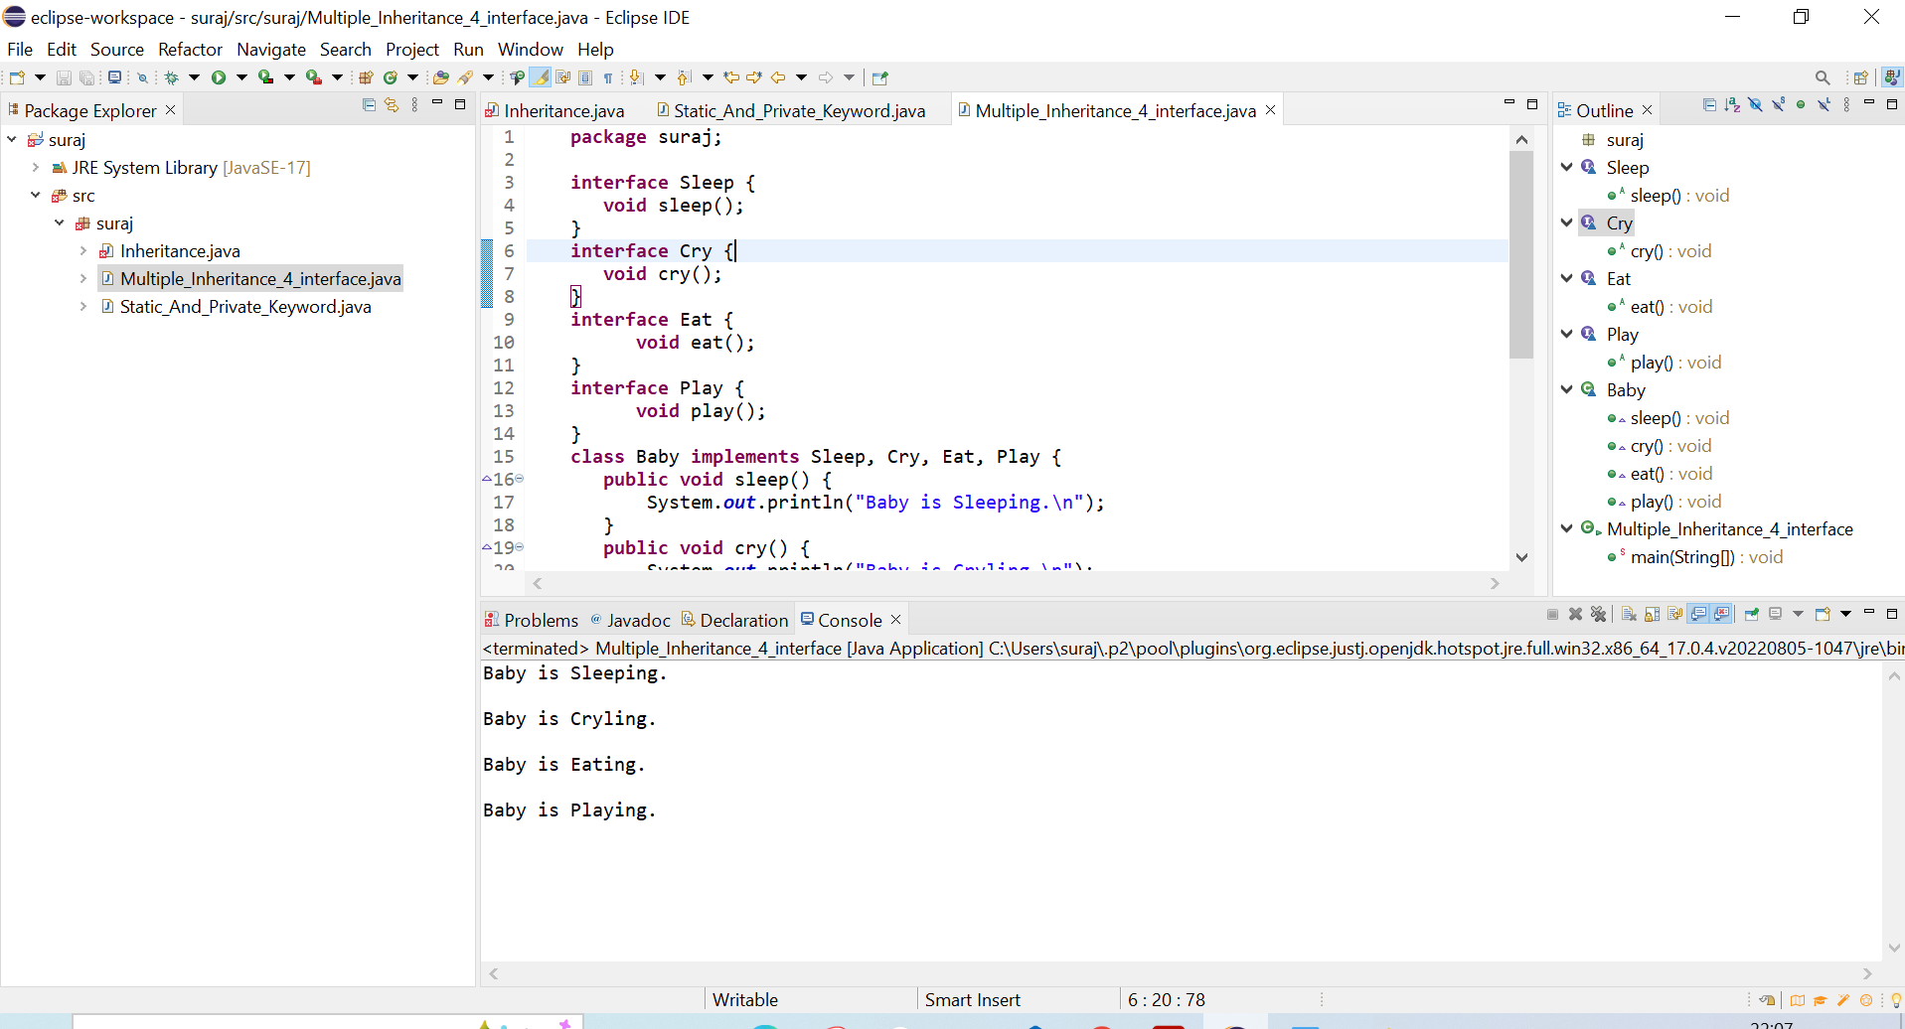

1. Try to write a program where one tries to modify the variable in the interface from the Main class. Check if it works or not, if not, Justify why

Answer :

No, we cannot modify the variable in the interface from the main class. Because an interface cannot be instantiated directly, the interface variables are static and final by default. So, we cannot change them.

Before Modification :

**package** suraj;

**interface** abc{

String ***name*** = "SURAJ KUMAR";

}

**public** **class** Modify_interface_variable **implements** abc{

**void** show(){

System.***out***.println(***name***);

}

**public** **static** **void** main(String args[]){

Modify_interface_variable obj = **new** Modify_interface_variable();

obj.show();

}

}

Output :

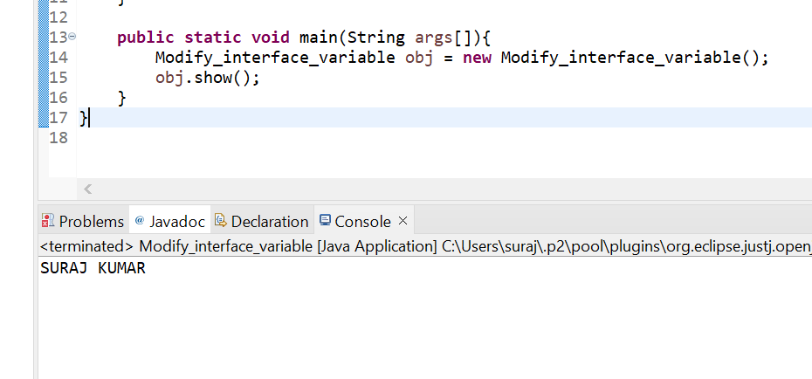

After Modification :

**package** suraj;

**interface** abc{

String ***name*** = "SURAJ KUMAR";

}

**public** **class** Modify_interface_variable **implements** abc{

**void** show(){

***name*** = "abcd";

System.***out***.println(***name***);

}

**public** **static** **void** main(String args[]){

Modify_interface_variable obj = **new** Modify_interface_variable();

obj.show();

}

}

Output :

