You must customise this document to set up the analysis artefacts that are appropriate to your project development type.
Double click below to set up the document:
- WATERFALL/TRADITIONAL/LEGACY
- ITERATIVE/OBJECT ORIENTED
When project teams select Waterfall or Iterative, the template is automatically adjusted to only include applicable sections. Project teams, therefore, only complete the sections applicable to their selected methodology.
If you have opened this document directly from the Intranet, Use File >> Save As to create a copy in your own folder structure. Then close this window and reopen the document you have created to edit it.
If you receive an error message when you try to Save As, close this window. Right click on the link, then select Copy Target As to download the file to your own folder structure.
NOTE: All the instructions in this template are written using the “Commentary” style. You can hide and redisplay the the instructions by clicking the “Show-Hide Instructions” button in the QIP toolbar. When you have finished your document, you can permanently remove instructions by using the "Delete commentary" button in the QIP toolbar. Do not correct any pagination issues until after you have hidden or removed commentary.
Use the page setup buttons in the QIP toolbar if you need to convert the document from A4 to letter or vice versa.
Use File>>Properties to:
- enter the project name in the Subject field.
- enter your business entity name in the Company field (for the copyright statements)
- enter the copyright year(s) in the Category field
- enter your name in the Author field
Use Edit>>Select All, then press F9 to update fields in the body of the document. Press Print Preview to update fields in page headers and footers.
Remove any sections that are inappropriate to describing the system under development
Be All Customer Relationship Management System
Analysis Specification

Version 0.2
05 June 2007
If you do not use document identification in your document management system, you can delete the Document ID

Revision History
Date | Version | Status | Prepared by | Comments
05 June 2007 | 0.1 | <Draft> | Joshua Harrison | First draft for review
07 June 2007 | 0.2 | <Draft> | Simon Fenton | Feedback incorporated from the walkthrough.

Document Control
Role | Name | e-mail | Telephone
Senior Analyst | Joshua Harrison | Joshua Harrison/…/…

Approval

Role | Name | Signature | Sign-Off Date
IT Project Manager | Nancy Fleming | Email sign-off received | 08 June 2007
Business Project Manager | Malcolm Striker | Email sign-off received | 11 June 2007
Senior Programmer | Gustavo Mantra | Email sign-off received | 08 June 2007
Senior Tester | Susan B Levine | Email sign-off received | 14 June 2007

Template version history.
1.0 – 15 Sep2006 First live release
1.1 – 24 Oct 2006 Conceptual Data Model and Entity Relationship Diagram changed from waterfall only to waterfall and iterative. Commentary1 text deleted at setup.
Table of Contents

Introduction 1
Requirements reference 2
Business Rules 9
Data view 10

Introduction

Purpose
The purpose of this Analysis Specification is to show what is needed to deliver the Be All Customer Relationship Management System requirements. This provides a bridge between the business requirements (what is needed) and the more technical design details (how it will be delivered).
This particular specification is for sample purposes. It provides only enough detail to illustrate what is generally expected for each of the sections; therefore, some sections may provide partial models. Also, in a real project, the team shall select “Waterfall” or “Iterative” on the title page, and then only complete the sections belonging to the selected methodology. Here, however, we have left all sections intact so that we can provide sufficient illustration of the techniques and content expectations.
Define the role or purpose of the Analysis Specification, in the overall project documentation.. Remember that Analysis must refer to “what” is needed at a detailed level, not “how” to provide it.

Scope
See Requirements Specification. Solution 1 from the Clear Choice, CROPS, has been chosen. This vendor solution delivers most of the functionality. However, there will be some in-house development required.
Describe what the Analysis Specification applies to; what is affected or influenced by this document

Audience
User representatives and analysts should use this document to clarify the requirements, ensure that they are testable, and resolve any conflicts. Subject experts such as lead technicians, DBA’s, and architects should use this document to drive out further details, verify their understanding, and answer any open questions about what is required in order to start design.
Identify the audience and indicate how they are intended to use the document..

References
- Initial Request for Be All Customer Management System, Version 2.0, 1 Nov 2004
- ClearChoices for Be All Customer Management System, Version 2.0, 1 Nov 2004
- Project Terms of Reference for Be All Customer Management System, Version 2.1, 1 Nov 2004
- Requirements Specification for Be All Customer Management System, Version 0.1, January 2005.

Provide a complete list of all documents referenced elsewhere in the Analysis Specification. Identify each document by title, report number (if applicable), date, and publishing organization. Specify the sources from which the references can be obtained. This information may be provided by reference to an appendix or to another document.

Requirements reference

Main responsibilities
Provide HSBC clients with a coherent experience of HSBC through the provision of client-relationship information to the various representatives of HSBC through a single Client Relationship Management Tool.
The system shall provide the following client-relationship activity information:
- business plans
- call reports
- meeting reports
- work in progress.
List the main system responsibilities.
************* Start waterfall only ****

Context Diagram
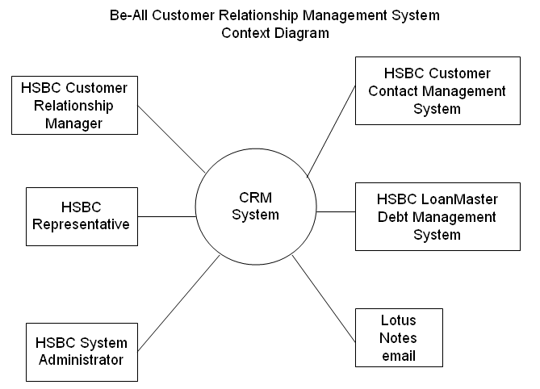
Defines the system boundaries. Used to make sure everyone has the same understanding of the problem, to get agreement on what is inside and outside of the system (scope)

Decision Tables
Here is one decision table illustrating 2 conditions in which to provide cross-selling alerts:
 | 1 | 2
New Mortgage | - | Yes
UK Corporate Client | Yes | -
Borrow $USD for Imported Goods | Yes | -
Notify of Cross-Selling Opportunity:
Cross Currency Rate Swap trade | X
Online Checking Account |  | X
Use Decision Tables to represent actions that result from conditions. The Decision Table is a two-dimensional table.

Decision Trees
Here is a partial decision tree that illustrates various types of cross sell alerts:
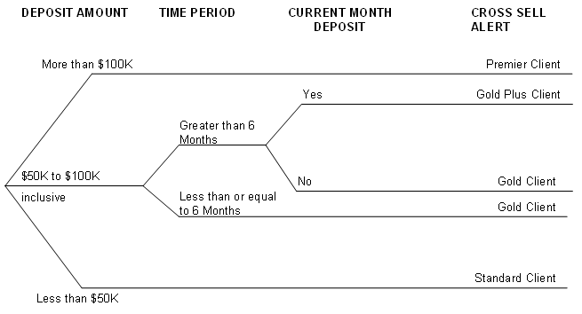
Use Decision Trees to represent actions that result from conditions. The Decision Tree is a visual model.
********* End waterfall only ***
*********Start both waterfall and iterative ***

Use Case Diagram
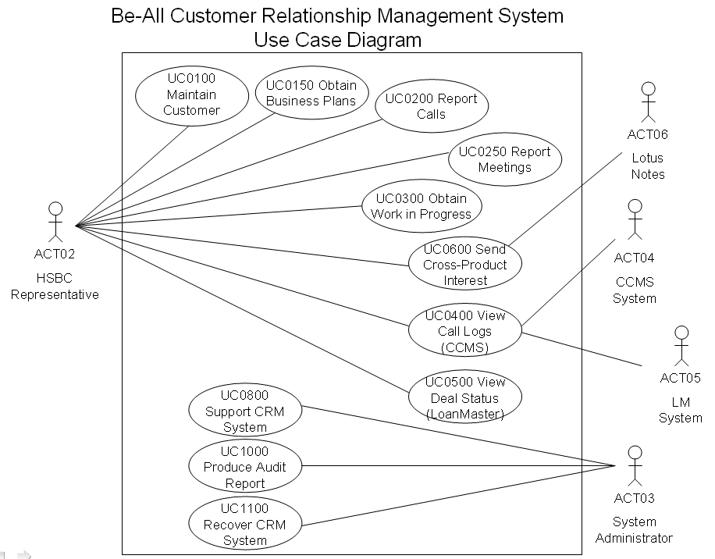
A visual depiction of one or more actors and use cases and their relationships. The diagram is intended to summarize but not fully describe the behaviour of the system. It can be used as a context diagram or table of contents.
>>>>End both waterfall and iterative>>>>
>>>>Start iterative only>>>>

Actor Reference
Describe who or what uses the system.
Actor code | Actor Name | Actor Description
ACT02 | HSBC Representative | Any authorized HSBC representative.
A type of ACT02 | Customer Relationship Manager | Each client has a Customer Relationship Manager (CRM). The CRM represents and provides information to the client.
ACT03 | System Administrator | Person who administers the system. This includes supporting the software, maintaining & controlling access, permissions, and system control tables.
ACT04 | CCMS System | HSBC Customer Contact Management System
ACT05 | LM System | LoanMaster System
ACT06 | Lotus Notes | HSBC’s eMail system
>>>> End iterative only>>>>
>>>>Start both waterfall and iterative>>>>

Use Case Reference
List all of the system use cases. Each use case should also be part of the Use Case Diagram.
Use Case ID | Use Name | Use Case Brief Description
UC0100 | Maintain Customer | Be able to search, view , maintain personal clients’ information, including contacts.
UC0150 | Obtain Business Plans | The system shall provide client relationship activity information regarding Business Plans.
UC0200 | Report Calls | The system shall provide client relationship activity information regarding Call Reports
UC0250 | Report Meetings | The ssystem shall provide client relationship activity information regarding Meeting Reports
CD0300 | Obtain work in Progress | The system shall provoide client relationship activity information regarding Work in Progress
UC0400 | View call Logs (CCMS) | Be able to view call logs from the HSBC Customer Contact Management System (CCMS) for the last 3 months.
UC0500 | View Deal Status (LoanMaster) | Be able to view deal status iformation from the HSBC LoanMaster debt management System for the last 3 months.
UC0600 | Send Cross-Product Interest | Send an alert of a cross-selling opporutnity to another colleague.
UC0800 | Support System | A system amministratior must be able to set entitlement to functions and data, control access, and provide suport as needed during a maintenance window.
UC1000 | Produce Audit Report | Audit any actvity in regard to  - unsuccessful logon  - -Use of System Administrator or equivalent  - -Account creation and deletion  - -User group assignments
UC1100 | Recover System | Recover from failed service within 15 minutes during 8:00 to 12:00 GMT and within 45 minutes at any other time.

************End both waterfall and iterative ***
*********** Start iterative only ***

System Sequence Diagram
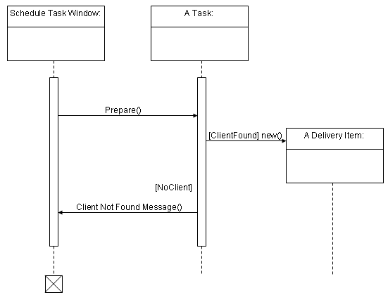
Sequence diagrams are interaction diagrams that emphasize the time-ordering of messages. Sequence (and collaboration) diagrams are isomorphic, meaning that you can take one and transform it into the other. A sequence diagram shows step-by-step what has to happen to accomplish a piece of functionality provided by the system. Sequence diagrams show the flow of steps over time, scenarios, while Collaboration Diagrams focus on how objects relate to one another.

System Collaboration Diagram
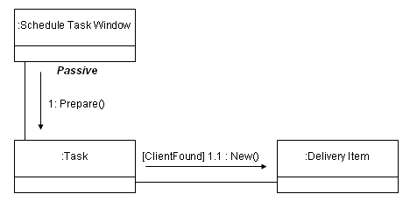
Collaboration diagrams are a kind of interaction diagram which emphasize the structural organization of the objects that send and receive messages. Collaboration (and Sequence) diagrams are isomorphic, meaning that you can take one and transform it into the other. A Collaboration Diagram represents the interactive view of the system. It displays object interactions organized around objects and their links to one another. Collaboration diagrams depict how objects relate to one another, while Sequence Diagrams focus on the step by step process.

Activity Diagram

Update Contact History
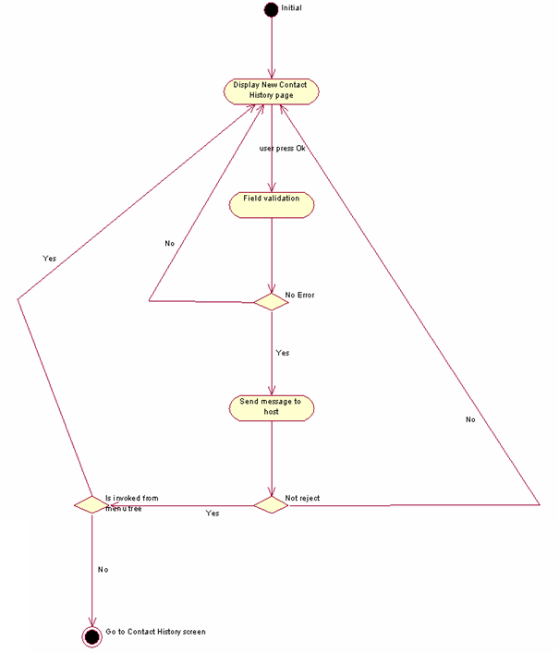
An activity diagram shows the flow from activity to activity within a system. An activity diagram addresses the dynamic view of a system. This type of diagram is important in modelling the function of a system and emphasizing the flow of control among objects.

Class Diagram
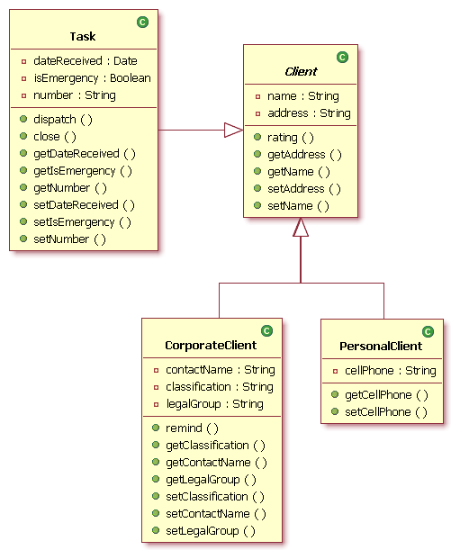

A class diagram shows a set of classes, interfaces, collaborations and their relationships. These diagrams are the most common diagram found in modelling object-oriented systems. Class diagrams address the static design view of a system.
************ End iterative only ***

Business Rules
Describe the rules the system must follow, from a business perspective, for example “Customers whose bills are unpaid for 90 days will be referred to a Collection Agency”. These might also be calculations (a+b=c), limitations (maximum withdrawal is $###.##), etc. These rules constrain how the business itself works, independent of how the solution supports the business.
Types of Business Rules:
Stimulus Response - These rules describe conditions that trigger some action.
BR0010 - WHEN a customer is a UK corporate client, IF borrowing $USD for imported goods, THEN notify HSBC representative of cross-selling opportunity: Cross Currency Rate Swap trade.
BR0015 - IF terminal is inactive for 30 minutes THEN user will be logged off.
Operation constraint - Describe rules applicable when some condition restricts possible actions.
BR0020 – Provide Client Information ONLY IF personal client of the HSBC Customer Relationship Manager.
BR0030 - The total market sectors assigned to a client MUST BE LESS THAN OR EQUAL TO 5.
Structure constraint - Specify any referential integrity that must always be met.
BR0040 - IT MUST ALWAYS HOLD THAT a Contact refers to at least one Client.
BR0050 - The first client contact is ALWAYS with an HSBC Customer Relationship Manager.
Inference - Certain facts lead to a specific conclusion
BR0060 - A customer is a premier status IF AND ONLY IF the savings account balance is greater than $100,000 USD.
BR0070 – Users who have 3 consecutive unsuccessful log-on attempts, when successful logon is not achieved within 15 minutes, or who have not used the system in 90 days are considered suspended.
Computation - The information is derived from a formula.
BR0080 – Client Revenue = Total of past 12 months’ revenues from a client.

Data view
************* Start both waterfall and iterative ***

Data Dictionary
A compilation of definitions for all information included in a system. Include single pieces of information, such as “First Name”, and combinations or views of the information, such as the information in an interface or included in a view for display or reporting. Sorted by Element Name.
Element Name | Alias | Description | Data Rules
See more detailed data in template below |  |  | Size, values, calculations, optional/mandatory

CoE Data Dictionary
The Data Architecture group under the Data CoE has a specialized template for the data dictionary for any logical modeling effort to be done by them. This Excel template contains macros necessary to their procedures, and for loading the model to the Group Metadata Repository (GMR). We have used this template for recording the details of our data dictionary.
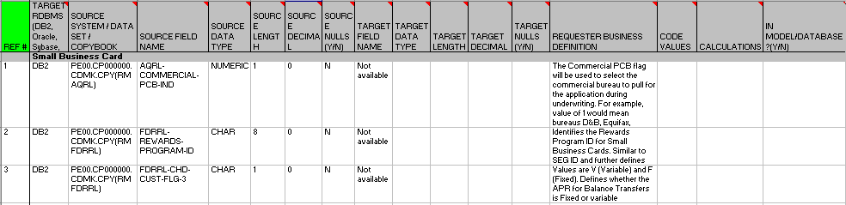

State Diagram

State Chart: Create Lead
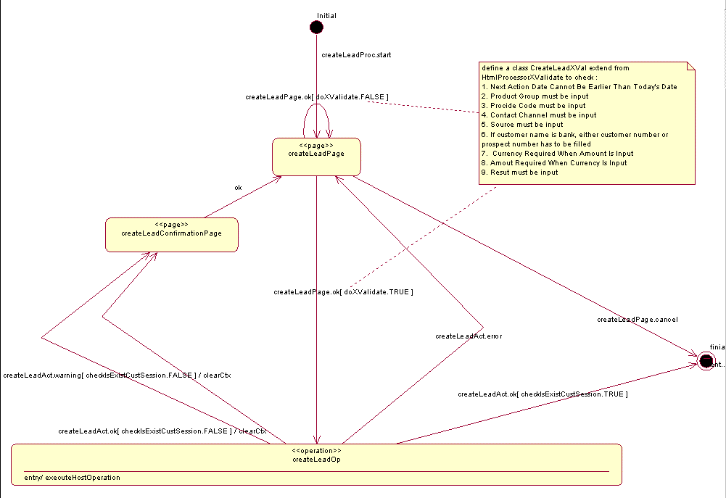
A state diagram shows a state machine consisting of states, transitions, events and activities. State diagrams address the dynamic view of a system. They are important in modelling the behaviour of an interface, class, or collaboration, and emphasize the event-ordered behaviour of an object, which is useful in reactive systems.
***************End both waterfall and iterative **
*************Start waterfall only ***

Data Flow Diagram
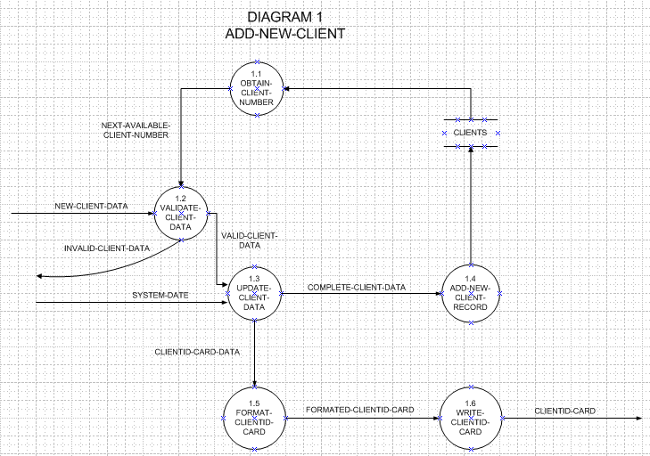
Shows information flowing through a system and the functions performed on it.
********** End waterfall only ***
**********Start waterfall and iterative ***

Conceptual Data Model
See Entity Relationship Diagram below.
A concise, non-technical description of the user data requirements. Includes detailed descriptions of the entity types, relationships, constraints. These descriptions help assure all requirements are met and do not conflict. Represents properties of the information without being concerned with storage details. The next step after conceptual data is called Logical Data Modelling.

Entity Relationship Diagram

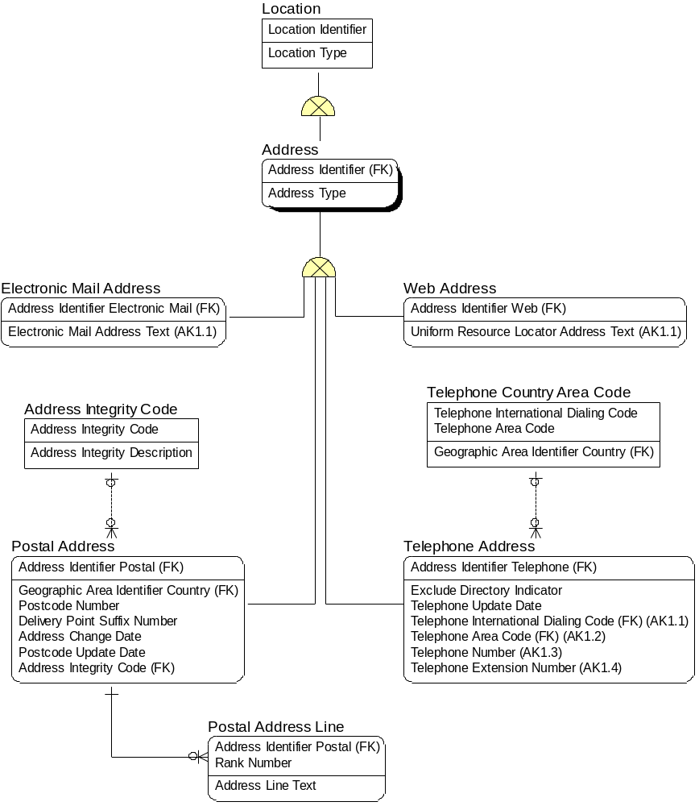
The Analysis phase begins investigation into what the Entity Relationship Diagram will be. The Data Architecture Group within the Data Domain provides help in developing the Entity Relationship Diagram, as this is a specialized skill set.
The Entity Relationship diagram represents the Physical Data Model. It provides specific storage structures and access paths for the database files to achieve good performance for the use cases or functional requirements, system behaviours.
The Physical Data Model takes into account who, what, where, and how often information will be added, changed, deleted, queried.
To accommodate how the information is used, the Physical Data Model usually includes various types of indexing, clustering on storage devices, linking, pointers, hashing methods, security and referential integrity rules.
The following non-functional requirements help determine physical data model design options: response time, space utilization accounting for capacity and scalability requirements, transaction throughput (average number of transactions that can be processed per minute, measured under peak conditions) for acceptable performance, entitlement, and security.

************End waterfall and iterative ***
************Start iterative only ***

Domain Model
See Banking Domain Objects in GSR.
Also:
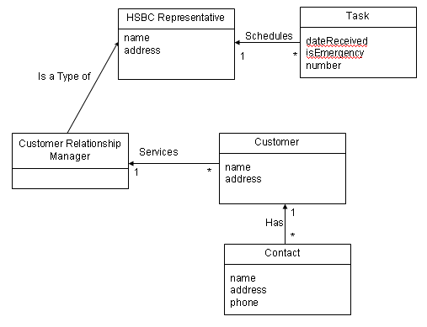
Domain models relate physical objects to abstracts concepts to each other in a system.
************End iterative only ***

Glossary
Term | Definitions
Customer | A person or business that actually or may potentially use HSBC products and/or services. Also known as “Client”.

Define any terms that help the team understand the words used to describe business and technical perspectives.

