You must customise this document to set up the analysis artefacts that are appropriate to your project development type.
Double click below to set up the document:
- WATERFALL/TRADITIONAL/LEGACY
- ITERATIVE/OBJECT
When project teams select Waterfall or Iterative, the template is automatically adjusted to only include applicable sections. Project teams, therefore, only complete the sections applicable to their selected methodology.
If you have opened this document directly from the Intranet, Use File >> Save As to create a copy in your own folder structure. Then close this window and reopen the document you have created to edit it.
If you receive an error message when you try to Save As, close this window. Right click on the link, then select Copy Target As to download the file to your own folder structure.
NOTE: All the instructions in this template are written using the “Commentary” style. You can hide and redisplay the the instructions by clicking the “Show-Hide Instructions” button in the QIP toolbar. When you have finished your document, you can permanently remove instructions by using the "Delete commentary" button in the QIP toolbar. Do not correct any pagination issues until after you have hidden or removed commentary.
Use the page setup buttons in the QIP toolbar if you need to convert the document from A4 to letter or vice versa.
Use File>>Properties to:
- enter the project name in the Subject field.
- enter your business entity name in the Company field (for the copyright statements)
- enter the copyright year(s) in the Category field
- enter your name in the Author field
Use Edit>>Select All, then press F9 to update fields in the body of the document. Press Print Preview to update fields in page headers and footers.
Remove any sections that are inappropriate to describing the system under development
Be-All Customer Relationship Management System
Design Specification

Version <0.1>
11 June 2007
If you do not use document identification in your document management system, you can delete the Document ID

Revision History
Date | Version | Status | Prepared by | Comments
15 June 2007 | <0.1> | <Final> | Jan Tomlin | For Analysis Review

Document Control
Role | Name | e-mail | Telephone
Owner | Jan Tomlin | Janet S Tomlin /…/… | 799 883827

Approval

Role | Name | Signature | Sign-Off Date
IT Project Manager | Nancy Fleming | Email sign-off received | 15 June 2007
Business Project Manager | Malcolm Striker | Email sign-off received | 18 June 2007
Senior Programmer | Gustavo Mantra | Email sign-off received | 13 June 2007
Senior Tester | Susan B Levine | Email sign-off received | 21 June 2007

Template version history.
1.0 – 15 Sep2006 First live release
1.1 – 24 Oct 2006 Remove commentary1 text at set up
Table of Contents
Introduction 1
Architecture external view 2
Architecture internal view 7
Deployment View 14
Data view 15

Figure 1 - Pseudo Code 18

Introduction

Purpose
The purpose of this Design Specification is to show how the Be-All Customer Relationship Management System shall work. This provides the technical design details.
This particular specification is for sample purposes. It provides only enough detail to illustrate what is generally expected for each of the sections; therefore, some sections may provide partial models. Also, in a real project, the team shall select “Waterfall” or “Iterative” on the title page, and then only complete the sections belonging to the selected methodology. Here, however, we have left all sections intact so that we can provide sufficient illustration of the techniques and content expectations.

Define the role or purpose of the Design Specification, in the overall project documentation. Remember that Design refers to “how” the system will provide what is required.

Scope
See Requirements Specification.
Describe what the Design Specification applies to; what is affected or influenced by this document

Audience
Developers, IT Security, and Solution Architects should use this document to specify how the system shall be constructed, clarify any questions remaining after analysis, ensure that the design is testable with the Quality staff, and resolve any conflicts. The User Representatives verify that the External Design meets their requirements. Developers use this document to make sure that their design questions are answered sufficiently in order to start building the system.
Identify the audience and indicate how they are intended to use the document..

References
- Initial Request for Be All Customer Management System, Version 2.0, 1 Nov 2004
- ClearChoices for Be All Customer Management System, Version 2.0, 1 Nov 2004
- Project Terms of Reference for Be All Customer Management System, Version 2.1, 1 Nov 2004
- Requirements Specification for Be All Customer Management System, Version 0.1, January 2005.
- Analysis Specification for Be All Customer Management System, Version 0.2, June 2007.
Provide a complete list of all documents referenced elsewhere in the Design Specification. Identify each document by title, report number (if applicable), date, and publishing organization. Specify the sources from which the references can be obtained. This information may be provided by reference to an appendix or to another document.

Architecture external view
This section describes in detail the external part of the architecture. In particular, it explains the collaboration with other systems, the supported protocols, messages, etc.

Overview
Implement CROPS with the in-house development of internal interfaces.
CROPS is considered to represent the most viable solution because:
- it provides the best functional fit out-of-the-box;
- it conforms to Group technical standards; and
- the vendor is known to the users and is currently delivering a good service.
See Context Diagram within the Analysis Specification
Put the system in context of the enterprise. In particular, it is important to show the collaboration with other systems.

Communication protocols
Standard browser-based communication.
Describe the supported communication protocols.

Messages
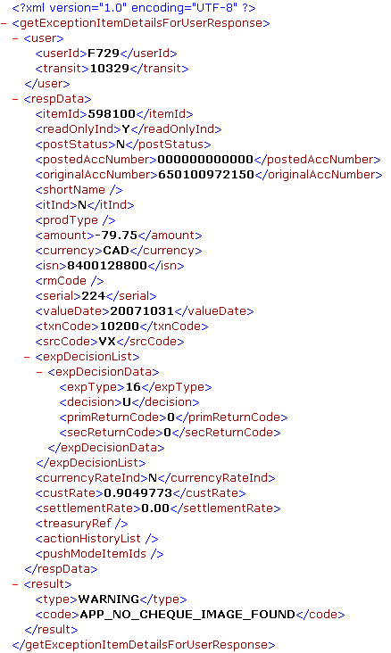
Message: Outbound return file to clearing centre
Transaction: return an cheque item for clearing.
<?xml version="1.0" encoding="ISO-8859-1"?>
<OUTBOUND>
<HEADER>
<Record_Type>H</Record_Type>
<Record_Number></Record_Number>
<Customer_Identifier></Customer_Identifier>
<Processing_Site></Processing_Site>
<Processing_Date></Processing_Date>
<File_Creation_Date></File_Creation_Date>
<File_Creation_Time></File_Creation_Time>
</HEADER>
<ITEM_DETAIL>
<Record_Type>D</Record_Type>
<Record_Number></Record_Number>
<Truncation_Indicator></Truncation_Indicator>
<ISN></ISN>
<Serial></Serial>
<Routing_Transit></Routing_Transit>
<BOFD_Transit></BOFD_Transit>
<Suspense_FI_Number></Suspense_ FI_Number>
<Suspense_Account_Transit></Suspense_Account_Transit>
<Suspense_Account></Suspense_Account>
<Suspense_Serial_Number></Suspense_Serial_Number>
<ULI></ULI>
</ITEM_DETAIL>
<TRAILER>
<Record_Type>T</Record_Type>
<Record_Number></Record_Number>
<Financial_Record_Count></Financial _Record_Count>
<Financial_Dollar_Amount></Financial_Dollar_Amount>
</TRAILER>
</OUTBOUND>

Update Contact History
Transaction: Update Contact History
Description: The message handles posting for Update Contact History
UPHOST MESSAGE
Field Name | Description | Len | Type | Value
Header Section:
headerVersion | Header Version Id | 2 | A
countryCode | Country Code | 2 | A
groupMember | Group Member | 4 | A
mediaId | Media ID(4A : TCID, 6A: blank - future use) | 10 | A
userid | Logon User Id | 4 | A
logonDate | Logon Date; Obtain from host at signon | 8 | Z | yyyymmdd
logonTime | Logon Time; Obtain from host at signon | 6 | Z | hhmmss

DOWNHOST MESSAGE
Field Name | Description | Len | Type | Value
Header Section:
headerVersion | Header Version Id | 2 | A
countryCode | Country Code | 2 | A
groupMember | Group Member | 4 | A
mediaId | Media ID(4A : TCID, 6A: blank - future use) | 10 | A
userid | Logon User Id | 4 | A
logonDate | Logon Date; Obtain from host at signon | 8 | Z | yyyymmdd
logonTime | Logon Time; Obtain from host at signon | 6 | Z | hhmmss
msgIdentifier | Message Type(2A: System Code, 3A: Deal code, 5A: blank - future use) | 10 | A | 'EWUCO '

Describes in detail the messages used by the system to communicate with others. The term message is used in its general meaning: it can refer to proper messages transmitted by a message infrastructure, or the object graph present in a remote invocation.
>>>>Begin Waterfall only>>>>

Screen layouts
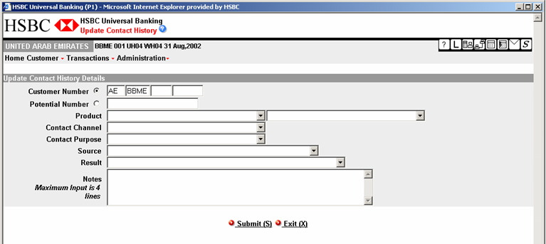
Describe in detail the screens employed by the system to obtain input from and/or present results to the end use

Report layouts
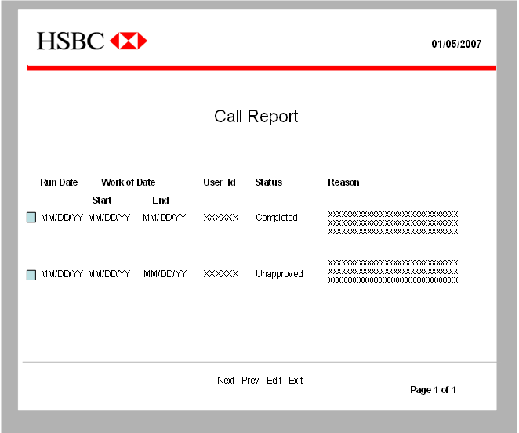
Describe in detail the reports produced by the system.
>>>>End Waterfall only>>>>
>>>>Begin Iterative only >>>

Usecase Storyboard
See vendor training documentation.
Sequences of screen shots that depict use case behaviour, enacting some part of a scenario.

User Interface Prototype
Describe in detail the reports produced by the system.
Mock-up of any user interface, such as screens or reports.
>>>>End Iterative only >>>

Architecture internal view
This section describes the architecturally significant parts of the design model, such as its decomposition into subsystems and packages. Show the decomposition of each significant package and/or component.

Multi-layered architecture
See Overview section.
Describe the “standard” multi-layered architecture:
- Presentation layer
- Business Service
- Business Object Layer
- Integration Layer
For each layer, describe the main mechanisms that are executed in the layer.

Overview
Sun Solaris server

ORACLE
database
Sun Solaris server

WebSphere
J2EE
PC Desktop

Browser
CROPS configuration
Describe the overall decomposition of the design model in terms of its components. If the architecture enforces a Component Based paradigm, then you must show the main components, otherwise, it is sufficient to show the main packages and the inter-dependencies. Presented parts should be allocated within the corresponding architecture layer. Packages, Components that span multiple-layers should not be allowed.

Standards
CROPS runs on Group-approved hardware (Sun Solaris) and uses Group-approved software (ORACLE database, Websphere web server with J2EE and a Browser front end).
Adheres to R2 standards and GSR for re-usable components.
List the adopted standards, such as: JMS, JDBC, how this design adheres to R2 standards, etc.

Detailed Software Specifications
Provide the software specifications for the new system.
Reference vendor specifications.
CROPS version 5.1 running on WebSphere version 6.0.

Detailed Hardware Specifications
Specify the required hardware and operating systems to support the new software. Show hardware and operating system requirements for each tier, such as product server, report server, individual’s workstation, etc.
CROPS will run in SYNDC (Standard HSBC platform).
>>>>Begin waterfall only >>>

System Flowchart
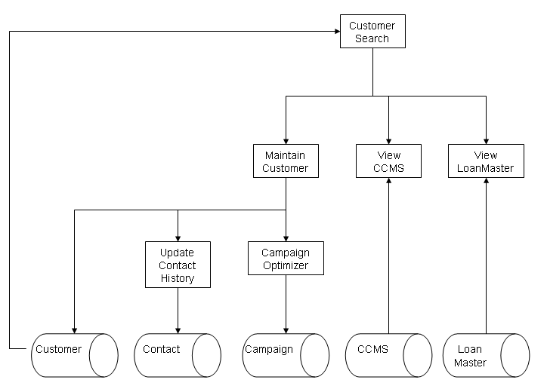
Model that is used to show the major system inputs, outputs, and procedures.

Structure Charts
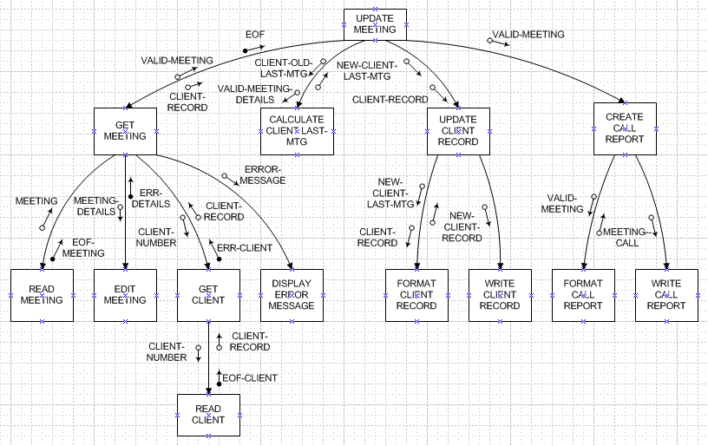
A graphic tool for representing the hierarchy and interfaces between components.
>>>>End waterfall only >>
>>>>Begin Iterative only >>

Usecase Realisation
See Rose modelling tool.
Bridges the gap between the user’s description of what they need (independent from the technical solution) and the technical design (solution dependent). Use Case Realizations can be in a narrative form or visual, such as sequence and collaboration diagrams. The difference between these diagrams in the Analysis Phase versus the Design Phase is that in Design, these Use Case Realizations take into account how the use case is implemented in the system. Therefore, one Use Case may have different Use Case Realizations for alternative solutions.

Design Classes
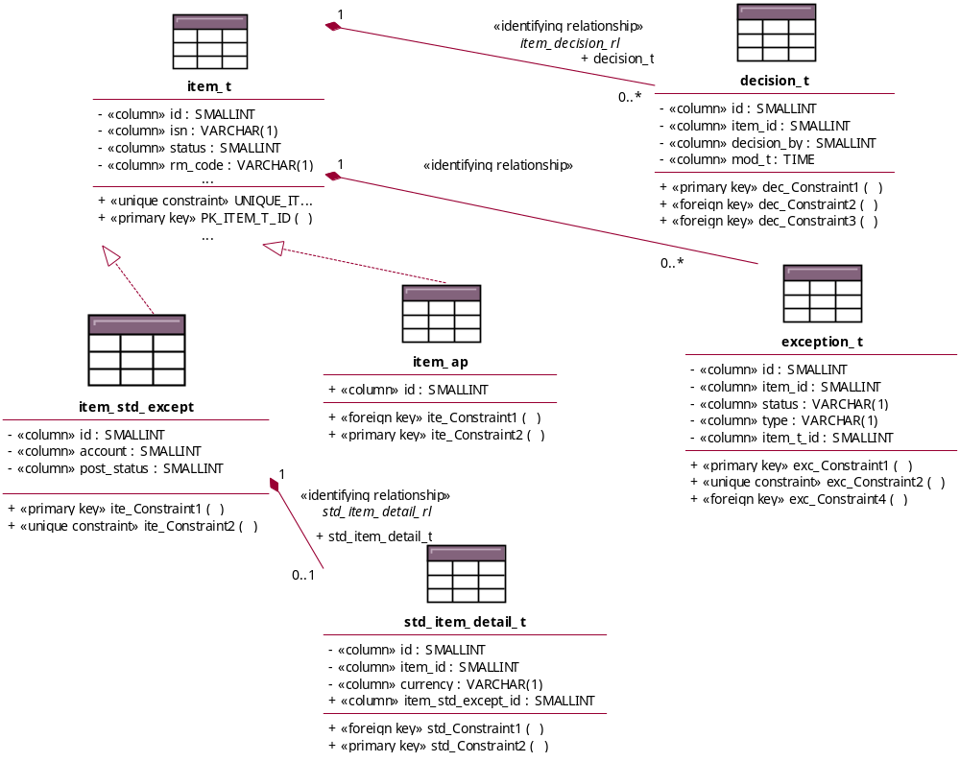
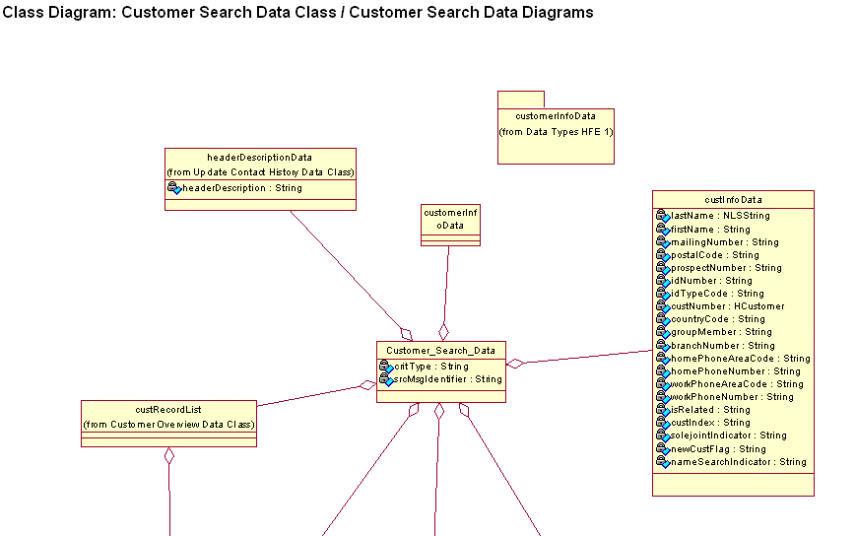
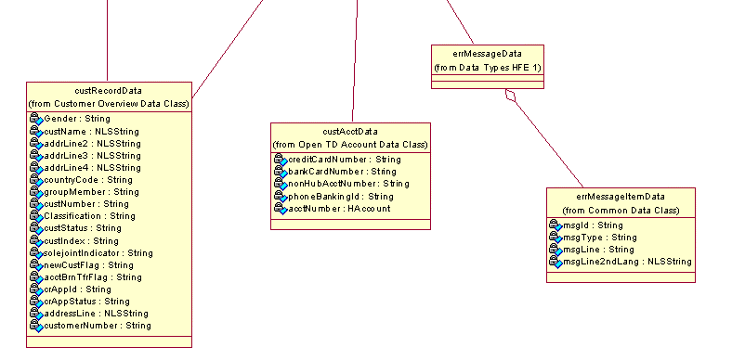

Detailed Specification for one of these classes:
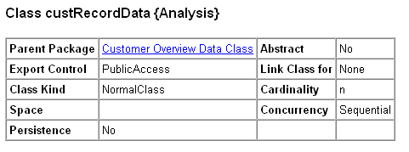
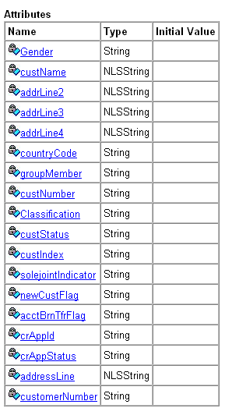
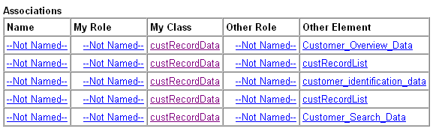

A class diagram shows a set of classes, interfaces, collaborations and their relationships. These diagrams are the most common diagram found in modelling object-oriented systems. Class diagrams address the static design view of a system.
>>>>End iterative only >>>

Interface Design
eMail interface is defined in GSR. See IMailer Interface, section 5.1
An Interface is whatever is required when components need to communicate with each other to accomplish a desired result. The Interface could be shared data, power, a useful computation, for instance.

Component List
(See Error: Reference source not found for each component.)
Component ID | Component Name | Component Description | Re-Usable Component Name & Location | Re-use “As-Is” or Copy | Re-Usable Component Owner
Abc123 | Abc component | Abc requirements… | Developed In House

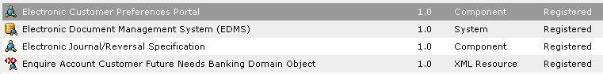
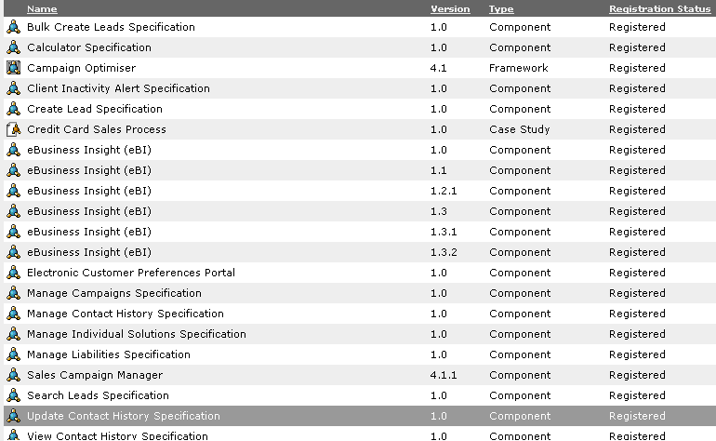
A component is a non-trivial, nearly independent, and replaceable part of a system with a defined interface and behaviour. It may be source code, run time, or an executable.
Design components for Re-use. Search for existing components at HSBC, such as those found in the HSBC Group Software Registry, or within the marketplace (off the shelf for purchase) before building from scratch.
It is in our stockholders' best interest make the most use of a component that they have already paid for, wherever possible and practical, across any system or organizational boundary. When done successfully, these reusable components become HSBC assets.
Advantages of reuse:
1) Increases the return on investment by providing more benefit as components are used to meet additional business needs.
2) Increases quality, since the reusable component was already tested and implemented for its original use.
3) Standardizes processes and business rules. Eliminates rework and redundancy.
Obstacles of reuse:
1) Different systems may not be compatible or open to the standard reusable interface.
2) Different business groups may not agree on the standard business rules and processes.
3) Finding appropriate reusable components. When designing for reuse, people must be able search for applicable components, so the reusable components must be stored in a common place with appropriate methods to find and retrieve them.
Characteristics of successfully reused components:
1) There must be an economic benefit for supporting the component. For example, many different people or
systems should be using it, adding continued value across a variety of implementations.
2) Someone must take ownership to support it, to improve quality, make enhancements, assure technology
remains aligned with R2.
3) Design for re-use. The approach should be to first to determine whether or not a needed component exists either within HSBC or in the marketplace before building from scratch.

Deployment View

Deployment Diagram
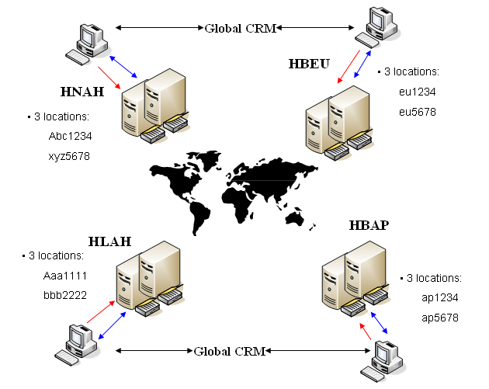
This section describes one or more physical network (hardware) configurations on which the software is deployed and run. It is a view of the Deployment Model. At a minimum for each configuration it should indicate the physical nodes (computers, CPUs) that execute the software and their interconnections (bus, LAN, point-to-point, and so on.)

Data view

Data Map
This is part of the Logical Data View. Describe the persistent data storage perspective of the system. This section should include a database design in terms of tables and linkages and details of any relevant data mappings
Target location | Target format | Source location(s) | Source format(s) | Transformation rules
N/A – There is no existing system from which to convert or map data
The Logical Data Model is a high level data model derived from the Conceptual Data Model.
System-independent mapping: The conceptual data model is mapped to the standard data elements in the data dictionary. This does not consider any specific characteristics or special cases that apply to the particular data storage method.

Database Structure
See Entity Relationship Diagram below for database details.
The Database Structure is part of the Logical Data Model. It may also be in the form of an Entity Relationship Diagram, representing the structure of a database.
In creating the Logical Data Model, tailor data schemas to a specific data storage or Database Management System by applying specific rules and constraints for the chosen data storage method. The result is often specific statements, such as DDL, to specify the database structures.

Entity Relationship Diagram
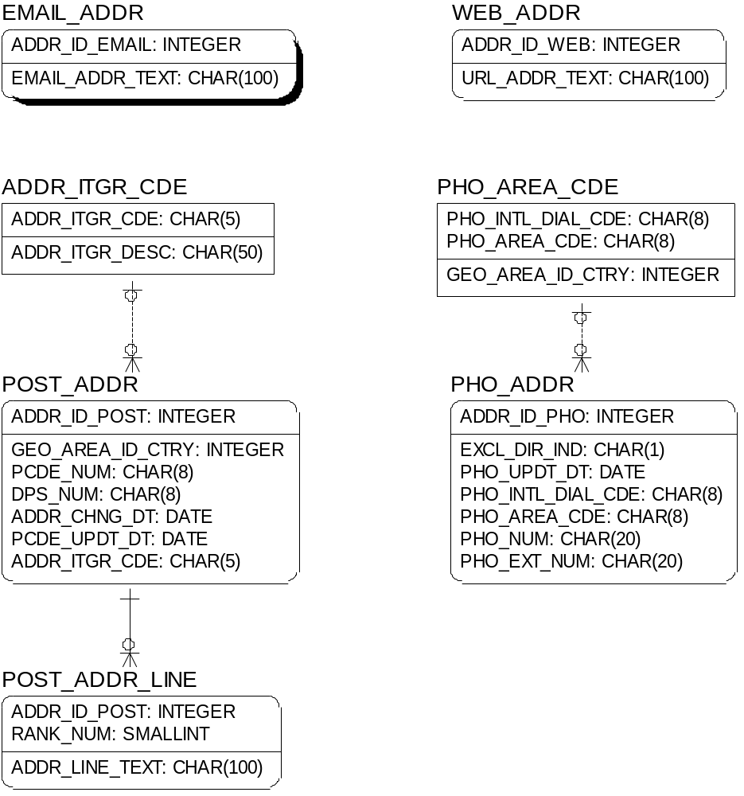
This Entity Relationship diagram represents the Physical Data Model. It provides specific storage structures and access paths for the database files to achieve good performance for the use cases or functional requirements, system behaviours.
The Physical Data Model takes into account who, what, where, and how often information will be added, changed, deleted, queried.
To accommodate how the information is used, the Physical Data Model usually includes various types of indexing, clustering on storage devices, linking, pointers, hashing methods, security and referential integrity rules.
The following non-functional requirements help determine physical data model design options: response time, space utilization accounting for capacity and scalability requirements, transaction throughput (average number of transactions that can be processed per minute, measured under peak conditions) for acceptable performance, entitlement, and security.

Entity Details (Inputs and Outputs)

POST_ADDR
Key | Field Name | Type | Len | Null | Description
FK | CUSTID | BIGINT | 8 | No
FK | GEO_AREA_ID_CTRY | INTEGER | 4 | No
 | PCDE_NUM | CHAR | 8 | No
 | DPS_NUM | CHAR | 8 | No
 | ADDR_CHNG_DT | DATE | 8
 | PCDE_UPDT_DT | DATE | 8 | No
FK | ADDR_ITGR_CDE | CHAR | 5 | No | Maps to IPS_USERS.ID

Figure 1 - Pseudo Code
Include Pseudo code for each component as needed.

