Math 107 Final Name: _____________________________
David Lippman – W10

Show work where appropriate. Answers without appropriate justification will not receive full credit.

An election is held, with the following preference schedule:

Number of Voters | 190 | 200 | 20
1st choice | A | B | C
2nd choice | C | C | B
3rd choice | B | A | A

- Find the winner of this election under the plurality method
__________________

- Find the winner of this election under the instant runoff method

__________________

- Find the winner of this election under the Borda count method

__________________

- Find the winner of this election under Copeland’s (pairwise comparison) method
__________________

- Is there a Condorcet candidate in this election? If so, find it.
_________________

- Using the digraph below, create a priority list for the digraph above using the Critical Path Algorithm. Then schedule the tasks on two processors.

T₉ (6)
T₁ (7)
T₅ (3)

T₂ (3)
T₈ (4)
T₆ (8)
T₁₀ (4)

T₃ (6)
T₁₁ (9)
T₇ (6)
T₄ (5)

Priority List: ___________________________________________________________

Schedule:

- Suppose a population grows according to the linear growth model. In the year 2009 (P₀), the population was 25,000. The population is growing by 800 people each year. Find an explicit formula for the population (for P_{N}), then use it to predict the population in 2012.

P_{N} = ___________________

Pop in 2012: _____________

- Suppose a population grows according to the exponential growth model. In the year 2009 (P₀), the population was 25,000. The population is growing by 7% each year. Find an explicit formula for the population (for P_{N}), then use it to predict the population in 2012.

P_{N} = ___________________

Pop in 2012: _____________

- You deposit $30,000 in an account earning 9% interest compounded monthly. How much will you have in the account in 15 years?

- You decide to buy a new truck for $34,000. The loan company offers you a 3% interest rate for 60 months (5 years). What will your monthly payments be?

To test a theory about how caffeine affects memory, a researcher randomly splits a group of volunteers into two groups. The first group is given a cup of decaffeinated coffee, then asked to perform a memory task. The second group is given a cup of regular caffeinated coffee, and asked to perform the same memory task.

- What is the treatment being tested? (note: the treatment, not the group)

- Which is the control group in this study (if there is one)?

- What is the purpose of giving the first group decaffeinated coffee, instead of giving them nothing at all? Use appropriate vocabulary.

Ten students’ quiz scores are shown here. Use them for problems 14-16
20, 20, 19, 17, 17, 16, 16, 14, 11, 0

- Find the average (mean) of these scores

- Find the median of these scores

- Write the five-number summary for these scores and sketch a box plot

- Based on the following chart, how many students got a “C” or better on the project?

____________
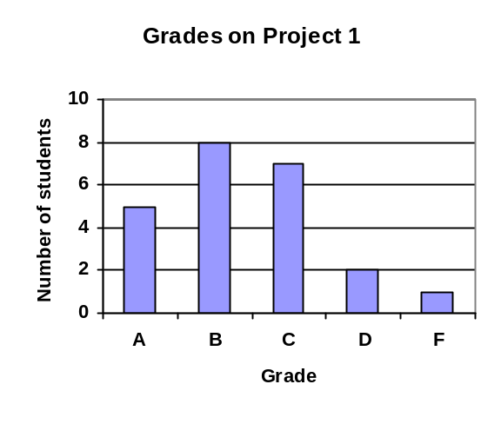
- Based on the chart above, how many students do I have in my class in total?
____________

D
A
B
C
17
5
2
8
15
12
18
22
10
13
E
A company needs to connect 5 buildings with cable. Use the graph to the right for questions 19-20

- If the company wants to construct a full loop (circuit) of cable, use the Nearest Neighbor algorithm, starting at building A.

- If the company wants to construct a minimum cost spanning tree, find it using Kruskal’s algorithm.
D
A
B
C
E

