Quiz – Growth Models - Math 107 Name: ______________________________
David Lippman – W10

Show enough work so I can see how you did the question.

- China’s carbon dioxide emissions were 6,000 million metric tons in 2006, and have been growing by 222 million metric tons each year. If this trend continues, what will China’s carbon dioxide emissions be in 2020?

- Tuition at UW has been growing by approximately 7% each year. This year, annual tuition for an undergraduate at resident rates was $7,125. If tuition continues to grow at the same rate, estimate the annual tuition in 12 years.

- News (and rumors) tends to grow logistically, spreading quickly at first, and then leveling off as everyone has heard it. Suppose a town contains 10,000 people and 100 people start spreading some news. Absent constraint, the number of people who have heard the news increases by 15% each hour. After 24 hours, 2056 people will have heard the news. Determine how many will have heard the news one hour after that.

- 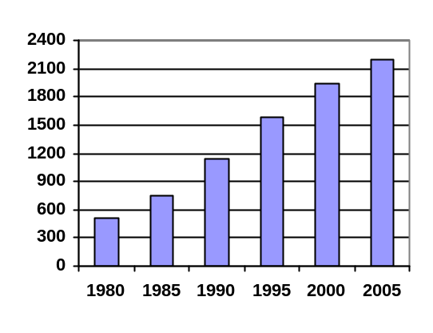The chart to the right shows the total US prison and jail population (in thousands) from 1980 to 2005. Find an equation for the growth trend, and use it to predict the number of prisoners in 2012 if the trend continues.

- In 1995, Starbucks had 677 stores. By 1998 they had 1886 stores.
  - If they continued to grow exponentially at the same rate, how many Starbucks stores does the model predict there will be in 2006?

  - Suppose someone suggested using a quadratic model, which has the form 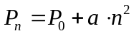. Find the unknown quantities, and use this model to predict the number of Starbucks stores in 2006.

