Quiz - Statistics – Math 107 Name: ________________________
David Lippman – W10

I was interested how much time my students in my online class were spending on studying. I randomly contacted 2 students out of those who received an A, 2 who received a B, etc. I asked them how many hours they spent studying in an average week. The responses were (in hours): 4, 7, 8, 8, 9, 10, 11, 13, 16, 22. I also asked whether they were, overall, happy with the class or not. Use this info for questions 1-7.

- Is this an OBSERVATIONAL STUDY / EXPERIMENT (circle one)

- The hours data is QUANTITATIVE / CATEGORICAL

- The happy/not data is QUANTITATIVE / CATEGORICAL

- Describe the sampling method

- What was the target population of this survey?

- Find the mean (average) of this data.

- Construct a 5 number summary AND draw a box plot for this data.

The ages of students in an evening statistics course were:
18, 20, 21, 22, 22, 25, 26, 28, 30, 32, 37, 39, 45

- Create a frequency distribution with 4 to 6 data classes.

Age Range | Frequency

- Use your frequency distribution from above to create a histogram or bar graph.

- Jamie got 4 commission checks last month. Find the standard deviation of the amounts: $120, $200, $180, $240. Treat this data as population data.

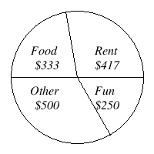
- Kara categorized her spending for this month into four categories: Rent, Food, Fun, and Other. The amounts she spent in each category are pictured here. What percent of her total spending did she spend on Food?

- The boxplot below shows salaries for Construction workers and Teachers. Jennie makes the minimum salary for a construction worker. Markos makes the median salary for a teacher. Does Jennie or Markos make more money? How much more?
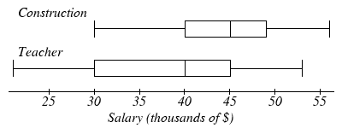

- In order to determine the effects of a new pill that is supposed to reduce hair loss, a researcher conducts the following experiment: 500 volunteer subjects (300 men and 200 women) all of which suffer some degree of hair loss are selected to participate in the study. The researcher gives to the women the real pill and the men a sugar pill, but only the researcher knows this.

  - Is this an OBSERVATIONAL STUDY / EXPERIMENT (circle one)

  - This study is BLIND / NOT BLIND
c) The results of the experiment are likely to be invalid mostly because (pick one)
- the treatment group and control group were not the same size.
- the gender of the patient could be a confounding variable in this experiment.
- the subjects were volunteers.
- the subjects did not know if they were getting the real treatment.
- None of the above

- Seventeen popular breakfast cereals were examined for sugar content. The results, rounded to the nearest 100 milligrams (mg), are shown in the graph below.

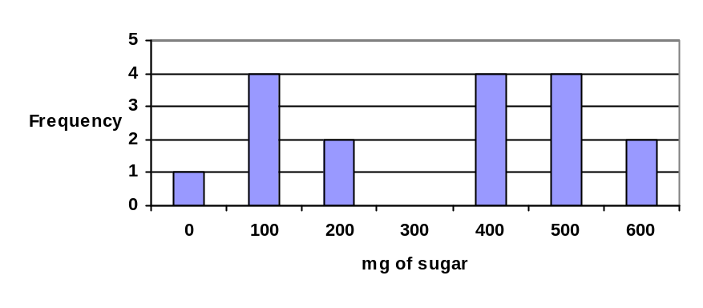

  - Find the mean mg of sugar in the sample.

  - Find the median mg of sugar in the sample.

