SOFTWARE REQUIREMENTS SPECIFICATION
IRO – Issues Reporting Outlet
A web-based system for relating and reporting issues concerning AAUA students and indigenes of Akungba, Iwaro, Etioro, Ayegunle and neighbouring communities

Course: CSC426 – Weekly Dev, Weekend 3
Lecturer: Dr. O. O. Ajayi
Prepared by: Opeyemi Oyinlola
Matric No.: ____________________
Department: Computer Science, Adekunle Ajasin University, Akungba-Akoko
Version: 1.0

Table of Contents
1. Introduction
2. Overall Description
3. System Architecture and Component Interactions
4. Functional Requirements
5. Non-Functional Requirements
6. Use-Case Descriptions
7. Data Requirements
8. Future Enhancements

1. Introduction

1.1 Purpose
This document specifies the requirements for IRO (Issues Reporting Outlet), a web-based system through which AAUA students and indigenes of the host communities can report, relate and follow up issues that affect them. It describes the system's major components and how they interact, together with its functional and non-functional requirements. It is intended for the client firm, the developer, the lecturer/assessor and future maintainers.

1.2 Scope
IRO provides a single, trusted channel for town-and-gown issues such as insecurity, rent and accommodation disputes, student–indigene conflicts, harassment and extortion, land disputes, roads and transport, water and electricity, sanitation and health. Reporters can submit issues (optionally anonymously), receive a tracking ID and follow progress. An administrator (the IRO Desk – a joint university and community liaison office) reviews, prioritises, responds to and resolves issues.
Because the issues are sensitive, the system emphasises anonymity, confidentiality of reporter details and clear accountability through status updates. The current release is a lightweight prototype built with HTML, CSS and JavaScript, storing data in the browser (localStorage).

1.3 Definitions, Acronyms and Abbreviations
Term | Meaning
IRO | Issues Reporting Outlet – the system specified in this document
AAUA | Adekunle Ajasin University, Akungba-Akoko
Indigene | A native or resident of Akungba, Iwaro, Etioro, Ayegunle or neighbouring communities
Reporter | Any user (student or indigene) who submits an issue
IRO Desk / Admin | Authorised officer(s) who manage reported issues
Tracking ID | Unique code (IRO-XXXXXX) issued for every report
SRS | Software Requirements Specification
FR / NFR | Functional Requirement / Non-Functional Requirement
localStorage | Browser storage used to persist data in the prototype

1.4 References
- IEEE Std 830-1998, Recommended Practice for Software Requirements Specifications.
- CSC426 Weekly Dev – Weekend 3 brief, Dr. O. O. Ajayi (01/07/26).
- IRO community questionnaire (Google Form) and Ishikawa analysis (Section 2.6).

1.5 Overview
Section 2 gives an overall description of the product, its users and constraints, including the problem analysis. Section 3 describes the system architecture and how the major components interact. Section 4 lists functional requirements, Section 5 non-functional requirements, Section 6 the use cases and Section 7 the data requirements.

2. Overall Description

2.1 Product Perspective
IRO is a new, self-contained web application. It replaces informal channels (word of mouth, social media posts, letters to student union or community leaders) that are slow, untracked and unsafe for reporters. It runs in any modern web browser and needs no installation.

2.2 Product Functions
- Submit an issue as a Student or an Indigene, optionally anonymously.
- Classify the issue by category, community and priority.
- Generate a tracking ID and let the reporter track progress.
- Let the IRO Desk log in, view statistics, filter and search issues.
- Let the IRO Desk update status, respond to reporters and delete invalid reports.

2.3 User Classes and Characteristics
User class | Description | Technical skill
Student | Registered AAUA student living on or off campus in host communities | Basic smartphone/web use
Indigene / Resident | Natives, landlords, traders and residents of Akungba, Iwaro, Etioro, Ayegunle etc. | Varies; low to moderate
Admin (IRO Desk) | University and community liaison officers who manage issues | Moderate

2.4 Operating Environment
- Client: any modern browser (Chrome, Firefox, Edge, Safari) on desktop or mobile.
- Hosting: static web hosting such as GitHub Pages; no server runtime needed for the prototype.

2.5 Design and Implementation Constraints
- Built with HTML5, CSS3 and vanilla JavaScript to limit complexity within the submission timeframe.
- Prototype data is stored in the browser (localStorage), so reports are visible only on the device where they were made. A production version would use a central database.
- The demo admin account (admin / iro2026) is for demonstration only.
- Source code and documentation must be stored in a GitHub repository.

2.6 Problem Analysis (Ishikawa)
An Ishikawa (fishbone) analysis was carried out to identify the root causes of the problem "issues affecting AAUA students and indigenes go unreported, unheard or unresolved". Causes were grouped under People, Methods/Process, Communication, Technology, Environment and Management/Policy. IRO addresses the causes that software can solve: a single formal channel, anonymous reporting, a central issue database, tracking and feedback to reporters, and a joint IRO Desk with clear accountability.
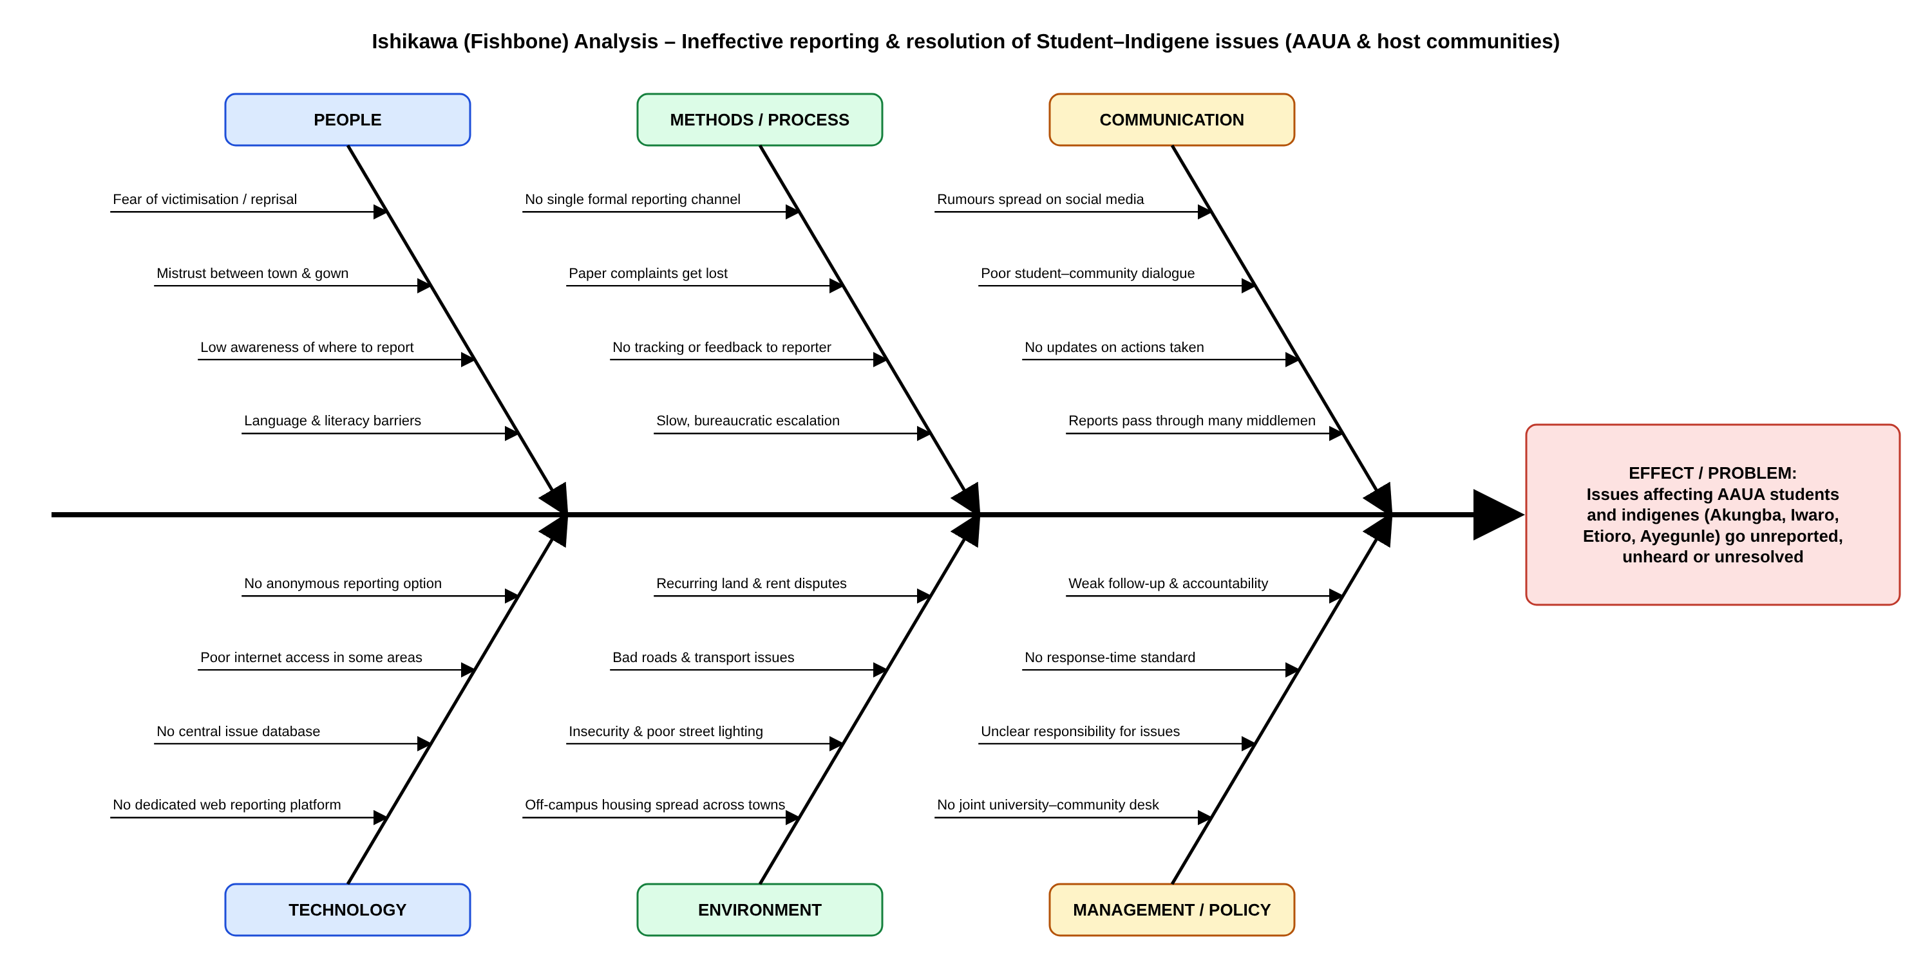
Figure 1: Ishikawa diagram of the IRO problem domain (source: docs/diagrams/ishikawa_iro.drawio)

2.7 Assumptions and Dependencies
- Users have access to an internet-enabled phone or computer.
- The university and community leaders will jointly staff the IRO Desk.
- Emergencies (e.g. violent attacks) are still reported to the police; IRO complements but does not replace emergency services.

3. System Architecture and Component Interactions

3.1 Major Components
Component | File(s) | Responsibility
Presentation layer (UI) | index.html, report.html, track.html, admin.html, assets/style.css | Pages, forms, tables and responsive layout shown to users
Report module | app.js – initReportPage(), validateReport() | Collects, validates and submits issue reports; shows tracking ID
Tracking module | app.js – initTrackPage() | Looks up an issue by tracking ID and shows its status timeline
Admin module | app.js – initAdminPage(), renderDashboard() | Login, statistics, filtering, status updates and deletion
Issue model | app.js – class Issue | Represents one issue; generates ID; records status updates
Data access layer | app.js – class IssueStore | Loads, saves, finds, updates and deletes issues; computes statistics
Authentication | app.js – class Auth | Validates admin credentials and manages the session
Storage | Browser localStorage / sessionStorage | Persists issues (localStorage) and admin session (sessionStorage)

3.2 Component Interactions

3.2.1 Submitting an issue
- The reporter fills the form on report.html (Presentation layer).
- The Report module calls validateReport(); errors are shown and nothing is saved if validation fails.
- On success, a new Issue object is created; its constructor generates the tracking ID and an initial "Pending" update. If anonymous, name and phone are blanked.
- IssueStore.add() saves the issue to Storage; the UI displays the tracking ID with a link to track it.

3.2.2 Tracking an issue
- The reporter enters a tracking ID on track.html (or follows the link).
- The Tracking module calls IssueStore.find(id), which reads Storage and returns the Issue.
- The UI renders status and update timeline only – no personal details are shown.

3.2.3 Managing issues (Admin)
- The admin logs in on admin.html; Auth.login() validates credentials and sets a session flag.
- renderDashboard() requests IssueStore.stats() and IssueStore.load(), applies filters and draws the table.
- On Update, Issue.addUpdate(status, note) appends to the history and IssueStore.update() saves it; the reporter sees the note when tracking.
- On Delete (after confirmation), IssueStore.remove(id) removes the issue. Logout calls Auth.logout().

3.3 Use-Case Diagram
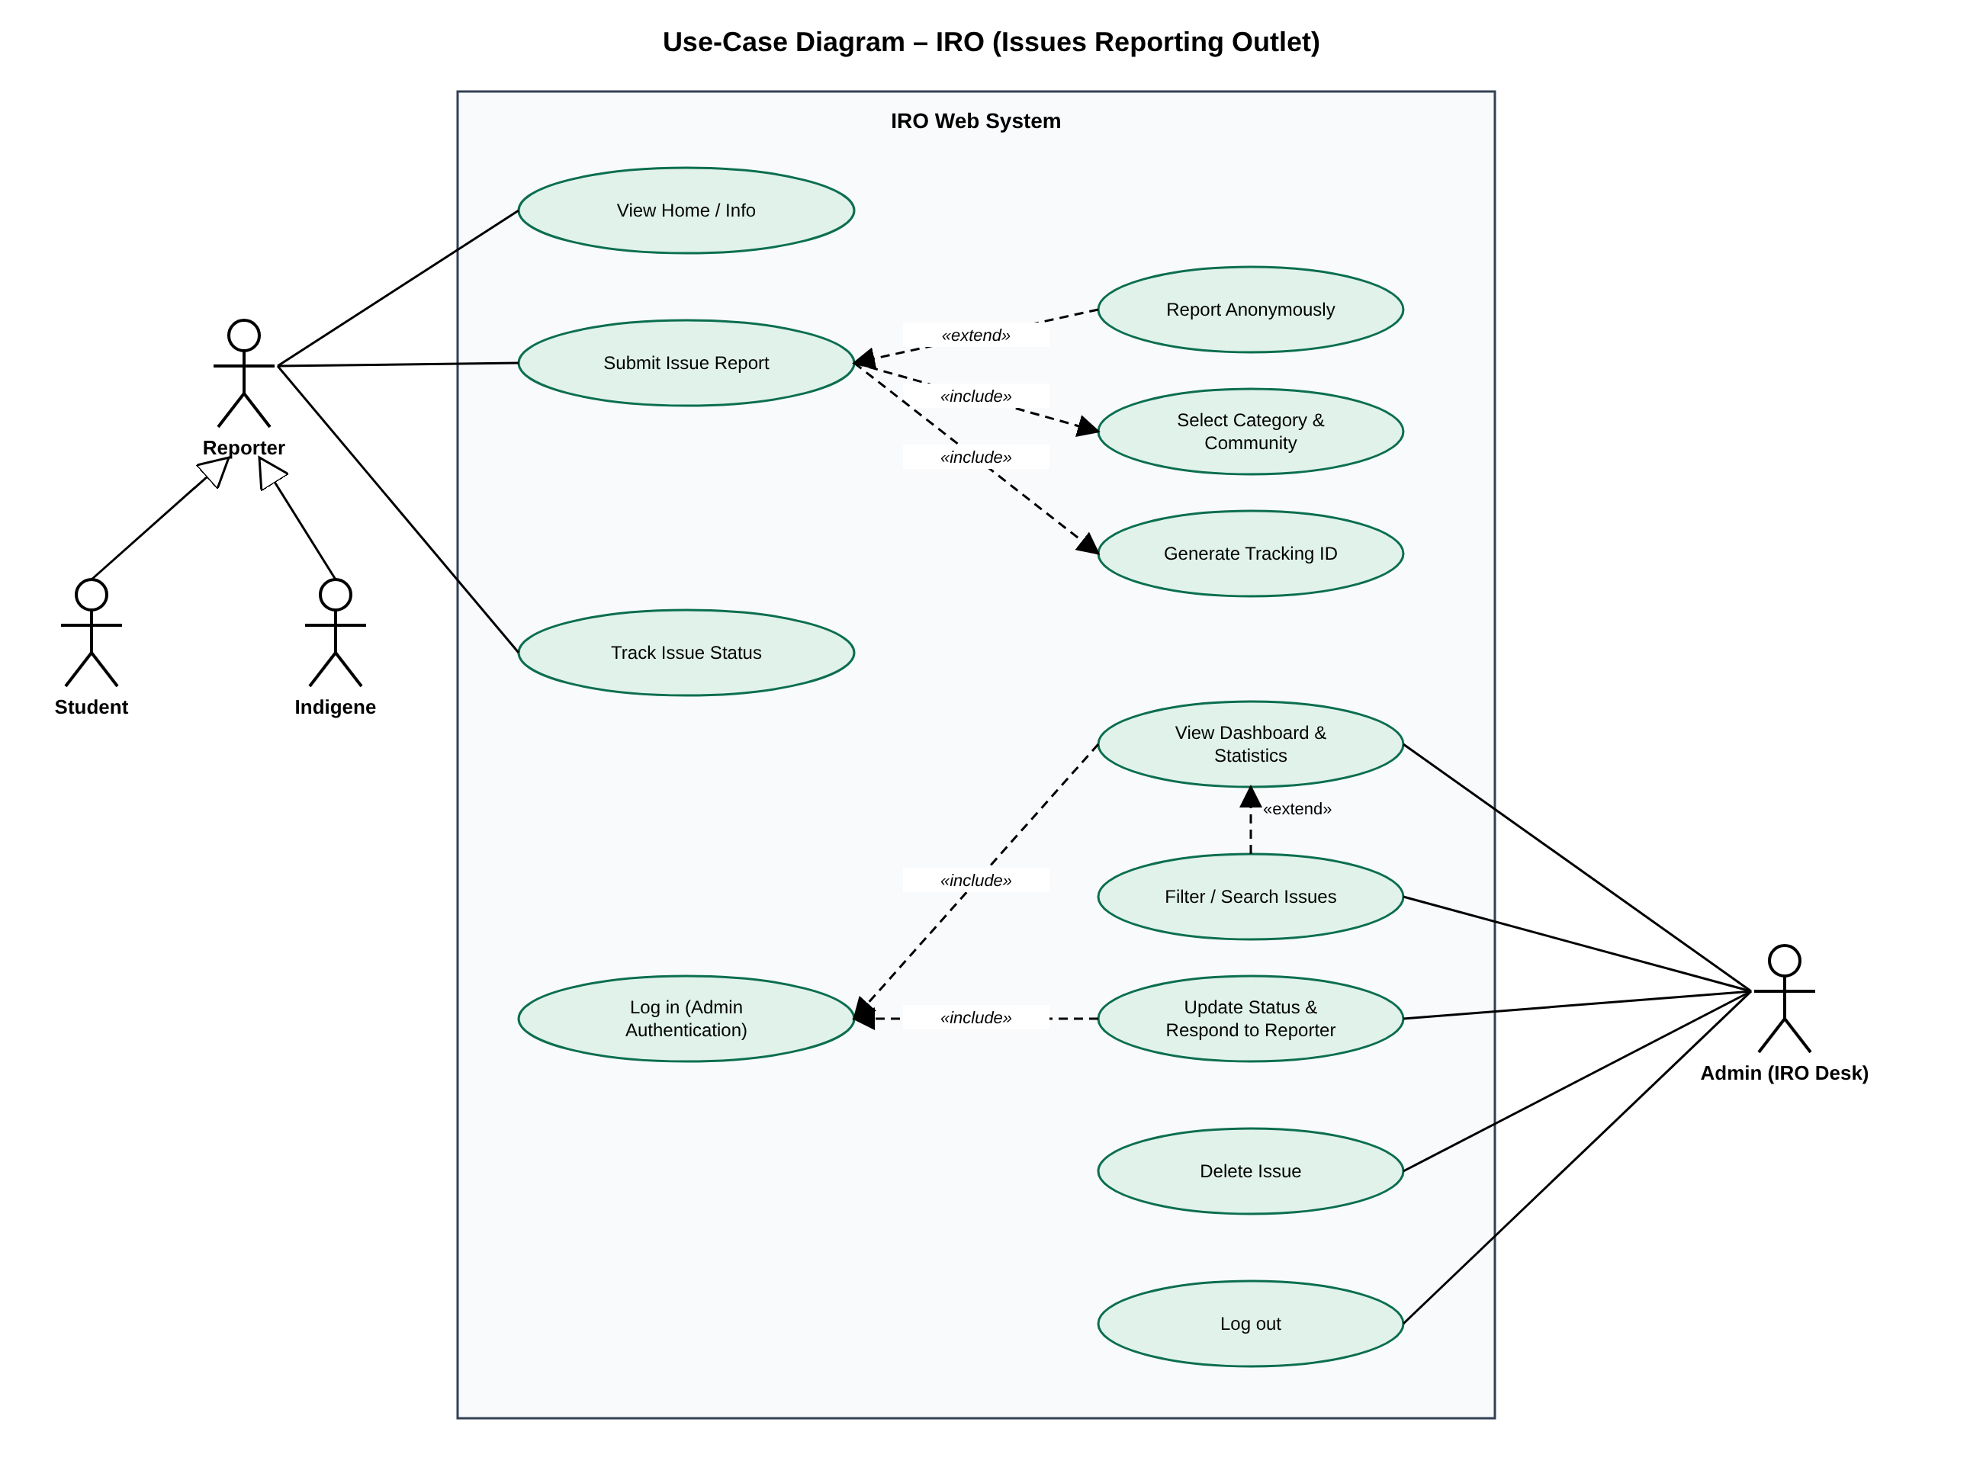
Figure 2: Use-case diagram of IRO (source: docs/diagrams/usecase_iro.drawio)

4. Functional Requirements
ID | Requirement | Description | Priority
FR-01 | Reporter type | The system shall require every reporter to identify as either an AAUA Student or an Indigene/Resident. | High
FR-02 | Submit issue | The system shall allow a reporter to submit an issue with category, community, priority, title, specific location and description. | High
FR-03 | Anonymous reporting | The system shall allow a reporter to submit an issue anonymously; name and phone shall then not be stored. | High
FR-04 | Student details | The system shall show an optional Matric Number field only when the reporter is a Student. | Medium
FR-05 | Community selection | The system shall provide the host communities Akungba, Iwaro, Etioro, Ayegunle and Other. | High
FR-06 | Input validation | The system shall validate required fields, minimum title (5) and description (20) lengths and Nigerian phone format before saving. | High
FR-07 | Tracking ID | The system shall generate a unique tracking ID (format IRO-XXXXXX) for each submitted issue and display it to the reporter. | High
FR-08 | Track issue | The system shall allow anyone with a tracking ID to view the issue's status and its full update history. | High
FR-09 | Admin login | The system shall restrict the dashboard to authenticated administrators (IRO Desk) via username and password. | High
FR-10 | Dashboard statistics | The system shall display totals of issues by status and by reporter type (students vs indigenes). | Medium
FR-11 | Filter & search | The system shall let the admin filter issues by status, reporter type and category, and search by title, description or ID. | Medium
FR-12 | Update status | The system shall let the admin change an issue's status (Pending, Under Review, Resolved, Rejected) and attach a response note visible to the reporter. | High
FR-13 | Delete issue | The system shall let the admin delete an issue after confirmation. | Low
FR-14 | Logout | The system shall let the admin end the session; dashboard pages shall then be hidden. | Medium
FR-15 | Public summary | The home page shall show counts of issues reported, resolved and in progress. | Low

5. Non-Functional Requirements
ID | Attribute | Requirement
NFR-01 | Security & Privacy | Anonymous reports shall store no personal identifiers. All user input shall be HTML-escaped before display to prevent script injection. Admin functions require login.
NFR-02 | Confidentiality | Reporter name, phone and matric number shall be visible only on the admin dashboard, never on the public tracking page.
NFR-03 | Usability | A first-time user shall be able to submit an issue in under 3 minutes with no training. Plain English labels and hints shall be used.
NFR-04 | Performance | Each page shall load and respond to user actions in under 2 seconds on a 3G connection.
NFR-05 | Availability | The system shall be available 24/7 when hosted (e.g. GitHub Pages), with no server dependency for the prototype.
NFR-06 | Portability / Compatibility | The system shall work on current Chrome, Firefox, Edge and Safari, on desktop and mobile.
NFR-07 | Responsiveness | The layout shall adapt to screens from 360px (phones) upward without horizontal scrolling.
NFR-08 | Reliability | Submitted issues shall persist in browser storage across page reloads; invalid input shall never be saved.
NFR-09 | Maintainability | Code shall be modular (Issue, IssueStore, Auth classes and per-page init functions), commented and version-controlled on GitHub.
NFR-10 | Scalability | The data layer (IssueStore) shall be isolated so it can be replaced by a server database (e.g. MySQL/Firebase) without changing the UI.

6. Use-Case Descriptions
Field | Detail
Use case | UC-01 Submit Issue Report
Actor | Reporter (Student / Indigene)
Pre-condition | Reporter is on report.html
Main flow | 1. Reporter selects Student or Indigene.  2. Reporter optionally ticks Report anonymously.  3. Reporter selects community, category and priority, and enters title, location and description.  4. Reporter clicks Submit Issue.  5. System validates input, saves the issue and shows the tracking ID.
Alternative flow | 3a. Invalid input: system lists errors; reporter corrects them.
Post-condition | Issue stored with status Pending.

Field | Detail
Use case | UC-02 Track Issue Status
Actor | Reporter
Pre-condition | Reporter has a tracking ID
Main flow | 1. Reporter opens track.html and enters the ID.  2. System finds the issue.  3. System shows status and update history.
Alternative flow | 2a. ID not found: system shows "No issue found".
Post-condition | Reporter knows current status.

Field | Detail
Use case | UC-03 Update Status & Respond
Actor | Admin (IRO Desk)
Pre-condition | Admin is logged in
Main flow | 1. Admin finds the issue (optionally filtering/searching).  2. Admin selects a new status and clicks Update.  3. Admin enters a response note.  4. System records the update and refreshes the dashboard.
Alternative flow | 3a. Admin cancels: no change is made.
Post-condition | New status and note visible to the reporter.

Field | Detail
Use case | UC-04 Log in
Actor | Admin (IRO Desk)
Pre-condition | Admin is on admin.html
Main flow | 1. Admin enters username and password.  2. System validates credentials.  3. System shows the dashboard.
Alternative flow | 2a. Invalid credentials: error shown, dashboard stays hidden.
Post-condition | Admin session started.

7. Data Requirements
Each issue is stored as a JSON object with the following fields:
Field | Type | Description
id | String | Tracking ID, e.g. IRO-7KQ2MX
reporterType | String | Student or Indigene
anonymous | Boolean | True if the reporter chose anonymity
name, phone | String | Reporter contact (empty when anonymous)
matricNo | String | Optional, students only
community | String | Akungba, Iwaro, Etioro, Ayegunle or Other
category | String | One of 10 issue categories
priority | String | Low, Medium, High or Urgent
title, description, location | String | Details of the issue
status | String | Pending, Under Review, Resolved or Rejected
createdAt | ISO date | Submission date and time
updates | Array | History of {status, note, date} entries

8. Future Enhancements
- Central database and server API (e.g. PHP/MySQL or Firebase) so reports are shared across devices.
- SMS/WhatsApp notifications on status change, and USSD reporting for users without smartphones.
- Yoruba language option, image/evidence upload and role-based accounts for community leaders.

Appendix A: Use-Case Diagram

Appendix B: Ishikawa (Fishbone) Diagram

Part A: Object Listing

A.1 Project files
File | Type | Purpose
app/index.html | HTML page | Home page: introduction, how it works, public statistics
app/report.html | HTML page | Issue reporting form (Student / Indigene, anonymous option)
app/track.html | HTML page | Issue tracking by tracking ID
app/admin.html | HTML page | Admin login and issues dashboard
app/assets/style.css | Stylesheet | Layout, colours, forms, tables, badges, responsive rules
app/assets/app.js | JavaScript | Classes, data storage, validation and page logic

A.2 Class: Issue
Member | Kind | Description
id | Property (String) | Unique tracking ID, e.g. IRO-7KQ2MX
reporterType | Property (String) | "Student" or "Indigene"
anonymous | Property (Boolean) | True when the reporter hides identity
name, phone | Property (String) | Reporter contact; blank/"Anonymous" when anonymous
matricNo | Property (String) | Student matric number (optional)
community | Property (String) | Akungba, Iwaro, Etioro, Ayegunle or Other
category, priority | Property (String) | Issue classification
title, description, location | Property (String) | Issue details
status | Property (String) | Pending, Under Review, Resolved or Rejected
createdAt | Property (ISO date) | Date/time of submission
updates | Property (Array) | History of {status, note, date}
constructor(data) | Method | Builds an Issue from form data or stored JSON
generateId() | Static method | Returns a random IRO-XXXXXX tracking ID
addUpdate(status, note) | Method | Changes status and appends a history entry

A.3 Class: IssueStore (data access)
Member | Kind | Description
load() | Static method | Reads all issues from localStorage and returns Issue objects
saveAll(issues) | Static method | Writes the full list of issues to localStorage
add(issue) | Static method | Adds a new issue to the top of the list
find(id) | Static method | Returns the issue matching a tracking ID
update(issue) | Static method | Replaces a stored issue with its updated version
remove(id) | Static method | Deletes an issue by ID
stats() | Static method | Returns counts by status and reporter type

A.4 Class: Auth (admin session)
Member | Kind | Description
login(username, password) | Static method | Checks credentials; starts session on success
isLoggedIn() | Static method | Returns true if an admin session exists
logout() | Static method | Ends the admin session

A.5 Functions
Function | Used on | Description
$(sel) | All pages | Shortcut for document.querySelector
escapeHTML(str) | All pages | Escapes user text before display (prevents script injection)
formatDate(iso) | Track, Admin | Formats dates for Nigerian locale
badge(status) | Track, Admin | Returns coloured status badge HTML
fillSelect(select, options, placeholder) | Report, Admin | Fills a drop-down list
initHomePage() | index.html | Shows public statistics
initReportPage() | report.html | Sets up form, toggles fields, handles submission
validateReport(form) | report.html | Returns a list of validation errors
initTrackPage() | track.html | Looks up and displays an issue's timeline
initAdminPage() | admin.html | Handles login/logout and filter events
renderDashboard() | admin.html | Draws statistics and the issues table; handles update/delete

A.6 Constants
Constant | Type | Value / Description
STORAGE_KEY | String | "iro_issues" – localStorage key for issues
SESSION_KEY | String | "iro_admin_session" – sessionStorage key
ADMIN | Object | Demo admin credentials {username, password}
CATEGORIES | Array | 10 issue categories
COMMUNITIES | Array | Akungba, Iwaro, Etioro, Ayegunle, Other
STATUSES | Array | Pending, Under Review, Resolved, Rejected
PRIORITIES | Array | Low, Medium, High, Urgent

A.7 Main interface objects (HTML elements)
Element ID | Page | Description
#reportForm | report.html | Issue report form
reporterType (radio) | report.html | Student / Indigene choice
#anonymous | report.html | Report-anonymously checkbox
#name, #phone, #matricNo | report.html | Reporter identity fields
#community, #category, #priority | report.html | Classification drop-downs
#title, #location, #description | report.html | Issue detail fields
#formMessage | report.html | Success / error message box
#trackForm, #trackId, #trackResult | track.html | Tracking form, input and result area
#loginForm, #username, #password | admin.html | Admin login form
#dashboard, #stats, #issueRows | admin.html | Dashboard, statistics and issues table
#fStatus, #fType, #fCategory, #fSearch | admin.html | Dashboard filters
#homeStats | index.html | Public statistics

Part B: Code Listing (GitHub)
The full source code is hosted on GitHub instead of being printed here.
Repository: https://github.com/opes1/IRO-Issues-Reporting-Outlet
Live app: https://opes1.github.io/IRO-Issues-Reporting-Outlet/

File | GitHub link | Lines
app/assets/app.js | https://github.com/opes1/IRO-Issues-Reporting-Outlet/blob/main/app/assets/app.js | 375
app/assets/style.css | https://github.com/opes1/IRO-Issues-Reporting-Outlet/blob/main/app/assets/style.css | 126
app/index.html | https://github.com/opes1/IRO-Issues-Reporting-Outlet/blob/main/app/index.html | 56
app/report.html | https://github.com/opes1/IRO-Issues-Reporting-Outlet/blob/main/app/report.html | 99
app/track.html | https://github.com/opes1/IRO-Issues-Reporting-Outlet/blob/main/app/track.html | 40
app/admin.html | https://github.com/opes1/IRO-Issues-Reporting-Outlet/blob/main/app/admin.html | 72

