Customer Maintenance Assignment 4
Opeyemi Obute
The application finds customers by ID and updates their contact name, address, city, and country. The main form includes my name in its title.
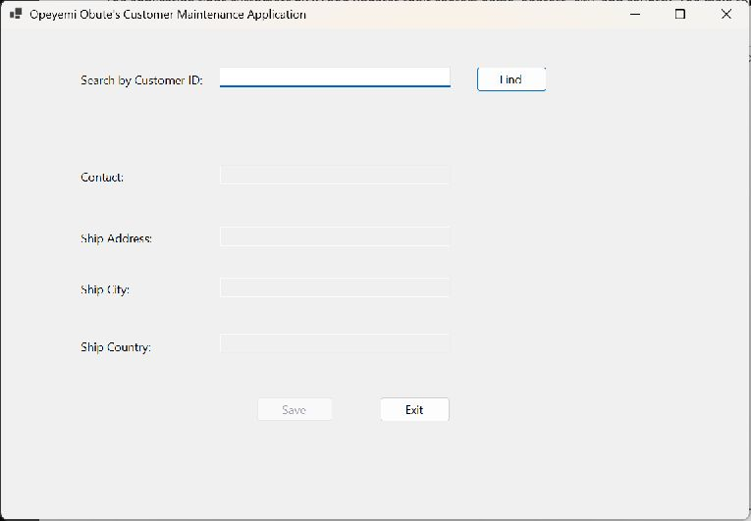
Application screenshot

Customer lookup
ALFKI returns Maria Anders, Obere Str. 57, Berlin, Germany. The Find button uses _context.Customers.Find(id).
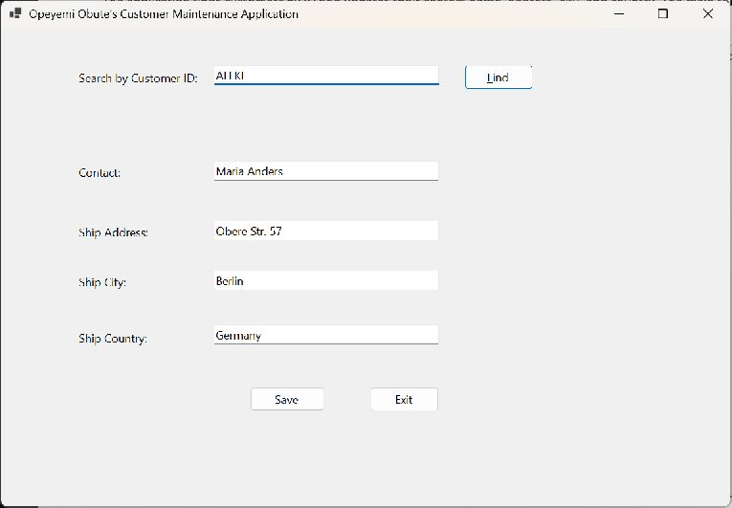
Application screenshot

Find event handler
The Find handler validates the ID, retrieves the customer, fills the text boxes, and displays a message when no match exists.
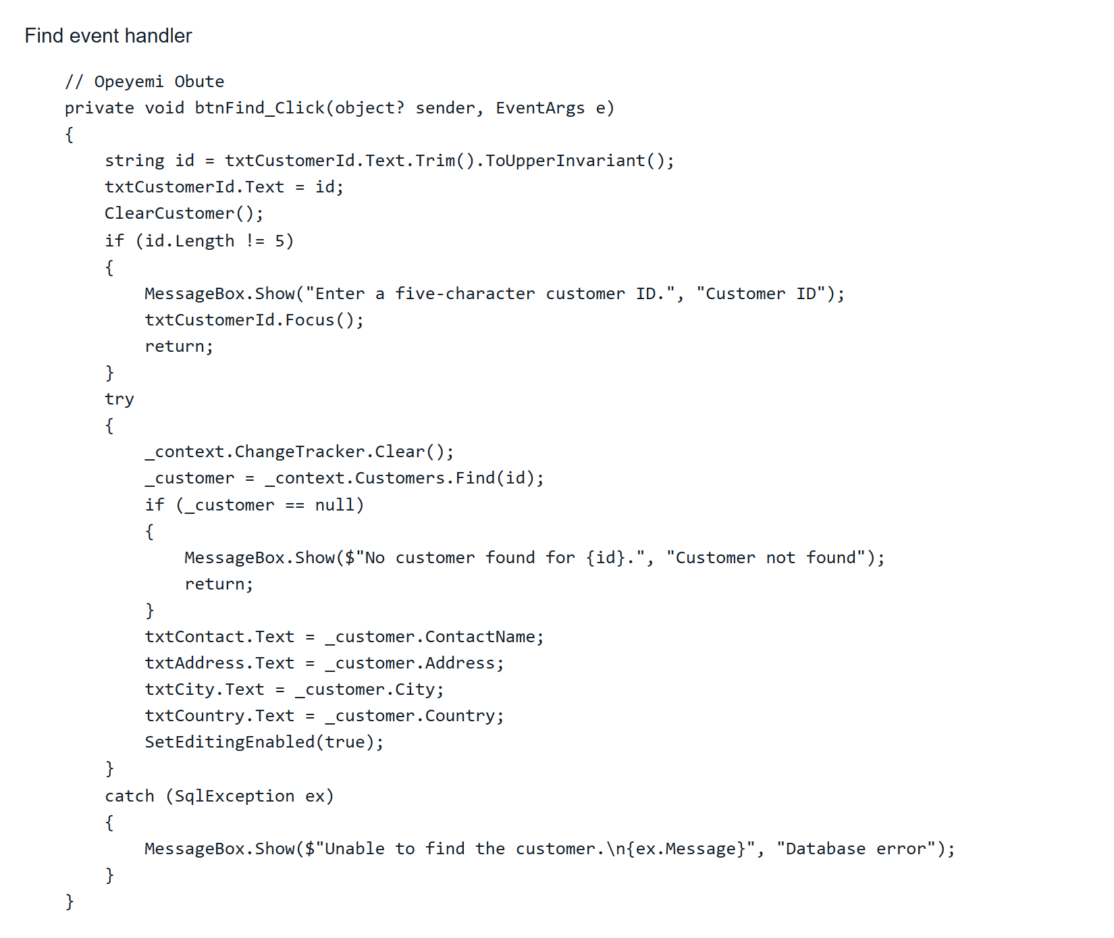
Screenshot of project source code

Save event handler
The Save handler assigns the edited fields, calls Update, and persists the customer with SaveChanges. A separate database connection confirmed that a test edit was saved; the original value was restored.
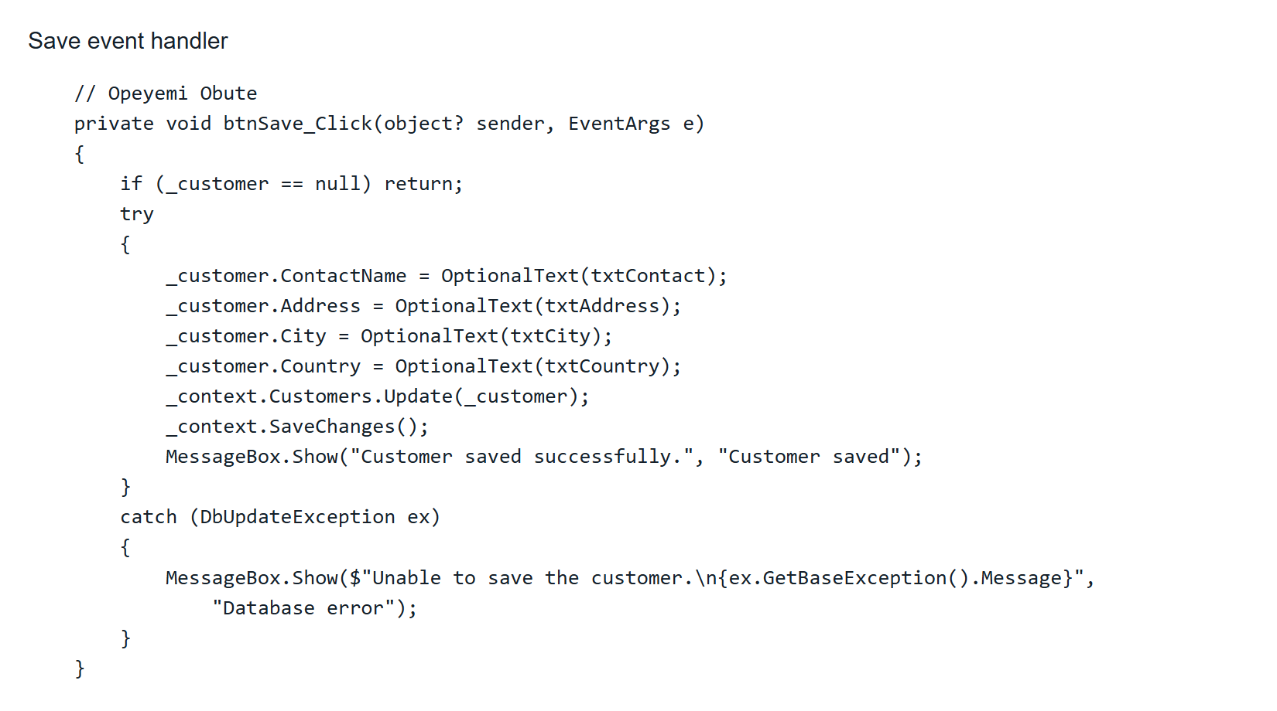
Screenshot of project source code

Exit and search ID event handlers
Exit closes the form. Changing the search ID clears the loaded customer and disables editing until a successful lookup.
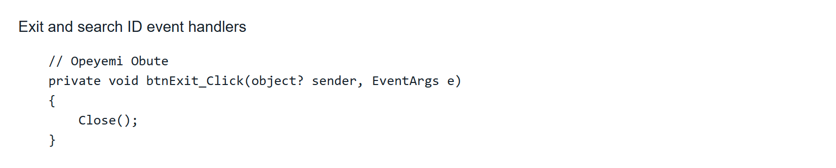
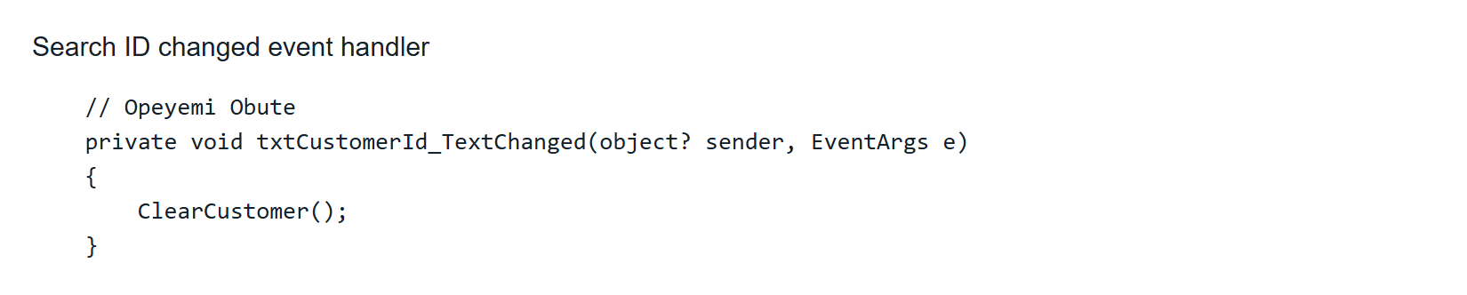
Screenshot of project source code

Northwind database context
The Customers model and context were scaffolded from the supplied MDF with the Customers table selected. The context reads the Northwind connection string from App.config.
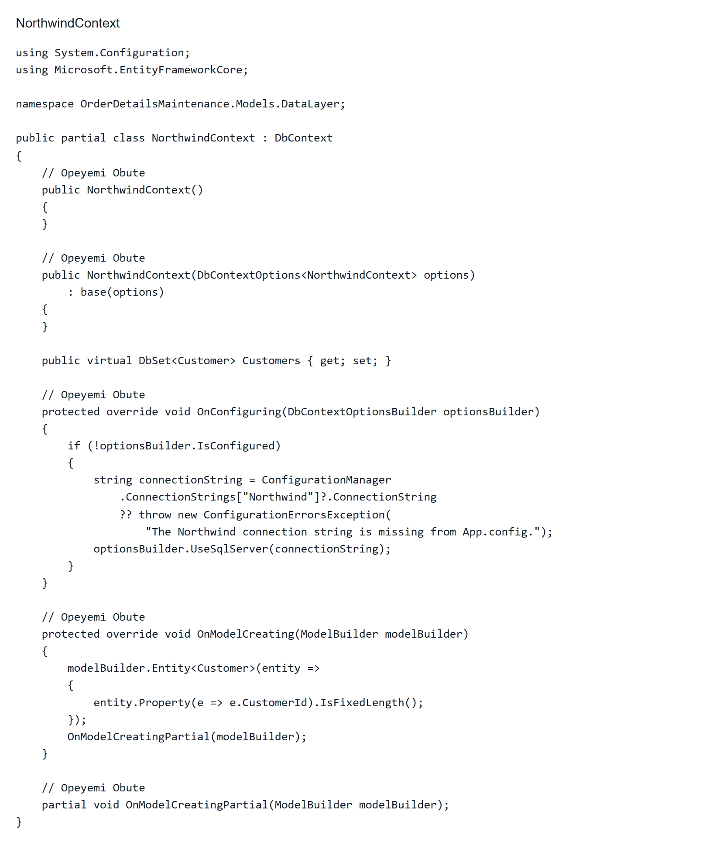
Screenshot of project source code

