Olivia Gardella

7 December 2017

SI206 Final Project Report

1. My goals for this project included creating a fully-working program from scratch which utilized APIs, SQLite databases, and visualization software. My personal goal was to finish the entire project before 12/11 to get extra credit. Another goal was to get minimal help and push myself to be as resourceful as possible when stuck. Last goal was to fully comment the code and submit.
2. I achieved all my goals. I successfully created a fully-working program from scratch which utilized APIs, SQLite databases, and visualization software. I finished my project on 12/7, so I could get the extra credit. While working on it, I pushed myself to be as resourceful as possible, which I did by finding anything I had a question to online, with minimal help from Colleen or the GSIs. Finally, I fully commented the code.
3. One problem I faced was an infinite loop within my Facebook API. I figured out it was because of how I was paging and the variable names I used. Another problem was how to use datetime, which I solved by doing research as to how I would use it for the two APIs. Also, I decided to change one of my visualizations from my Dec1 plan. Instead of using google maps for the Facebook API, I decided it made more sense to use plot.ly to create a pit chart showing how much I posted on different days of the week. Colleen said this was ok as long as I was doing it through python, which I did.
4. Below are the two visualizations I created. First database and graph shows the temperature over time in Ann Arbor. Second database and graph shows how much I post to Facebook on different days of the week. (Colleen said the databases showing the days were an appropriate report and way to show days of the week)

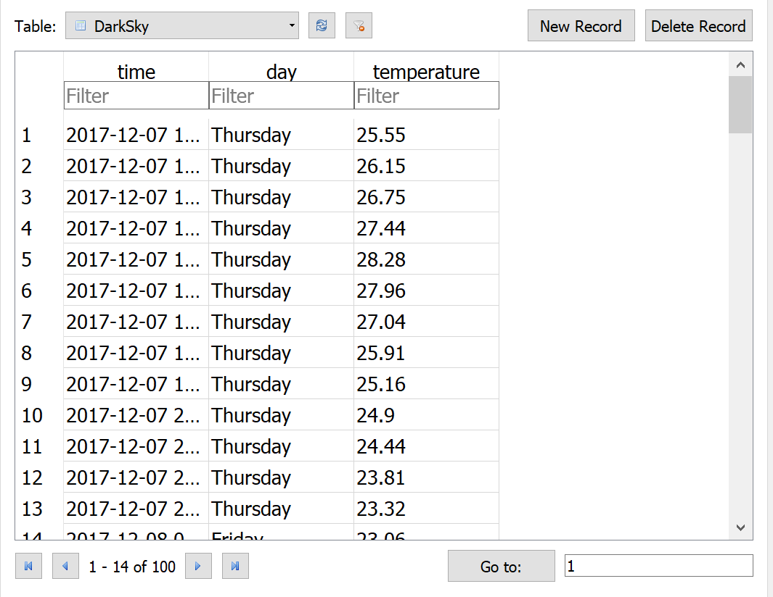

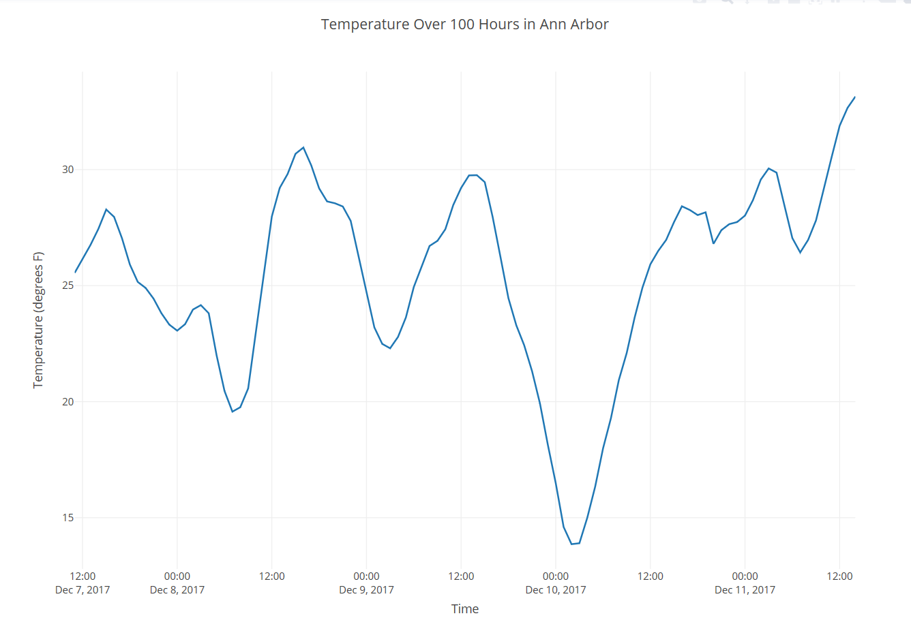

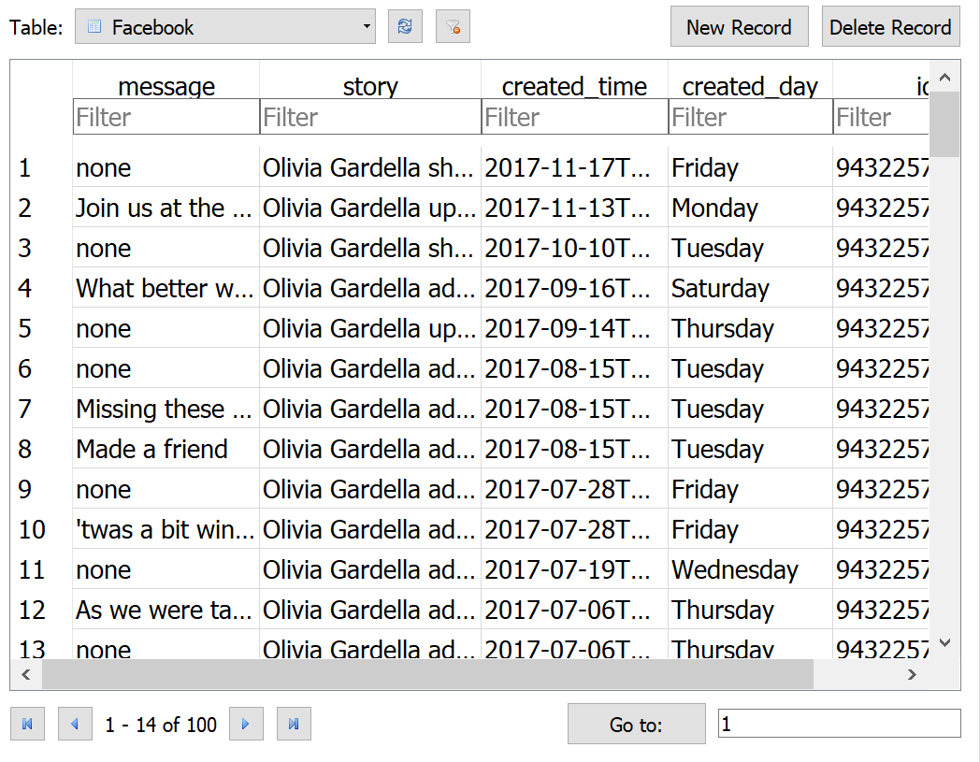

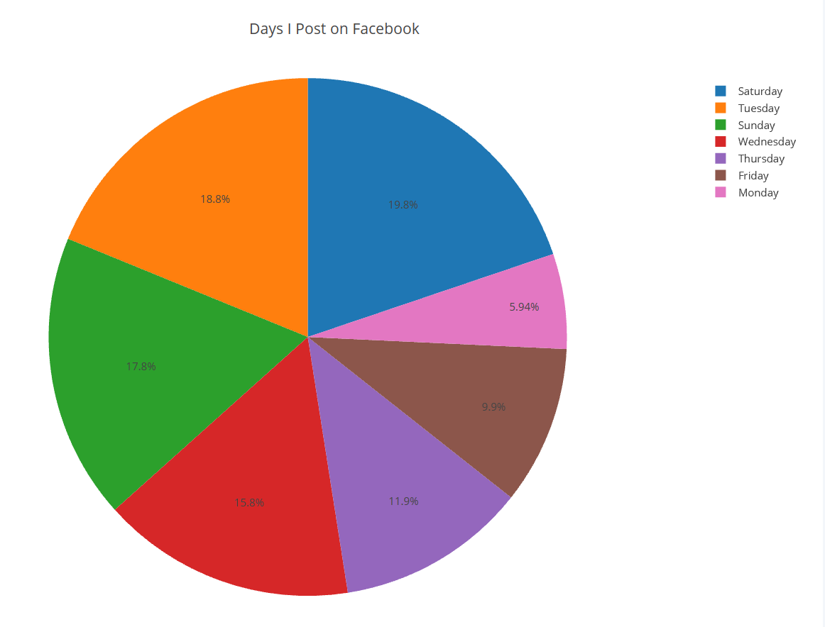

1. Instructions:

Download the project4.py, project4cache.json, and api_info.py files (the api_info file will not be used, it is just to show how I was calling the api keys before) and make sure all these files are in the same folder.

1. **Running the file with the cache already in folder**:

Navigate to this folder in the terminal and run the project4.py file. This first time it runs, since the cache is in the same folder already, it will print out “using cached data” followed by lines for the user to input their plot.ly key and username. If you put in your correct key and username, plot.ly will create the Facebook visualization (you can see it in your plot.ly account under “my files”). If you input anything but your correct key and username, it will print out “Cannot create FB visualization without plot.ly key and username” and the visualization will not be created.

Now it will again print “using cached data” followed by lines for the user to input their plot.ly key and username. If you put in your correct key and username, plot.ly will create the DarkSky visualization (you can see it in your plot.ly account under “my files”). If you input anything but your correct key and username, it will print out “Cannot create DarkSky visualization without plot.ly key and username” and the visualization will not be created.

When the file is finished running, you can find the two sqlite databases in the same folder the files are in, and view them in the DB Browser for SQLite.

1. **Running the file with no cache**:

Now we want to run the file again, but instead of using the cache, we want to get data from the internet. First, delete the cache file from your folder (can also delete the databases if you wish). Run the project4.py file.

It will first ask you for your Facebook access token. If you input an incorrect access token here, the file will show an error and stop running. If you enter your correct token, it will take a few minutes to gather the data, then it will print “getting data from internet” and ask you for your plot.ly key and username. If you put in your correct key and username, plot.ly will create the Facebook visualization (you can see it in your plot.ly account under “my files”). If you input anything but your correct key and username, it will print out “Cannot create FB visualization without plot.ly key and username” and the visualization will not be created.

Next, the file will ask for your DarkSky key. If you input an incorrect api key here, the file will show an error and stop running. If you enter your correct key, it will take a few moments to gather the data, then it will print “getting data from internet” and ask you for your plot.ly key and username. If you put in your correct key and username, plot.ly will create the DarkSky visualization (you can see it in your plot.ly account under “my files”). If you input anything but your correct key and username, it will print out “Cannot create DarkSky visualization without plot.ly key and username” and the visualization will not be created.

Once the file is done running, navigate to the folder the files are in to view the two databases and the cache. The two visualizations can be viewed in your plot.ly account online under “my files.”

Documentation:

|  |  |  |  |
| --- | --- | --- | --- |
| **Date** | **Issue Description** | **Location of Resource** | **Result (did it solve the issue?)** |
| 12/1 | How to get started with DarkSky api | course file called darksky.py | Yes |
| 12/1 | How to get started with FB api | course files called fbapi.py, fbapi2.py, fbposts.py, fbposts2.py | Yes |
| 12/2/17 | DarkSky API only returning 46 hours into the future, but I need 100 | <https://darksky.net/dev/docs> | Yes, I found the extend=hourly to extend it to 168 |
| 12/2/17 | How to use datetime to convert DarkSky time to readable format | <https://docs.python.org/2/library/datetime.html>  In class exercise | The link helped me understand it, the exercise helped me format it |
| 12/2/17 | Trying to limit table to 100 rows | <https://stackoverflow.com/questions/6329032/sqlite3-and-limiting-the-number-of-results> | Didn’t help, I just decided to use a counter instead to only go through database insertion 100 times |
| 12/2/17 | Using plot.ly to graph temperatures over 100 hours in DarkSky | <https://plot.ly/python/graph-data-from-mysql-database-in-python/> | Yes |
| 12/3/17 | How to use FB api | <https://stackoverflow.com/questions/32838434/how-to-get-user-posts-through-facebook-sdk-python-api/32896364#32896364> | Help me understand fb api |
| 12/5 | How to use datetime to get day of week from FB post | <https://stackoverflow.com/questions/7142618/parse-fb-graph-api-date-string-into-python-datetime>  and  <https://docs.python.org/2/library/datetime.html> | Yes, I figured it out |
| 12/6 | Using plot.ly to visualize DarkSky data | <https://plot.ly/python/> and <https://plot.ly/python/getting-started/> and  <https://plot.ly/python/line-charts/> | Yes, I figured it out |
| 12/7 | Using plot.ly to visualize FB data | <https://plot.ly/python/pie-charts/> | Yes |