#1 Womens Ad A
25 lifetime leads | 43.67 CPL | 1,091.86 ILS spend
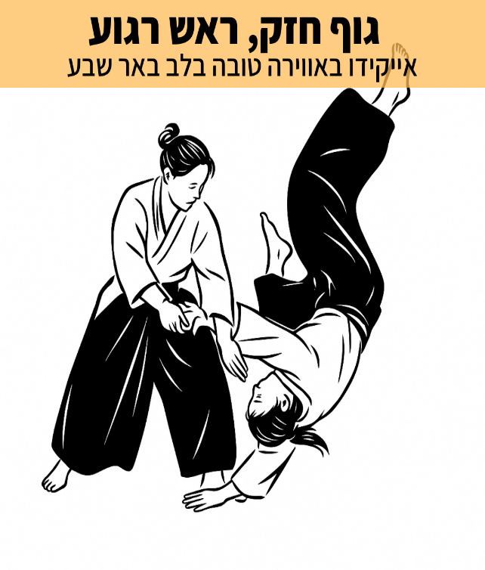 | Headline  ×’×•×£ ×—×–×§, ×¨××© ×¨×’×•×¢  Primary text  ×ž×—×¤×©×ª ×ª×—×‘×™×‘ ×©×ž×›× ×™×¡ ×ž×©×ž×¢×•×ª, ×ª× ×•×¢×” ×•×¨×•×’×¢ ×œ×™×•×ž×™×•×?  ××™×™×§×™×“×• ×–×” ×”×¨×‘×” ×™×•×ª×¨ ×ž××™×ž×•×Ÿ. ×–×• ×“×¨×š ×—×™×™× ×©×œ ×—×™×‘×•×¨ ×¤× ×™×ž×™ ×•×—×™×¦×•× ×™.  âš¡ï¸×©×™×¤×•×¨ ×ª× ×•×¢×ª×™×•×ª: ×›×•×—, ×’×ž×™×©×•×ª, ×©×™×•×•×™ ×ž×©×§×œ, ×•×™×¦×™×‘×•×ª  âš¡ï¸×‘×˜×—×•×Ÿ ×‘×’×•×£: ×œ×œ×ž×•×“ ×œ×™×¤×•×œ ×•×œ×”×ª×’×œ×’×œ. ×ª×¨×’×™×©×™ ×‘×˜×—×•×Ÿ ×—×“×© ×‘×’×•×£.  âš¡ï¸×©×œ×™×˜×” ×¢×¦×ž×™×ª ×‘×ž×¦×‘×™ ×ž×ª×—: ×”×ª×ž×•×“×“×•×ª ×¢× ×§×•× ×¤×œ×™×§×˜ ×‘×—×•×¤×©×™×•×ª ×•×™×¦×™×¨×ª×™×•×ª  ×”×“×•×’'×• ×‘×ž×¨×›×– ×‘××¨ ×©×‘×¢ ×”×•× ×™×“×™×“×•×ª×™ ×•×œ× ×ª×—×¨×•×ª×™. ××¤×©×¨ ×œ×”×ª×—×™×œ ×‘×›×œ ×’×™×œ ×•×‘×›×œ ×¨×ž×ª × ×¡×™×•×Ÿ.  ×ª× ×™ ×§×œ×™×§ ×¢×œ ×”×ª×ž×•× ×” ×•×‘×•××™ ×œ×”×ª× ×¡×•×ª ×‘×©×™×¢×•×¨ × ×¡×™×•×Ÿ ×œ×œ× ×”×ª×—×™×™×‘×•×ª.  Text asset: Meaningful Movement

#2 Womens Ad D
15 lifetime leads | 52.98 CPL | 794.71 ILS spend
 | Headline  ×¢×•×¦×ž×”, ×¨×•×’×¢, ×•×‘×˜×—×•×Ÿ ×¢×¦×ž×™  Primary text  ðŸ˜‰×—×•×’×™× ×œ×™×œ×“×™×? ×™×©.  ðŸ˜‰×¤×¢×™×œ×•×™×•×ª ×ž×©×¤×—×ª×™×•×ª? ×™×©.  ðŸ¤¨×•×ž×” ××™×ª×š?  ðŸ¥‹××™×™×§×™×“×•: ×¤×¡×§ ×–×ž×Ÿ ××ž×™×ª×™ ×’× ×œ×š ×›×™ ×ž×’×™×¢ ×œ×š!  ××™×ž×•× ×™× ×‘××•×•×™×¨×” ×˜×•×‘×” ×•×œ× ×ª×—×¨×•×ª×™×ª ×‘×œ×‘ ×‘××¨ ×©×‘×¢. ×ž×ª××™× ×œ×›×œ ×’×™×œ ×•×›×œ ×¨×ž×ª × ×¡×™×•×Ÿ.  ×›×“××™ ×œ×š: ×ª×¢×©×™ ×§×œ×™×§ ×¢×œ ×”×ª×ž×•× ×” ×œ×©×™×¢×•×¨ × ×¡×™×•×Ÿ ×œ×œ× ×”×ª×—×™×™×‘×•×ª!  Text asset: Time Out For You (Mom)

#3 Womens Ad J
6 lifetime leads | 57.02 CPL | 342.14 ILS spend
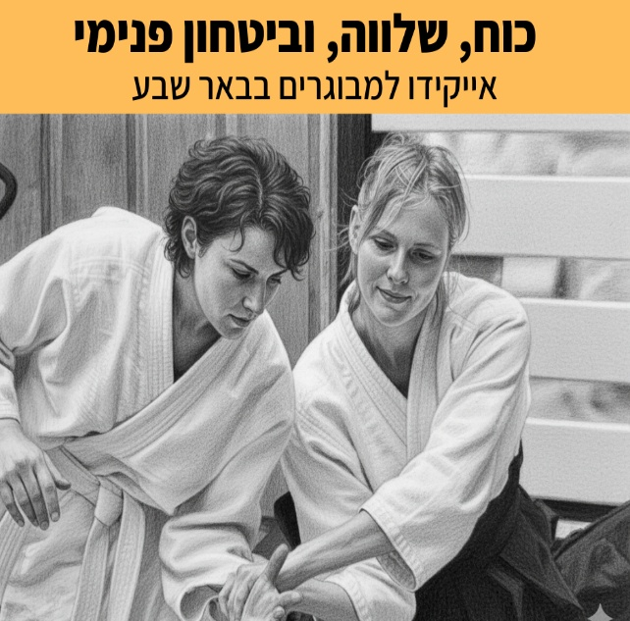 | Headline  ×›×•×—, ×©×œ×•×•×”, ×•×‘×™×˜×—×•×Ÿ ×¤× ×™×ž×™  Primary text  ðŸ˜‰ ×§× ×™×•×ª ×œ×‘×™×ª? ×¡×™×“×¨×ª.  ðŸ˜‰ ×¤×’×™×©×•×ª ×¢×‘×•×“×”? ×¡×™×“×¨×ª.  ðŸ¤¨ ×•×ž×” ××™×ª×š?  ðŸ¥‹ ××™×™×§×™×“×•: ×”×¤×¡×§×” ××ž×™×ª×™×ª ×¢×‘×•×¨×š â€“ ×›×™ ×ž×’×™×¢ ×œ×š!  ××™×ž×•× ×™× ×‘××•×•×™×¨×” × ×¢×™×ž×” ×•×œ× ×ª×—×¨×•×ª×™×ª ×‘×ž×¨×›×– ×‘××¨ ×©×‘×¢. ×ž×ª××™× ×œ×›×•×œ×Ÿ ×ž×’×™×œ 16 ×•×¢×“ 70 ×•×œ×›×œ ×¨×ž×ª × ×™×¡×™×•×Ÿ.  ×›×“××™ ×œ×š: ×œ×—×¦×™ ×¢×œ ×”×ª×ž×•× ×” ×œ×©×™×¢×•×¨ ×”×™×›×¨×•×ª ×œ×œ× ×”×ª×—×™×™×‘×•×ª!  Text asset: Time Out For You (Managed Life)

#4 Womens Ad G
6 lifetime leads | 64.82 CPL | 388.90 ILS spend
 | Headline  ×¢×•×¦×ž×”, ×¨×•×’×¢, ×•×‘×˜×—×•×Ÿ ×¢×¦×ž×™  Primary text  ðŸ˜µâ€ðŸ’«×¢×•×ž×¡?  ðŸ“±×ž×¡×›×™× ×‘×œ×™ ×¡×•×£?  ðŸ¥±×¢×™×™×¤×•×ª ×©×œ× ×¢×•×‘×¨×ª?  ðŸ¥‹×‘××™×™×§×™×“×• ×œ×•×ž×“×™× ×œ×”×•×¦×™× ××ª ×”×ž×ª×— ×“×¨×š ×ª× ×•×¢×” â€“ ×•×œ×’×œ×•×ª ×× ×¨×’×™×” ×—×“×©×”.  ××•×ž× ×•×ª ×œ×—×™×ž×” ×œ× ××œ×™×ž×” ×©×ž×œ×ž×“×ª ×™×¦×™×‘×•×ª ×•×©×œ×•×•×”, ×ž×¤×ª×—×ª ×ª×¢×•× ×ª×™×•×ª, ×•×ž×§×¤×™×¦×” ××ª ×”×× ×¨×’×™×”  ×”×¦×˜×¨×¤×™ ×œ××™×ž×•× ×™ ××™×™×§×™×“×• ×œ×ž×‘×•×’×¨×™× ×‘××•×•×™×¨×” ×œ× ×ª×—×¨×•×ª×™×ª, ×›××Ÿ ×‘×‘××¨ ×©×‘×¢.  ×›×“××™ ×œ×š: ×ª×¢×©×™ ×§×œ×™×§ ×¢×œ ×”×ª×ž×•× ×” ×œ×©×™×¢×•×¨ × ×¡×™×•×Ÿ ×œ×œ× ×”×ª×—×™×™×‘×•×ª!  Text asset: Screens To Energy

#5 Womens Ad B
5 lifetime leads | 65.21 CPL | 326.06 ILS spend
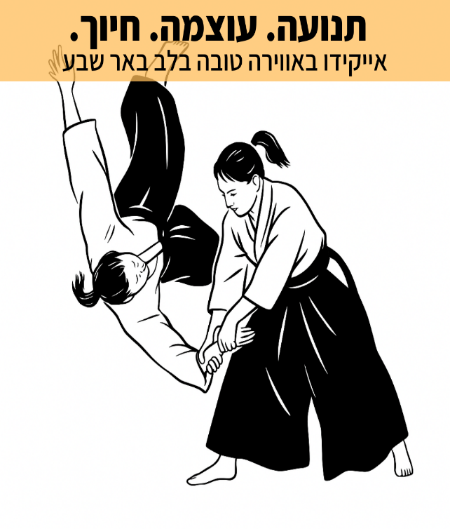 | Headline  ×ª× ×•×¢×”. ×¢×•×¦×ž×”. ×—×™×•×š.  Primary text  ðŸ˜‰×—×•×’×™× ×œ×™×œ×“×™×? ×™×©.  ðŸ˜‰×¤×¢×™×œ×•×™×•×ª ×ž×©×¤×—×ª×™×•×ª? ×™×©.  ðŸ¤¨×•×ž×” ××™×ª×š?  ðŸ¥‹××™×™×§×™×“×•: ×¤×¡×§ ×–×ž×Ÿ ××ž×™×ª×™ ×’× ×œ×š ×›×™ ×ž×’×™×¢ ×œ×š!  ××™×ž×•× ×™× ×‘××•×•×™×¨×” ×˜×•×‘×” ×•×œ× ×ª×—×¨×•×ª×™×ª ×‘×œ×‘ ×‘××¨ ×©×‘×¢. ×ž×ª××™× ×œ×›×œ ×’×™×œ ×•×›×œ ×¨×ž×ª × ×¡×™×•×Ÿ.  ×›×“××™ ×œ×š: ×ª×¢×©×™ ×§×œ×™×§ ×¢×œ ×”×ª×ž×•× ×” ×œ×©×™×¢×•×¨ × ×¡×™×•×Ÿ ×œ×œ× ×”×ª×—×™×™×‘×•×ª!  Text asset: Time Out For You (Mom)

