**Statistical Machine Learning course  
 PA1- Results**

Ophir Yaniv – 305463341

**Part A:**

Loss and accuracy graphs for each binary PLA:

Confusion table and the TPR for each binary PLA :

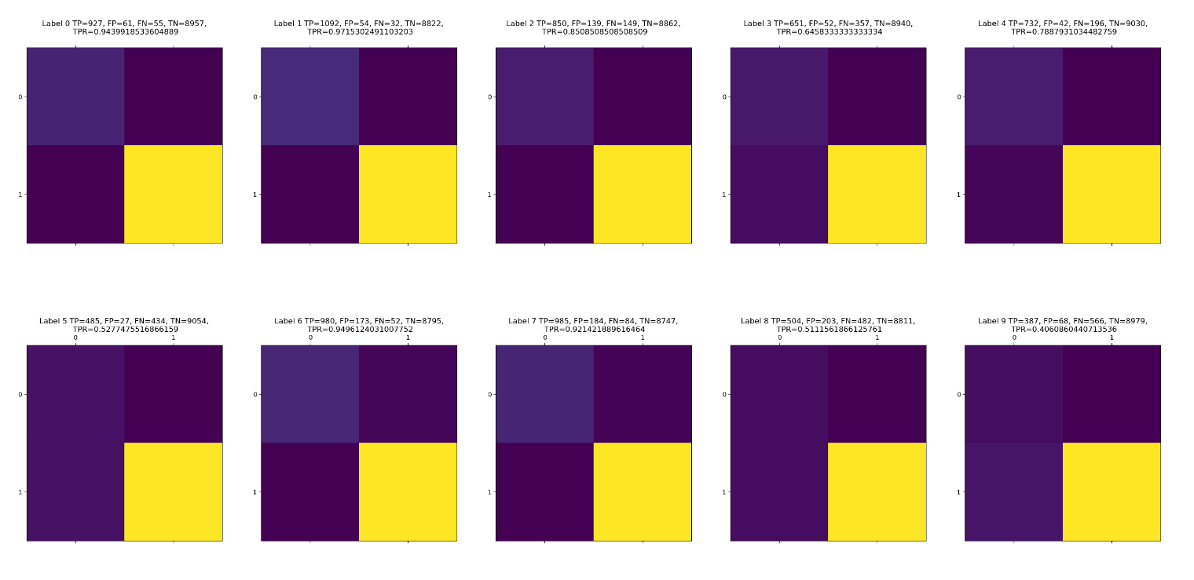

Confusion Matrix for Multi-class PLA:

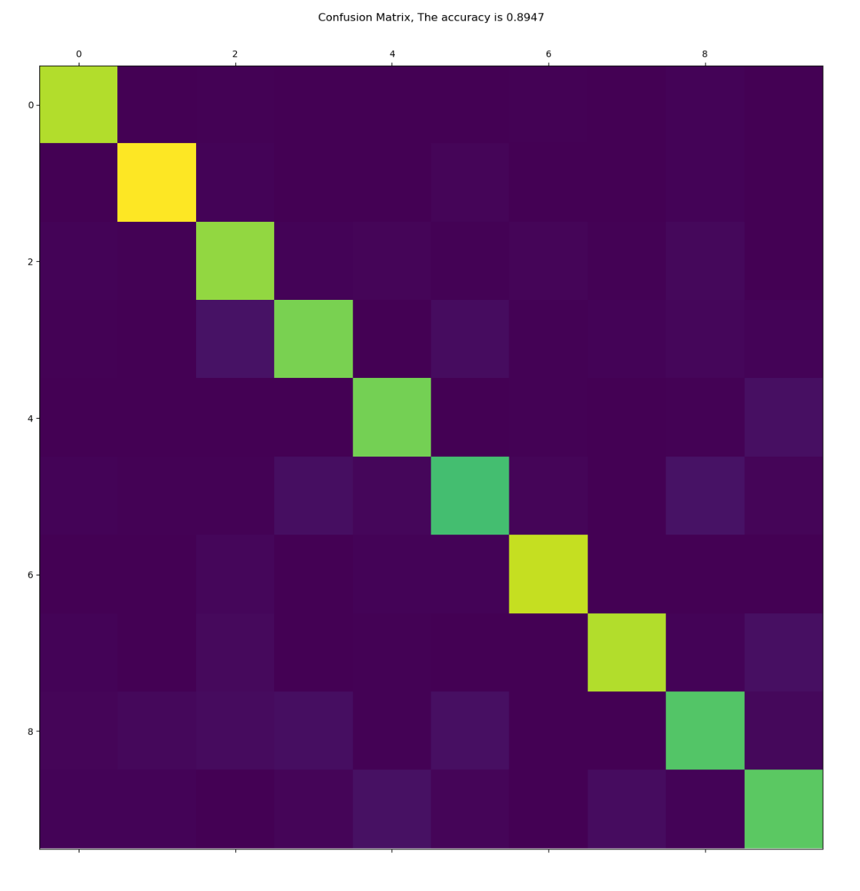

From the graphs of the loss and accuracy per label it seems that each of the binary PLA is learning, the loss is reducing, and the accuracy is increasing.  
Furthermore, the confusion tables for each label summarized the results for each binary PLA, there as expected the TP and the TN has the highest rank that mean that the algorithm is most of the time predict good. Since the imbalance of the data per binary PLA the TN is rank more than the TN

From the diagonal shape of the confusion matrix I can learn that most of the prediction the algorithm does are true. Moreover, I got accuracy = 89% that is corresponding with the confusion table.

**Part B:**

The loss during training:

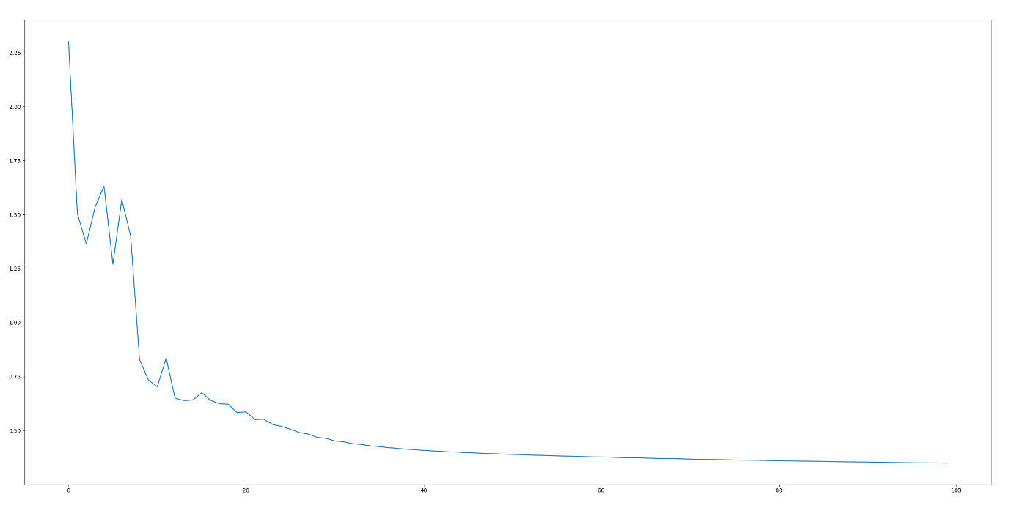

Table of confusion for each of the digits and the TPR:

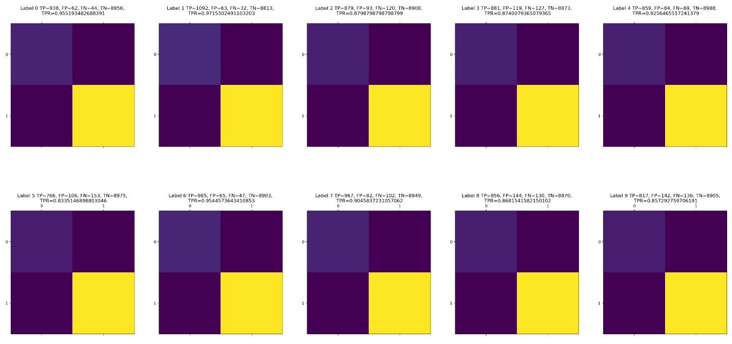

The confusion matrix for the multi-class classification problem on the test-data and the accuracy:

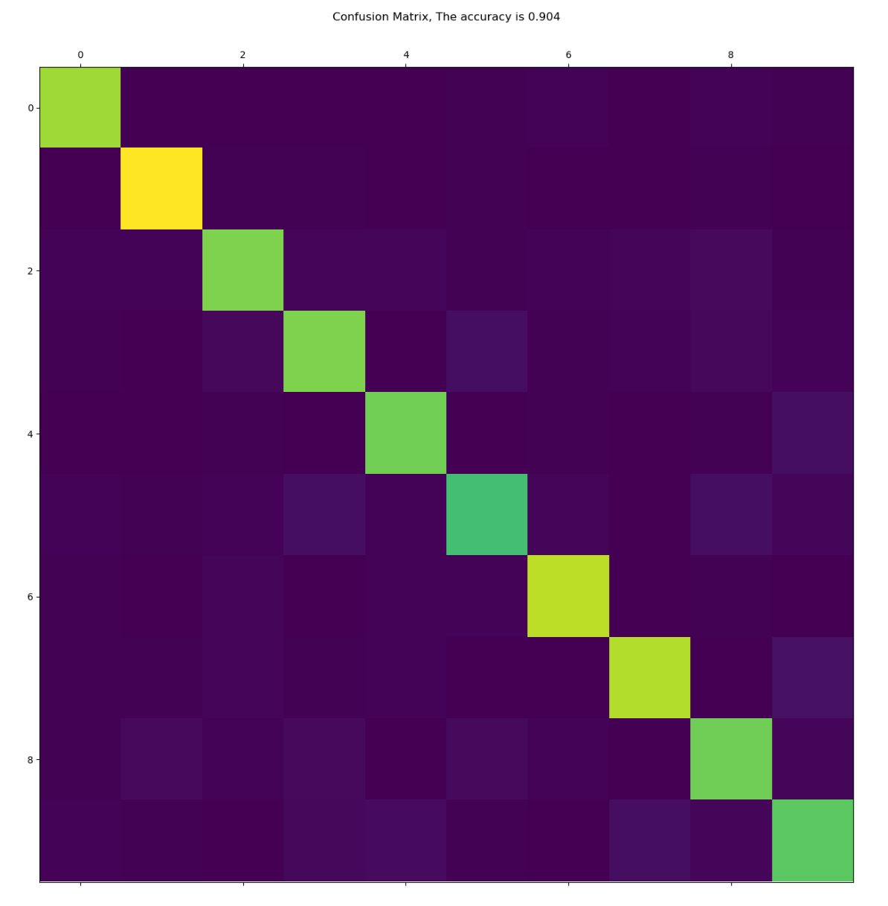

From the loss graph it can be seen that the SoftMax regression algorithm is learning, the loss is decreasing each epoch.

Same as in part A the confusion tables are show that the algorithm is predicting each label well.

Here I got an accuracy = 90% and a nice diagonal confusion matrix that means that the algorithm is working.