**Landis+Gyr - FullStack Developer Take-home challenge**

* Get consumption for a non-existing meter

**Request:** GET /consumption?meter_number=1234

**Response:** 404 0

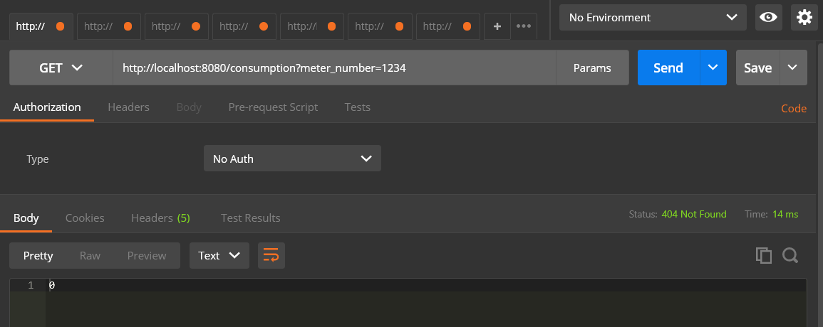

* Create meter

**Request:** POST /event {"type":"import", "meterNumber":"1714A6"}

**Response:** 201 {"meter": {"meterNo": "1714A6", "consumption": 0, "microgeneration": 0}}

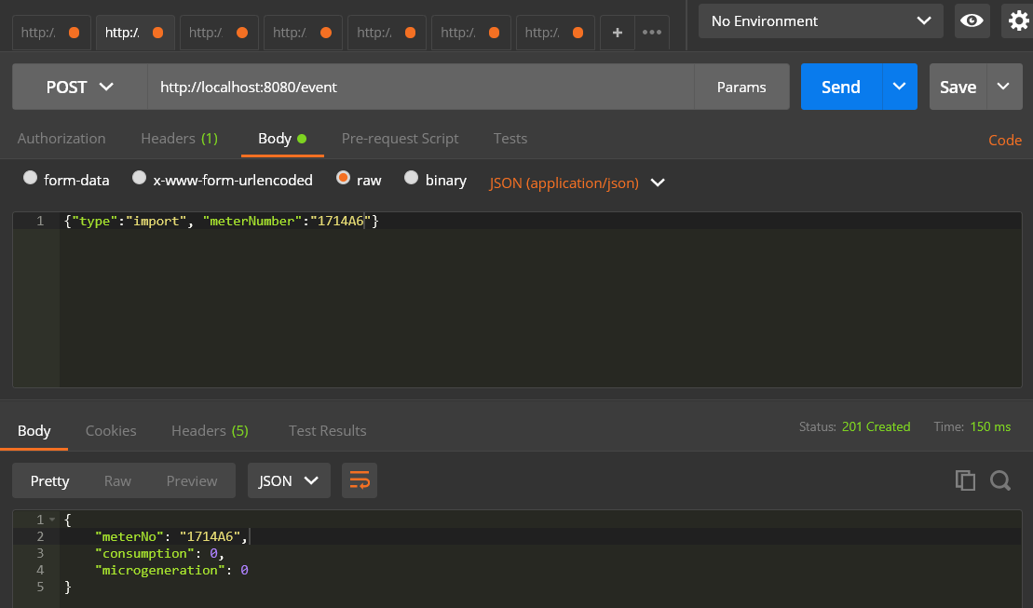

* Receive energy data consumption and microgeneration from an existing meter

**Request:** POST /event {"type": "push", "meterNumber": "1714A6", "activeEnergy": 377, "injectedEnergy": 47}

**Response:** 201 {"meter": {"meterNo": "1714A6", "consumption": 377, "microgeneration": 47}}

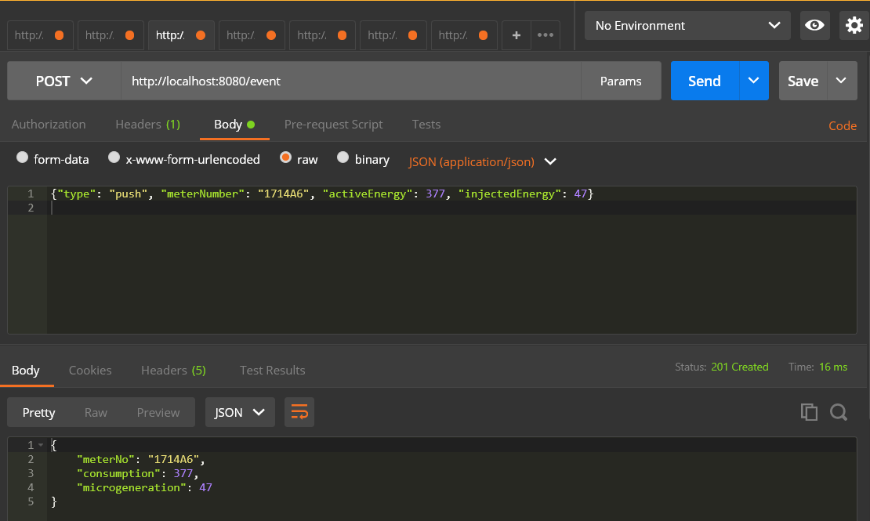

* Get consumption for an existing meter

**Request:** GET /consumption?meter_number=1714A6

**Response:** 200 377

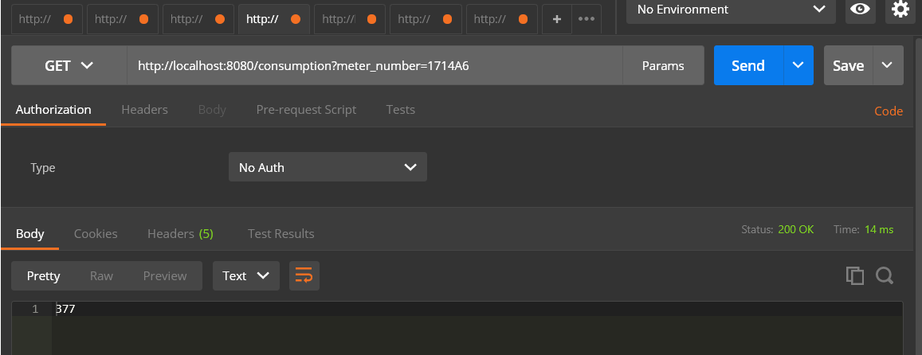

* Get microgeneration for an existing meter

**Request:** GET /microgeneration?meter_number=1714A6

**Response:** 200 47

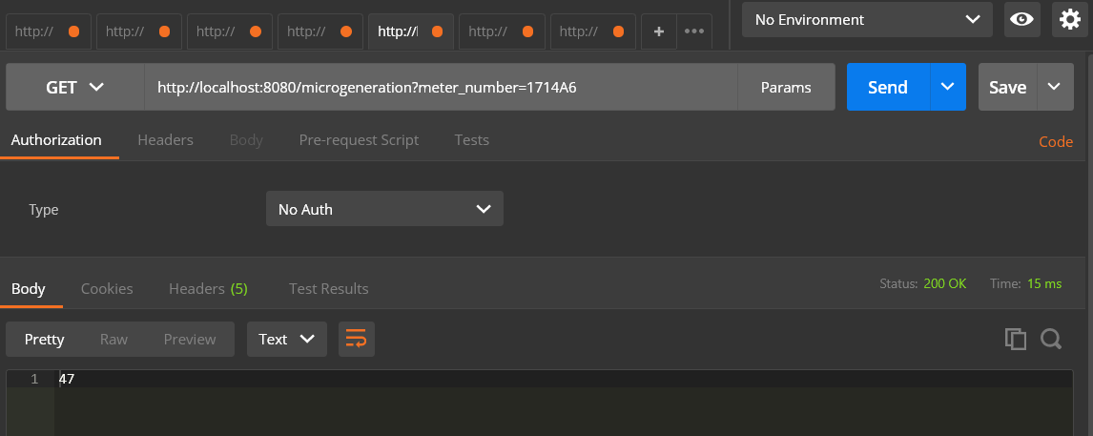

* Bill energy consumption from a non-existing meter

**Request:** POST /event {"type": "billing", "meterNo": "123", "unit": 0.42}

**Response:** 404 0

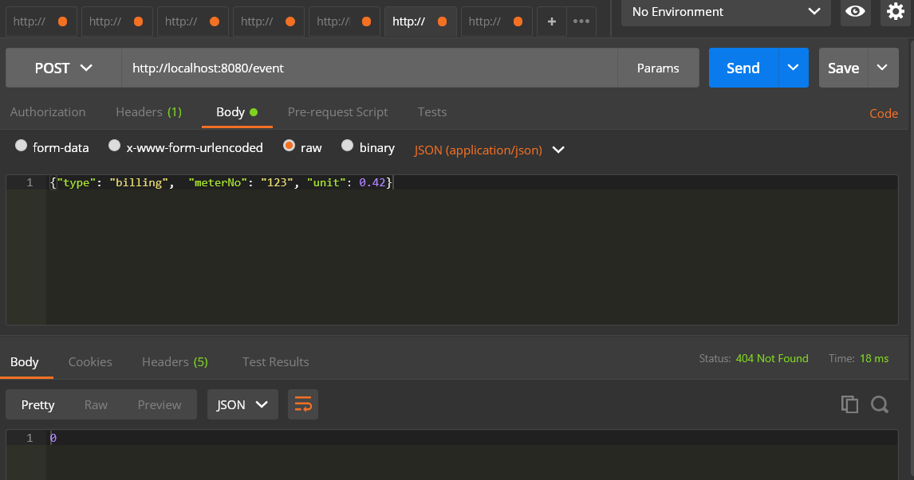

* Bill energy consumption from an existing meter

**Request:** POST /event {"type": "billing", "meterNumber": "1714A6", "unit": 0.42}

**Response:** 201 {"meter": {"meterNo": "1714A6", "cash": 138.6}}

