10527124 資訊三甲 邱正皓

(a) List the data of all departments.

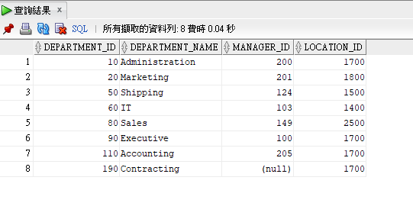

(b) List the last name, hired day, e-mail and salary of employees who work for department 10.

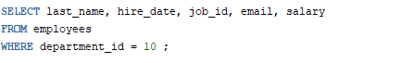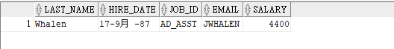

(c) List the last name, hired day, e-mail and salary of employees who salary more than 25,000.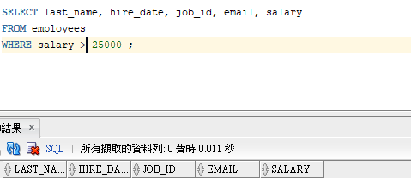

(d) Retrieve all employee names that contain an “A” within the name.

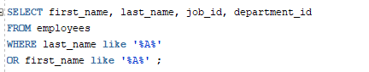

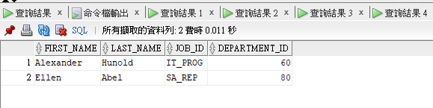

(e) Display the average, highest, lowest and sum of the monthly salaries and the number of employees in company.

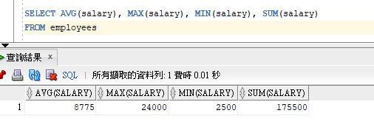

(f) Display the average, highest, lowest and sum of the monthly salaries and the number of employees for each department.

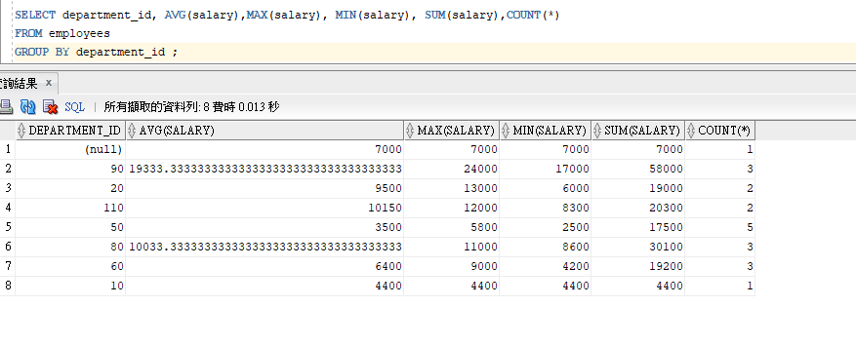

(g) Display the average, highest, lowest and sum of the monthly salaries and the number of employees for department average salary more than 20,000.

