10527124 邱正皓 SQL Practice 3

1. Show the last name, job title, salary, and department name of those employees who earn commission. Sort the data by salary in descending order.

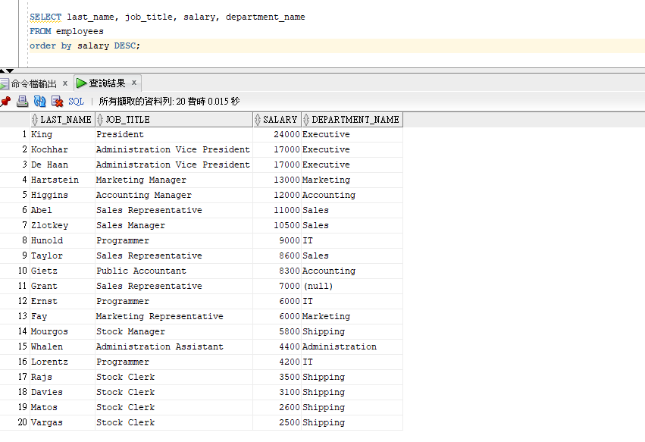

(b) Find the name and department name of employees whose salary is greater than ‘Abel’.

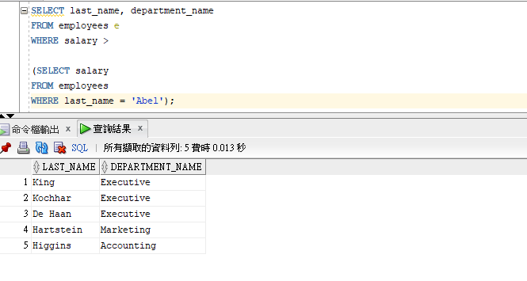

(c) Show the department number, department name, and number of employees working in each department that:

(1) Includes fewer than 3 employees.

(2) Has the highest number of employees.

(d) Write a query to display the top 3 earners in the EMPLOYEES table. Display their last names, salaries and department name.

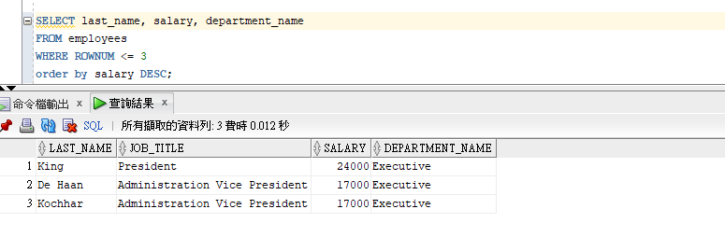

(e) Write a query to display last names of employees who earn less than average salary in their department.

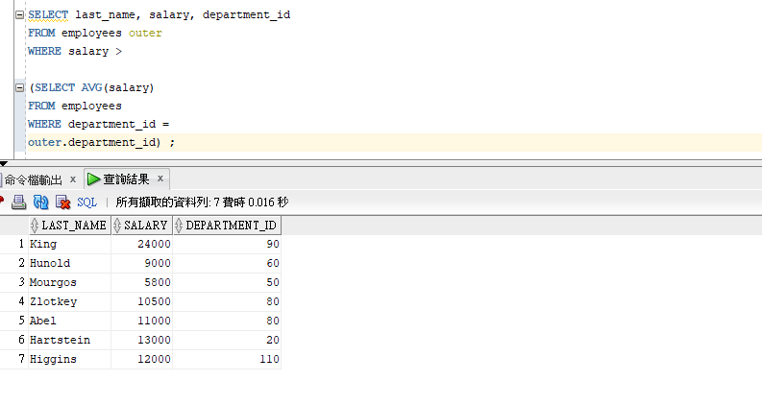

(f) Find all departments that do not have any employees.

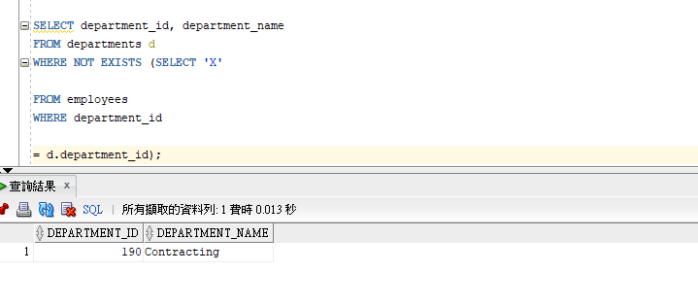

(g) Find all employees who are not supervisor.

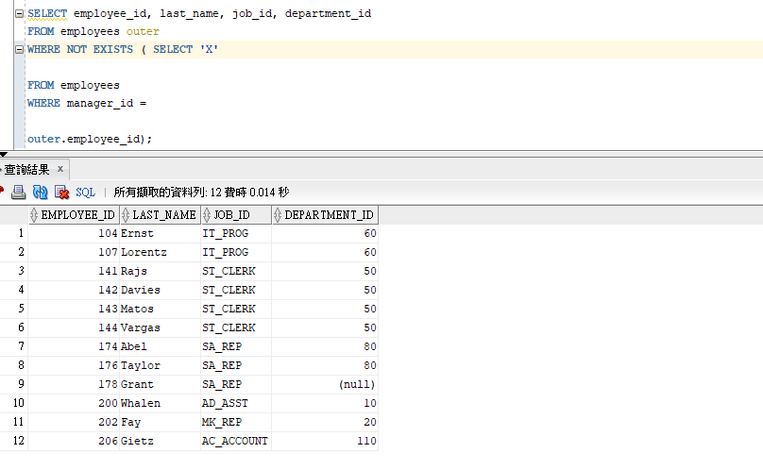

(1) Do this using the NOT EXISTS operator.

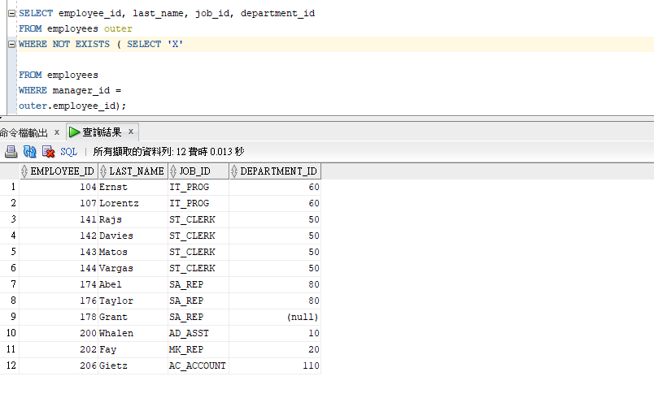

(2) Can this be done by using NOT IN operator? How, or why not?

(h) Use a correlated subquery to delete only those rows from the EMPLOYEES table that also exist in the JOB_HISTORY table.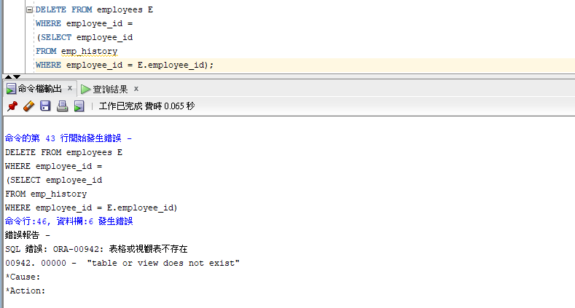

(i) Wrtie a query to display the last names of employees who have one or more coworkers in their departments with later hire date but higher salaries.