INTERNSHIP REPORT

*A report submitted in partial fulfillment of the Automation and Digitalization of Tools Used in* Kenya *Legal & Ethical Issues Network on HIV and AIDS*(KELIN)

# ACKNOWLEDGEMENT

# 

First, I would like to thank Kenya Legal & Ethical Issues Network on HIV and AIDS (KELIN) as an organization for giving me a space and working area for me to realize practically the impact of technology and mathematics in today’s world. The exposure was such effective and day by day I couldn’t miss to build on a new thing in my career path of software development.

I can honestly count every interaction and engagement with all the staff members (including M&E team) as positive and all the time I could note down the area for improvement as I move along. The meetings I attended, training, team building, and any other activity were of great importance.

# ABSTRACT

The KELIN Database System is a system that move the activities within the organization to online based system, keeping track of these activities, monitor and to some extend evaluate. Through the entire report, have included links and snapshot that support every page mentioned. The database for now contains a dummy dataset (data used to indicate the capability of the system) except for the Grants.

**INDEX**

## S.no CONTENTS Page no

1. Introduction……………………………………………………………………....1

1.1 Modules………………………………………………………………….2

1. System Analysis
   1. Front-End …………………………………………………………………..3
   2. Back-End……………………………………………………………………4

3 Sample System Screenshots

3.1 Participant Entry Form ………………………………………………………5

3.2 Grant Entry Form …………………………………………………………….6

3.3 Activity Enty Form ……………………………………………………………7

4 Conclusion …………………………………………………………………………8

**WEEKLY OVERVIEW OF ACTIVITIES DONE**

|  |  |  |  |
| --- | --- | --- | --- |
| **1**  **st**    **WEEK** | **DATE** | **DAY** | **ACTIVITY** |
| 25/07/2022 | Monday | Was Given Opportuanity to interact With KELIN STAFF |
| 26/07/2022 | Tuesday | Went Through KELIN Strategic Workplan |
| 27/07/2022 | Wednesday | Went Through Monitoring and Evaluation Tools |
| 28/07/2022 | Thursday | Had a walkthrough with WLPR Program manager |
| 29/07/2022 | Friday | Had a walkthrough with Communication team |
|

|  |  |  |  |
| --- | --- | --- | --- |
| 2nd Week | **DATE** | **DAY** | **ACTIVITY** |
| 1/08/2022 | Monday | Realized The Need of Digitalizing IEC Material |
| 2/08/2022 | Tuesday | Assembles all the libraries (packages language) needed for digitalization of IEC Material |
| 3/08/2022 | Wednesday | Designed a system for the iec material |
| 4/08/2022 | Thursday | Developed the iec material system , that keep track on various staff engage with these iec material |
| 5/08/2022 | Friday | Created a local Network for the IEC material System that can server people within KELIN building |
|
| 3rd Week | **DATE** | **DAY** | **ACTIVITY** |
| 8/08/2022 | Monday | Realized The need of Having KELIN activities to be moved online |
| 9/08/2022 | Tuesday | Design a system that can work well for KELIN activities |
| 10/08/2022 | Wednesday | Gathered all Programing Language like Python ,HTML, CSS, bootstrap, Java, XTML to be used to built the system |
| 11/08/2022 | Thursday | Identified Each role for each Language |
| 12/08/2022 | Friday | Model the system at the designing stage to incorporate Visualization process |
|
| 4th Week | **DATE** | **DAY** | **ACTIVITY** |
| 15/08/2022 | Monday | Attended team building at stoni Athi |
| 16/08/2022 | Tuesday | Realized the need of teamwork whenever one is implementing on a given plan and the need to have options |
| 17/08/2022 | Wednesday | Noted down the gaps in regards to digitalization of tools |
| 18/08/2022 | Thursday | Listed all the issues and figured out how to have them captured in the system |
| 19/08/2022 | Friday | Thought of all relevant charts to be used in the visualization Process |
|

|  |  |  |  |
| --- | --- | --- | --- |
| 5th  Week | **DATE** | **DAY** | **ACTIVITY** |
| 22/08/2022 | Monday | Listed fields like activity, participant, grants, to be the main models in the database |
| 23/08/2022 | Tuesday | Did a connection of these models to capture all activities within KELIN |
| 24/08/2022 | Wednesday | Noted down how each field will be connected at the backend |
| 25/08/2022 | Thursday | Connected all the fields and thought of all the bugs that may arise during user interaction with the system |
| 26/08/2022 | Friday | Finished building the system that captures all the program data and to some extend organization data |
|

|  |  |  |  |
| --- | --- | --- | --- |
| 6th Week | **DATE** | **DAY** | **ACTIVITY** |
| 29/08/2022 | Monday | Thought of merging the m&E system with the database system |
| 30/08/2022 | Tuesday | Merged all the M&E activities with the master database system |
| 31/08/2022 | Wednesday | Noted down all the linkages |
| 1/09/2022 | Thursday | I Successfully managed the linkages including adding of rich text editors for typing. |
| 2/09/2022 | Friday | Continuing testing of the system |
|
| 7th Week | **DATE** | **DAY** | **ACTIVITY** |
| 5/09/2022 | Monday | Finished building the system that was now able to be shared locally |
| 6/09/2022 | Tuesday | Realized all the information that the system is able to capture |
| 7/09/2022 | Wednesday | Tested all the fields and those that raised errors were corrected |
| 8/09/2022 | Thursday | Tested all the input fields and all were working effectively |
| 9/09/2022 | Friday | Tested all the graphs and charts and they were effectively working |
|
| 8th Week | **DATE** | **DAY** | **ACTIVITY** |
| 12/09/2022 | Monday | Attend a one week training on National laws and Policies Related to SRHR |
| 13/09/2022 | Tuesday | Noted down the acts that supports SRHR |
| 14/09/2022 | Wednesday | Noted down the policies and laws that support SRHR |
| 15/09/2022 | Thursday | Develop advocacy message for issues related to SRHR |
| 16/09/2022 | Friday | Went through the advocacy strategy and noted down the key issues of the whole process |
|
| 9th Week | **DATE** | **DAY** | **ACTIVITY** |
| 19/09/2022 | Monday | Figured out how to automate process within the system |
| 20/09/2022 | Tuesday | Added all the automations at the backend |
| 21/09/2022 | Wednesday | Restructured the user interface |
| 22/09/2022 | Thursday | Incorporated more options for the user interface in the system |
| 23/09/2022 | Friday | Realized the need to move the system from local based to network based |
|
|  |
| 10th  Week | **DATE** | **DAY** | **ACTIVITY** |
| 26/09/2022 | Monday | Developed a network that enables anyone from any place to have access of the system |
| 27/09/2022 | Tuesday | Managed to host the system online |
| 28/09/2022 | Wednesday | Managed to note down all the bugs that may arise during hosting |
| 29/09/2022 | Thursday | Attended a two day meeting on Transform health |
| 30/09/2022 | Friday | Designed a system to be used by Coalition Partners |
|

## 1. INTRODUCTION

The complexity of Organization environments constantly grows, both with regard to the amount of data relevant for making strategic decisions and the complexity of time needed to finish the process. Relevant data are stored across a variety of data repositories, possibly using different data models and formats, and potentially crossed with numerous external sources including papers.

**KELIN Dashboard Database System Capabilities**

1. Ensuring that paper work is reduced by enabling online circulation of information ,
2. Automation of process like generating of reports
3. Visualization of Activities including grants
4. Online registration of Activities to enable tracking
5. Shareable link to participant for online registration
6. Space for publication of articles and documentation
7. Online generation of Assessment test
8. Online Storage of Data and querying it for any interest like wanting to know how many Elders KELIN has Trained so far
9. Keeping track of participant details including the type like whether the participant is a lawyer, a judge, a doctor, an elder, a widow … after which the system imposed a mathematical modeling to aggregate all these.

**1.1Module Description(Nav Bar)**:



<https://grants.up.railway.app/>

KELIN

=====

1. User registers into the site.
2. Dashboard is displayed with various activities including grants visualized by use of Gantt charts, bar charts, line graphs , pie charts, tables, histograms, scatter plots and tables.
3. Every Element in the dashboard is interactive and any click will leads you to another page of intrest
4. Not all users will be guaranteed all information, for example an admin can access all the information available in the database through the dashboard and can further edit, create or delete data available in the database

You can check this here><https://grants.up.railway.app/>

Reports

=======

1. User can upload, create or edit a report. *N/B you can only edit your own report*
2. User can download activity report, monthly report, quarterly report and biannual report.
3. User will have a chance to check the reports from various thematic and comment on it if need to.

You can check this using this <https://kdds.up.railway.app/activities/>

Input Field

=============

1. User can register an activity into the system
2. User can add participant or share a link to the participant for the registration of the activity
3. User can add grants when permitted by admin

You can check it here <https://kdds.up.railway.app/project-input>

Poll Application

=============

1)User can dynamically develop assessment or evaluation questions, this probably for M&E team

2) User can view the assessment questions of various activities and check how participant performed in

Various assessments

3) Use can create poll questions

4) User can publish articles and do documentation

5) User can publish articles and do documentation

You can check this here> <https://kdds.up.railway.app/home-poll>

## 2. SYSTEM ANALYSIS

**2.1 Front-End and Back-end**

**Front-end:**

This is what will be shown to the user, it contains the dashboard with KELIN, Reports, Inputs Fields and Poll Apps aligned in the navbar. All the information that goes into the database comes from this end. The system monitors closely every activity in the front-end and gives a respond immediately when a user sends a request to any click. It’s at this point where the system checks on what goes into the database and to some extent raise error warning when wrong submission or request is done. For the admin, you can always navigate to admin page by slashing home page followed by admin i **.e ee/admin** this will leads you to admin page where admin can customize all the information displayed by the system including assigning viewing rights to various users. You can check this here

<https://grants.up.railway.app/admin/login/?next=/admin/>

***N/B all users getting to front-end page must get authenticated by the system through logging in, unless the process is customized/authorized by the admin then some users will be allowed to view the information by not necessary having to log in.***

**Back-End**

This take care of what comes from the user end. It’s more of technical and coordinate with what is in the database and link it with the request made by the user then it automatically render the result to the user.

***N/B Access to this end is limited as this can leads to crushing of the system.***

**2.2 System configurations**

The whole system can get configured any time when in any case some of the needs of the user was not captured and therefore needed to be deployed into the system. Configuration is also not limited meaning any field can be customized to the need of the user.

**3. System screenshots and Links**

These screenshot below provide a sample overview of the system and also links to these inputs which will take you to the actual page.

**Participant Entry Form** [**https://kdds.up.railway.app/participant-input**](https://kdds.up.railway.app/participant-input)

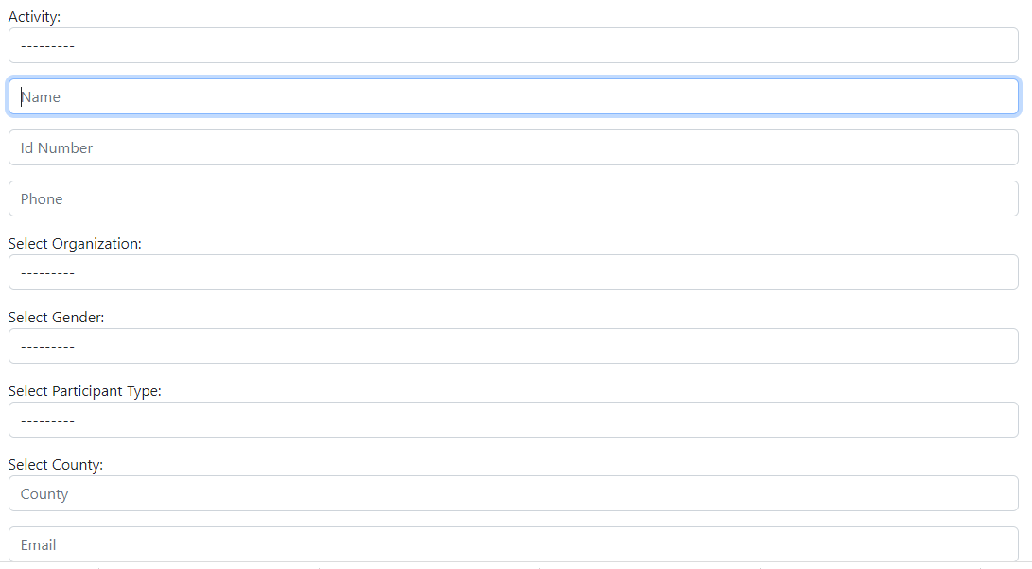

Grants Entry Form > <https://grants.up.railway.app/add-grants>

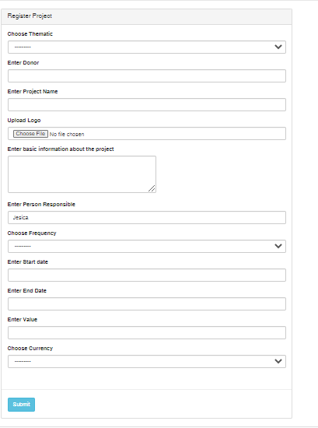

Activity Entry Form ><https://kdds.up.railway.app/activity-input>

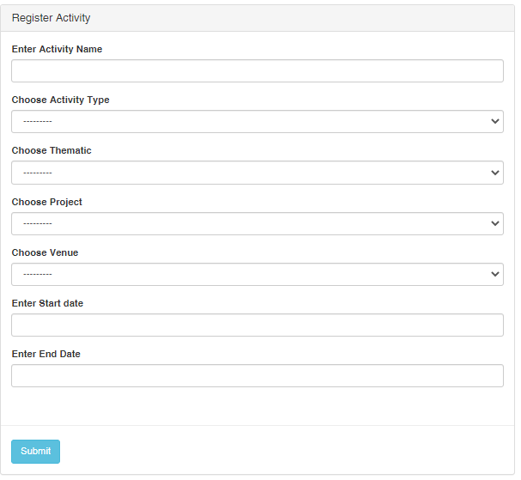

**Conclusion**

The entire system is not yet for full production, most of the information included are dummy and have already started an effort of moving every information available in KELIN database for various thematic. There is a need as well to inform every KELIN staff member of the ongoing process so that their inputs and suggestions can be captured before the full production.

I also noted the migration (SharePoint) facilitated by James, I took this into consideration and have included integrations to the system so that at any point the two can be linked if there is need to.