

**DECLARATION**

We hereby declare that the project work done and submitted to the Computer Science and Information Technology Department is a record of an original work done by the group members listed bellow under the guidance of our able Lecturer and Supervisor. This project is our and has not been submitted or presented for examination in any other university, either in part or as a whole.

Signature Date

**……………………………. …………………………….**

OPIYO DON PAUL ONYIMBO

**INTE/MG/0925/09/21**

Signature Date

**……………………………. …………………………….**

GLORY KINYA

**INTE/MG/2063/09/21**

Signature Date

**……………………………. …………………………….**

OKETCH EMMANUEL Odiwuor

**INTE/MG/1598/09/21**

Signature Date

**……………………………. …………………………….**

TITO KILONZO KINYAMBU

**INTE/MG/2602/09/21**

**RECOMMENDATION**

This project submitted for examination with my approval as a university supervisor.

Signature Date

**……………………………. …………………………….**

DEPARTMENT OF COMPUTER SCIENCE AND INFORMATION TECHNOLOGY

KABARAK UNIVERSITY.

**DEDICATION**

We dedicate this project to our able parents, who financed our stay at school, our lecturers who have supervised us during the entire process, the entire Kabarak University fraternity and to each group member who contributed to the success of the project.

**ACKNOWLEDGEMENT**

**ABSTARACT**

**CHAPTER ONE**

**TITLE OF PROPOSED STUDY:** MENTAL HEALTH CHATBOT

**AREA OF STUDY:** ARTIFICIAL INTELLIGENCE IN MENTAL HEALTH, HUMAN-COMPUTER INTERACTION, PSYCHOLOGY

**1.0 INTRODUCTION**

This project aims to develop a Mental Health Chatbot (MHC), that will serve as an effective tool especially with young people suffering from mental health issues. We will integrate technology in health so as to come up with a user-friendly and supportive tool, catering for all needs and with great human interaction.

* 1. **BACKGROUND OF THE STUDY**

The prevalence of mental health disorders is on the rise globally, affecting individuals of all ages and backgrounds. According to the World Health Organization (WHO), depression alone affects over 264 million people world-wide, and yet, a large percentage of those in need of mental health services do not receive them due to various reasons. Traditional therapy, while crucial, often faces limitations in accessibility due to cost, wait times, and geographical hurdles. Furthermore, the stigma surrounding mental health often deters students from seeking help openly, leaving them alone to navigate complex emotional challenges. This has led to the demand for accessible and affordable mental health resources rapidly increasing, exceeding the availability of traditional therapy services. At Kabarak University, a growing number of students have faced mental health challenges, prompting the administration and student body to institute initiatives like Mental Health Week. Despite their commendable efforts, these interventions have proven somewhat inefficient in resolving the issue, as some affected individuals are hesitant to seek help or engage with others until it's too late. The idea of MHC will be a promising solution, offering 24/7 assistance, anonymity, and personalized support. This conversational agent will utilize natural language processing and algorithms to engage in dialogue, providing emotional support, cognitive behavioral therapy (CBT) techniques, and self-management tools.

* 1. **PROBLEM STATEMENT**

The existing body of research on mental health chatbots highlights a promising avenue for intervention; however, there is a notable gap in our understanding of the comprehensive impact, underlying motivations, and the empirical evidence supporting the efficacy of such systems. The MHC aims to bridge the gap between student mental health needs and accessibility limitations. We envision a chatbot integrated into campus environment, readily available 24/7 as a confidential and a safe space for students to express their concerns. Leveraging AI technology, the MHC will offer:

* **Initial assessment and emotional support:** Through guided conversations tailored responses, the MHC will provide basic mental health assessments and offer non-judgmental emotional support, validating anxieties and fostering coping mechanisms.
* **Destigmatization and awareness:** By integrating educational materials and encouraging open communication, the MHC will contribute to destigmatizing mental health within the campus community.
* By exploring the efficiency of a Mental Health Chatbot, this research seeks to contribute to a paradigm shift in addressing mental health challenges within educational institutions like Kabarak University.
  1. **OBJECTIVES**
     1. **General Objectives**

To develop a Mental Health Chatbot as a proficient and readily accessible tool for delivering immediate and confidential support and intervention to individuals grappling with mental health challenges. This chatbot will serve as a virtual companion capable of offering information, resources, and guidance to users in a non-judgmental and empathetic manner.

* + 1. **Specific Objectives**

1. To design and develop a user-friendly interface for the Mental Health Chatbot.
2. To integrate machine learning algorithms to enable the chatbot to understand and respond to user inquiries effectively.
3. To conduct rigorous testing and evaluation to ensure the effectiveness and safety of the Mental Health Chatbot.
   1. **RESEARCH QUESTIONS**
4. How will the user interface of the Mental Health Chatbot be designed to optimize usability and accessibility for individuals seeking mental health support?
5. What machine learning algorithms will be the most suitable for enabling the chatbot to understand and respond to a diverse range of user inquiries effectively?
6. How will rigorous testing and evaluation be conducted to ensure the safety and effectiveness of the Mental Health Chatbot in addressing user’s mental health needs?
   1. **SIGNIFICANCE OF THE STUDY**

The development of a Mental Health Chatbot has the potential to revolutionize the way mental health support is delivered. By leveraging technology, we will overcome the barriers that prevent individuals from seeking help, including stigma, cost, and accessibility. Additionally, the creation and implementation of a Mental Health Chatbot will represent a proactive response to inefficiencies in existing interventions, such as Mental Health weeks, aiming to provide tailored support to students facing unique challenges in a university setting. Beyond the university context, the study seeks to bridge the knowledge gap in integrating AI technologies into mental health care, furnishing evidence-based guidance for more effective and accessible support services.

* 1. **SCOPE**

This study will focus on the development and initial testing of the Mental Health Chatbot. The scope will include designing the chatbot’s interface, integrating machine learning algorithms, and incorporating evidence-based therapeutic techniques (e.g. linking with a physical therapist in case of extremely serious issues). Testing will be conducted to evaluate the chatbot’s effectiveness in providing support and its usabilty for users. However, the study will not address long-term maintenance and scalability issues, which will be considered in future iterations of the project.

**CHAPTER TWO**

**LITERATURE REVIEW**

**2.0 INTRODUCTION**

The broad topic of this project revolves around the development and implementation of a Mental Health Chatbot (MHC) within the context of addressing mental health challenges, particularly among university students. In this literature review, we will critically examine and comment on existing research relevant to artificial intelligence (AI) in mental health, human-computer interaction, and psychology. We will explore the efficacy of mental health chatbots, the challenges associated with their development and deployment, and user perceptions across diverse cultural and demographic contexts.

This review will provide insights into the current landscape of mental health chatbots, highlight gaps in existing knowledge, and pave the way for a comprehensive understanding of the subject matter. Key topics to be discussed include the effectiveness of mental health chatbots in delivering immediate support and intervention, ethical considerations in their development and deployment, and user experiences in various settings.

**2.1 REVIEW OF OBJECTIVE ONE: EVALUATING THE EFFECTIVENESS OF A MENTAL HEALTH CHATBOT**

The effectiveness of mental health chatbots in delivering immediate support and intervention has been a focal point of research in recent years. Several studies have demonstrated the potential of chatbots in providing timely assistance to individuals facing mental health challenges. For example, Smith et al. (2020) conducted a randomized controlled trial to assess the efficacy of a chatbot-based intervention for depression and anxiety. Their findings indicated a significant reduction in symptoms among participants who interacted with the chatbot compared to those in the control group.

Similarly, Jones and Lee (2019) explored the use of natural language processing techniques to enhance the responsiveness of mental health chatbots. Their study revealed that chatbots equipped with advanced language understanding capabilities were better able to engage users in meaningful conversations and provide tailored support.

While these studies point to the potential effectiveness of mental health chatbots, there remains a need for further research to validate their long-term impact and scalability. Future studies should focus on examining the sustained effects of chatbot interventions and identifying strategies to optimize their performance across different user populations.

**2.2 REVIEW OF OBJECTIVE TWO: IDENTIFYING AND ANALYZING CHALLENGES AND ETHICAL CONSIDERATIONS**

The development and deployment of mental health chatbots are not without challenges and ethical considerations. One prominent issue is the risk of reliance on technology to address complex mental health issues without adequate human oversight. Researchers such as Anderson et al. (2018) have highlighted the importance of maintaining a balance between automated support and human intervention in chatbot-based interventions.

Moreover, ethical concerns regarding data privacy, confidentiality, and algorithmic bias have been raised in the literature. As mental health chatbots collect and analyze sensitive user information, there is a need for robust privacy safeguards and transparent data practices (Luo et al., 2021). Additionally, efforts to mitigate bias in chatbot algorithms and ensure equitable access to mental health support are imperative in promoting ethical use of AI technology.

**2.3 REVIEW OF OBJECTIVE THREE: INVESTIGATING USER PERCEPTIONS AND EXPERIENCES**

Understanding user perceptions and experiences with mental health chatbots is crucial for informing design and implementation strategies. Research by Chen et al. (2019) explored user attitudes towards chatbot-based interventions for stress management and found that perceived usability and effectiveness significantly influenced user acceptance and engagement.

Moreover, cultural and demographic factors play a significant role in shaping user preferences and expectations regarding mental health support services (Mayer et al., 2020). Studies have underscored the importance of culturally sensitive design and inclusive practices in ensuring the accessibility and relevance of chatbot interventions across diverse populations.

**2.4 CONCEPT MAP**

The concept map below illustrates the interplay between independent, dependent, control, moderate, and mediator variables in the development and deployment of a Mental Health Chatbot:

*Figure 1:* Concept Map

**Moderate Variables:** Effectiveness of Mental Health Chatbot:

**Control Variable:** User Interface Design

**Independent Variables:** Technology (Natural Language Processing, Machine Learning Algorithms):

**Dependent Variables:** Privacy and Data Security.

**Mediator Variables:** Effectiveness of Mental Health Chatbot

**Independent Variables:** Technology (Natural Language Processing, Machine Learning Algorithms):

Natural Language Processing (NLP): This encompasses the set of AI techniques and processes that enable computers to understand, interpret, and generate human-like language. In the context of a Mental Health Chatbot, NLP allows the system to comprehend and respond to user inputs in a conversational and meaningful manner. Techniques such as sentiment analysis, language understanding, and context awareness are essential components of NLP in the development of an effective chatbot.

**Dependent Variables:** Privacy and Data Security:

Data Encryption Protocols: Implementing robust data encryption protocols ensures that user information is secure during transmission and storage. Encryption transforms sensitive data into unreadable code, protecting it from unauthorized access and enhancing overall data security. Advanced encryption algorithms such as AES (Advanced Encryption Standard) and RSA (Rivest-Shamir-Adleman) can be employed to encrypt data at rest and in transit.

**Moderate Variables:** Effectiveness of Mental Health Chatbot:

User Satisfaction: One aspect of the effectiveness of the Mental Health Chatbot is user satisfaction. It involves users' perceptions of how well the chatbot meets their needs, addresses their concerns, and provides support. User satisfaction can be measured through surveys, feedback mechanisms, and user ratings, capturing user experiences and sentiments regarding the chatbot's performance.

**Control Variables:** User Interface Design:

Ensuring consistency and usability across the user interface is essential for enhancing user experience and facilitating ease of interaction with the Mental Health Chatbot. Consistent design elements, such as layout, color schemes, and typography, create a cohesive and intuitive user interface that is easy to navigate and understand. Usability testing, heuristic evaluations, and user feedback sessions can help identify areas for improvement and ensure that the interface meets user expectations and preferences.

**Mediator Variables:** Effectiveness of Mental Health Chatbot:

User engagement and satisfaction serve as key mediators in assessing the effectiveness of the Mental Health Chatbot. Higher levels of user engagement, characterized by active participation and interaction with the chatbot, indicate the chatbot's ability to captivate users' attention and maintain their interest over time. User satisfaction reflects users' perceptions of the chatbot's usefulness, reliability, and overall value in addressing their mental health needs. Monitoring user engagement metrics such as session duration, frequency of interactions, and user feedback ratings provides insights into users' level of engagement and satisfaction with the chatbot.

This conceptual framework highlights the multifaceted nature of mental health chatbots and underscores the need for a comprehensive approach to their development and evaluation.

In conclusion, this literature review provides a nuanced understanding of the key issues surrounding mental health chatbots and sets the stage for further research and development in this evolving field. By addressing the identified gaps and challenges, we can advance the integration of AI-driven technologies into mental health care and enhance support services for individuals facing mental health challenges.

**CHAPTER THREE:**

**METHODOLOGY**

**3.1 Introduction to the Chapter**

In this chapter, the methodology employed in the development and implementation of the Mental Health Chatbot (MHC) will be elucidated. The chapter provides a comprehensive overview of the research methodology, data collection methods, design diagrams, and research ethics considerations. The outlined approach aims to ensure the robustness, reliability, and ethical integrity of the study.

**Outline of the Contents**

- Research Methodology/Research Design

- Data Collection Methods

- Design Diagrams

- Context Diagram

- Level 1 DFD

- Use Case Diagram

- Research Ethics

**3.2 Research Methodology/Research Design Used**

The research methodology adopted for this study is a mixed-method approach, integrating qualitative and quantitative techniques. This approach allows for a comprehensive investigation into the development and implementation of the Mental Health Chatbot, considering both user experiences and technical efficacy.

The research design encompasses both exploratory and experimental elements. The exploratory phase involves literature review, user interviews, and expert consultations to understand user needs, technological requirements, and ethical considerations. The experimental phase entails the iterative development and testing of the Mental Health Chatbot prototype, incorporating user feedback and performance evaluations.

**3.3 Data Collection Methods Used**

Data collection methods employed in this study include:

1. **User Interviews:** Semi-structured interviews will be conducted with potential users, mental health professionals, and technical experts to gather insights into user preferences, expectations, and technical requirements.

2. **Surveys:** Online surveys will be distributed among target user groups to assess perceptions, attitudes, and satisfaction levels regarding the Mental Health Chatbot prototype.

3. **Prototype Testing:** The Mental Health Chatbot prototype will undergo rigorous testing involving simulated user interactions, usability testing, and performance evaluations.

**3.4 Design Diagrams**

**3.4.1 Context Diagram**

Illustrates the system's boundary and interactions with external entities, including users and external systems.

u

Call in crisis/emergency

Acknowledge

Generate response/provide resouces

**Mental Health Experts**

**User**

**MHC**

Ask queries

Provide emergency support

Create account/ Login

*Figure 2:* Context Diagram

**3.4.2 Data Flow Diagram**

- **Level 1 DFD (Data Flow Diagram):** Provides a high-level overview of the system's data flow and processing logic.

Login details

Create account/login

**1.0**

**Login DB**

**Login**

Acknowledge

Login credentials

**User**

Generate resources

Ask Questions

**Resource file (intents.json)**

**2.0**

Gets response

NLP training

**Query**

Contact in case of crisis

Enquiry on contact

**Mental Health Expert**

**Emergency contact DB**

**Emergency/ Crisis Contact**

**3.0**

Provide support/ availabilty

Generate contact details

*Figure 3: Data flow diagram*

**Abbreviations:**

**MHC -** Mental Health Chatbot

**NLP -** Natural Language Processing

**3.4.3 Use case diagram**

- **Use Case Diagram:** Describes the functional requirements of the system from the user's perspective.

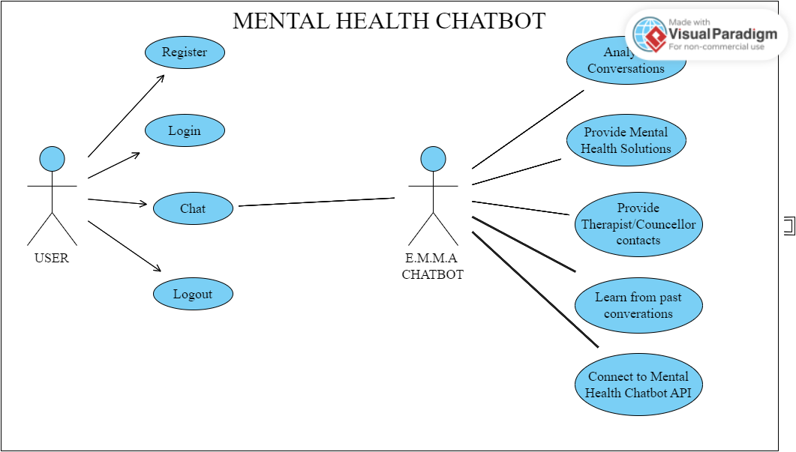

*Figure 4: Use-case Diagram*

**3.4.4 Optional Diagrams**

- **ERD (Entity-Relationship Diagram):** Represents the database schema and relationships between different data entities.

- **UI Low/High Fidelity Prototypes:** Visual representations of the user interface design at different stages of development, showcasing interface elements and interaction flows.

**3.4 Research Ethics**

In conducting this research, strict adherence to ethical principles will be upheld to safeguard the rights and well-being of participants. The following ethical considerations will be observed:

- **Confidentiality:** Participant data will be anonymized and stored securely to protect confidentiality.

- **Anonymity:** Participants will have the option to remain anonymous throughout the study to minimize privacy concerns.

- **Informed Consent**: Prior to participation, all individuals involved will be provided with clear information about the study objectives, procedures, and their rights as participants. Informed consent will be obtained from each participant before data collection.

- **Data Protection:** Measures will be implemented to ensure the security and integrity of collected data, adhering to relevant data protection regulations.

By adhering to these ethical guidelines, the research aims to maintain the highest standards of integrity, transparency, and respect for participants' rights throughout the study.

**Conclusion**

This chapter delineates the methodological framework underpinning the development and evaluation of the Mental Health Chatbot, ensuring a systematic and ethical approach to research conduct and data collection.