Ntxtf :
1

Global env

Parameters:
Body: (new text-field%
[label “Enter Equation]
[parent diaPanel2])

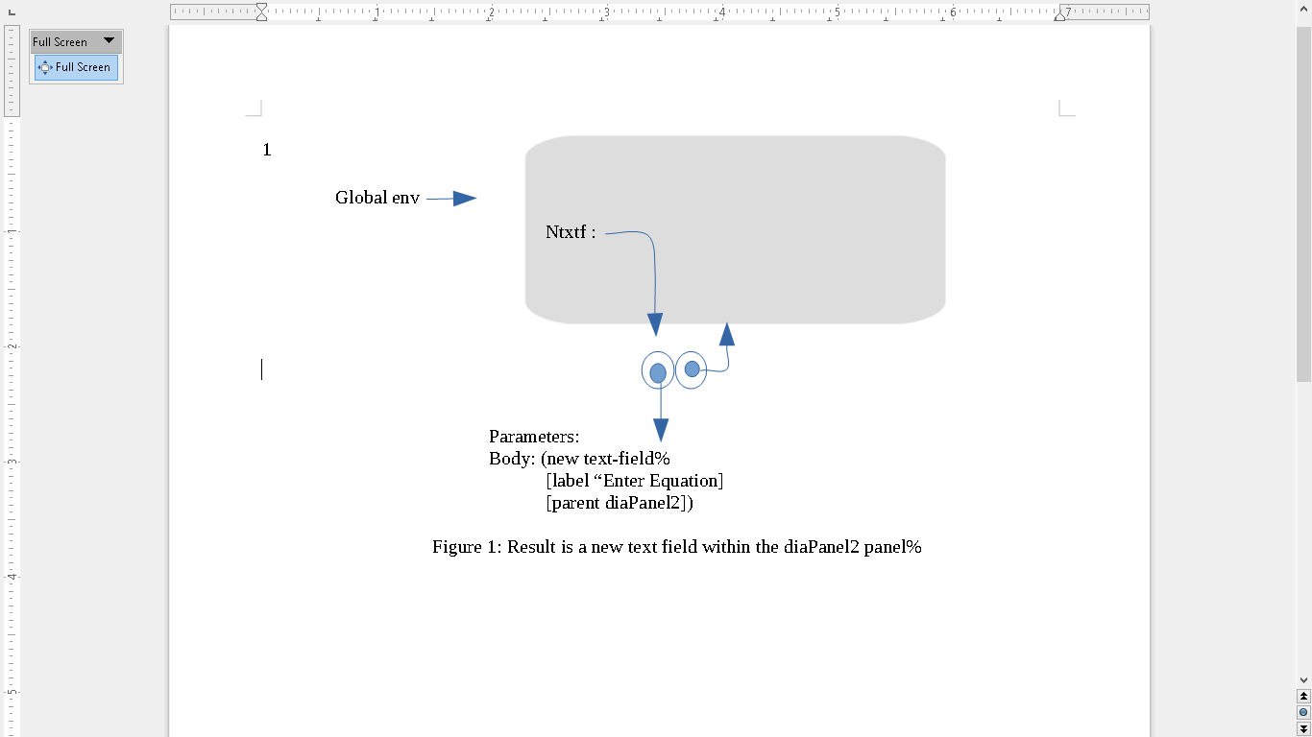
Figure 1: Result is a new text field within the diaPanel2 panel%

