How Test-Capture is used

This guide assumes you’ve already used Bottle-Racket to convert an assignment test file, either ps1-ps3 or ps5, into a Racket test suite and test area file. It will walk through an example of how this GUI is used.

The script file is test-capture.rkt in the Bottle-Racket directory. When you run the script, you get a window specifying a test area file which will be used to determine where the test running script is generated and where it will be run. Along with that, an output directory text field is provided which determines where your results will go and this is appended to the user settings directory, and by default it’s populated with the text “QA Test Result”. Then there are the To and Subject fields for the email header.

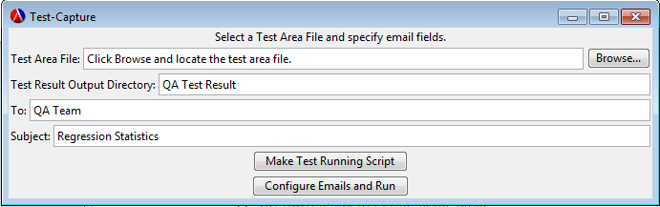

You see two buttons at the bottom:
1.) Make Test Running Script generates a test-running script for the test area file provided, in the same directory. This does not actually run the script, it just creates the script.
2.) Configure Emails and Run will open up the Email DB UI and you can specify what email list the test results will go out to. When you close that dialog box, the test script will then run right after and generate a test results file to be sent out to the email list specified in the UI.
These next two pictures are just to show you that clicking Browse for the Test Area File field will have you search for the area file on your computer.
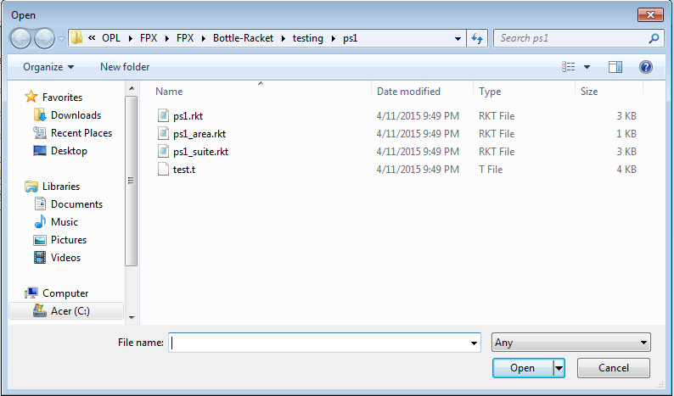
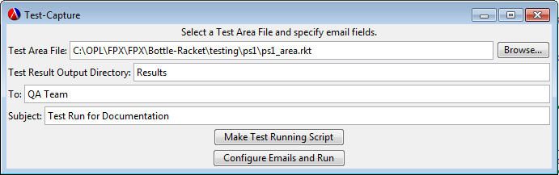

This shows what happens when you click Make Test Running Script after specifying the necessary test area file, first finding the test area file in the first place after you’ve run Bottle-Racket to create it. You see test_script.rkt is generated in the same directory as the test area file specified, and the message on the Test-Capture GUI updates saying the test running script file was created for that area file.
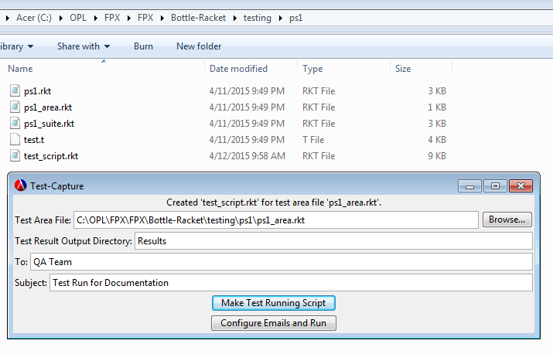

After that, clicking Configure Emails and Run will direct you to the Email DB UI which allows you to select an email list for the recipients of the test results of the test-running script. When this dialog box is closed, the test-running script will start immediately. The dialog box is on the next page.
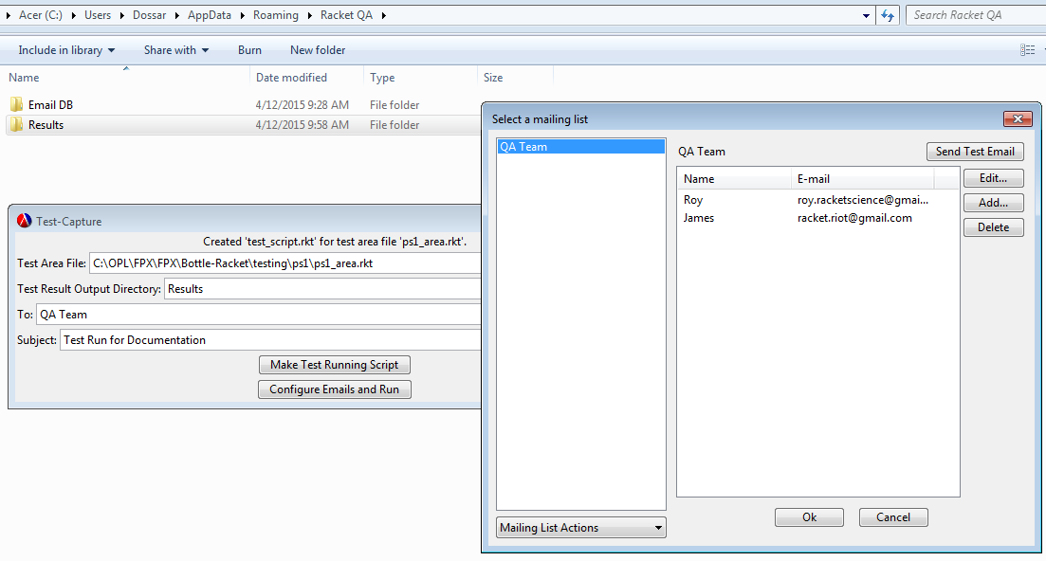

Running the script may take a few seconds, so be patient. The message on the Test-Capture GUI will update stating that the tests were run successfully. The email should also be sent.

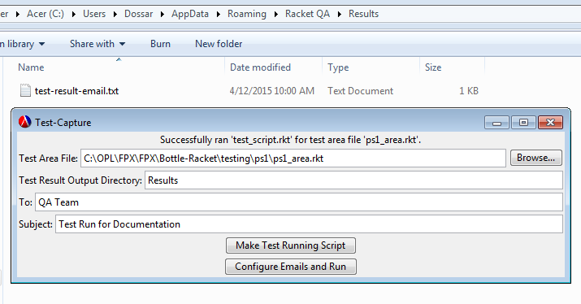

This picture shows the resulting email from the above script run.

