Alternative Final Exercise

Loading Libraries

rm(list=ls())  
library(haven)  
library(readxl)  
library(dplyr)

##   
## Attaching package: 'dplyr'

## The following objects are masked from 'package:stats':  
##   
## filter, lag

## The following objects are masked from 'package:base':  
##   
## intersect, setdiff, setequal, union

library(ggplot2)  
library(plm)

## Loading required package: Formula

##   
## Attaching package: 'plm'

## The following objects are masked from 'package:dplyr':  
##   
## between, lag, lead

Loading Data

# Load in WDI Data  
wdi.data <- read_dta("~/desktop/stats/final_exercise/wdi.dta")  
  
# LOAD WDI COUNTRIES  
wdi.countries <- read_excel("~/desktop/stats/final_exercise/Country.xlsx")

# Selected Attributes  
wdi.selected <- select(wdi.data, countryname, countrycode, year, sp_ado_tfrt, se_sec_enrr, se_sec_enrr_fe, se_sec_enrr_ma, ny_gdp_pcap_cd, si_pov_gini, sp_pop_totl_fe_zs, se_com_durs, sp_dyn_conu_zs, sp_uwt_tfrt, sp_pop_totl, sh_sta_mmrt_ne, sp_rur_totl_zs, sl_tlf_0714_fe_zs, sl_tlf_acti_1524_fe_ne_zs, se_prm_enrr)  
  
# Rename Columns  
names(wdi.selected) <- c("Country_Name", "Country Code", "Year", "Adolescent_Fertility_Rate","Secondary_School_Enrollment", "Female_Secondary_School_Enrollment", "Male_Secondary_School_Enrollment", "GDP_Per_Capita", "GINI", "Percent_Female", "Compulsory_Education", "Contraceptive Prevalence", "Unmet Need for Contraception", "Population", "Maternal_Mortality_Rate", "Percent_Rural_Population", "Female_Child_Employment", "Female_Labor_Force_Participation", "Primary_School_Enrollment")  
  
wdi.did <- filter(wdi.selected, (Country_Name =="Costa Rica" | Country_Name=="Peru") & (Year >= 1986 & Year <= 2002))  
  
wdi.more <- filter(wdi.selected, (Country_Name =="Costa Rica" | Country_Name=="Peru" | Country_Name=="Panama" | Country_Name=="Guatemala" | Country_Name=="Honduras" | Country_Name=="Dominican Republic" | Country_Name=="Ecuador" | Country_Name=="Venezuela, RB" | Country_Name=="Colombia" | Country_Name=="Paraguay") & (Year >= 1986 & Year <= 2002))  
  
ggplot(data=wdi.did)+   
 geom_line(aes(`Year`, `Adolescent_Fertility_Rate`, group=`Country_Name`, colour=`Country_Name`),) +   
 ggtitle("Plot of Adolescent Fertility Rate by Year, Costa Rica & Peru") +  
 geom_vline(xintercept = 1994) +  
 geom_vline(xintercept = 1986) +  
 geom_vline(xintercept = 2002)

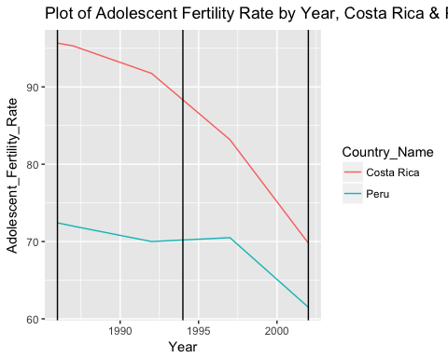 Primary School Enrollment Regressions

ggplot(data=wdi.did)+   
 geom_line(aes(`Year`, `Primary_School_Enrollment`, group=`Country_Name`, colour=`Country_Name`),) +  
 ggtitle("Plot of Primary School Enrollment by Year, Costa Rica & Peru") +  
 geom_vline(xintercept = 1994) +  
 geom_vline(xintercept = 1986) +  
 geom_vline(xintercept = 2002)

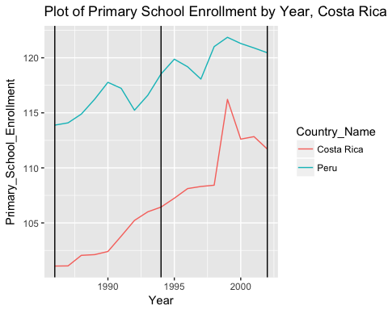

ggplot(data=wdi.more)+   
 geom_line(aes(`Year`, `Primary_School_Enrollment`, group=`Country_Name`, colour=`Country_Name`),) +  
 ggtitle("Plot of Primary School Enrollment by Year, More") +  
 geom_vline(xintercept = 1994) +  
 geom_vline(xintercept = 1986) +  
 geom_vline(xintercept = 2002)

## Warning: Removed 2 rows containing missing values (geom_path).

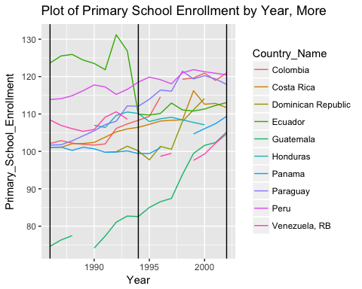 Set up Diff-in-Diff Variables

# Set "intervention"" variable for all observations after 1994  
wdi.did$intervention <- ifelse(wdi.did$Year > 1994, 1, 0)  
# Set "treated" for all treated countries (i.e. Costa Rica)  
wdi.did$treated <- ifelse(wdi.did$Country_Name == "Costa Rica", 1, 0)  
# Set up the interaction variable "did" to be intervention * treated  
# In this case set 1 for observations of Costa Rica after 1994 when the intervention occured  
wdi.did$did <- wdi.did$intervention * wdi.did$treated

Primary School Regressions Regress Adolescent Fertility Rate on Primary School Enrollment

# Regress Adolescent Fertility Rate on Primary School Enrollment  
primarySchoolEnrollReg <- lm(data=wdi.did, Adolescent_Fertility_Rate ~ Primary_School_Enrollment + GDP_Per_Capita)  
  
summary(primarySchoolEnrollReg)

##   
## Call:  
## lm(formula = Adolescent_Fertility_Rate ~ Primary_School_Enrollment +   
## GDP_Per_Capita, data = wdi.did)  
##   
## Residuals:  
## Min 1Q Median 3Q Max   
## -8.6404 -1.8750 0.5987 1.6743 6.1687   
##   
## Coefficients:  
## Estimate Std. Error t value Pr(>|t|)   
## (Intercept) 2.489e+02 9.780e+00 25.454 <2e-16 ***  
## Primary_School_Enrollment -1.519e+00 8.247e-02 -18.419 <2e-16 ***  
## GDP_Per_Capita -2.006e-04 6.123e-04 -0.328 0.745   
## ---  
## Signif. codes: 0 '***' 0.001 '**' 0.01 '*' 0.05 '.' 0.1 ' ' 1  
##   
## Residual standard error: 3.086 on 31 degrees of freedom  
## Multiple R-squared: 0.9216, Adjusted R-squared: 0.9166   
## F-statistic: 182.2 on 2 and 31 DF, p-value: < 2.2e-16

Diff-in-Diff regression to show impact of intervention on Primary School Enrollment First Stage Regression (see bottom for second stage regresssion)

# Diff-in-Diff regression to show impact of intervention on Primary School Enrollment  
# When you control for GDP_Per_Capita the significance disappears....  
primaryDidReg <- lm(Primary_School_Enrollment ~ treated + intervention + did, data = wdi.did)  
  
summary(primaryDidReg)

##   
## Call:  
## lm(formula = Primary_School_Enrollment ~ treated + intervention +   
## did, data = wdi.did)  
##   
## Residuals:  
## Min 1Q Median 3Q Max   
## -3.4404 -1.7962 0.1549 1.4410 5.5363   
##   
## Coefficients:  
## Estimate Std. Error t value Pr(>|t|)   
## (Intercept) 116.0494 0.7096 163.535 < 2e-16 ***  
## treated -12.6925 1.0036 -12.647 1.48e-13 ***  
## intervention 4.2818 1.0345 4.139 0.00026 ***  
## did 3.0451 1.4629 2.081 0.04602 *   
## ---  
## Signif. codes: 0 '***' 0.001 '**' 0.01 '*' 0.05 '.' 0.1 ' ' 1  
##   
## Residual standard error: 2.129 on 30 degrees of freedom  
## Multiple R-squared: 0.9105, Adjusted R-squared: 0.9015   
## F-statistic: 101.7 on 3 and 30 DF, p-value: 8.165e-16

Secondary School Enrollment Charts

ggplot(data=wdi.did)+   
 geom_line(aes(`Year`, `Secondary_School_Enrollment`, group=`Country_Name`, colour=`Country_Name`),) +  
 ggtitle("Plot of Secondary School Enrollment by Year, Costa Rica & Peru") +  
 geom_vline(xintercept = 1994) +  
 geom_vline(xintercept = 1986) +  
 geom_vline(xintercept = 2002)

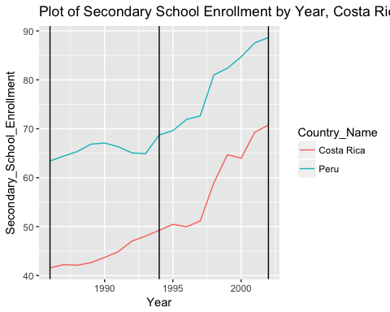

ggplot(data=wdi.more)+   
 geom_line(aes(`Year`, `Secondary_School_Enrollment`, group=`Country_Name`, colour=`Country_Name`),) +  
 ggtitle("Plot of Secondary School Enrollment by Year, More") +  
 geom_vline(xintercept = 1994) +  
 geom_vline(xintercept = 1986) +  
 geom_vline(xintercept = 2002)

## Warning: Removed 9 rows containing missing values (geom_path).

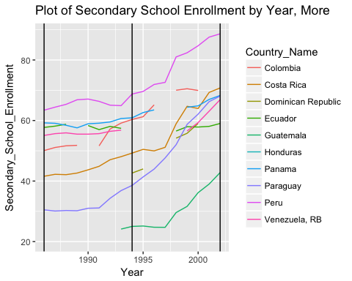 Secondary School Enrollment Regressions Regress Adolescent Fertility Rate on Secondary School Enrollment

secondarySchoolEnrollReg <- lm(data=wdi.did, Adolescent_Fertility_Rate ~ Secondary_School_Enrollment + GDP_Per_Capita)  
  
summary(secondarySchoolEnrollReg)

##   
## Call:  
## lm(formula = Adolescent_Fertility_Rate ~ Secondary_School_Enrollment +   
## GDP_Per_Capita, data = wdi.did)  
##   
## Residuals:  
## Min 1Q Median 3Q Max   
## -4.7675 -2.4310 -0.2971 2.6618 4.8119   
##   
## Coefficients:  
## Estimate Std. Error t value Pr(>|t|)   
## (Intercept) 1.201e+02 2.971e+00 40.42 <2e-16 ***  
## Secondary_School_Enrollment -7.226e-01 3.819e-02 -18.92 <2e-16 ***  
## GDP_Per_Capita 1.043e-03 5.825e-04 1.79 0.0833 .   
## ---  
## Signif. codes: 0 '***' 0.001 '**' 0.01 '*' 0.05 '.' 0.1 ' ' 1  
##   
## Residual standard error: 3.011 on 31 degrees of freedom  
## Multiple R-squared: 0.9254, Adjusted R-squared: 0.9206   
## F-statistic: 192.2 on 2 and 31 DF, p-value: < 2.2e-16

First State Regression Diff-in-Diff regression to show impact of intervention on the Secondary School Enrollment

# Diff-in-Diff regression to show impact of intervention on Secondary School Enrollment  
# When you control for GDP_Per_Capita the significance disappears....  
secondaryDidReg <- lm(Secondary_School_Enrollment ~ treated + intervention + did, data = wdi.did)  
  
summary(secondaryDidReg)

##   
## Call:  
## lm(formula = Secondary_School_Enrollment ~ treated + intervention +   
## did, data = wdi.did)  
##   
## Residuals:  
## Min 1Q Median 3Q Max   
## -10.1967 -2.3852 -0.0971 3.3242 10.8572   
##   
## Coefficients:  
## Estimate Std. Error t value Pr(>|t|)   
## (Intercept) 65.796 1.910 34.442 < 2e-16 ***  
## treated -21.188 2.702 -7.842 9.44e-09 ***  
## intervention 14.005 2.785 5.029 2.15e-05 ***  
## did 1.289 3.938 0.327 0.746   
## ---  
## Signif. codes: 0 '***' 0.001 '**' 0.01 '*' 0.05 '.' 0.1 ' ' 1  
##   
## Residual standard error: 5.731 on 30 degrees of freedom  
## Multiple R-squared: 0.8462, Adjusted R-squared: 0.8308   
## F-statistic: 55.02 on 3 and 30 DF, p-value: 2.639e-12

Second State Regression Diff-in-Diff regression to show the impact of the intervention on the Adolescent Fertility Rate

fertilityDidReg <- lm(Adolescent_Fertility_Rate ~ treated + intervention + did + GDP_Per_Capita, data = wdi.did)  
  
summary(fertilityDidReg)

##   
## Call:  
## lm(formula = Adolescent_Fertility_Rate ~ treated + intervention +   
## did + GDP_Per_Capita, data = wdi.did)  
##   
## Residuals:  
## Min 1Q Median 3Q Max   
## -6.3966 -1.1767 0.1593 1.4945 5.6418   
##   
## Coefficients:  
## Estimate Std. Error t value Pr(>|t|)   
## (Intercept) 78.655932 2.366961 33.231 < 2e-16 ***  
## treated 28.717862 2.396757 11.982 9.4e-13 ***  
## intervention 1.419999 2.094208 0.678 0.50311   
## did -7.814527 2.203090 -3.547 0.00135 **   
## GDP_Per_Capita -0.006104 0.001695 -3.602 0.00116 **   
## ---  
## Signif. codes: 0 '***' 0.001 '**' 0.01 '*' 0.05 '.' 0.1 ' ' 1  
##   
## Residual standard error: 3.067 on 29 degrees of freedom  
## Multiple R-squared: 0.9275, Adjusted R-squared: 0.9175   
## F-statistic: 92.8 on 4 and 29 DF, p-value: 4.279e-16