Install bash kernel for jupyter notebook

<http://slhogle.github.io/2017/bash_jupyter_notebook/>

# Install Jupyter notebook

[**http://jupyter.org/install**](http://jupyter.org/install)

$ python3 -m pip install --upgrade pip

$ python3 -m pip install jupyter

# Install bash kernel

[**https://github.com/takluyver/bash_kernel**](https://github.com/takluyver/bash_kernel)

$ pip3 install bash_kernel

$ python3 -m bash_kernel.install

# Launch Jupyter notebook

$ jupyter notebook

# ~~Install conda~~

~~[https://conda.io/docs/user-guide/install/index.html#regular-installation](https://conda.io/docs/user-guide/install/index.html" \l "regular-installation)~~

# ~~Install conda environment~~

~~Create the environment using Python 3 and add the IPython and Juypter system with notebook support.~~

~~$ conda create -n py3k python=3 jupyter notebook~~

# ~~Activate the python 3 environment~~

~~$ source activate py3k~~

# ~~Install Jupyter notebook – only if you didn't install it with the environment~~

~~$ conda install -c anaconda jupyter~~

# ~~Install the bash kernel~~

~~$ pip install bash_kernel~~

~~$ python -m bash_kernel.install~~

~~$ source deactivate py3k~~

# ~~Run the notebook~~

~~$ source activate py3k~~

~~$ jupyter notebook~~

Here, select on the top New → Bash

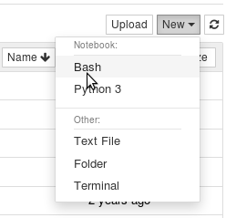

~~$ source deactivate py3k~~