15-10-2026
First project structure

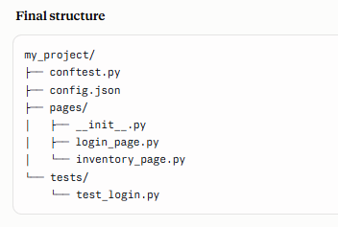

Why this POM structure
- login_page.py: only the login form (username, password, login button, error message)
- inventory_page.py: the page after login (title, logo, menu, logout link) with logout() and expect_loaded().
- test_login.py: a valid login followed by logout, and an invalid login that checks the error message.
- conftest.py: the logged_in_page fixture logs in once at the start and logs out once after the last test, using both page classes.

----Flow -----
- conftest.py is loaded first. Pytest registers its fixtures and imports the page classes. At this point it only registers the fixtures; nothing has run yet.
- config.json is read when the config fixture is first needed, not when conftest.py loads. That happens at the start of the test session, because browser_context_args depends on config. After that it is cached for the whole session.
- Tests are collected, and each test’s fixtures are set up. The set_test_id_attribute fixture runs for every session because it is autouse. Other fixtures run only if a test asks for them.
- Test files run. The tests create page objects and call their methods (login_page.login(...), inventory_page.logout()), and the page classes hold the locators and actions.
- Teardown happens at the end. For logged_in_page, the code after yield runs once, after the last test that used it, and logs out.

