Inflation in the United States and Its Effects on Local People

Name
University
Subject code: Subject name
Professor _____
Due date

Inflation in the United States and Its Effects on Local People
This paper examines how inflation changes household purchasing power and community life in the United States. It emphasizes that national averages can conceal large differences across incomes, ages, locations, consumption baskets, and balance sheets. The discussion synthesizes peer-reviewed research on household-level inflation, cost-of-living inequality, expectations, and redistribution.
The analysis uses a household-welfare perspective rather than treating inflation only as a change in a national index. It asks how price increases alter the real choices available to renters, homeowners, workers, retirees, borrowers, savers, parents, commuters, and small-business customers. Local people are not a single economic category, so the paper distinguishes common pressures from differences created by geography and financial position. The evidence base includes U.S. scanner data, expenditure surveys, metropolitan consumption research, calibrated household models, and studies of expectations and subjective well-being. Together, these sources show why a stable national average can coexist with intense hardship for particular families. They also clarify why the source and composition of inflation matter: an oil shock, a rent increase, and a broad monetary expansion do not pass through household budgets in identical ways.

Understanding Inflation as a Local Household Experience
Inflation is often reported as one national percentage, but local people encounter it through a collection of specific transactions: a grocery basket, a rent renewal, a gasoline purchase, a medical bill, a school expense, or an interest payment. The national Consumer Price Index is indispensable for describing the overall movement of prices, yet an average index does not mean that every household experiences the same rate. Households buy different combinations of goods, live in housing markets with different levels of scarcity, travel different distances, and have unequal access to discounts or financial assets. Consequently, two families with the same nominal income can experience meaningfully different changes in purchasing power. Research using detailed scanner data finds wide dispersion in household inflation, much of it arising from different prices paid for similar goods rather than from broad differences in expenditure categories (Kaplan & Schulhofer-Wohl, 2017).
This distinction matters for understanding the recent U.S. inflation experience. An aggregate decline in inflation means that prices are rising more slowly; it does not generally mean that the price level has returned to its earlier level. A local household may therefore hear that inflation has moderated while still confronting a grocery bill, rent, or insurance premium far above its pre-surge amount. The cumulative loss of purchasing power can remain salient after the monthly inflation news improves. In addition, households pay unusual attention to frequently purchased items. Grocery-price exposure shapes beliefs about overall inflation because consumers repeatedly observe those prices and tend to place more weight on price increases than on decreases (D’Acunto et al., 2021). This helps explain why official statistics and personal perceptions may diverge without either measure being meaningless.

Why the Burden Is Unequal
Inflation changes real living standards through several channels. The first is expenditure composition. Lower-income households generally devote larger shares of their budgets to food, utilities, rent, and transportation. When these necessities rise rapidly, there is less discretionary spending that can be postponed. The second channel is shopping flexibility. Higher-income households often have more storage space, transportation options, internet access, credit, and spare cash with which to buy in bulk, switch stores, or wait for promotions. During the Great Recession, income-specific price indexes diverged partly because higher-income households were better able to substitute toward different products and shopping outlets (Argente & Lee, 2021). The third channel is balance-sheet exposure. Inflation benefits some nominal borrowers by reducing the real value of fixed debts, while it harms holders of cash and fixed nominal claims. Doepke and Schneider (2006) show that unexpected inflation can redistribute wealth substantially across age and wealth groups even when aggregate income changes little.
These channels mean that inflation is not automatically regressive in every circumstance. The source of the shock and the household's position matter. Del Canto et al. (2025) find that inflationary oil shocks are regressive in the United States, whereas monetary expansions can have progressive effects, with asset-accumulation costs playing a central role. Nevertheless, several models calibrated to household transaction patterns conclude that sustained inflation behaves like a regressive consumption tax because wealthier households can reduce cash exposure and avoid some transaction costs (Erosa & Ventura, 2002). Kakar and Daniels (2019) similarly find that higher long-run inflation increases consumption inequality in a heterogeneous-household U.S. model. The practical lesson is not that every price increase harms every person equally, but that households with limited liquidity and little room to substitute are commonly less able to defend their real consumption.
Table 1
Selected Evidence on Unequal Inflation Exposure
Study | Evidence base | Household implication
Kaplan & Schulhofer-Wohl (2017) | U.S. scanner panel | Large dispersion in prices paid; lower-income households experienced higher cumulative inflation.
Argente & Lee (2021) | Income-specific U.S. price indexes | Shopping and product substitution partly explain the inflation gap.
Hobijn & Lagakos (2005) | U.S. household expenditure data | Poor households are more exposed to gasoline; older households to medical costs.
Kakar & Daniels (2019) | Calibrated heterogeneous-household model | Long-run inflation raises consumption inequality and burdens cash-reliant groups.

Food, Energy, and Everyday Purchases
Food prices have an outsized psychological and budgetary role because they are visible, frequent, and unavoidable. A family can delay buying furniture, but it cannot indefinitely delay eating. Grocery inflation also varies within categories. Consumers may respond by choosing store brands, reducing meat purchases, changing package sizes, visiting multiple stores, or using coupons. These strategies take time and may produce nutritional or convenience costs that are not visible in a price index. Cavallo and Kryvtsov (2024) document that post-pandemic inflation was accompanied by 'cheapflation,' in which lower-priced varieties sometimes increased faster than expensive varieties. Discounts mitigated part of the burden, but switching toward cheaper products did not always deliver the expected protection. For a local household already purchasing low-cost products, the adjustment margin may be especially narrow.
Energy costs reach households both directly and indirectly. Gasoline affects commuters, rural residents, and workers with fixed on-site schedules, while electricity and natural gas affect home budgets. Higher fuel prices also raise transportation and distribution costs embedded in retail prices. Hobijn and Lagakos (2005) find that poorer U.S. households are especially sensitive to gasoline-price fluctuations, while older households face distinctive exposure through medical spending. Local geography amplifies these differences. A household in a transit-rich neighborhood can reduce driving more easily than a household in a rural county. Renters may have little authority to improve insulation or replace inefficient appliances. Thus, identical market prices can create unequal welfare effects because the feasible behavioral responses differ.
Figure 1
Cumulative Inflation Differed Across Household Income Groups
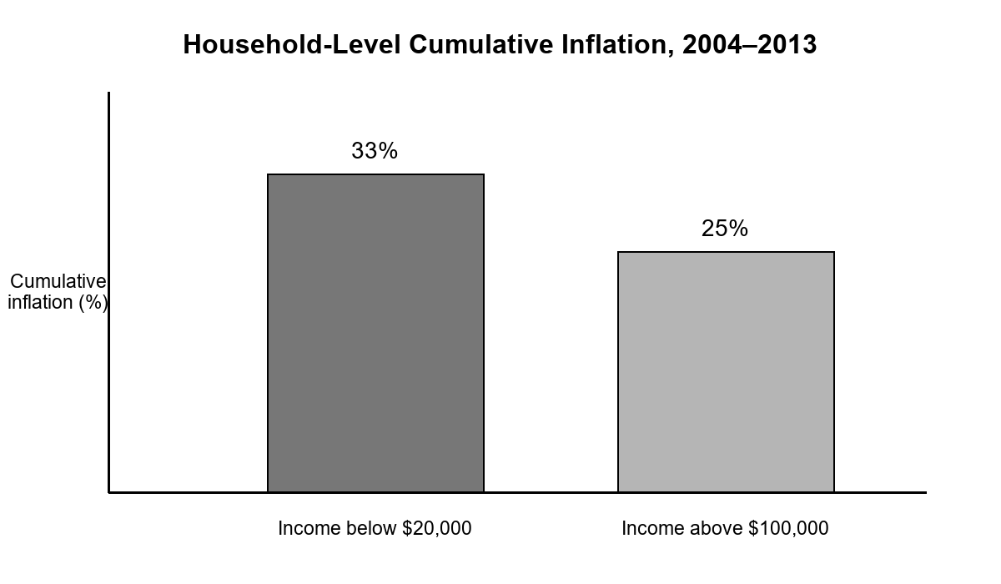
Note. Values summarize the cumulative household-level inflation comparison reported by Kaplan and Schulhofer-Wohl (2017).

Housing, Rent, and Neighborhood Stability
Housing is usually the largest household expense, but housing inflation is experienced differently by renters, recent buyers, and long-term owners. Existing homeowners with fixed-rate mortgages can be partly insulated from immediate shelter-cost increases, although taxes, maintenance, utilities, and insurance may rise. Renters can face large discrete changes when leases renew. Prospective buyers experience another mechanism: monetary tightening intended to control inflation raises mortgage rates, increasing monthly payments even when house-price growth slows. These effects vary sharply by metropolitan area because construction constraints, job growth, migration, and vacancy rates are local. A national shelter index therefore conceals neighborhood-level pressure and timing differences.
Housing costs also interact with community stability. When rent consumes a larger share of income, households may double up, move farther from employment, delay household formation, or reduce spending at local businesses. Moving can disrupt school continuity, child-care arrangements, health care, and informal support networks. These are not simply accounting changes. They affect the time and social resources available to families. Research on consumption across U.S. metropolitan areas shows that local income structure is associated with spending patterns, particularly for shelter and food, reinforcing the point that economic strain is geographically embedded rather than purely national (Charles & Lundy, 2013). Although that study concerns inequality more broadly, its local lens helps explain why inflation can reshape neighborhood consumption even when average national income remains stable.

Wages, Work, and Real Income
Whether inflation lowers living standards depends partly on wage adjustment. A worker whose pay rises as fast as the cost of the household's actual consumption basket may preserve real income. In practice, wage changes are uneven and delayed. Workers with bargaining power, high-demand skills, cost-of-living clauses, or the ability to change employers may obtain faster nominal gains. Hourly workers, retirees on imperfectly indexed income, and employees in locally concentrated labor markets may adjust more slowly. Even when average wage growth appears strong, a household can lose ground if its essential expenses rise faster than its earnings. Inflation inequality therefore compounds nominal income inequality: the same pay raise purchases different real improvements for households facing different price changes.
Measurement choices shape the diagnosis. Jaravel (2019) shows that product innovation and variety can generate unequal gains across income groups in the U.S. retail sector. If higher-income consumers receive more new-product benefits, conventional price measures may understate differences in real consumption growth. This evidence demonstrates that relative price changes and access to new products can alter measured welfare inequality even when analysts focus on a common inflation rate. These findings warn against evaluating local people only through nominal wage statistics. A complete assessment should compare after-tax income with a household-relevant cost of living, recognize changes in product quality and availability, and account for the time costs of searching, commuting, and substituting.

Savings, Debt, and Financial Security
Inflation erodes the purchasing power of cash and fixed nominal assets. This effect is especially relevant for households that keep emergency funds in non-interest-bearing accounts or rely heavily on cash transactions. Wealthier households generally have broader access to inflation-protected securities, equities, real estate, and professional advice. Attanasio et al. (2002) find substantial heterogeneity in household money demand and in the welfare cost of inflation because financial technology changes how people manage currency. Access to accounts, credit cards, automatic transfers, and interest-bearing assets can reduce the need to hold cash. For households outside or at the edge of mainstream finance, inflation can therefore impose a larger transaction burden even before considering differences in the prices they pay.
Debt complicates the picture. Unexpected inflation can reduce the real burden of fixed-rate nominal debt, which may help some mortgage borrowers. However, variable-rate debt, new borrowing, and revolving credit become more expensive when interest rates rise. Local people carrying credit-card balances may face both higher prices and higher finance charges. Young families seeking a mortgage or vehicle loan may be harmed even if existing borrowers benefit. The redistribution described by Doepke and Schneider (2006) consequently operates across generations and balance-sheet positions, not just income groups. A household's vulnerability depends on liquidity, debt structure, asset maturity, and the timing of major purchases.
Table 2
Channels Connecting Inflation to Local Household Welfare
Channel | Immediate effect | Households with greater exposure
Necessities | Food, energy, rent, and transport absorb more income | Lower-income and liquidity-constrained households
Shopping flexibility | Search, bulk buying, and substitution can reduce prices paid | Households without time, transport, storage, or spare cash
Balance sheets | Cash loses value; fixed nominal debts may shrink in real terms | Cash holders, new borrowers, and variable-rate debtors
Local markets | Rent, wages, insurance, and services adjust unevenly | Renters and residents of supply-constrained areas

Expectations, Confidence, and Household Decisions
Households make decisions based not only on current prices but also on expected future inflation. Expectations can affect whether people purchase durable goods now, postpone spending, negotiate wages, or alter savings. Yet expectations are heterogeneous and frequently differ from professional forecasts. Weber et al. (2022) review evidence that personal experience, information sources, demographics, and attention all shape household beliefs. Frequently observed prices are especially influential, which can cause food or gasoline movements to dominate perceptions. This behavior is understandable: households learn from the prices they encounter, but those observations are not a random sample of the national economy.
Inflation also affects well-being through uncertainty and perceived loss of control. Leblang et al. (2025), using large cross-country survey data, report negative associations between inflation and several dimensions of subjective well-being. For U.S. communities, uncertainty can lead households to maintain larger precautionary buffers, avoid long-term commitments, or reduce discretionary purchases. Small businesses then experience weaker or more volatile local demand. The process can become self-reinforcing at the neighborhood level: uncertainty reduces spending, businesses reduce hours or investment, and households become more cautious. This does not imply that household expectations mechanically cause national inflation, but it does show why credible communication and predictable policy matter for local economic confidence.
Figure 2
Inflation Gap Between Low- and High-Income Households Varied Over Time
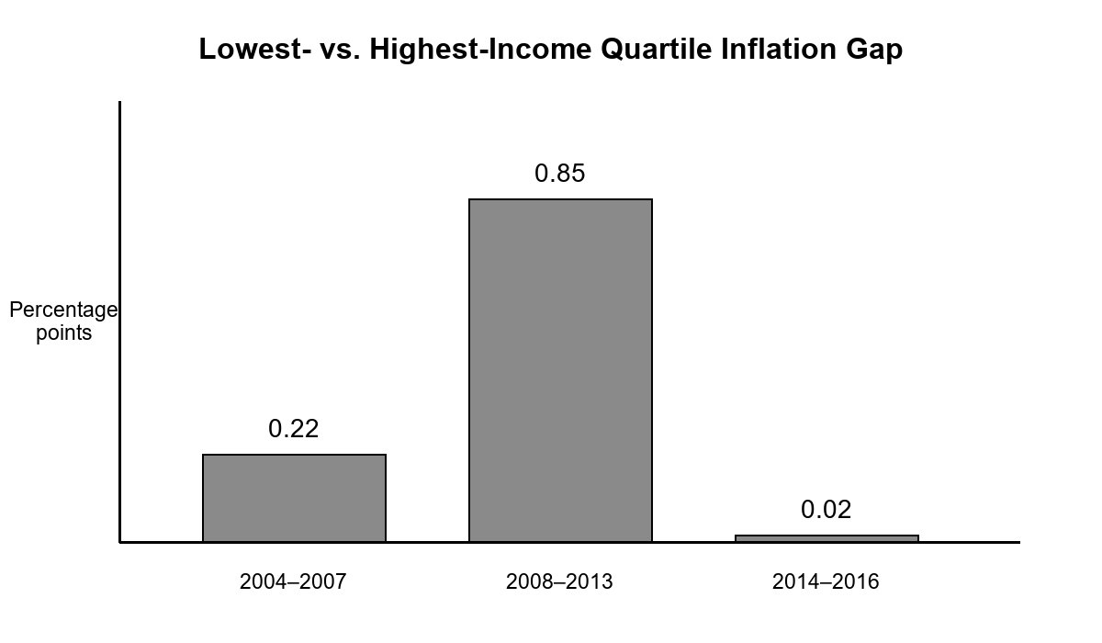
Note. Annual gaps are based on the income-specific price indexes reported by Argente and Lee (2021).

Community Businesses and Public Services
Local businesses face many of the same pressures as households: higher input prices, rent, utilities, transportation expenses, insurance, and borrowing costs. A large firm may hedge commodity prices or negotiate supplier contracts, while a neighborhood restaurant, child-care provider, or repair shop has fewer options. Passing costs to customers risks losing demand; absorbing costs reduces margins and may lead to shorter hours, delayed hiring, or closure. When households simultaneously cut discretionary spending, the strain intensifies. The distributional effects of inflation therefore extend beyond consumer budgets to the local institutions that provide employment and services.
Public services are also exposed. Municipalities may collect more nominal tax revenue, but wages, construction, fuel, school meals, and contracted services become more expensive. Budget rules and tax lags can prevent rapid adjustment. Libraries, transit agencies, schools, and social-service organizations may reduce service quality precisely when residents need support. The welfare framework in Del Canto et al. (2025) is useful here because it emphasizes feasible choices and borrowing constraints rather than only observed consumption. A household may appear to maintain spending by using debt, skipping preventive care, or drawing down savings, while its feasible future choices deteriorate.

Health, Education, and Family Trade-Offs
Inflation can change health behavior even when medical prices are not the fastest-growing component of the household budget. Families facing higher food, rent, utility, and transportation costs may postpone dental care, reduce prescription adherence, cancel counseling, or choose cheaper insurance coverage with higher out-of-pocket risk. Older residents are particularly sensitive because medical care occupies a larger budget share; U.S. evidence on inflation inequality identifies health spending as an important source of higher cost-of-living growth for older households (Hobijn & Lagakos, 2005). The consequences can appear with a delay. A skipped appointment lowers current spending but may produce greater health and financial costs later. Inflation therefore affects well-being through constrained choices and uncertainty, not only through the direct price of a particular service. This broader pathway is consistent with evidence linking inflation to lower subjective well-being after accounting for household and national characteristics (Leblang et al., 2025).
Education and caregiving decisions are similarly exposed. Higher rent or food bills can reduce funds for books, internet service, extracurricular activities, tutoring, or college saving. Parents may work additional hours, increasing child-care needs and reducing time available for homework supervision. College students may take more paid work, borrow more, commute farther, or delay enrollment. Families caring for older relatives confront parallel choices involving transportation, home assistance, and unpaid time. These responses are rarely captured by a single consumer-price statistic, yet they influence long-run mobility and community participation. The effects also accumulate geographically. When many households reduce enrichment spending or delay education, local providers lose revenue, while public schools and nonprofit organizations face higher operating costs. A local analysis of inflation should therefore track not only current consumption but also the investments in health, education, and care that households sacrifice to preserve immediate necessities.

Policy Implications for Local People
A distribution-sensitive policy response begins with measurement. National inflation should be supplemented by income-specific, age-specific, and regional indicators, while analysts should remain cautious about assuming that demographic averages capture individual variation. Kaplan and Schulhofer-Wohl (2017) find that observable household characteristics explain only part of household inflation dispersion. Better local data can identify where food, shelter, transportation, or health costs are driving hardship. It can also improve the design of benefit adjustments and emergency assistance. Indexing transfers to a broad average may leave some groups exposed when their essential basket rises faster.
Targeted fiscal measures can reduce hardship without treating every household as equally affected. Options include nutrition assistance, energy support, rental assistance, transit access, refundable tax credits, and benefits that adjust promptly to prices. Design matters because broad subsidies can increase demand or disproportionately benefit higher users. Monetary policy remains necessary for maintaining price stability, but its interest-rate channel creates its own distributional effects. Policymakers should therefore evaluate the combined incidence of inflation, wage changes, taxes, transfers, and borrowing costs rather than viewing each instrument in isolation. The evidence that oil shocks can be regressive while monetary expansions can be progressive illustrates why the source of inflation and the policy response must be analyzed together (Del Canto et al., 2025).

Conclusion
Inflation in the United States is a national macroeconomic process with intensely local consequences. The burden depends on what households buy, the prices available in their neighborhoods, their capacity to search and substitute, the timing of wage adjustments, and their balance sheets. Peer-reviewed evidence consistently shows meaningful heterogeneity. Lower-income households often face higher effective inflation or fewer defenses against it, but age, location, debt, assets, and the source of the shock can change who gains and who loses. The most visible effects appear in necessities, housing stability, transportation, and financial security.
For local people, the central issue is cumulative purchasing power and the narrowing of feasible choices. Slower inflation does not erase an elevated price level, and an average wage increase does not guarantee that every household is recovering. Effective analysis should connect aggregate indicators to household budgets and neighborhood conditions. Effective policy should combine durable price stability with timely, targeted protection for households that lack liquidity or substitution options. That approach recognizes inflation not merely as a statistic but as a lived change in the ability of families to maintain food, shelter, mobility, savings, and participation in community life.
References
Argente, D., & Lee, M. (2021). Cost of living inequality during the Great Recession. Journal of the European Economic Association, 19(2), 913–952. https://doi.org/10.1093/jeea/jvaa018
Attanasio, O. P., Guiso, L., & Jappelli, T. (2002). The demand for money, financial innovation, and the welfare cost of inflation: An analysis with household data. Journal of Political Economy, 110(2), 317–351. https://doi.org/10.1086/338743
Cavallo, A., & Kryvtsov, O. (2024). Price discounts and cheapflation during the post-pandemic inflation surge. Journal of Monetary Economics, 148, 103644. https://doi.org/10.1016/j.jmoneco.2024.103644
Charles, M., & Lundy, J. D. (2013). The local Joneses: Household consumption and income inequality in large metropolitan areas. Research in Social Stratification and Mobility, 34, 14–29. https://doi.org/10.1016/j.rssm.2013.08.001
D’Acunto, F., Malmendier, U., Ospina, J., & Weber, M. (2021). Exposure to grocery prices and inflation expectations. Journal of Political Economy, 129(5), 1615–1639. https://doi.org/10.1086/713192
Del Canto, F., Grigsby, J., Qian, E., & Walsh, C. (2025). Are inflationary shocks regressive? A feasible set approach. The Quarterly Journal of Economics, 140(4), 2685–2747. https://doi.org/10.1093/qje/qjaf028
Doepke, M., & Schneider, M. (2006). Inflation and the redistribution of nominal wealth. Journal of Political Economy, 114(6), 1069–1097. https://doi.org/10.1086/508379
Erosa, A., & Ventura, G. (2002). On inflation as a regressive consumption tax. Journal of Monetary Economics, 49(4), 761–795. https://doi.org/10.1016/S0304-3932(02)00115-0
Hobijn, B., & Lagakos, D. (2005). Inflation inequality in the United States. Review of Income and Wealth, 51(4), 581–606. https://doi.org/10.1111/j.1475-4991.2005.00170.x
Jaravel, X. (2019). The unequal gains from product innovations: Evidence from the U.S. retail sector. The Quarterly Journal of Economics, 134(2), 715–783. https://doi.org/10.1093/qje/qjy031
Kakar, V., & Daniels, G. E. (2019). Role of cash and costs of inflation for different income groups in the U.S. Economic Modelling, 80, 303–319. https://doi.org/10.1016/j.econmod.2018.11.016
Kaplan, G., & Schulhofer-Wohl, S. (2017). Inflation at the household level. Journal of Monetary Economics, 91, 19–38. https://doi.org/10.1016/j.jmoneco.2017.08.002
Leblang, D., Smith, M. D., & Wesselbaum, D. (2025). Does inflation affect well-being? Empirical Economics, 69(3), 1527–1549. https://doi.org/10.1007/s00181-025-02761-w
Weber, M., D’Acunto, F., Gorodnichenko, Y., & Coibion, O. (2022). The subjective inflation expectations of households and firms: Measurement, determinants, and implications. Journal of Economic Perspectives, 36(3), 157–184. https://doi.org/10.1257/jep.36.3.157

