Original Blue Heading
This paragraph must remain in Calibri 14 with blue text.
Metric | Value
Preserved table | 42
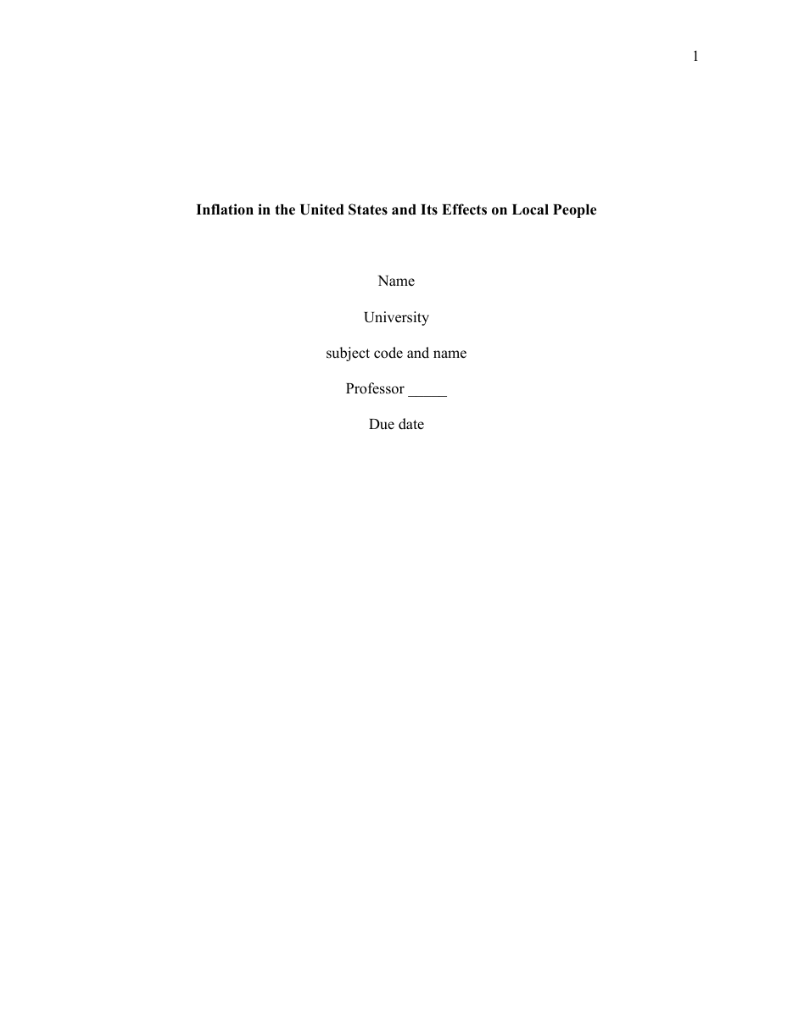
References
Removed Author. (2024). This must not appear.

