Common form components — approval pack
Co-operative Corporations Act filing prototypes
Date: 6 November 2026 Status: Draft for review
This pack shows the shared UI building blocks used across the filing prototypes. Review each screenshot and the annotation table, then mark Approve, Revise, or Defer. Comments in the Decision column will guide the next prototype iteration.
How to complete this pack
Red numbered badges on each screenshot match the Annotation table underneath. For every row, tick one Decision (Approve / Revise / Defer) and add comments if you want a change. Complete the sign-off table at the end.
Prototypes covered
- Form 1 — Articles of Incorporation (with share capital)
- Form 2 — Articles of Incorporation (without share capital)
- Form 3 — Application for Supplementary Letters Patent
- Form 7 — Articles of Amendment
- Form 10 — Articles of Amalgamation
- Form 11 — Application for Letters Patent of Amalgamation
- Form 14 — Articles of Continuance (with share capital)
- Form 15 — Articles of Continuance (without share capital)

1. Inventory and decisions
Use this table as the master sign-off. Screenshot IDs are in section 2.
ID | Component | Used on | Decision | Comments
C01 | Before you begin | 1, 2, 3, 7, 10, 11 (Forms 14 and 15 use an instructions page instead) | ☐ Approve ☐ Revise ☐ Defer
C02 | Cover letter — contact information | 1, 2, 3, 7, 10, 11, 14 (standalone Cover letter prototype; Form 15 has no cover letter yet) | ☐ Approve ☐ Revise ☐ Defer
C03 | Co-operative details — type, primary activity, official email | All eight filing forms for primary activity and official email. Co-operative type/sub-type on Forms 1, 2, 7, 10, 14, 15. | ☐ Approve ☐ Revise ☐ Defer
C04 | Co-operative name and Nuans report | Always on Forms 1, 2, 14, 15. Conditional (name change) on Forms 3, 7, 10, 11. | ☐ Approve ☐ Revise ☐ Defer
C05 | Head office address | 1, 2, 11, 14, 15 | ☐ Approve ☐ Revise ☐ Defer
C06 | First directors — count, rules, and list | 1, 2, 11, 14, 15 | ☐ Approve ☐ Revise ☐ Defer
C07 | Add director — person details | 1, 2, 11, 14, 15 (field set varies slightly by form) | ☐ Approve ☐ Revise ☐ Defer
C08 | Incorporators — list | 1 and 2 only | ☐ Approve ☐ Revise ☐ Defer
C09 | Add incorporator — individual or corporation | 1 and 2 only (Form 1 also collects shares taken) | ☐ Approve ☐ Revise ☐ Defer
C10 | Membership and special provisions | 1, 2, 14, 15 | ☐ Approve ☐ Revise ☐ Defer
C12 | Submit — signed PDF and authorization | 1, 2, 3, 7, 10, 11 (not yet on 14 or 15) | ☐ Approve ☐ Revise ☐ Defer
C13 | Registry details callout (existing entity) | 3, 7, 10, 11 (filings against an existing corporation / co-operative) | ☐ Approve ☐ Revise ☐ Defer
C14 | Amalgamating co-operatives / corporations — list | 10 (Form 11 list and add actions are C17–C19) | ☐ Approve ☐ Revise ☐ Defer
C16 | Add amalgamating co-operative | 10 (Form 11 add actions are C18 and C19) | ☐ Approve ☐ Revise ☐ Defer
C17 | Amalgamating corporations — list | 11 only | ☐ Approve ☐ Revise ☐ Defer
C18 | Add my Corporation | 11 only | ☐ Approve ☐ Revise ☐ Defer
C19 | Add Another Corporation | 11 only | ☐ Approve ☐ Revise ☐ Defer
C15 | Supporting documents | 3, 7, 10, 11 (plus director consent PDFs on Forms 1, 2, 11) | ☐ Approve ☐ Revise ☐ Defer

2. Screenshots and annotation tables
Each page is a representative example from the prototype. The same pattern is reused on the forms listed in Used on.
C01 Before you begin
Source: Form 1 — Before you begin Used on: 1, 2, 3, 7, 10, 11 (Forms 14 and 15 use an instructions page instead)
Landing page before the numbered steps: form name, estimated time, what you will do, documents to gather, payment, instructions, and contact.
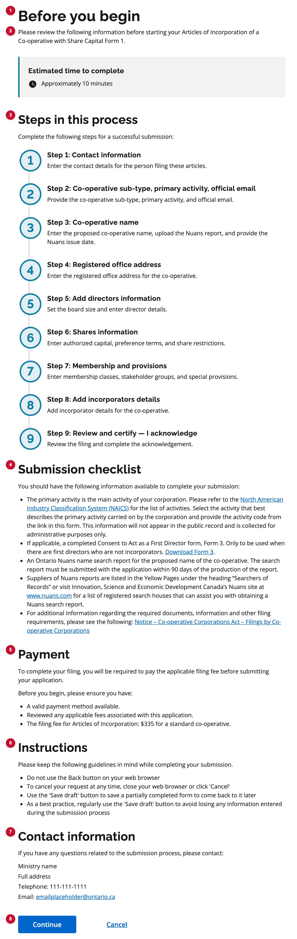
Figure C01. Before you begin — numbered badges match the table below.
# | UI element | What it is | Decision | Comments
1 | Page title | Before you begin. | ☐ Approve  ☐ Revise  ☐ Defer
2 | Lead text | Tells the filer to review the information for this filing before starting. | ☐ Approve  ☐ Revise  ☐ Defer
3 | Steps in this process | Numbered outline of the filing steps. | ☐ Approve  ☐ Revise  ☐ Defer
4 | Submission checklist | Documents and information the filer should gather before starting. | ☐ Approve  ☐ Revise  ☐ Defer
5 | Payment | Filing fee reminder and payment checklist. Copy differs by form; layout is the same. | ☐ Approve  ☐ Revise  ☐ Defer
6 | Instructions | Navigation and save-draft guidance while completing the filing. | ☐ Approve  ☐ Revise  ☐ Defer
7 | Contact information | Ministry contact for questions about the submission process. | ☐ Approve  ☐ Revise  ☐ Defer
8 | Continue | Primary action into Step 1 (cover letter). | ☐ Approve  ☐ Revise  ☐ Defer

C01 Content worksheet — Before you begin
Use this worksheet to write approved copy for each annotation, for Forms 1–11. Yellow cells are for you to fill in. Shared copy is written once. Form-specific copy has one table per annotation (one row per form). Forms 4, 5, 6, 8, and 9 are not in the prototype yet — add copy if those filings will use this page. Forms 14 and 15 use an instructions landing instead; they are at the end.
Shared copy (same on every Before you begin)
If a form must differ, note the exception in Comments. Otherwise this copy applies to Forms 1–11.
# | Annotation | Current copy | Approved copy
1 | Page title | Before you begin
— | Estimated time heading | Estimated time to complete
6 | Instructions heading | Instructions
6 | Instructions intro | Please keep the following guidelines in mind while completing your submission.
6 | Instruction bullets | • Do not use the Back button on your web browser  • To cancel your request at any time, close your web browser or click ‘Cancel’  • Use the ‘Save draft’ button to save a partially completed form to come back to it later  • As a best practice, regularly use the ‘Save draft’ button to avoid losing any information entered during the submission process
7 | Contact heading | Contact information
7 | Contact intro | If you have any questions related to the submission process, please contact:
7 | Ministry / address / phone / email | Ministry name  Full address  Telephone: 111-111-1111  Email: emailplaceholder@ontario.ca
8 | Buttons | Continue  Cancel
3 | Steps heading + intro | Steps in this process  Complete the following steps for a successful submission:
4 | Checklist heading + intro | Submission checklist  You should have the following information available to complete your submission:
5 | Payment heading + lead | Payment  To complete your filing, you will be required to pay the applicable filing fee before submitting your application.  Before you begin, please ensure you have:

#2 Lead text — by form
Pattern today: “Please review the following information before starting your {filing name}.”
Form | Current lead | Approved lead
Form 1 Articles of Incorporation (with share capital) | Please review the following information before starting your Articles of Incorporation of a Co-operative with Share Capital Form 1.
Form 2 Articles of Incorporation (without share capital) | Please review the following information before starting your Articles of Incorporation of a Co-operative without Share Capital Form 2.
Form 3 Application for Supplementary Letters Patent | Please review the following information before starting your Application for Supplementary Letters Patent Form 3.
Form 4 | Not in prototype
Form 5 | Not in prototype
Form 6 | Not in prototype
Form 7 Articles of Amendment | Please review the following information before starting your Articles of Amendment Form 7.
Form 8 | Not in prototype
Form 9 | Not in prototype
Form 10 Articles of Amalgamation | Please review the following information before starting your Articles of Amalgamation Form 10.
Form 11 Application for Letters Patent of Amalgamation | Please review the following information before starting your Application for Letters Patent of Amalgamation Form 11.

Estimated time — by form
Shown in the callout under the lead. Not a separate badge; include it here because the time may differ by form.
Form | Current time | Approved time
Form 1 Articles of Incorporation (with share capital) | Approximately 10 minutes
Form 2 Articles of Incorporation (without share capital) | Approximately 10 minutes
Form 3 Application for Supplementary Letters Patent | Approximately 10 minutes
Form 4 | Not in prototype
Form 5 | Not in prototype
Form 6 | Not in prototype
Form 7 Articles of Amendment | Approximately 10 minutes
Form 8 | Not in prototype
Form 9 | Not in prototype
Form 10 Articles of Amalgamation | Approximately 10 minutes
Form 11 Application for Letters Patent of Amalgamation | Approximately 10 minutes

#3 Steps in this process — by form
Write the step titles (and descriptions if they should change). Heading and intro are in Shared copy.
Form | Current steps | Approved steps
Form 1 Articles of Incorporation (with share capital) | 1 Contact information  2 Co-operative sub-type, primary activity, official email  3 Co-operative name  4 Registered office address  5 Add directors information  6 Shares information  7 Membership and provisions  8 Add incorporators details  9 Review and certify — I acknowledge
Form 2 Articles of Incorporation (without share capital) | 1 Contact information  2 Co-operative sub-type, primary activity, official email  3 Co-operative name  4 Registered office address  5 Add directors information  6 Member loans and restrictions  7 Membership and provisions  8 Add incorporators details  9 Review and certify — I acknowledge
Form 3 Application for Supplementary Letters Patent | 1 Contact information  2 Corporation details  3 Corporation name  4 Supplementary letters patent  5 Review and certify
Form 4 | Not in prototype
Form 5 | Not in prototype
Form 6 | Not in prototype
Form 7 Articles of Amendment | 1 Contact information  2 Business details  3 Amendment details  4 Supporting documents  5 Review and certify
Form 8 | Not in prototype
Form 9 | Not in prototype
Form 10 Articles of Amalgamation | 1 Contact information  2 Business details  3 Amalgamation details  4 Co-operative name  5 Supporting documents  6 Review and certify
Form 11 Application for Letters Patent of Amalgamation | 1 Contact information  2 Corporation details  3 Amalgamating corporations  4 Amalgamated corporation name  5 Head office address  6 Directors  7 Supporting documents  8 Review and certify

#4 Submission checklist — by form
Heading and intro are in Shared copy. Write the checklist items for each form.
Form | Current checklist (summary) | Approved checklist items
Form 1 Articles of Incorporation (with share capital) | Intro: You should have the following information available…  Includes NAICS, director consent Form 3, Nuans (90 days), Nuans suppliers, Notice — Filings by Co-operative Corporations.
Form 2 Articles of Incorporation (without share capital) | Same pattern as Form 1. Fee and non-profit notes sit in Payment, not here.
Form 3 Application for Supplementary Letters Patent | OCN, resolution date, requested provisions, Nuans if name change (90 days; separate EN/FR if used separately), similar-name consent, insolvency statement if new name, certified resolution.
Form 4 | Not in prototype
Form 5 | Not in prototype
Form 6 | Not in prototype
Form 7 Articles of Amendment | Includes Nuans if name change, Affidavit of Solvency (Amendment) when required, certified resolution, authorizing subsections.
Form 8 | Not in prototype
Form 9 | Not in prototype
Form 10 Articles of Amalgamation | Certified amalgamation agreement (effective within 6 months), Affidavit of Solvency (Amalgamation) per co-operative, Nuans if new name, NAICS, Notice — CCA filings.
Form 11 Application for Letters Patent of Amalgamation | Legal name and OCN of each amalgamating corporation, approval dates, certified amalgamation agreement (s. 113(3)), Nuans if new name, NAICS, head office, first directors.

#5 Payment — by form
Heading, lead, and “Before you begin, please ensure you have:” are in Shared copy unless a form needs different lead text (Form 7 currently adds a sentence about the fee depending on amendment type).
Form | Current payment copy | Approved payment copy
Form 1 Articles of Incorporation (with share capital) | Lead: pay the applicable filing fee before submitting.  Checklist intro: Before you begin, please ensure you have:  • A valid payment method available.  • Reviewed any applicable fees…  • Articles of Incorporation: $335 for a standard co-operative.
Form 2 Articles of Incorporation (without share capital) | Same lead and intro as Form 1.  • $335 for a co-operative without share capital.  • $155 for a non-profit co-operative without share capital.
Form 3 Application for Supplementary Letters Patent | No Payment section in the current prototype.
Form 4 | Not in prototype
Form 5 | Not in prototype
Form 6 | Not in prototype
Form 7 Articles of Amendment | Lead adds: The fee depends on the type of amendment.  • Name change or other amendment: $100  • Convert to a business corporation: $200  • Convert to a not-for-profit corporation: $100
Form 8 | Not in prototype
Form 9 | Not in prototype
Form 10 Articles of Amalgamation | No Payment section in the current prototype.
Form 11 Application for Letters Patent of Amalgamation | No Payment section in the current prototype.

Forms 14 and 15 — instructions landing (not Before you begin)
These two filings do not use the Before you begin template. Fill in the instructions-page copy here if they should stay on a different landing.
Form | Current copy | Approved copy
Form 14 Articles of Continuance as a Co-operative with Share Capital | Title: Articles of Continuance as a Co-operative with Share Capital  Act line: Co-operative Corporations Act — Form 14  Body: Instructions for this filing will be added as later stories are provided. Continue to Step 1 to enter contact information.  Buttons: Continue / Cancel
Form 15 Articles of Continuance as a Co-operative without Share Capital | Title: Articles of Continuance as a Co-operative without Share Capital  Act line: Co-operative Corporations Act — Form 15  Body: Instructions for this filing will be added as later stories are provided. Continue to Step 2 to enter the co-operative’s type, primary activity, and official email.  Buttons: Continue / Cancel

C02 Cover letter — contact information
Source: Form 1 — Step 1 Used on: 1, 2, 3, 7, 10, 11, 14 (standalone Cover letter prototype; Form 15 has no cover letter yet)
Filer contact details, pre-filled from the signed-in account. Used if the ministry needs to reach the person filing. Not on the public record.
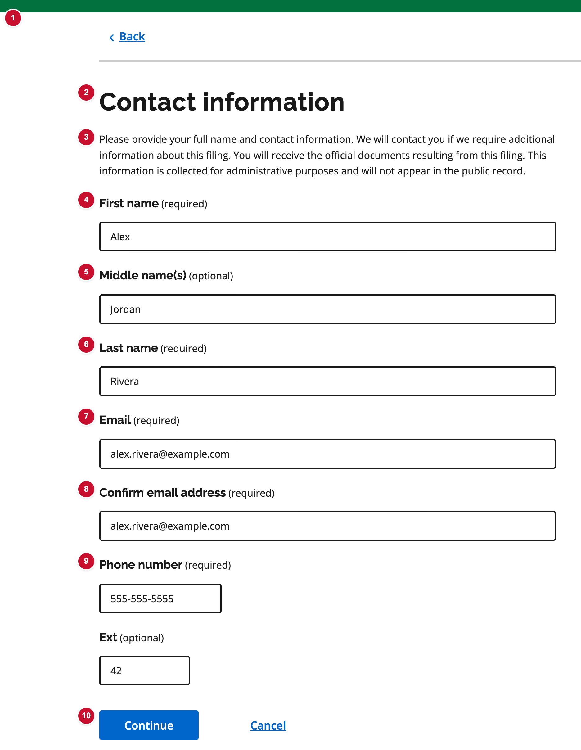
Figure C02. Cover letter — contact information — numbered badges match the table below.
# | UI element | What it is | Decision | Comments
1 | Step indicator and Back | Shows current step and returns to Before you begin. | ☐ Approve  ☐ Revise  ☐ Defer
2 | Page title | Contact information. Same heading on every cover letter. | ☐ Approve  ☐ Revise  ☐ Defer
3 | Lead text | Explains why contact is collected, that official documents are sent here, and that it is not on the public record. | ☐ Approve  ☐ Revise  ☐ Defer
4 | First name | Required. Pre-filled from the signed-in profile. | ☐ Approve  ☐ Revise  ☐ Defer
5 | Middle name(s) | Optional. | ☐ Approve  ☐ Revise  ☐ Defer
6 | Last name | Required. Pre-filled from the signed-in profile. | ☐ Approve  ☐ Revise  ☐ Defer
7 | Email | Required contact email for this filing. | ☐ Approve  ☐ Revise  ☐ Defer
8 | Confirm email address | Must match Email. | ☐ Approve  ☐ Revise  ☐ Defer
9 | Telephone number | Required, with optional extension. | ☐ Approve  ☐ Revise  ☐ Defer
10 | Continue / Cancel | Cover letter has Continue and Cancel only — no Save as draft. | ☐ Approve  ☐ Revise  ☐ Defer

C03 Co-operative details — type, primary activity, official email
Source: Form 1 — Step 2 Used on: All eight filing forms for primary activity and official email. Co-operative type/sub-type on Forms 1, 2, 7, 10, 14, 15.
Administrative details collected on every filing: NAICS primary activity, official email (entered twice), and (on most forms) co-operative type.
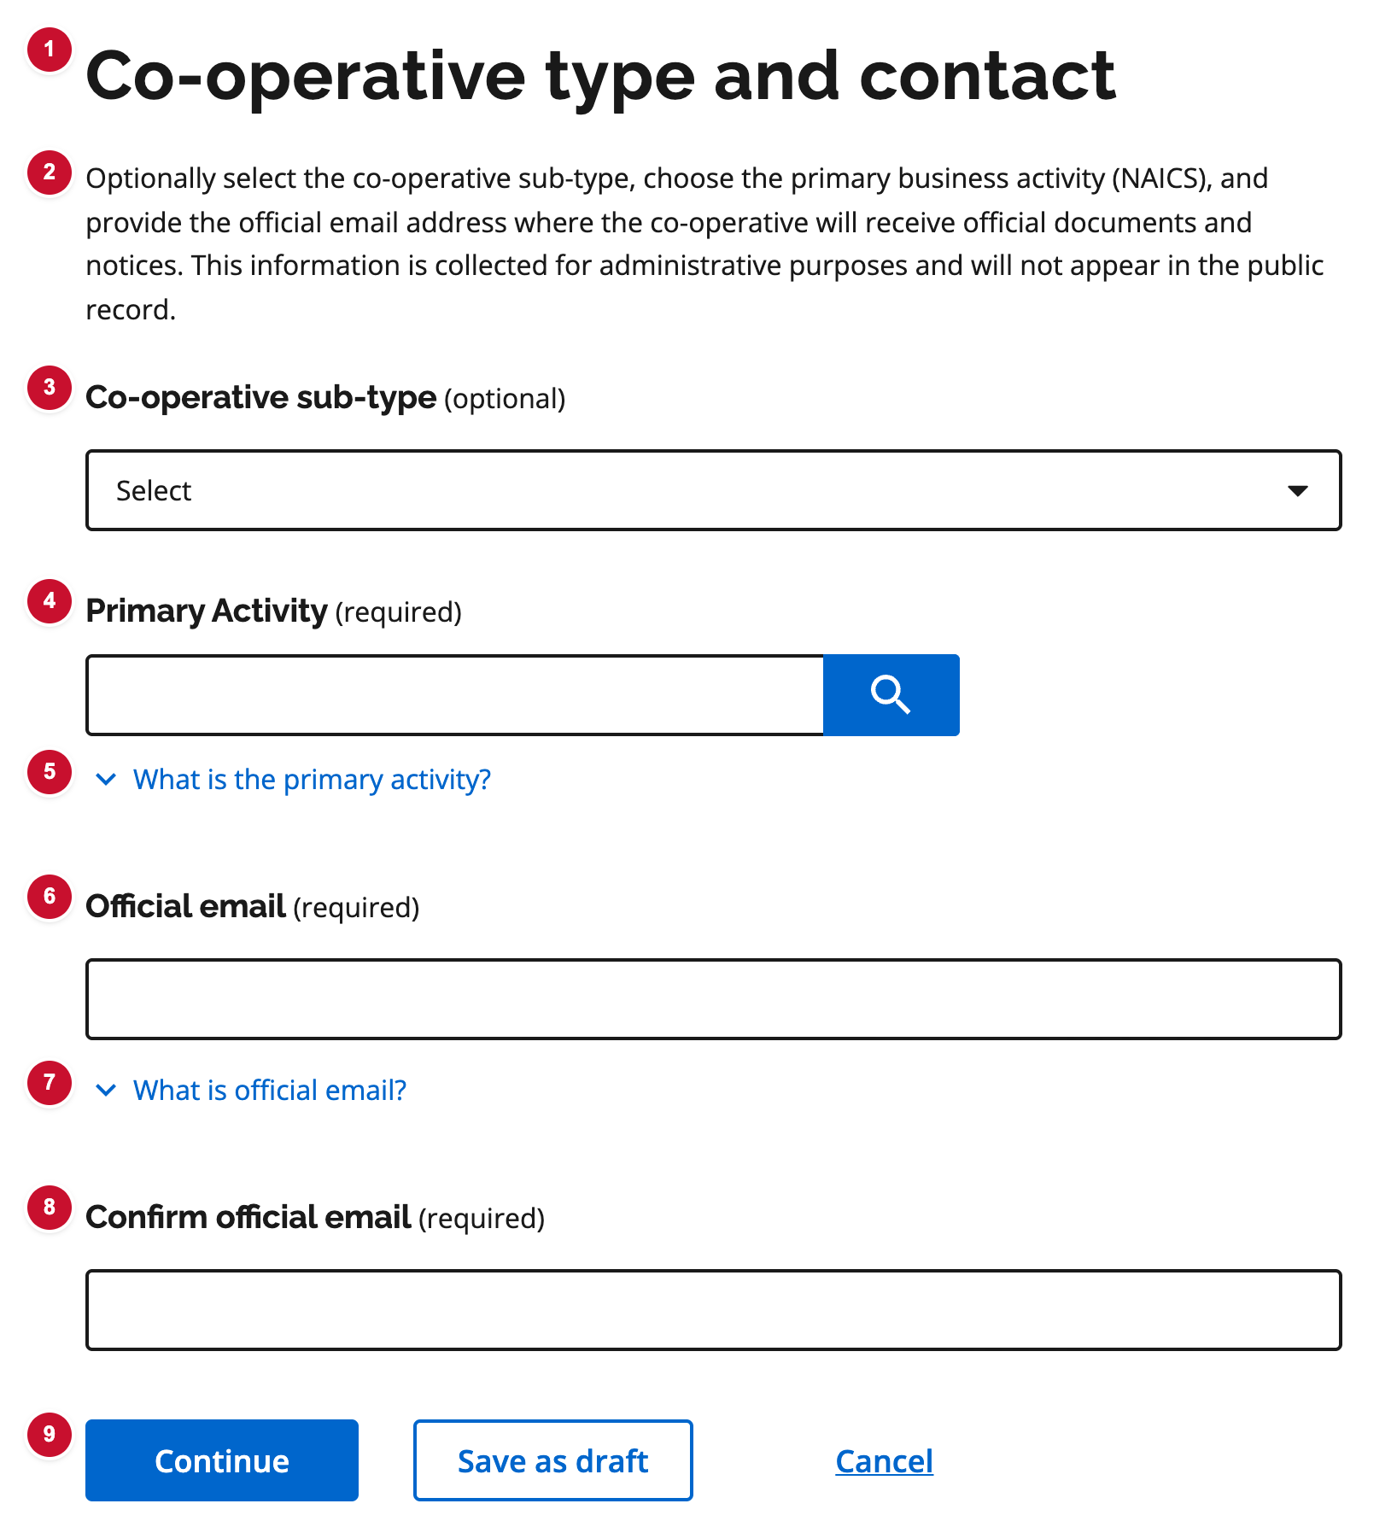
Figure C03. Co-operative details — type, primary activity, official email — numbered badges match the table below.
# | UI element | What it is | Decision | Comments
1 | Page title | Co-operative type and contact (wording differs by form). | ☐ Approve  ☐ Revise  ☐ Defer
2 | Lead text | Explains sub-type, NAICS, and official email. Not on the public record. | ☐ Approve  ☐ Revise  ☐ Defer
3 | Co-operative sub-type | Optional on Form 1/2; required as Type of co-operative on Forms 7, 10, 14, 15. | ☐ Approve  ☐ Revise  ☐ Defer
4 | Primary activity (NAICS) | Required. Search and select a NAICS Canada activity. | ☐ Approve  ☐ Revise  ☐ Defer
5 | Primary activity hint | Expander with NAICS Canada guidance and link. | ☐ Approve  ☐ Revise  ☐ Defer
6 | Official email | Required. Where the co-operative receives official documents. Not on the public record. | ☐ Approve  ☐ Revise  ☐ Defer
7 | Official email hint | Explains why official email is collected. | ☐ Approve  ☐ Revise  ☐ Defer
8 | Confirm official email | Must match Official email. | ☐ Approve  ☐ Revise  ☐ Defer
9 | Continue / Save as draft / Cancel | Same three actions on every step. | ☐ Approve  ☐ Revise  ☐ Defer

C04 Co-operative name and Nuans report
Source: Form 1 — Step 3 Used on: Always on Forms 1, 2, 14, 15. Conditional (name change) on Forms 3, 7, 10, 11.
Proposed or current name plus one or more Ontario Nuans reports (PDF and report date). Filers can add another report.
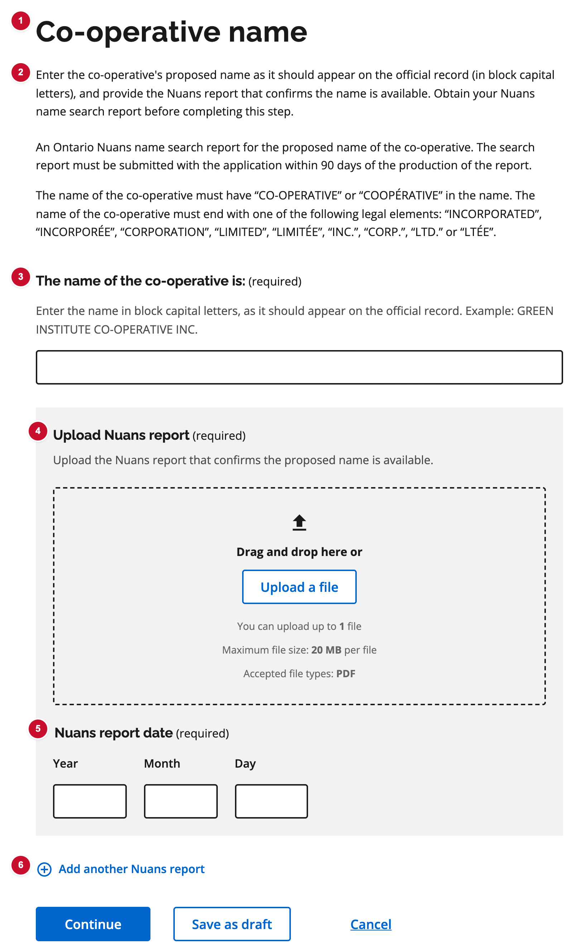
Figure C04. Co-operative name and Nuans report — numbered badges match the table below.
# | UI element | What it is | Decision | Comments
1 | Page title | Co-operative name (or keep vs change name on later forms). | ☐ Approve  ☐ Revise  ☐ Defer
2 | Lead text | Asks for the proposed name in block capitals and the Nuans report that confirms it is available. | ☐ Approve  ☐ Revise  ☐ Defer
3 | Name of the co-operative | Required proposed or current legal name. | ☐ Approve  ☐ Revise  ☐ Defer
4 | Nuans report upload | PDF of the Nuans report for this name. | ☐ Approve  ☐ Revise  ☐ Defer
5 | Nuans report date | Report must be dated within 90 days of submission. | ☐ Approve  ☐ Revise  ☐ Defer
6 | Add another Nuans report | Adds another PDF and date pair (up to the form maximum). | ☐ Approve  ☐ Revise  ☐ Defer

C05 Head office address
Source: Form 1 — Step 4 Used on: 1, 2, 11, 14, 15
Ontario head office: postal-code / street lookup, then municipality, street, city, province, and postal code. Manual entry if lookup does not find the address.
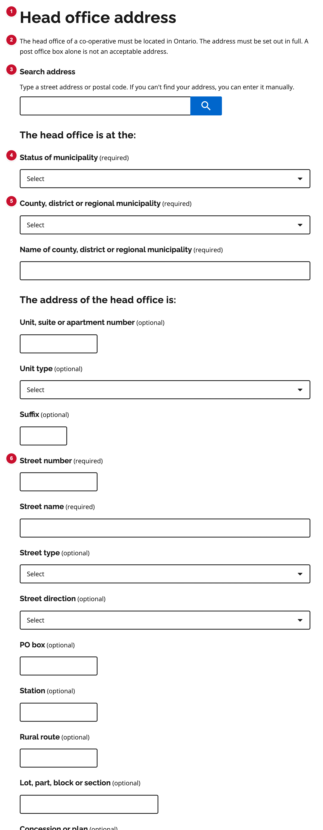
Figure C05. Head office address — numbered badges match the table below.
# | UI element | What it is | Decision | Comments
1 | Page title | Head office address. | ☐ Approve  ☐ Revise  ☐ Defer
2 | Lead text | Head office must be in Ontario and set out in full. A post office box alone is not enough. | ☐ Approve  ☐ Revise  ☐ Defer
3 | Search address | Type a street address or postal code. Ontario-only lookup. | ☐ Approve  ☐ Revise  ☐ Defer
4 | Status of municipality | City, town, township, and similar. | ☐ Approve  ☐ Revise  ☐ Defer
5 | County, district or regional municipality | Upper-tier geography for the head office. | ☐ Approve  ☐ Revise  ☐ Defer
6 | Street number and name | Civic address fields after lookup or manual entry. | ☐ Approve  ☐ Revise  ☐ Defer
7 | Province or territory | Ontario head office; province is selected from a list. | ☐ Approve  ☐ Revise  ☐ Defer
8 | Postal code | Canadian postal code, formatted on blur. | ☐ Approve  ☐ Revise  ☐ Defer

C06 First directors — count, rules, and list
Source: Form 1 — Step 5 Used on: 1, 2, 11, 14, 15
Board size (fixed or min/max), multi-stakeholder rules where they apply, and a summary list of first directors with Add / Edit / Remove.
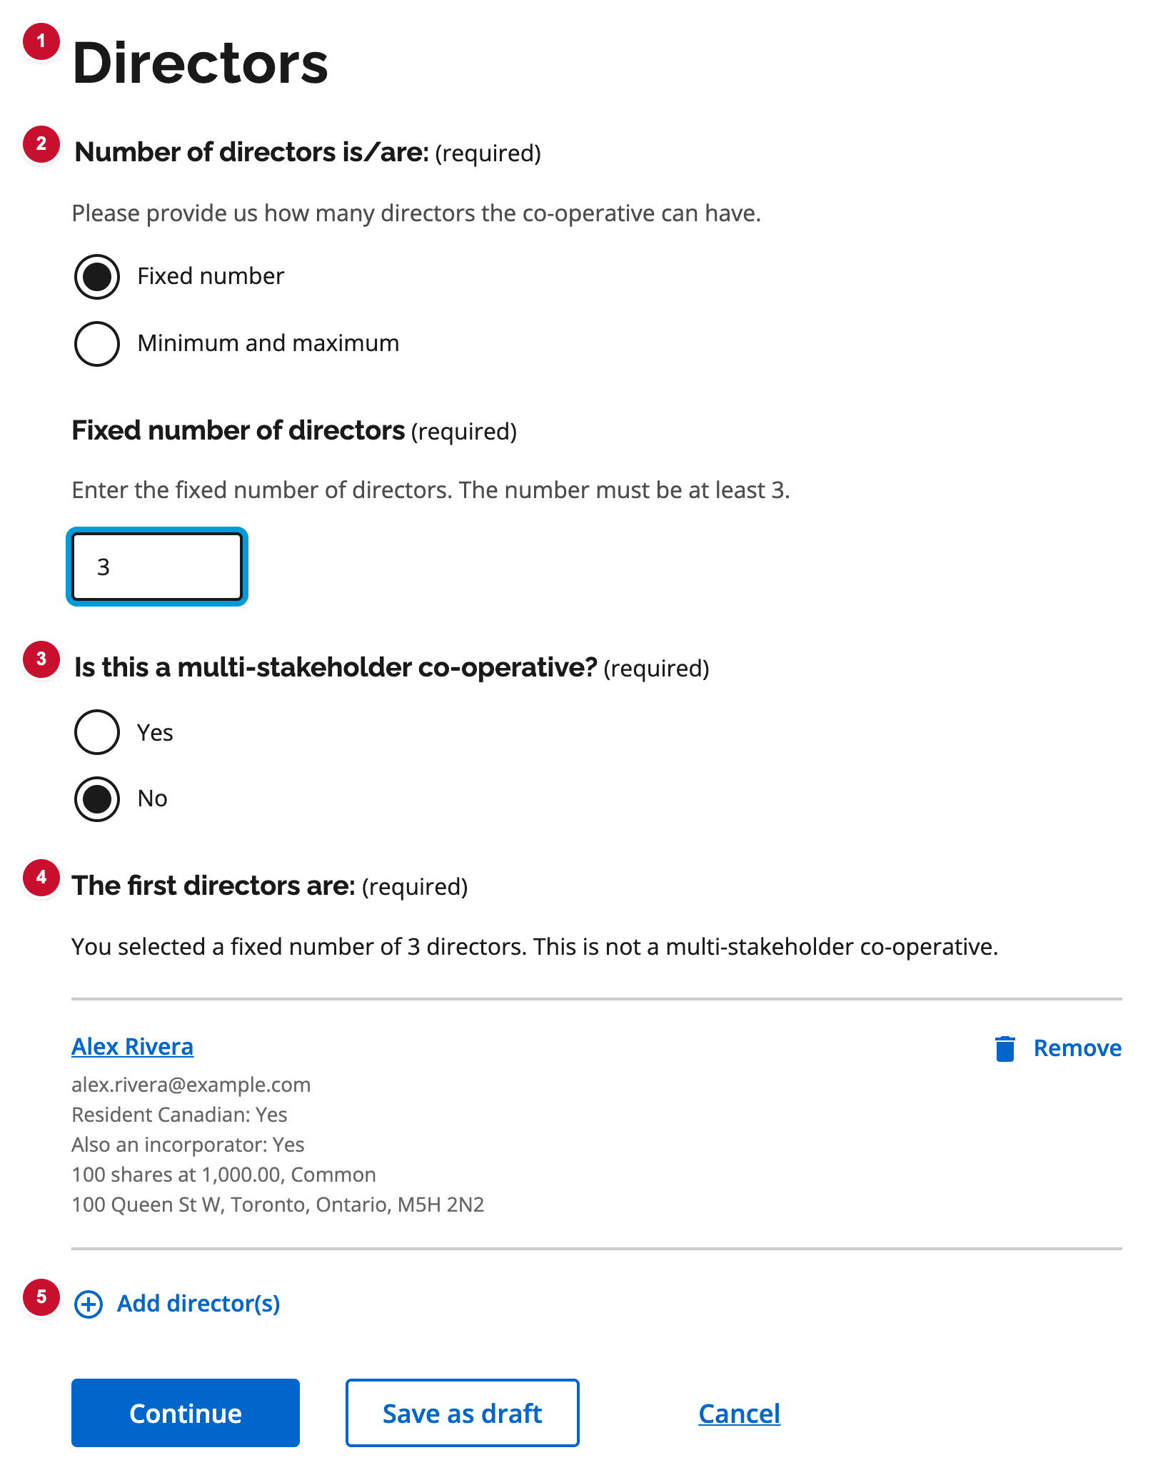
Figure C06. First directors — count, rules, and list — numbered badges match the table below.
# | UI element | What it is | Decision | Comments
1 | Page title | Directors. | ☐ Approve  ☐ Revise  ☐ Defer
2 | Number of directors | Fixed number, or minimum and maximum. | ☐ Approve  ☐ Revise  ☐ Defer
3 | Multi-stakeholder co-operative | Yes/no. If yes, stakeholder director counts are required (Forms 1, 2, 14, 15). | ☐ Approve  ☐ Revise  ☐ Defer
4 | First directors list | Summary cards with name, details, and Remove. | ☐ Approve  ☐ Revise  ☐ Defer
5 | Add director(s) | Opens the add-director subflow. | ☐ Approve  ☐ Revise  ☐ Defer

C07 Add director — person details
Source: Form 1 — Step 5 / add director Used on: 1, 2, 11, 14, 15 (field set varies slightly by form)
Subflow to add or edit one director: legal name, email, residency, address for service, written consent, and on Forms 1 and 2 whether they are also an incorporator.
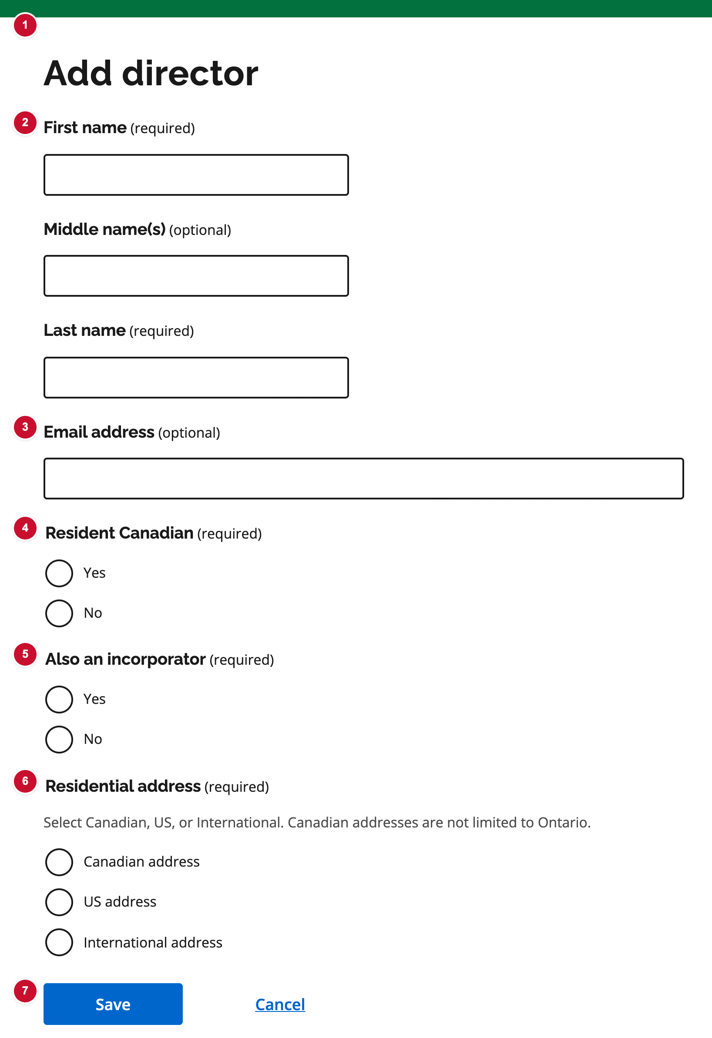
Figure C07. Add director — person details — numbered badges match the table below.
# | UI element | What it is | Decision | Comments
1 | Page title | Add director (or Edit director). | ☐ Approve  ☐ Revise  ☐ Defer
2 | First / middle / last name | Legal name. First and last required. | ☐ Approve  ☐ Revise  ☐ Defer
3 | Email address | Optional contact for this director. | ☐ Approve  ☐ Revise  ☐ Defer
4 | Resident Canadian | Required yes/no on Forms 1, 2, 14, 15. | ☐ Approve  ☐ Revise  ☐ Defer
5 | Also an incorporator | Forms 1 and 2 only. If yes, share details are collected here and carried into incorporators. | ☐ Approve  ☐ Revise  ☐ Defer
6 | Residential address | Canadian, US, or international address for service. | ☐ Approve  ☐ Revise  ☐ Defer
7 | Save / Cancel | Returns to the directors list. | ☐ Approve  ☐ Revise  ☐ Defer

C08 Incorporators — list
Source: Form 1 — Step 8 Used on: 1 and 2 only
List of incorporators (individuals or corporations). Directors marked as incorporators appear here automatically. Minimum 3, or 5 for a Worker Co-operative.
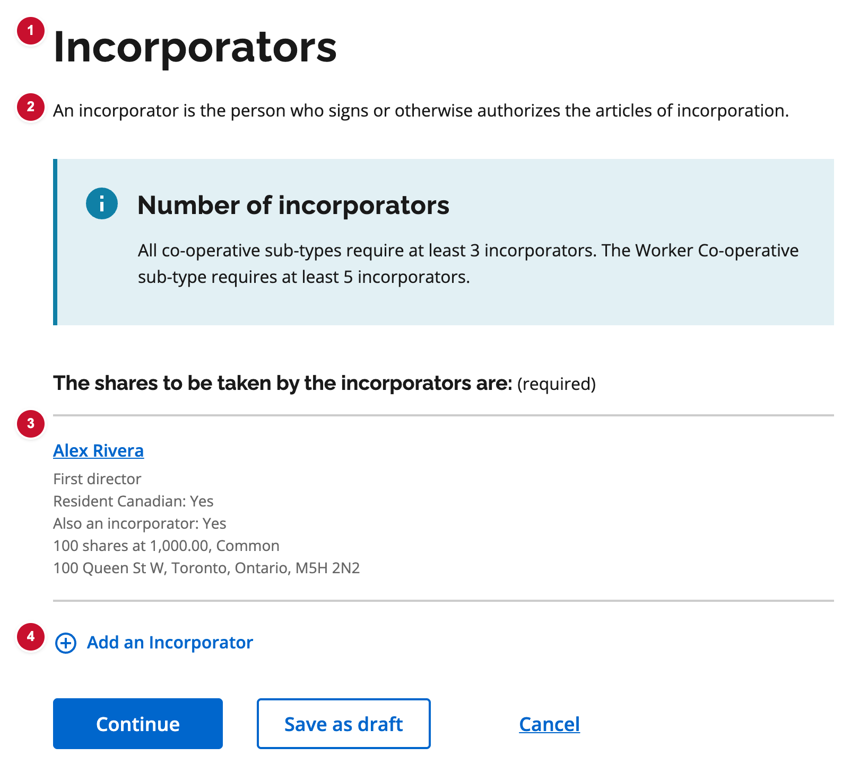
Figure C08. Incorporators — list — numbered badges match the table below.
# | UI element | What it is | Decision | Comments
1 | Page title | Incorporators. | ☐ Approve  ☐ Revise  ☐ Defer
2 | Lead text | Defines an incorporator as the person who signs or authorizes the articles. | ☐ Approve  ☐ Revise  ☐ Defer
3 | Incorporators list | Summary cards. Linked directors cannot be removed here. | ☐ Approve  ☐ Revise  ☐ Defer
4 | Add an Incorporator | Opens the add-incorporator subflow. | ☐ Approve  ☐ Revise  ☐ Defer

C09 Add incorporator — individual or corporation
Source: Form 1 — Step 8 / add incorporator Used on: 1 and 2 only (Form 1 also collects shares taken)
Subflow to add an incorporator as an individual (name, residency, address, shares) or a corporation (name and OCN search, signer, position).
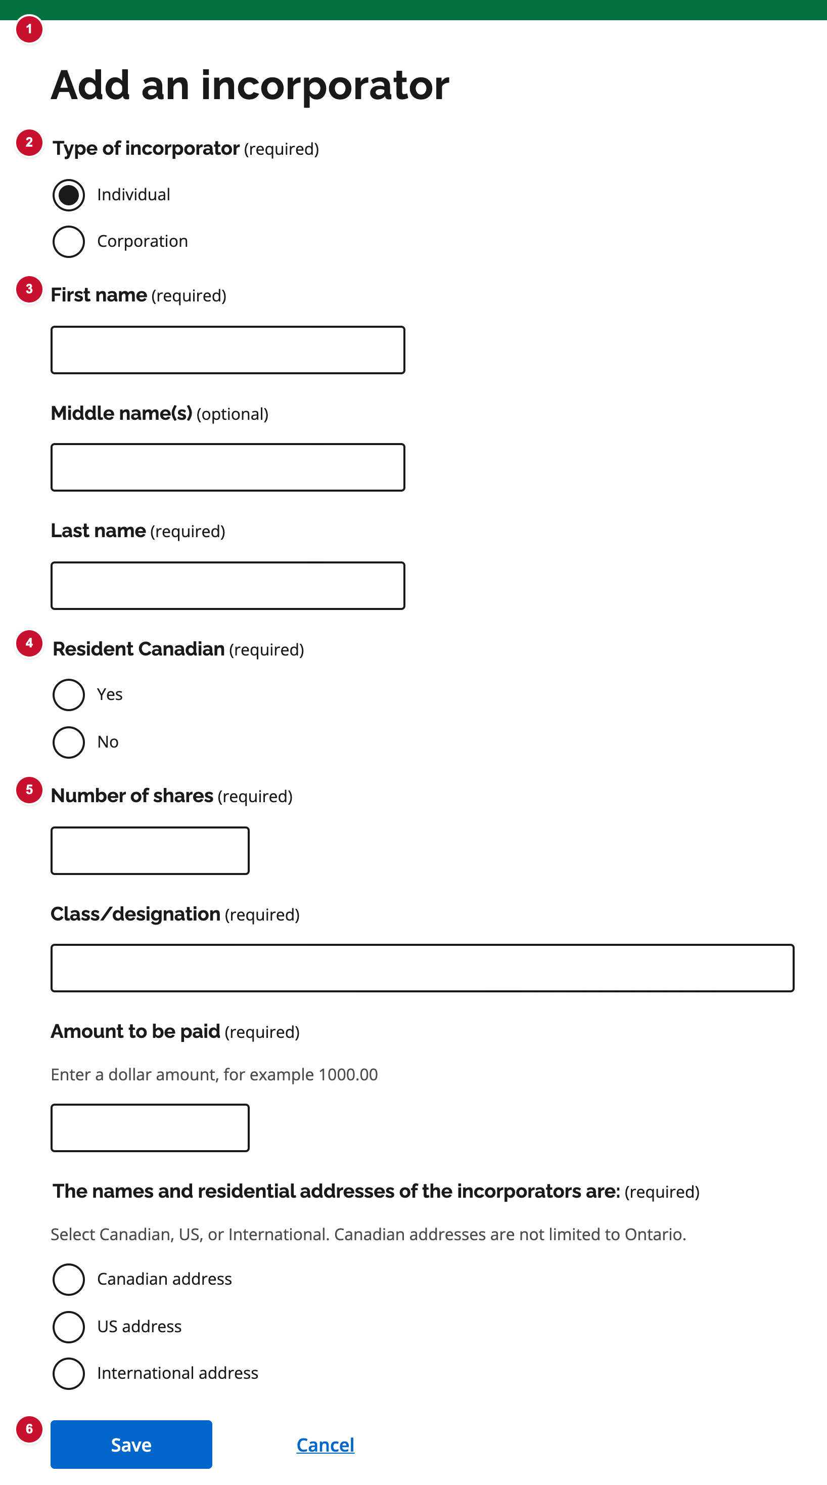
Figure C09. Add incorporator — individual or corporation — numbered badges match the table below.
# | UI element | What it is | Decision | Comments
1 | Page title | Add an incorporator (or Edit incorporator). | ☐ Approve  ☐ Revise  ☐ Defer
2 | Type of incorporator | Individual or corporation. | ☐ Approve  ☐ Revise  ☐ Defer
3 | Individual name | First, middle, last name when type is Individual. | ☐ Approve  ☐ Revise  ☐ Defer
4 | Resident Canadian | Required for individual incorporators. | ☐ Approve  ☐ Revise  ☐ Defer
5 | Shares taken | Form 1 only: number, class, and amount to be paid. | ☐ Approve  ☐ Revise  ☐ Defer
6 | Save / Cancel | Returns to the incorporators list. | ☐ Approve  ☐ Revise  ☐ Defer

C10 Membership and special provisions
Source: Form 1 — Step 7 Used on: 1, 2, 14, 15
Free-text article fields for membership classes, stakeholder groups, and special provisions. Hint tells filers to enter N/A if a field does not apply.
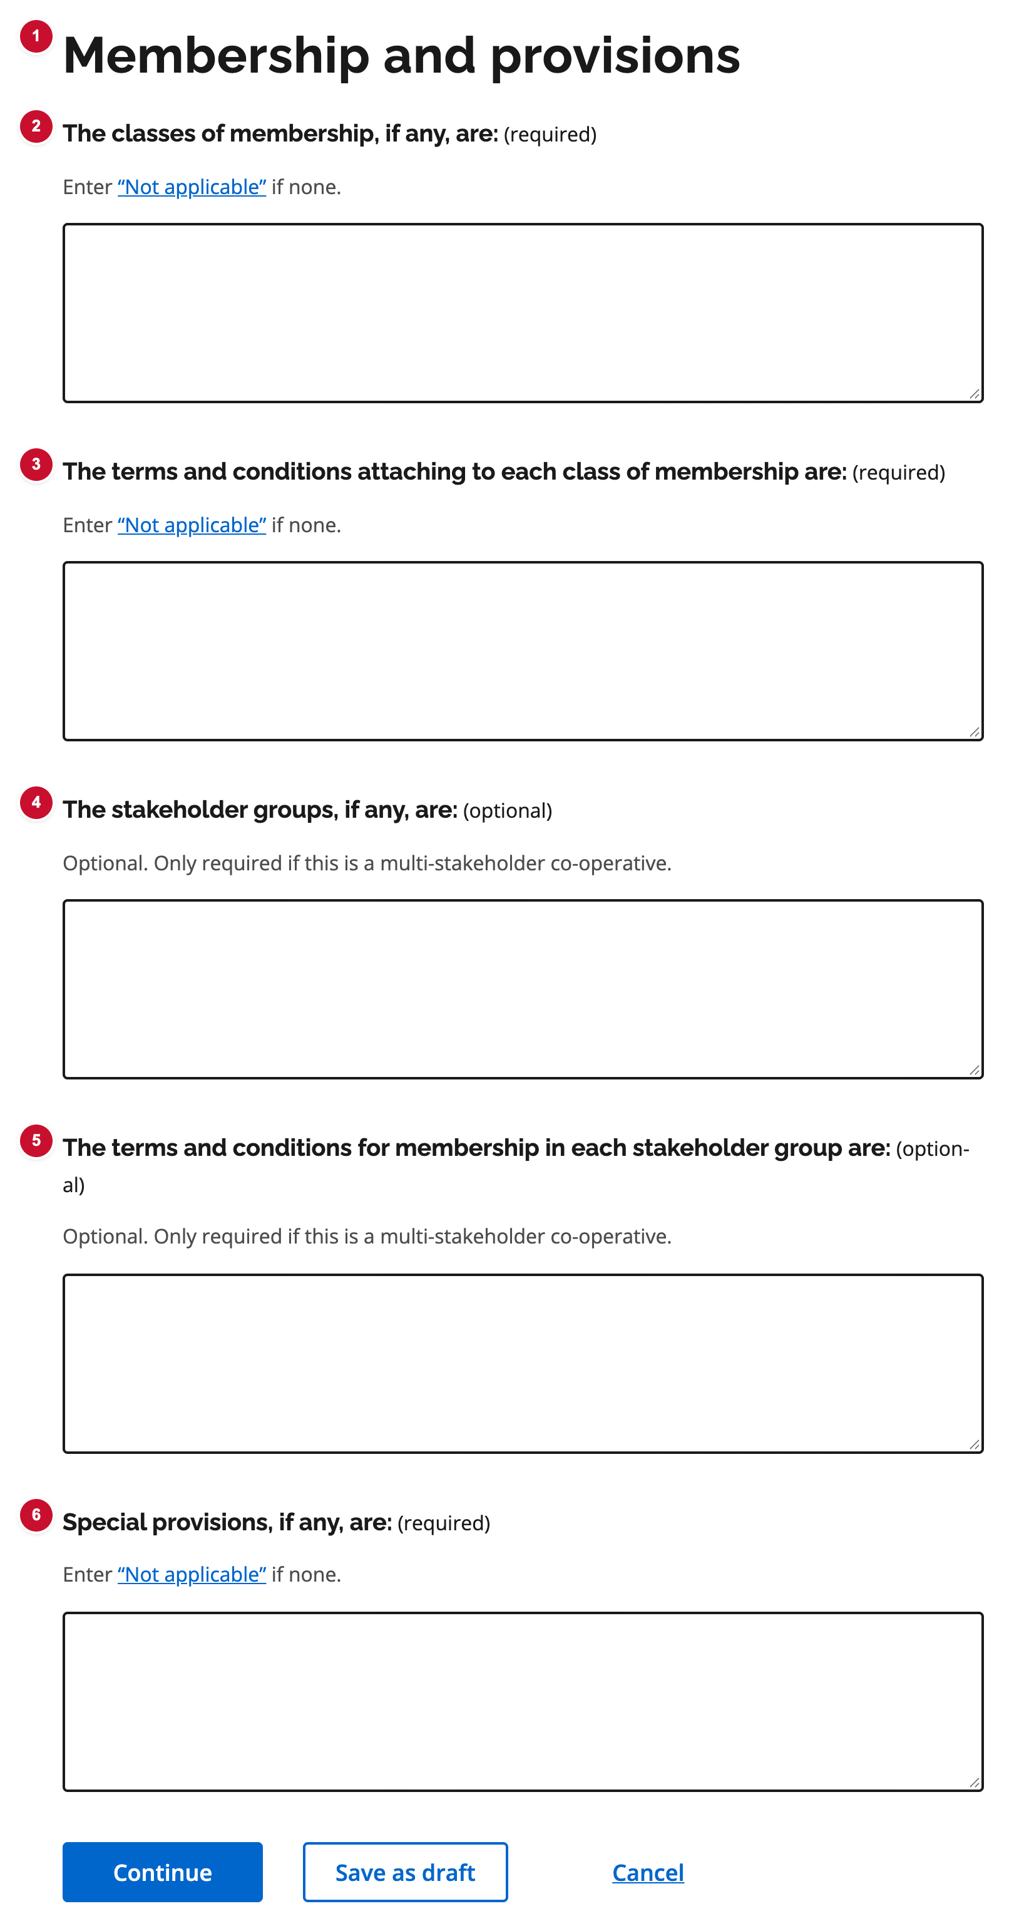
Figure C10. Membership and special provisions — numbered badges match the table below.
# | UI element | What it is | Decision | Comments
1 | Page title | Membership and provisions. | ☐ Approve  ☐ Revise  ☐ Defer
2 | Classes of membership | Optional classes; N/A if none. | ☐ Approve  ☐ Revise  ☐ Defer
3 | Terms for each class | Terms and conditions attaching to each class. | ☐ Approve  ☐ Revise  ☐ Defer
4 | Stakeholder groups | If any; N/A if none. | ☐ Approve  ☐ Revise  ☐ Defer
5 | Stakeholder group terms | Terms for membership in each group. | ☐ Approve  ☐ Revise  ☐ Defer
6 | Special provisions | Any other articles provisions; N/A if none. | ☐ Approve  ☐ Revise  ☐ Defer

C12 Submit — signed PDF and authorization
Source: Form 1 — Step 10 Used on: 1, 2, 3, 7, 10, 11 (not yet on 14 or 15)
Upload the signed articles PDF, confirm authorization to file, and submit. Same pattern on every form that has a submit step.
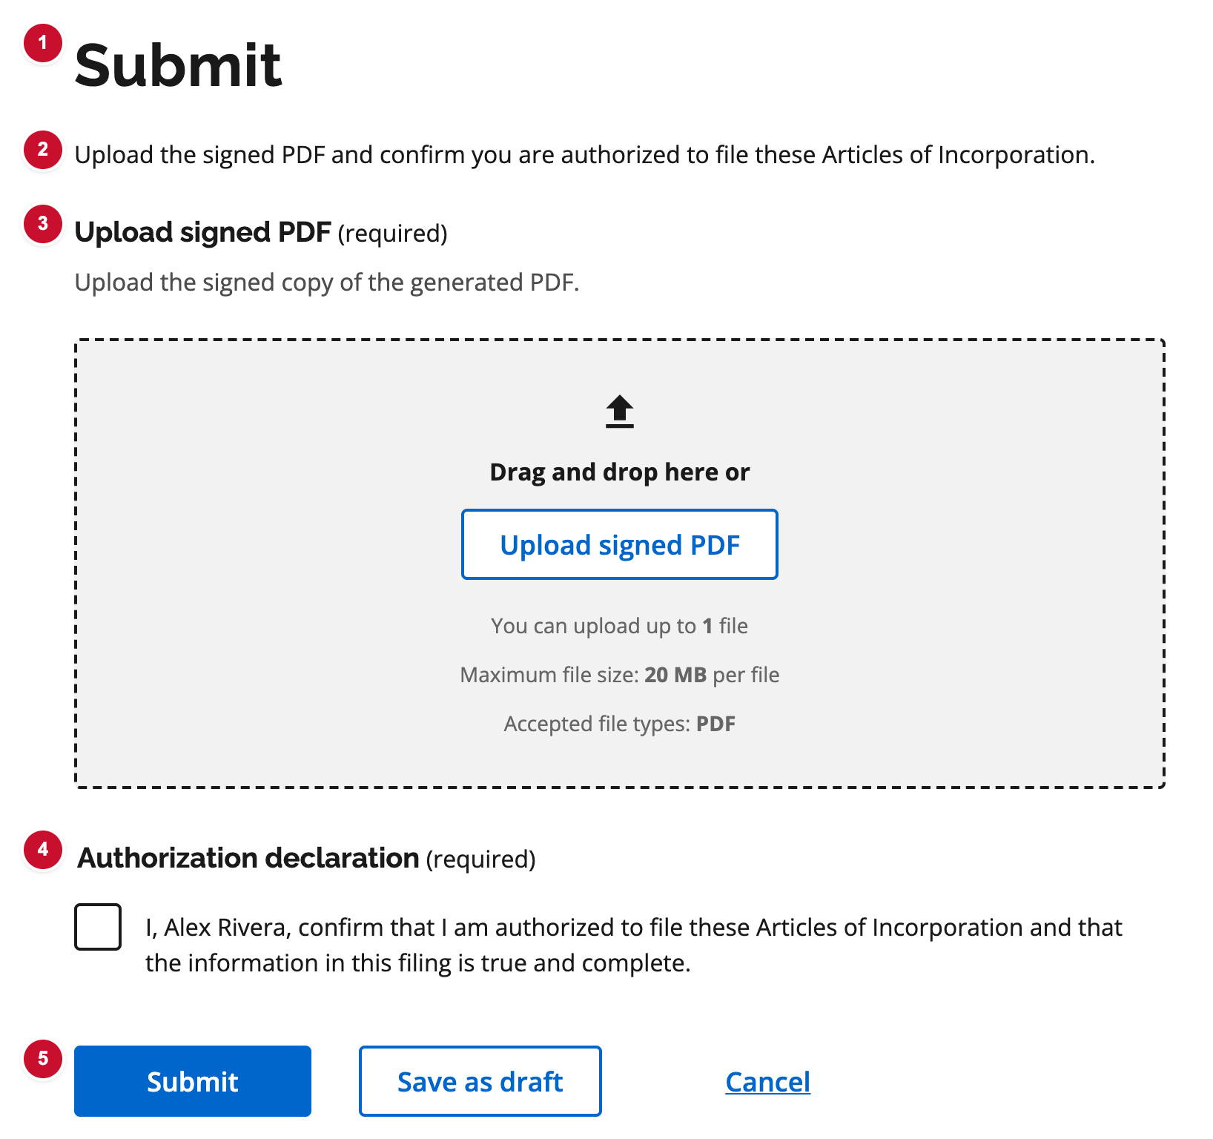
Figure C12. Submit — signed PDF and authorization — numbered badges match the table below.
# | UI element | What it is | Decision | Comments
1 | Page title | Submit. | ☐ Approve  ☐ Revise  ☐ Defer
2 | Lead text | Upload the signed PDF and confirm authorization to file. | ☐ Approve  ☐ Revise  ☐ Defer
3 | Upload signed PDF | Signed copy of the generated articles. | ☐ Approve  ☐ Revise  ☐ Defer
4 | Authorization | Checkbox confirming the filer is authorized to submit. | ☐ Approve  ☐ Revise  ☐ Defer
5 | Submit / Save as draft / Cancel | Submit replaces Continue on this last step. | ☐ Approve  ☐ Revise  ☐ Defer

C13 Registry details callout (existing entity)
Source: Form 7 — Step 2 Used on: 3, 7, 10, 11 (filings against an existing corporation / co-operative)
Read-only Ontario Business Registry details (legal name, OCN, incorporation date) shown above editable primary activity, official email, and type of co-operative.
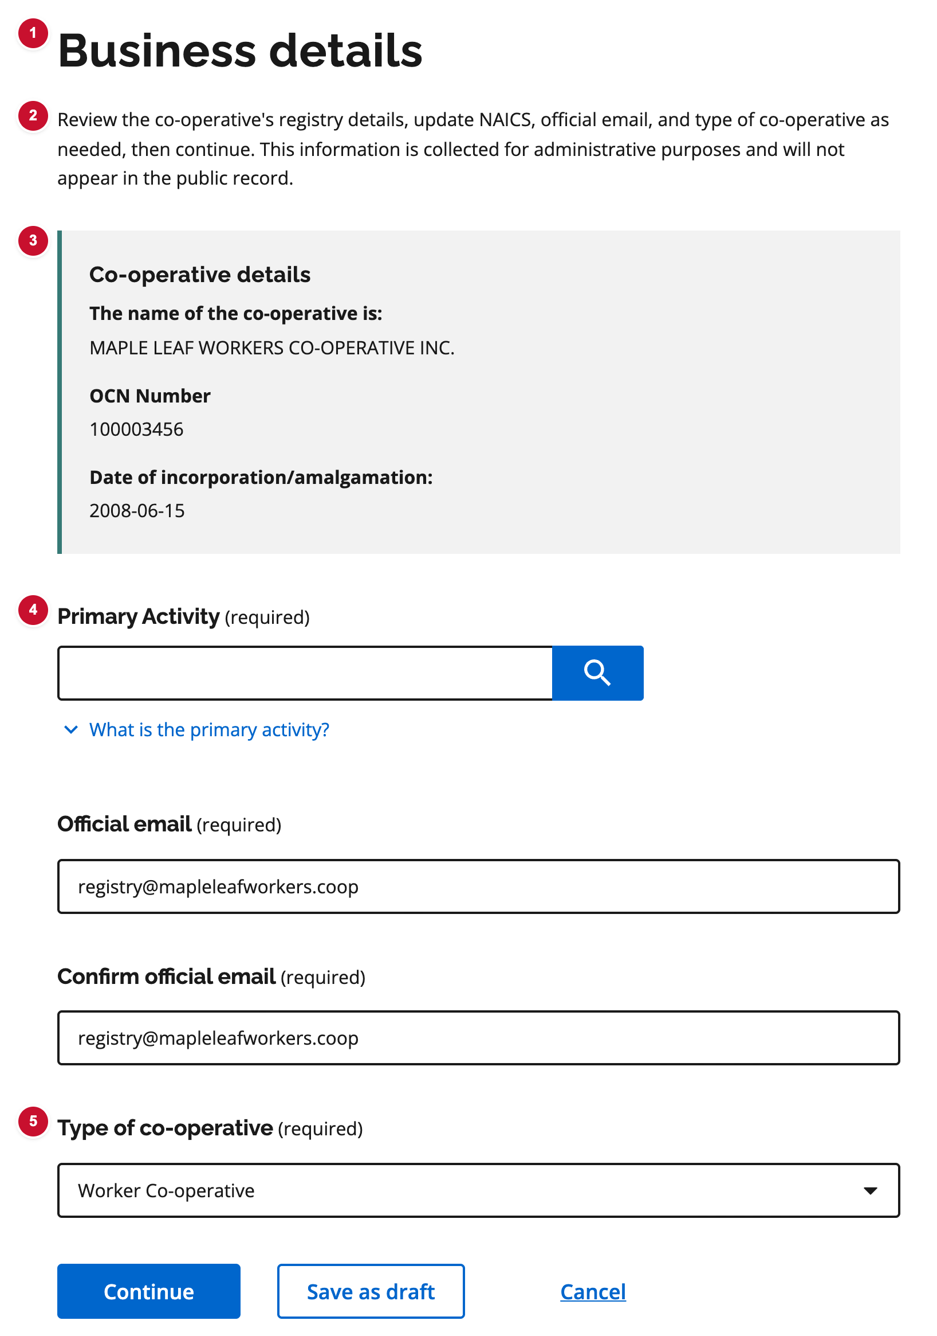
Figure C13. Registry details callout (existing entity) — numbered badges match the table below.
# | UI element | What it is | Decision | Comments
1 | Page title | Business details. | ☐ Approve  ☐ Revise  ☐ Defer
2 | Lead text | Review registry details, then update NAICS, official email, and type of co-operative. Not on the public record. | ☐ Approve  ☐ Revise  ☐ Defer
3 | Co-operative details callout | Read-only legal name, Ontario corporation number, and incorporation date from the registry. | ☐ Approve  ☐ Revise  ☐ Defer
4 | Primary activity | Same NAICS field as new-incorporation forms; may be pre-populated. | ☐ Approve  ☐ Revise  ☐ Defer
5 | Type of co-operative | Required dropdown on Forms 7 and 10. | ☐ Approve  ☐ Revise  ☐ Defer

C14 Amalgamating co-operatives / corporations — list
Source: Form 10 — Step 3 Used on: 10 (Form 11 list and add actions are C17–C19)
Same add / edit / remove list pattern as directors and incorporators, used for amalgamating co-operatives. Each row has legal name, OCN, and members’ approval date.
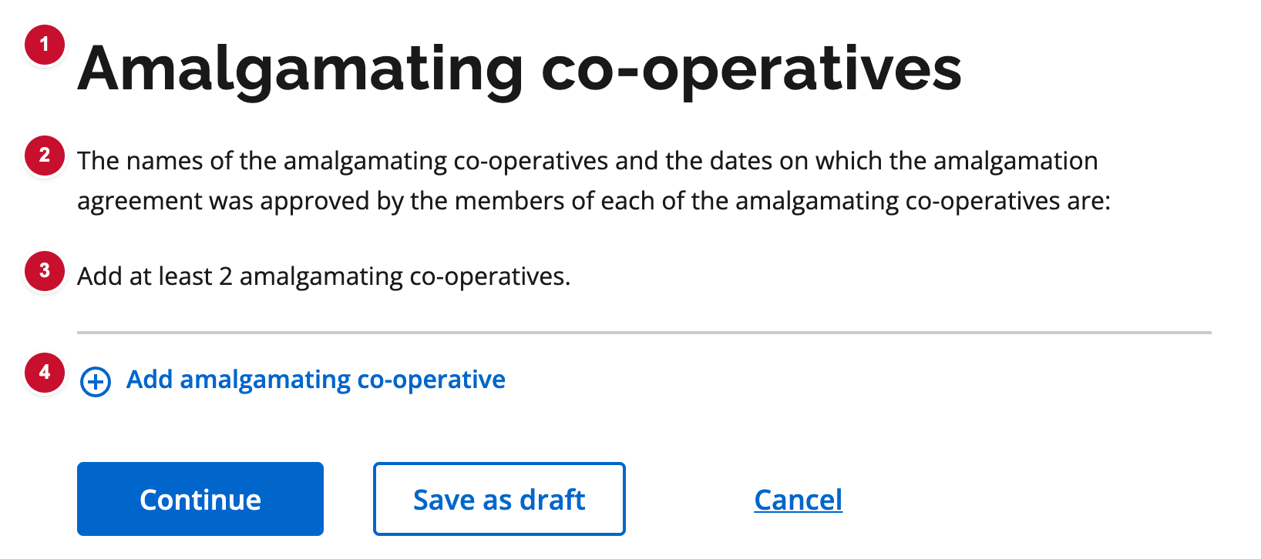
Figure C14. Amalgamating co-operatives / corporations — list — numbered badges match the table below.
# | UI element | What it is | Decision | Comments
1 | Page title | Amalgamating co-operatives. | ☐ Approve  ☐ Revise  ☐ Defer
2 | Lead text | Asks for each amalgamating co-operative’s name and the date members approved the amalgamation agreement. | ☐ Approve  ☐ Revise  ☐ Defer
3 | Entity list | Summary cards. At least two amalgamating co-operatives required. | ☐ Approve  ☐ Revise  ☐ Defer
4 | Add amalgamating co-operative | Opens the add-entity subflow (C16). | ☐ Approve  ☐ Revise  ☐ Defer

C16 Add amalgamating co-operative
Source: Form 10 — Step 3 / add amalgamating co-operative Used on: 10 (Form 11 add actions are C18 and C19)
Subflow to add or edit one amalgamating co-operative: registry search, optional manual name and OCN, and the date members approved the amalgamation agreement.
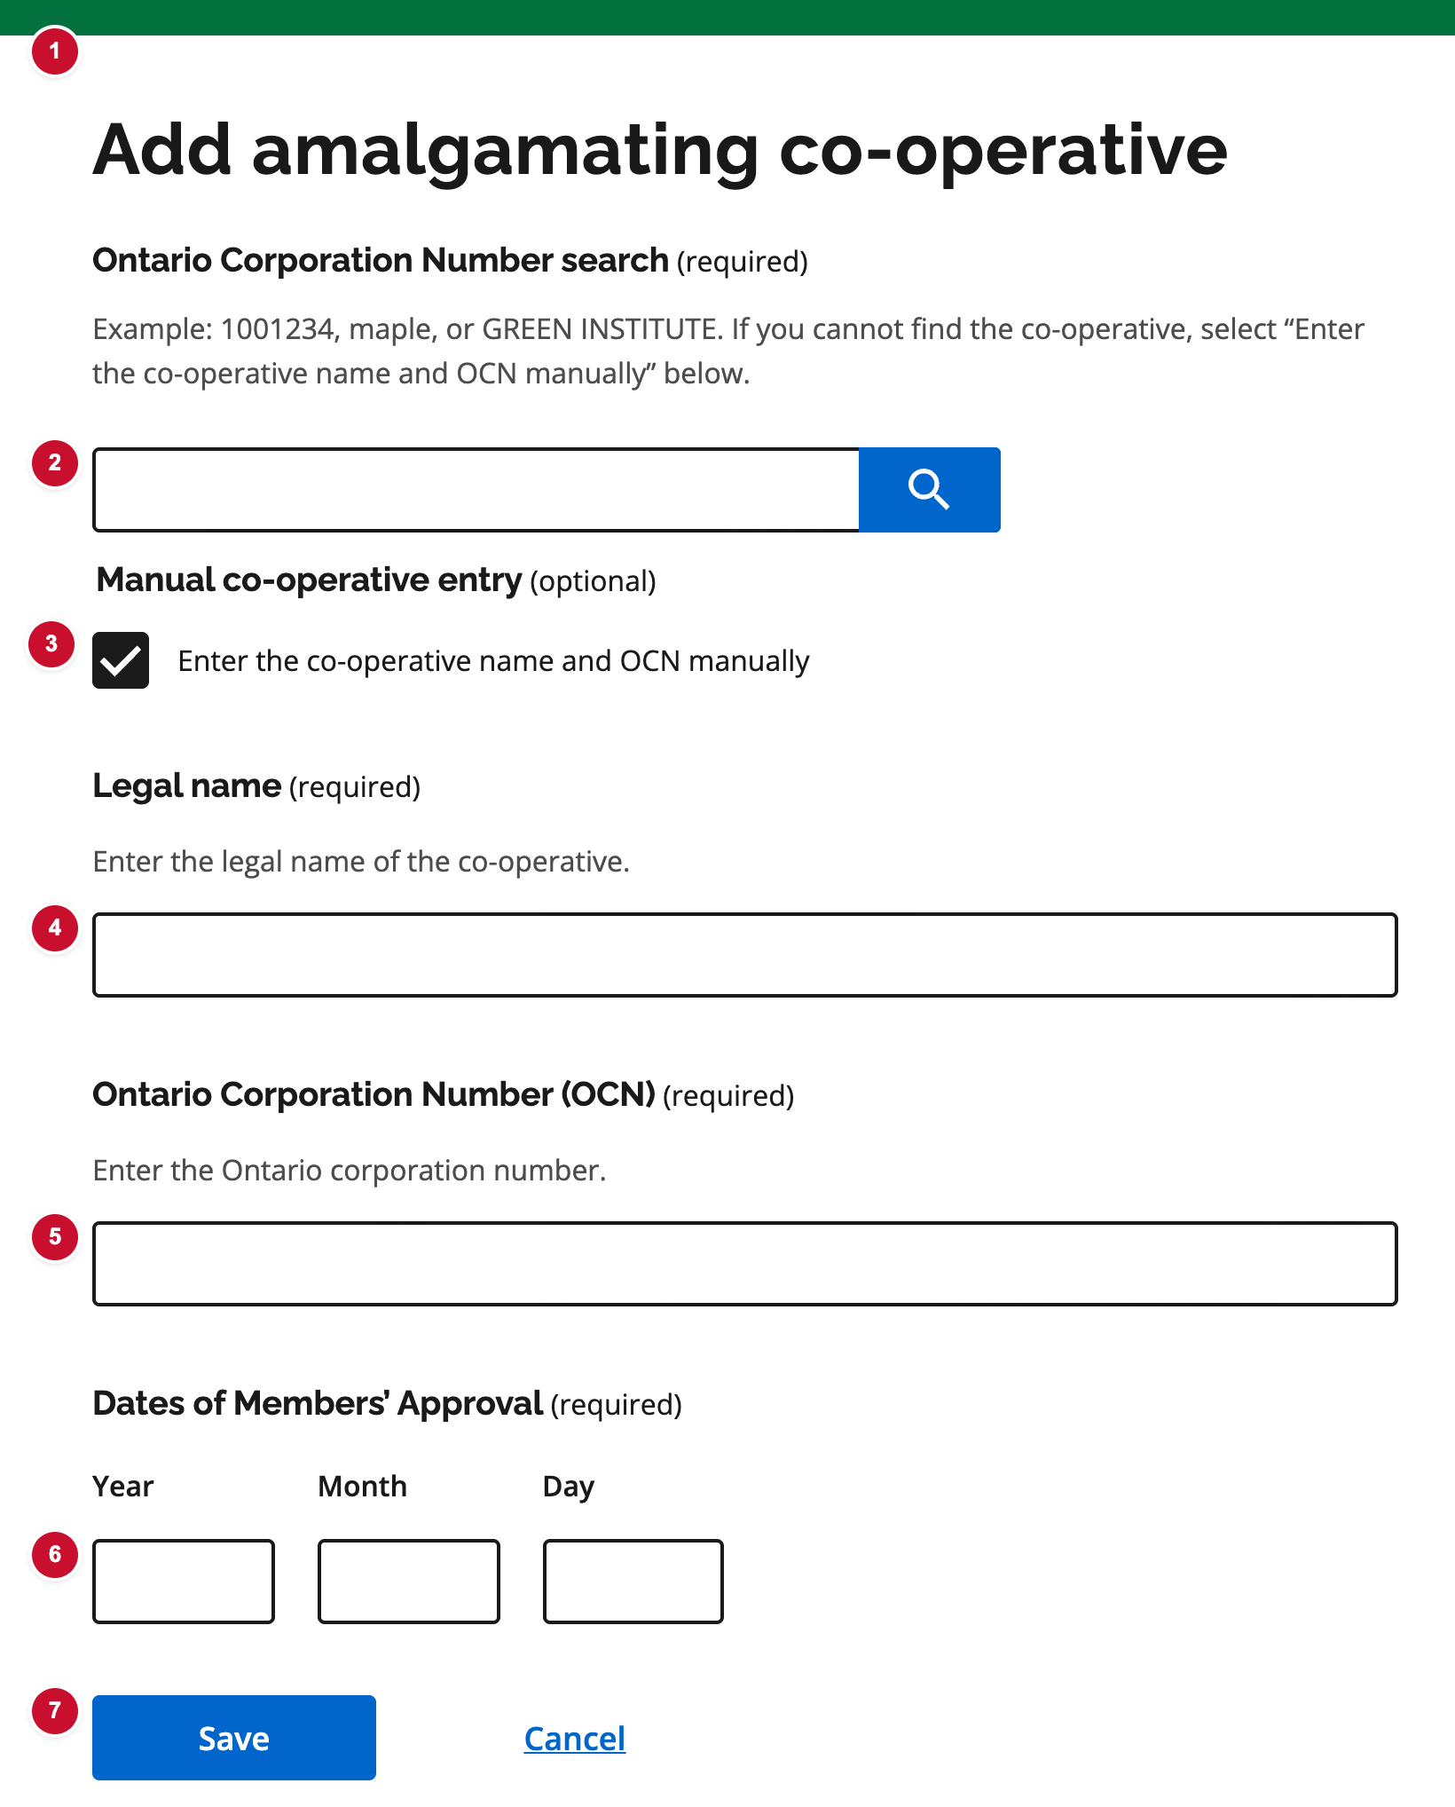
Figure C16. Add amalgamating co-operative — numbered badges match the table below.
# | UI element | What it is | Decision | Comments
1 | Page title | Add amalgamating co-operative (or Edit). | ☐ Approve  ☐ Revise  ☐ Defer
2 | Ontario Corporation Number search | Search by OCN or name. Selecting a result fills legal name and OCN. | ☐ Approve  ☐ Revise  ☐ Defer
3 | Enter name and OCN manually | Shows Legal name and OCN when the co-operative is not in the registry search. | ☐ Approve  ☐ Revise  ☐ Defer
4 | Legal name | Required when entering manually. | ☐ Approve  ☐ Revise  ☐ Defer
5 | Ontario Corporation Number | Required when entering manually. | ☐ Approve  ☐ Revise  ☐ Defer
6 | Date of members’ approval | Date members of this co-operative approved the amalgamation agreement. | ☐ Approve  ☐ Revise  ☐ Defer
7 | Save / Cancel | Returns to the amalgamating list. | ☐ Approve  ☐ Revise  ☐ Defer

C17 Amalgamating corporations — list
Source: Form 11 — Step 3 Used on: 11 only
List of amalgamating corporations with two add actions: the corporation on the signed-in account, or another corporation. At least two are required, and one must be the account corporation.
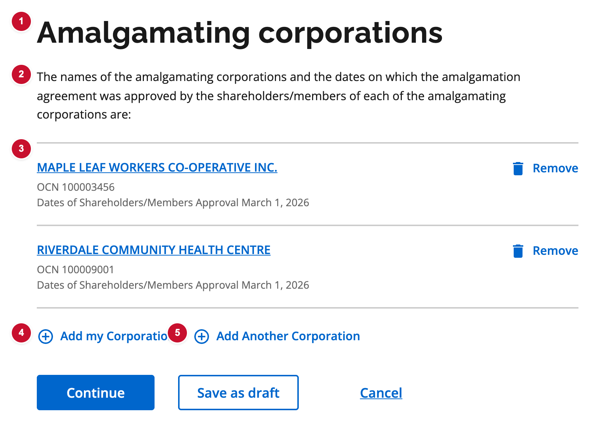
Figure C17. Amalgamating corporations — list — numbered badges match the table below.
# | UI element | What it is | Decision | Comments
1 | Page title | Amalgamating corporations. | ☐ Approve  ☐ Revise  ☐ Defer
2 | Lead text | Asks for each amalgamating corporation’s name and the date shareholders or members approved the amalgamation agreement. | ☐ Approve  ☐ Revise  ☐ Defer
3 | Corporation list | Summary cards with legal name, OCN, approval date, and Remove. At least two required. | ☐ Approve  ☐ Revise  ☐ Defer
4 | Add my Corporation | Opens the add subflow with the signed-in account’s corporation pre-filled (C18). | ☐ Approve  ☐ Revise  ☐ Defer
5 | Add Another Corporation | Opens the empty add subflow to search or enter another corporation (C19). | ☐ Approve  ☐ Revise  ☐ Defer

C18 Add my Corporation
Source: Form 11 — Step 3 / Add my Corporation Used on: 11 only
Add the corporation on the signed-in account. Legal name and OCN are pre-filled from the registry; the filer confirms the date of shareholders/members approval.
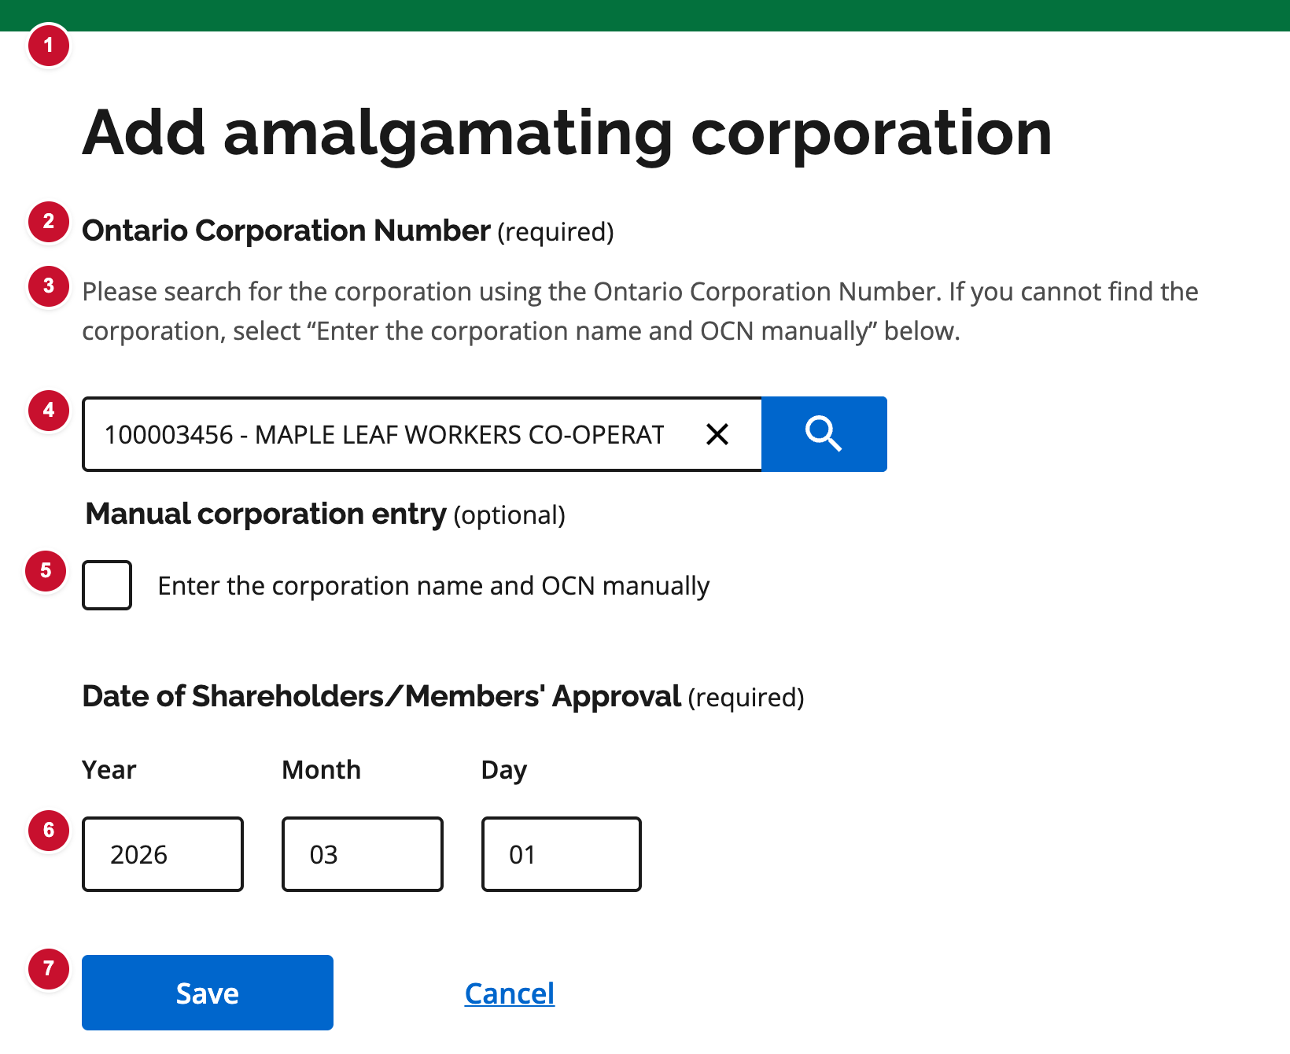
Figure C18. Add my Corporation — numbered badges match the table below.
# | UI element | What it is | Decision | Comments
1 | Page title | Add amalgamating corporation (same heading as Add Another Corporation). | ☐ Approve  ☐ Revise  ☐ Defer
2 | Ontario Corporation Number label | Field label. Required. | ☐ Approve  ☐ Revise  ☐ Defer
3 | Search hint | Tells the filer to search by Ontario Corporation Number, or use manual entry if the corporation is not found. | ☐ Approve  ☐ Revise  ☐ Defer
4 | Ontario Corporation Number search | Pre-filled with the signed-in account’s OCN and legal name. | ☐ Approve  ☐ Revise  ☐ Defer
5 | Enter name and OCN manually | Optional. Same manual-entry path as Add Another Corporation. | ☐ Approve  ☐ Revise  ☐ Defer
6 | Date of shareholders/members approval | Date shareholders or members of this corporation approved the amalgamation agreement. Pre-filled in the prototype. | ☐ Approve  ☐ Revise  ☐ Defer
7 | Save / Cancel | Returns to the amalgamating corporations list. | ☐ Approve  ☐ Revise  ☐ Defer

C19 Add Another Corporation
Source: Form 11 — Step 3 / Add Another Corporation Used on: 11 only
Add a corporation that is not the signed-in account: registry search, optional manual name and OCN, and the date of shareholders/members approval.
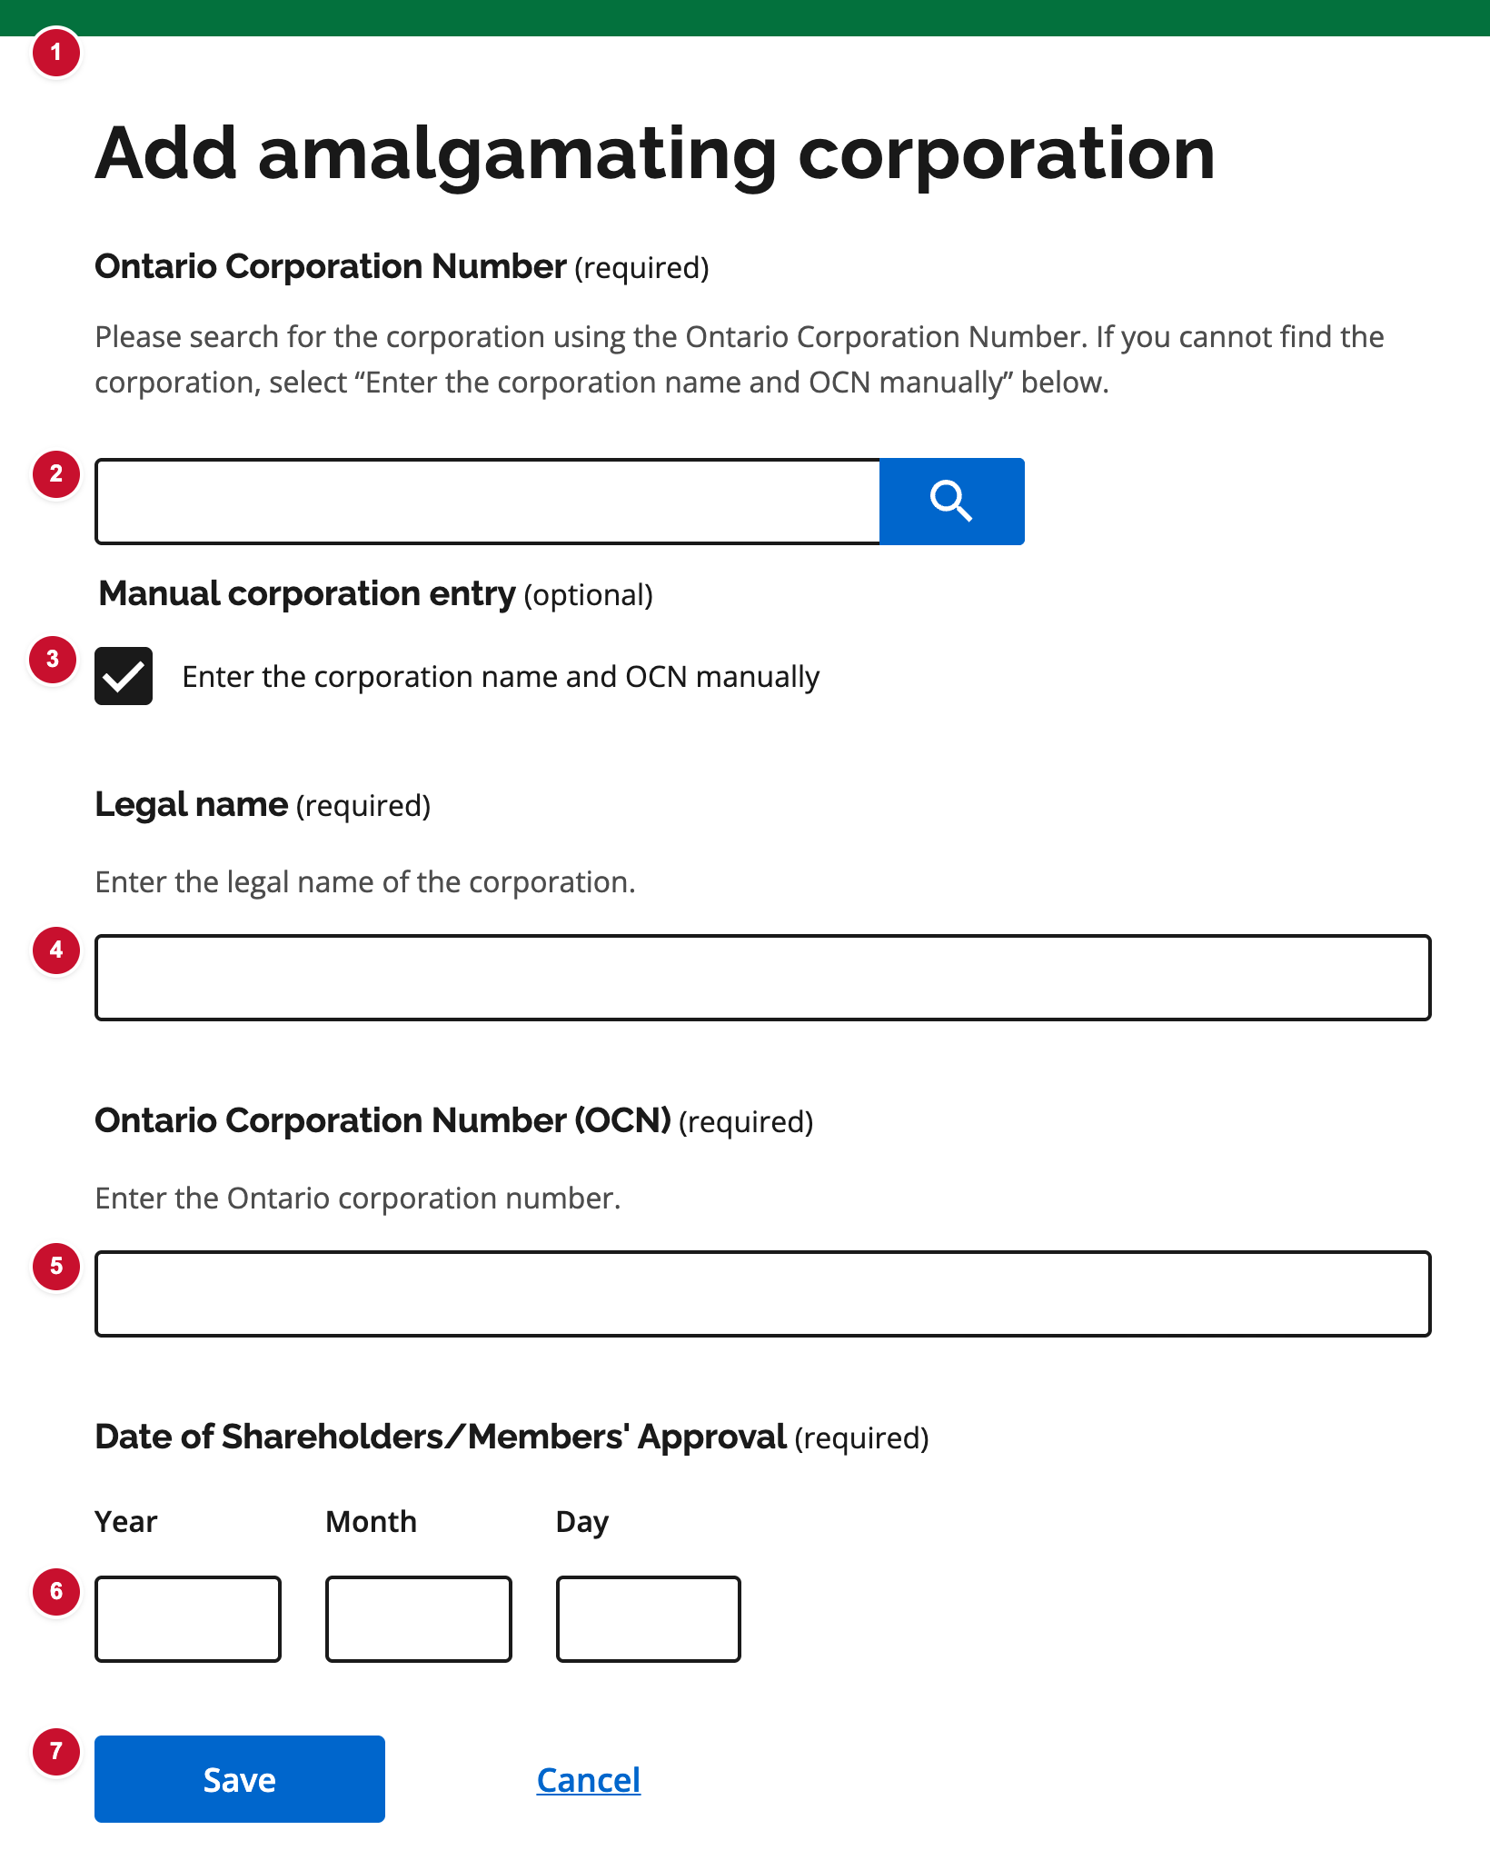
Figure C19. Add Another Corporation — numbered badges match the table below.
# | UI element | What it is | Decision | Comments
1 | Page title | Add amalgamating corporation (or Edit). | ☐ Approve  ☐ Revise  ☐ Defer
2 | Ontario Corporation Number search | Search by OCN or name. Selecting a result fills legal name and OCN. | ☐ Approve  ☐ Revise  ☐ Defer
3 | Enter name and OCN manually | Shows Legal name and OCN when the corporation is not in the registry search. | ☐ Approve  ☐ Revise  ☐ Defer
4 | Legal name | Required when entering manually. | ☐ Approve  ☐ Revise  ☐ Defer
5 | Ontario Corporation Number | Required when entering manually. | ☐ Approve  ☐ Revise  ☐ Defer
6 | Date of shareholders/members approval | Date shareholders or members of this corporation approved the amalgamation agreement. | ☐ Approve  ☐ Revise  ☐ Defer
7 | Save / Cancel | Returns to the amalgamating corporations list. | ☐ Approve  ☐ Revise  ☐ Defer

C15 Supporting documents
Source: Form 7 — Step 4 Used on: 3, 7, 10, 11 (plus director consent PDFs on Forms 1, 2, 11)
PDF uploads and optional typed text for certified resolutions, amalgamation agreements, affidavits, and additional documents.
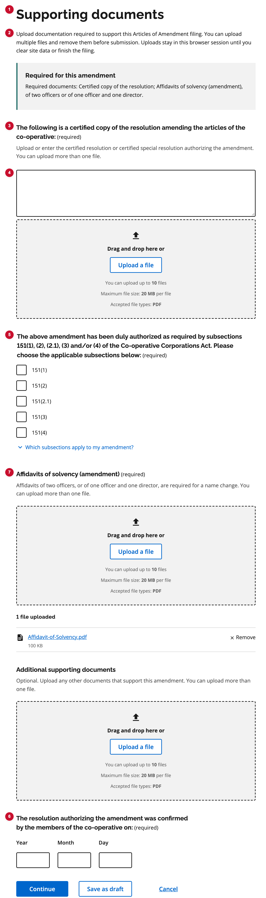
Figure C15. Supporting documents — numbered badges match the table below.
# | UI element | What it is | Decision | Comments
1 | Page title | Supporting documents. | ☐ Approve  ☐ Revise  ☐ Defer
2 | Lead text | Upload documents required for this filing. Uploads stay in this browser session until the filer clears site data or finishes. | ☐ Approve  ☐ Revise  ☐ Defer
3 | Certified resolution | Label for the required document. Filer can type it, upload a PDF, or both. | ☐ Approve  ☐ Revise  ☐ Defer
4 | Typed text | Textarea for the certified resolution. Completes the item without a file, or in addition to a PDF. | ☐ Approve  ☐ Revise  ☐ Defer
5 | Authorization subsections | Form 7: CCA subsections that authorize the amendment. | ☐ Approve  ☐ Revise  ☐ Defer
6 | Resolution confirmed date | Date members confirmed the resolution. | ☐ Approve  ☐ Revise  ☐ Defer
7 | Affidavits of solvency | Required supporting PDFs when the amendment type needs them. | ☐ Approve  ☐ Revise  ☐ Defer

C15 Content worksheet — Supporting documents
Approve the documents and the page copy for each form. Yellow cells are for approved content. Forms 4, 5, 6, 8, and 9 are not in the prototype yet.
Form | Documents | Current copy | Approved content
Form 1 Articles of Incorporation (share) | No Supporting documents page.  Nuans PDF + date — name step (always).  Director consent (Form 3) PDF — add director.  Signed articles PDF — Submit.
Form 2 Articles of Incorporation (no share) | No Supporting documents page.  Same documents as Form 1: Nuans on the name step; director consent PDF; signed articles PDF on Submit.
Form 3 Supplementary Letters Patent | Always on Step 4 (page is titled Supplementary letters patent).  Required: resolution confirmed date; typed provisions.  Optional: additional supporting PDFs.  If name change: Nuans PDF on the name step.  Signed articles PDF — Submit. | Title: Supplementary letters patent  Lead: Provide the date shareholders or members confirmed the resolution and describe the provisions being requested.  Date: The resolution authorizing this application was confirmed by the shareholders/members of the corporation on:  Help: Under section 34 or 131 of the Corporations Act.  Provisions: The corporation applies for the issue of supplementary letters patent to provide as follows:  Hint: What are supplementary letters patent? Supplementary letters patent change the corporation’s existing letters patent. Use this field to describe the provisions you are requesting, such as changes to the objects or special provisions of the corporation.  Additional: Additional supporting documents. Upload any other document to support this application.
Form 4
Form 5
Form 6
Form 7 Articles of Amendment | Always on Step 4.  Required: certified resolution (type and/or PDF, more than one file); CCA s.151 subsections; resolution confirmed date.  If name change: affidavits of solvency (amendment) — two officers, or one officer and one director; Nuans PDF on the name step.  Optional: additional supporting PDFs.  Signed articles PDF — Submit. | Title: Supporting documents  Lead: Upload documentation required to support this Articles of Amendment filing. You can upload multiple files and remove them before submission. Uploads stay in this browser session until you clear site data or finish the filing.  Callout heading: Required for this amendment  Callout: Required documents: Certified copy of the resolution. If name change, also: Affidavits of solvency (amendment), of two officers or of one officer and one director.  Certified resolution: The following is a certified copy of the resolution amending the articles of the co-operative:  Hint: Upload or enter the certified resolution or certified special resolution authorizing the amendment. You can upload more than one file.  Typed text: optional if a PDF is uploaded.  Subsections: The above amendment has been duly authorized as required by subsections 151(1), (2), (2.1), (3) and/or (4) of the Co-operative Corporations Act. Please choose the applicable subsections below:  Options: 151(1); 151(2); 151(2.1); 151(3); 151(4)  Hint expander: Which subsections apply to my amendment? Content: TBD  Affidavits (name change only): Affidavits of solvency (amendment). Affidavits of two officers, or of one officer and one director, are required for a name change. You can upload more than one file.  Additional: Additional supporting documents. Optional. Upload any other documents that support this amendment. You can upload more than one file.  Date: The resolution authorizing the amendment was confirmed by the members of the co-operative on:
Form 8
Form 9
Form 10 Articles of Amalgamation | Always on Step 5.  Required: certified amalgamation agreement (type and/or 1 PDF; effective within 6 months of submission); affidavits of solvency (amalgamation) — exactly 2 PDFs for each amalgamating co-operative.  If new name: Nuans PDF on the name step.  Signed articles PDF — Submit. | Title: Supporting documents  Lead: Upload one certified amalgamation agreement for this filing, and two Affidavits of Solvency for each amalgamating co-operative.  Callout heading: Required for this amalgamation  Callout: One Certified copy of the amalgamation agreement for this filing, and two Affidavits of solvency (amalgamation) for each amalgamating co-operative. PDF only, maximum 20 MB per file.  Agreement: The following is a certified copy of the amalgamation agreement:  Hint: Upload or enter the certified amalgamation agreement. You can upload one file. A certified copy of the amalgamation agreement approved by each of the amalgamating co-operatives. The effective date of the amalgamation agreement must be within six (6) months of the submission of the Articles of Amalgamation.  Typed text: optional if a PDF is uploaded.  Affidavits (repeat per co-operative, heading: legal name and OCN): Affidavits of solvency (amalgamation). Affidavits of solvency (amalgamation) of two officers or of one officer and one director for each of the co-operative corporations that are being amalgamated.
Form 11 Letters Patent of Amalgamation | Always on Step 7.  Required: certified amalgamation agreement — 1 PDF (corporate seal, secretary of each amalgamating corporation).  Optional: additional supporting PDFs.  Director consent (Form 3) PDF — add director.  If new name: Nuans PDF on the name step.  Signed articles PDF — Submit. | Title: Supporting documents  Lead: Upload a copy of the approved amalgamation agreement. You may also attach other documents that support this application.  Agreement: The following is a copy of the amalgamation agreement duly certified under corporate seal by the secretary of each of the amalgamating corporations:  Additional: Upload any other document to support this application (optional). PDF only, maximum 20 MB per file.
Form 14 Continuance (share) | No Supporting documents page yet.  Nuans PDF if a proposed co-operative name is entered (name step).  Directors: written-consent checkbox only (no PDF).
Form 15 Continuance (no share) | No Supporting documents page yet.  Same documents as Form 14.

3. Sign-off
Sign when the inventory in section 1 is complete. A Revise mark means the component stays in the prototypes but needs the comments addressed before it is treated as approved.
Role | Name | Decision | Date | Signature
Product / business owner |  | ☐ Approve ☐ Revise
Service design / UX |  | ☐ Approve ☐ Revise
Policy / legal (if required) |  | ☐ Approve ☐ Revise
Development lead |  | ☐ Approve ☐ Revise

Notes: Screenshots were captured from the local OPS-RBAC prototype on 6 November 2026. Form 15 does not yet include a cover letter or submit step. Forms 14 and 15 use an instructions page instead of Before you begin, and they stop at Review.

