Steel Inbound Control Tower
Founder memo | client proposal | boardroom pack | India GTM plan

Purpose
This document combines the product thesis, the client-facing proposal, the phased build roadmap, the 10-slide pitch narrative, and the India-specific first customer acquisition plan for a steel-specific raw-material inbound control tower.
What a first-time reader should understand
1) What the product does and why steel inbound risk is different from generic procurement. 2) What data the system uses and how onboarding starts without heavy ERP integration. 3) What the dashboard shows, how the workflow closes the loop, and how a pilot proves value. 4) Which accounts to target first in India and how a founder-led motion should land the first pilot.

1. Executive summary
SteelOps is not a generic procurement suite. It is a steel-specific inbound decision layer that sits beside ERP and converts fragmented shipment, port, inland, stock and quality signals into one operating rhythm for procurement, logistics, planning and plant teams.
The strongest entry point is the raw-material inbound control tower: shipment visibility, days-of-cover prediction, exception workflow, and sponsor-level risk visibility. The product is designed to work in the real operating environment of Indian steel — Excel trackers, SAP extracts, transporter messages, partial inland visibility, and uneven ecosystem digitisation — rather than waiting for perfect data.
The commercial logic is simple: land with a 10–14 week pilot for one plant and one or two critical materials; prove earlier warnings, better cross-functional ownership, and reduced disruption noise; then expand by route, plant, and workflow depth.
Core thesis
Build the steel-specific inbound operating layer first. Do not begin with a broad procurement platform. Own one painful coordination problem so clearly that the customer changes its daily operating rhythm.

2. Why now
India’s steel sector continues to expand, while policy and company reporting keep raw-material security, supply-chain resilience, and digitalisation in the foreground. That creates the right backdrop for a steel-specific decision layer rather than another reporting project.
Public signal | Why it matters commercially
Policy ambition to scale Indian steel capacity materially over the next decade | More movements, more route complexity, more coordination events
Continued discussion of coking-coal dependence and resource security | Inbound raw materials remain strategic, not local
Large producers publicly discuss digitalisation and supply-chain optimisation | The buyer already understands the problem; the startup must go deeper than dashboards
Integrated producers keep expanding site and network complexity | One avoided disruption can justify enterprise software spend

3. What the product is and is not
What it is | What it is not
A steel-specific inbound decision layer beside ERP | An ERP replacement
An operational truth model across shipment, port, inland, stock and quality | Only a vessel tracker
An exception workflow engine with accountability | Only a BI dashboard
A pilotable, staged system that starts with uploads and grows into passive ingestion | A heavy transformation program on day one

4. Product walkthrough: what the buyer sees
The dashboard must make the product legible in under one minute. The sponsor should see plant-material risk and top exceptions. The operator should see movement state, ETA drift, and the next action. The product becomes useful when one movement change translates into one action record.
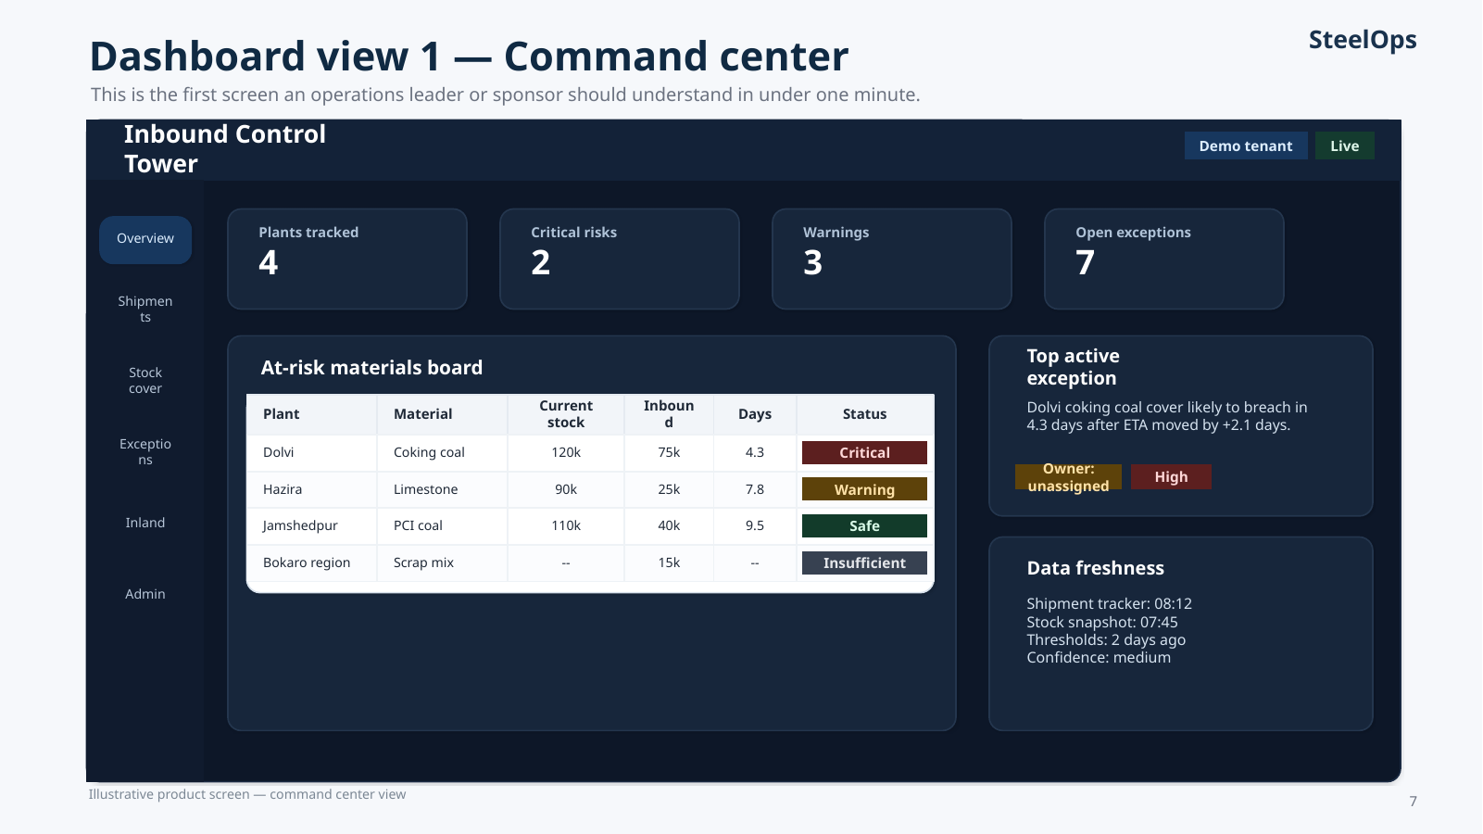
Figure 1. Illustrative command-center screen showing at-risk materials, top active exception, and data freshness.
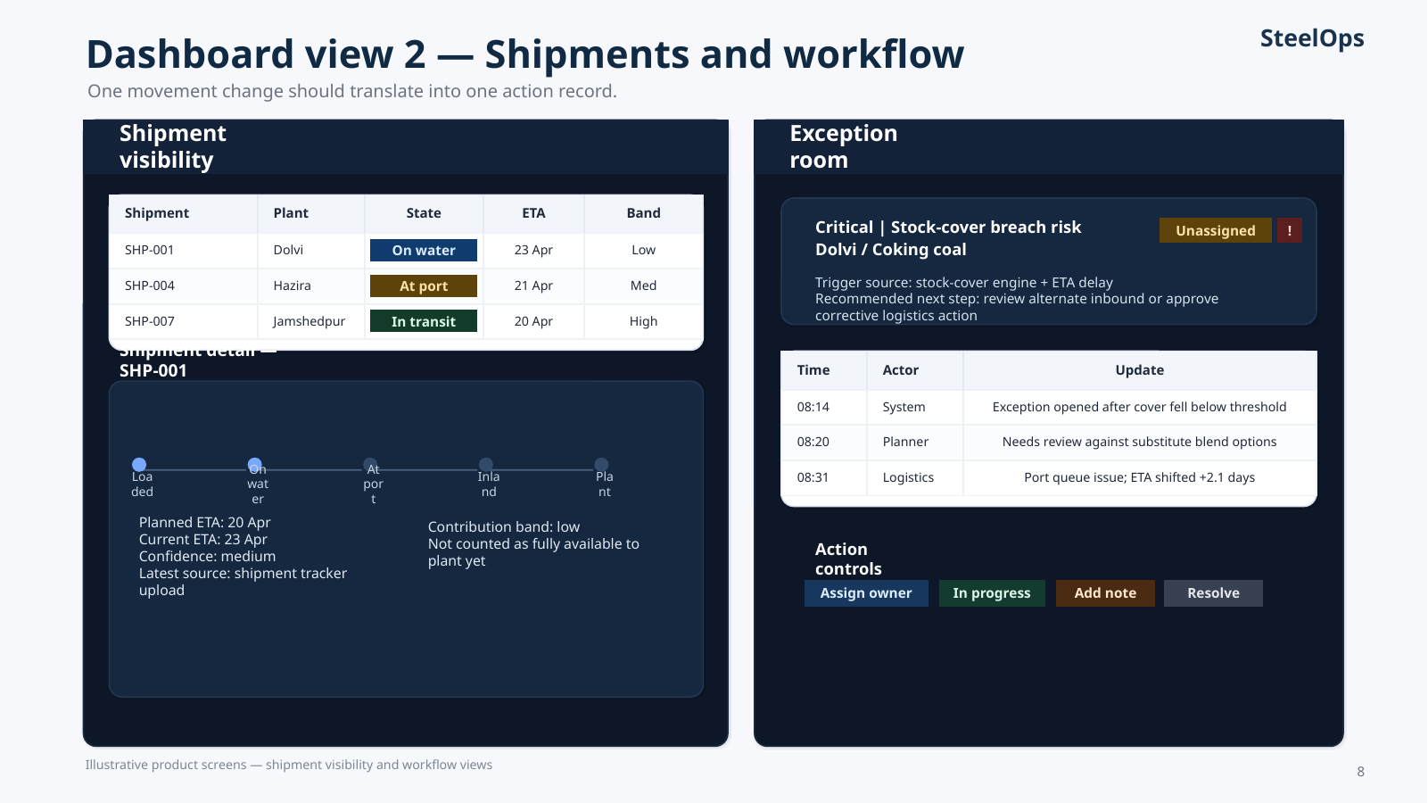
Figure 2. Illustrative shipment visibility and exception workflow screens. The product becomes operational when timeline context and action ownership live in the same system.
5. How the system works
The MVP works in six steps: ingest, normalize, derive state, calculate risk, open exceptions, and drive action. This sequencing is critical. The product should not begin with AI, optimization, or heavy integration. It must begin with operational truth that users trust.
- Ingest: shipment files, stock snapshots and threshold files enter through tenant-scoped uploads first; later the same pipeline supports mailbox, folder, vessel, or ERP enrichment.
- Normalize: plants, materials, shipments, thresholds and updates are mapped into a canonical steel-specific ontology rather than treated as loose rows.
- Derive state: inbound material moves through states such as on water, at port, discharging, in transit and available to consume.
- Calculate risk: the stock-cover engine combines available stock, daily consumption, thresholds and inbound pipeline to produce days of cover, breach status, estimated breach date and confidence.
- Open exceptions: deterministic rules convert critical stock risk, ETA delay, stale updates and inland inconsistencies into trackable cases.
- Drive action: users assign owners, change status, add notes, and close the loop in one system.
Design rule that prevents product failure
Never ask users to maintain data in your system that they already maintain somewhere else. Absorb existing signals, then require only exception-level input.

6. Data model and onboarding logic
Onboarding should start with the minimum data required to produce the first real insight: one shipment tracker, one stock snapshot, and one threshold file. This is not a compromise. It is the right path to fast value and low friction.
Input | Minimum purpose in pilot | Later enrichment
Shipment tracker | Shipment ID, plant, material, quantity, ETA, route assumptions | Vessel enrichment, emails, partner updates
Stock snapshot | Available-to-consume quantity and daily consumption | ERP snapshots, quality-linked release states
Thresholds | Warning / critical days of cover | Dynamic buffer policies by material family
Port events | Optional manual state correction | Discharge feeds, port system updates
Inland movement | Optional dispatch and expected-arrival updates | Transporter APIs, GPS or FASTag signals where available

Crucially, the product must not equate “vessel reached port” with “material is available to consume.” Material has to be modeled through states. When inland truth is incomplete, the product should estimate conservatively and display confidence explicitly.
7. Build sequencing and scope buckets
The right build order is truth first, risk second, workflow third, enrichment fourth, optimization last. This keeps the product shippable and prevents false precision.
Bucket | What belongs in it | Why
Must-have before first pilot | Tenant/user setup, onboarding ingestion, canonical model, stock-cover engine, shipment state model, command-center dashboard, exception workflow, auditability | Without these, the product is not operational
Should-have during pilot | State-based contribution logic, inland tracking basics, confidence layer, mailbox/folder ingestion, overrides, better filters and reporting | These improve trust and reduce friction during live pilot use
Post-pilot expansion | AIS vessel enrichment, deeper inland feeds, ERP/TMS connectors, notifications, scenario simulation, AI recommendations, supplier portal, mobile workflows | These improve scale, automation and differentiation after trust is earned

8. Boardroom-ready roadmap
The roadmap should be framed in horizons rather than feature sprawl.
Horizon 1 — MVP pilot: Schema, onboarding ingestion, stock-cover engine, shipment visibility, and exception workflow. Objective: prove one plant-material risk story and close the loop operationally.
Horizon 2 — Pilot enrichment: Refine shipment contribution by state, capture inland truth more reliably, add confidence/freshness layers, and reduce manual friction through mailbox/folder ingestion.
Horizon 3 — Scalable enterprise: Layer in ERP and TMS feeds, optional vessel enrichment, richer sponsor analytics, broader multi-plant visibility, and later optimization or recommendations.
9. 10-slide killer pitch narrative
The deck should not begin with features. It should begin with the operating problem. The narrative arc for first meetings should be:
- 1. Why this matters now in India steel.
- 2. The operating problem today: ERP + + Excel + WhatsApp blind spots between port and plant.
- 3. What the product is and is not.
- 4. How the system works from ingestion to action.
- 5. What data it uses and how onboarding starts without heavy integration.
- 6. Illustrative command-center dashboard.
- 7. Illustrative shipment visibility and exception workflow.
- 8. Pilot design and implementation path.
- 9. Commercial value and KPI proof.
- 10. India-specific first customer acquisition strategy.
10. Client proposal structure
For buyer conversations, the proposal should be framed as a narrow operational pilot rather than a broad transformation. The commercial wedge is continuity protection and cleaner coordination — not software ideology.
Recommended pilot framing
One plant, one or two critical materials, and a 10–14 week duration. Start with uploads and existing trackers. Prove earlier warnings, better owner assignment, reduced disruption noise, and one quantifiable financial or continuity outcome.

11. India-specific first customer acquisition strategy
The first-wave target profile should be integrated producers and complex single-site networks where inbound route complexity, continuity risk and sponsor visibility are all high. The secondary market is attractive later, but the first proof points should come from customers for whom one prevented disruption matters materially.
Priority | Target archetype | Reason to target now | Best pilot wedge
1 | JSW Steel / Tata Steel / AM/NS India | Scale, digital readiness, route complexity and high sponsor value | One corridor / one plant / one material family + exception room
2 | Regional integrated or ore-and-coal exposed producers | Strong pain with potentially faster founder-led access | Command center + stock-cover + manual uploads first
3 | Secondary steel groups | Large long-tail opportunity after product simplification | Mobile-first or lighter SKU later, not core first-wave motion

From Ranchi and the eastern belt, the founder advantage is not “small local vendor” positioning. The advantage is discovery depth. You can speak credibly to the operating rhythm of Jamshedpur, Bokaro, ore-and-coal corridors, transporter realities, and the practical difference between vessel arrival and plant availability.
11.1 Buyer map and founder-led sales motion
- Economic buyer: COO, supply-chain head, or group procurement leader depending on organization structure.
- Operational champion: raw-material procurement head, inbound logistics head, or plant planning leader.
- Technical gatekeeper: CIO, enterprise architecture or plant IT.
- Finance ally: controller or procurement finance partner who can validate demurrage, expedite or inventory-confidence benefits.
11.2 Outreach sequence
- Lead with an insight meeting, not a full product tour. Reconstruct one recent disruption in the prospect’s language.
- Run a diagnostic workshop to map the current truth gaps between nomination, ETA, port, inland movement and stock cover.
- Offer a tightly scoped pilot with success metrics defined before contracting.
- Use the product in weekly operating rhythm during the pilot, not as a static review deck.
- Convert only after one measurable value story is visible.
12. Founder operating plan for the next 90 days
Window | Primary outcome | Founder focus
Days 1–30 | Finish MVP spine | Close ingestion, risk, shipment state and exception workflow; keep scope brutally tight
Days 31–60 | Prepare pilot and deck | Refine screens, tighten docs, collect realistic demo data, build outreach pack
Days 61–90 | Land first discovery meetings | Run targeted outreach to first-wave accounts and nearby eastern-belt prospects; sell one pilot wedge, not the whole roadmap

13. References and public anchors
- Tata Steel Integrated Report FY2024-25: public statements on digitalisation, supply-chain optimisation, and the scale of material movement across India operations.
- JSW Steel corporate presentation and annual/integrated reporting: digital bulk raw material supply-chain initiatives, logistics control-tower language, and raw-material security positioning.
- AM/NS India public releases: expansion momentum and scale context for a control-tower land motion.
- Reuters reporting on India’s draft National Steel Policy 2025: capacity ambition, emissions pressure, and coking-coal dependence context.

