Document Based Schema
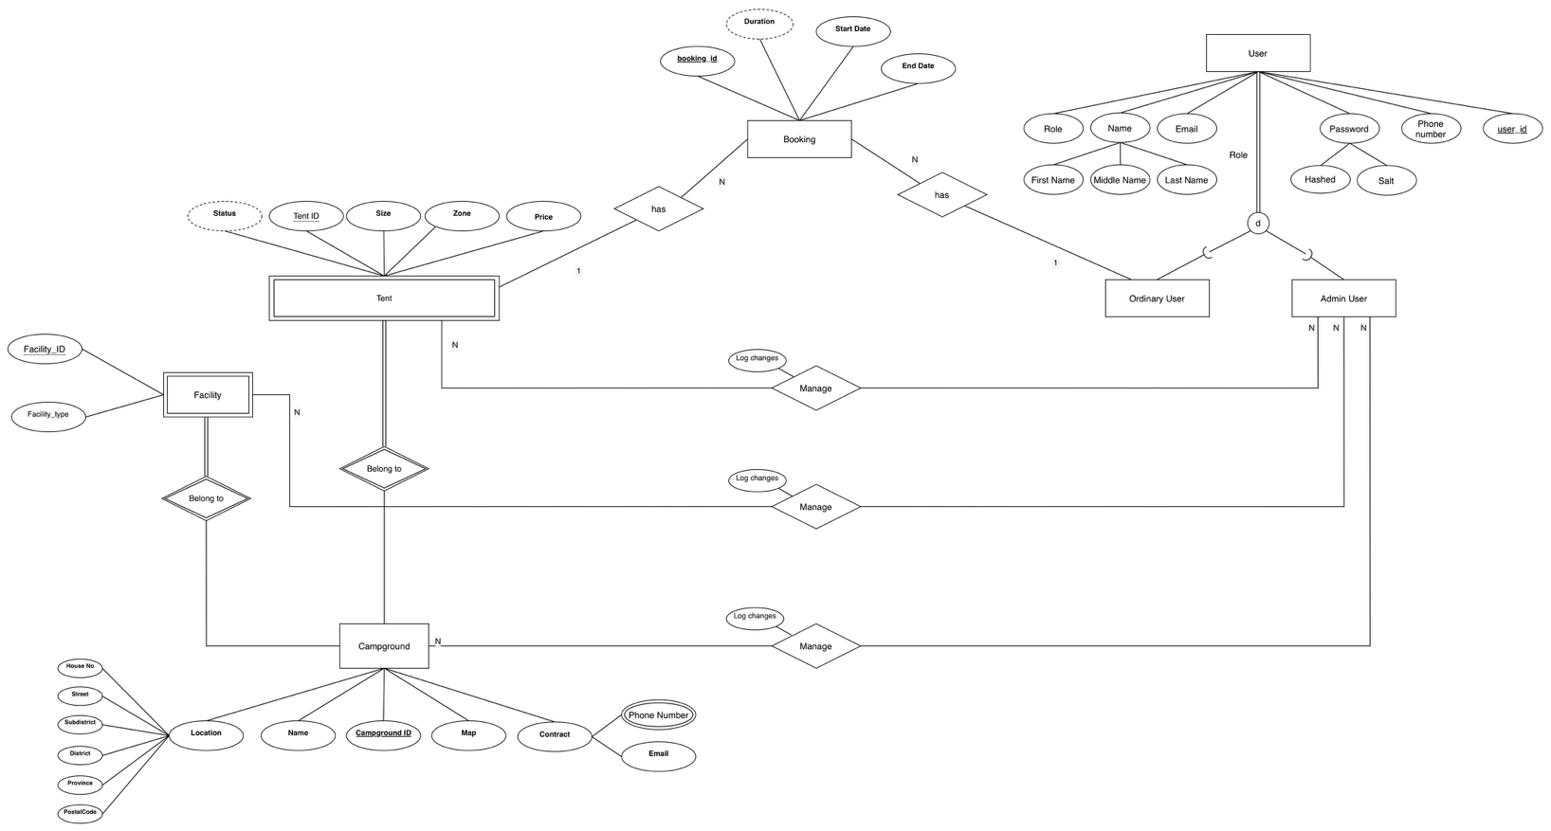

Users Collection

{
"title": "users",
"required": [ "_id", "fname", "lname", "telephone", "email", "password", "role" ],
"properties": {
"_id": { "bsonType": "objectId" },
"fname": { "bsonType": "string" },
"mname": { "bsonType": "string" },
"lname": { "bsonType": "string" },
"telephone": {
"bsonType": "string",
"pattern": "^[0-9]{9,10}$"
},
"email": {
"bsonType": "string",
"pattern": "^.+@.+$"
},
"password": { "bsonType": "string" },
"role": {
"bsonType": "string",
"enum": [ "user", "admin" ]
}
}
}

(has next page)

Campgrounds Collection

{
"title": "campgrounds",
"required": [ "_id", "name", "district", "province", "tents" ],
"properties": {
"_id": { "bsonType": "objectId" },
"name": { "bsonType": "string" },
"address": {
"bsonType": "object",
"properties": {
"house_no": { "bsonType": "string" },
"street": { "bsonType": "string" },
"subdistrict": { "bsonType": "string" },
"district": { "bsonType": "string" },
"province": { "bsonType": "string" },
"postal_code": { "bsonType": "string" },
"map_url": { "bsonType": "string" }
}
},
"contact_email": { "bsonType": "string" },
"phone_numbers": {
"bsonType": "array",
"items": {
"bsonType": "string",
"pattern": "^[0-9]{9,10}$"
}
},
"facilities": {
"bsonType": "array",
"items": {
"bsonType": "object",
"properties": {
"facility_id": { "bsonType": "int" },
"facility_type": { "bsonType": "string" }
}
}
},
"tents": {
"bsonType": "array",
"items": {
"bsonType": "object",
"required": [ "tent_id", "price" ],
"properties": {
"tent_id": { "bsonType": "int" },
"size": { "bsonType": "string" },
"zone": { "bsonType": "string" },
"price": { "bsonType": "decimal" }
}
}
}
}
}

Bookings Collection

{
"title": "bookings",
"required": [ "_id", "user_id", "campground_id", "tent_id", "start_date", "end_date" ],
"properties": {
"_id": { "bsonType": "objectId" },
"user_id": { "bsonType": "objectId" },
"campground_id": { "bsonType": "objectId" },
"tent_id": { "bsonType": "int" },
"booking_date": { "bsonType": "date" },
"start_date": { "bsonType": "date" },
"end_date": { "bsonType": "date" },
"status": {
"bsonType": "string",
"enum": [ "pending", "confirmed", "cancelled" ]
}
}
}

