# GEARS GO! ANDROID APP

# Setting up Gear Testing on Android

By GNguyen, 2014

## Overview

This project will give user ability to login to any Opswat account, and then authorize this app. After authorized, user can use this app to manage remotely their devices. The manage abilities include seeing how many devices have issues, and see details information about each devices.

To do that, this project will use GEAR Cloud API. The mainly API used on this program included:

|  |  |
| --- | --- |
| API | Reason |
| <https://gears.opswat.com/o/api/v2/account.json> | Use this query to return user account details. |
| <https://gears.opswat.com/o/api/v2/devices.json> | Use this query to list devices for a given account. |
| <https://gears.opswat.com/o/api/v2/devices/:id> | Use this query to list devices by ID. |

In addition, this project was web-based and built based on HTML, CSS and Javascript. Read the details below.

## Requirements

To setup and build the project on Android, you must obtain the following environment:

|  |  |  |  |
| --- | --- | --- | --- |
| Component | Version | URL | Reason |
| Windows | 7 - 64bit |  | Operating system. For building that project on IOS, you must have a MAC OS X machine. |
| Ant | 1.9+ | [http://ant.apache.org/](http://ant.apache.org/%20) | Apache Ant is used to drive processes described in build files as targets and extension points dependent upon each other |
| Java | 7 – 64bbit | <http://www.oracle.com/technetwork/java/javase/downloads/index.html> | Project is developed using Java Plugin. You MUST use at least Java 7. |
| Netbeans (optional) | 7.4+ | <https://netbeans.org/downloads/> | Used to compile and Running project on Android graphically. Version 7.4+ integrated Cordova inside. |
| Cordova | 3.5.0 | <http://cordova.apache.org/> | Cordova is a platform  for building native mobile  applications using HTML, CSS  and JavaScript. |
| Android SDK and ADT | Latest | <http://developer.android.com/sdk/index.html> | SDK for developer android application. ADT is used for emulate android. |
| git | 1.8+ | <http://git-scm.com/> | Used to pull down cordova and plugins. |

## Setting up user account and application key

* Login to <https://gears.opswat.com/developers>
* Add an application to your account. After that, remember your **client ID** and **client Secret**. Your **client ID** and **client Secret** will be used throughout the app to call Gear Cloud API.

## Setting up Git

* Install git using yum:

yum install git-core

## Setting up JDK

* Download the package from Oracle.
* Install that packet in a destination, for example: C:\Program Files (x86)\Java\jdk1.7.0_60
* Set environmental variables:

JAVA_HOME to C:\Program Files (x86)\Java\jdk1.7.0_60

JAVA_PATH to %JAVA_HOME%

Add %JAVA_HOME%\bin to PATH

* Verify java is now in the path. Open a new terminal window and type the following:

java -version

## Setting up Ant

* Download the package from apache.
* Unzip package to the following location: C:\Users\ apache-ant-X.X.X
  + Where X.X.X is your version of Ant (e.g. apache-ant-1.9.4)
* Set environmental variables:

ANT_HOME to C:\Users\ apache-ant-X.X.X

Add %ANT_HOME%/bin to PATH

* Verify ant is now in the path. Open a new terminal window and type the following:

ant -version

## Setting up Android SDK

* Download the installer from link above
* Run the installer, remember your installing destination, for example: C:\android-sdk-windows\
* Set environmental variables:

Add C:\android-sdk-windows\tools to PATH

## Setting up Cordova.

1. Download and install NodeJS
2. Download and install Git
3. Install the cordova module using npm utility of Node.js



## Configure the application to build on your machine

1. First, check out the code from Github:

URL: <https://github.com/opswatgears/innovation2014_topic4_1.git>

1. Locate your Android SDK Installation folder, for ex: C:\android-sdk-windows
2. Open the file local.properties on two location:

1. .. Source\Gear Go\platforms\android

2. .. Source\Gear Go \platforms\android\CordovaLib

And change the sdk.dir to the exactly location on your machine, for ex:

sdk.dir= C:\\android-sdk-windows

1. Build and run the project
   1. On Real Device

In the project folder, use that command:



* 1. On emulator

In the project folder, use that command:



Note: You must run an emulator with your AVD or other android emultor.

## How to use the GEAR!GO app

1. Clink the “Login” button to sign in into your Opswat account

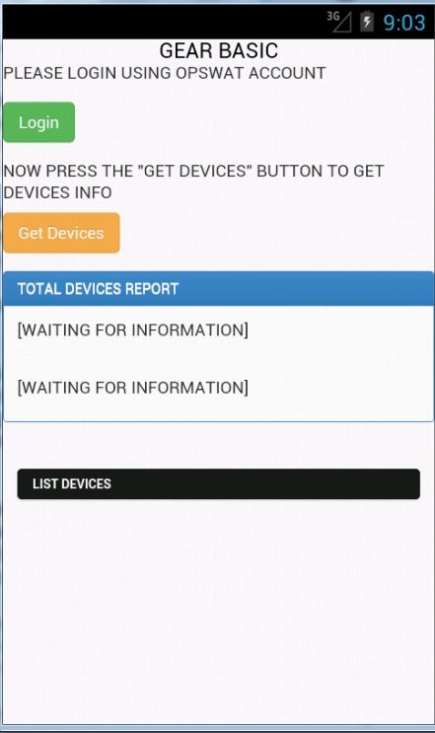

2. An inapp browser will open to allow you to login

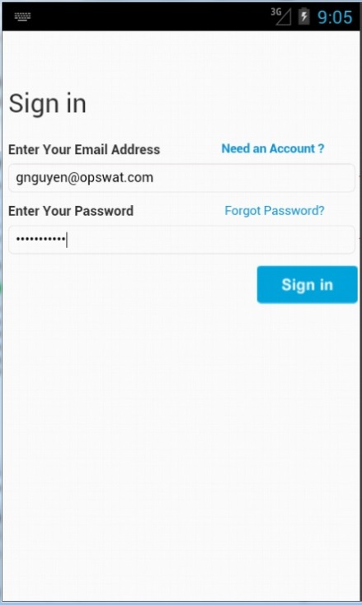

After login, you will be redirect to authorized page to authorize this acc can use your information

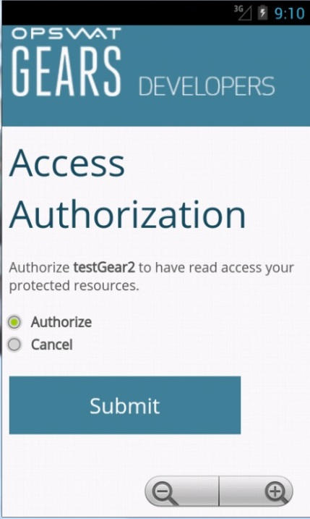

3. Now, after you have to access token to Gear Cloud, click on “Get Devices” to get all your device information.

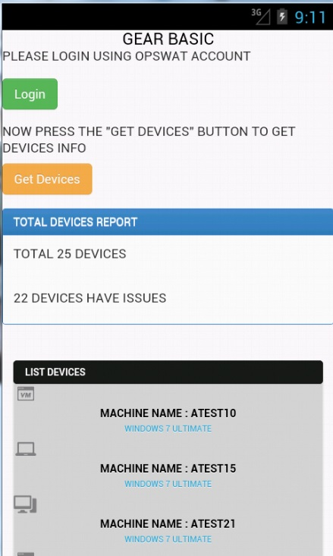

4. Below the list devies is all your devices. You can click to each of them to see the details about this device compliant or not. Each type of machine will have a different display image. For EX, this pic is about a VM type device

