**Name : Dekawadiya Nayeem**

**1. Pull and Merge difference**

- Pull request is a feature of git that allows user to submit changes they have made to a branch in a repository to be reviewed and if changes as approved then it is merged with main branch.

- Merge is the action of taking and applying the changes from one branch to another branch

1. To create a pull request go to GitHub.com and nevigate to the main page of the repository
2. Click on Pull request then click on new pull request.
3. In the base:select branch where you want to merge your changes and in compare:select branch where you made your changes and add suitable title and descriptions for your pull request.
4. Now click on Create pull request.

Marge

1. open the pull request you want to merge.
2. click on merge pull request.

**2. Rebase**

- Rebase is a command that allows you to take the commits from a specific branch and put them on top of another branch.

- Primary objective of rebase is to maintaining linear project history

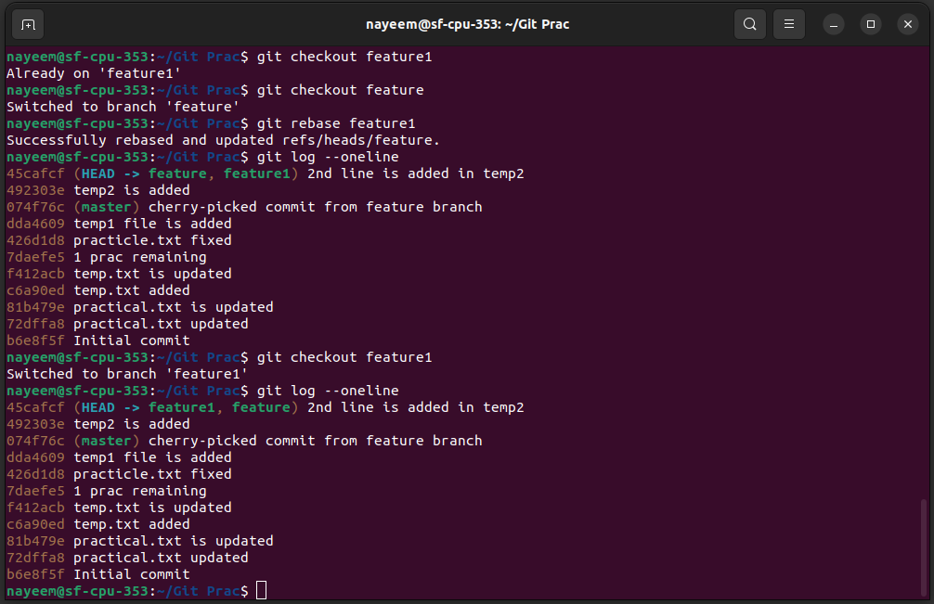

**3. Change commit message**

- We can change previous commit massage with the help of amend command.

- With this command we can change the commit massage of most recent commit.

- Syntax : git commit --amend. This will open default text-editor and allow you to change most recent commit massage of the most recent commit.

- We can also specify the new commit massage with “git commit --amend -m “New commit massage”.

- Amending commit will change SHA-1 of that commit and any commit that come after this branch.

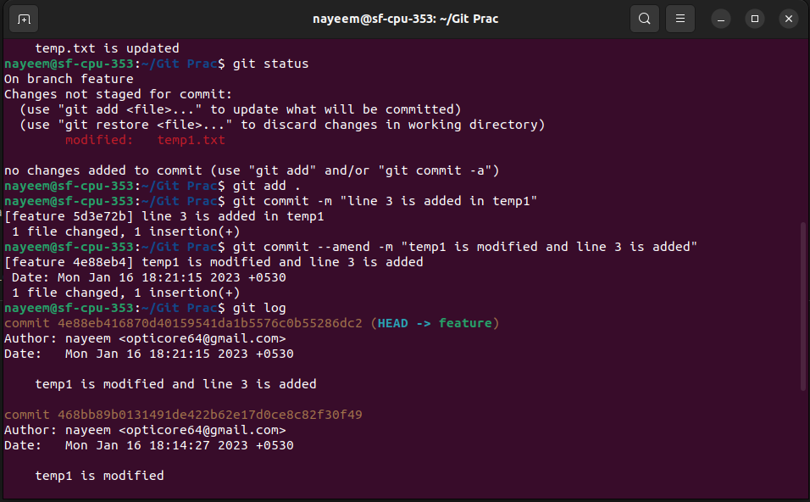

**4.Cherry Pick**

- With cherry pick we can select specific commit from one branch and apply it to another branch.

- It is use full when we want to apply changes made in one branch to another branch without merging the entire branch.

- First we need to switch to the branch where we want to apply changes then run command “git cherry-pick <comment hash>”(commit hash is the unique identifier of the commit).

-it will create a new commit.

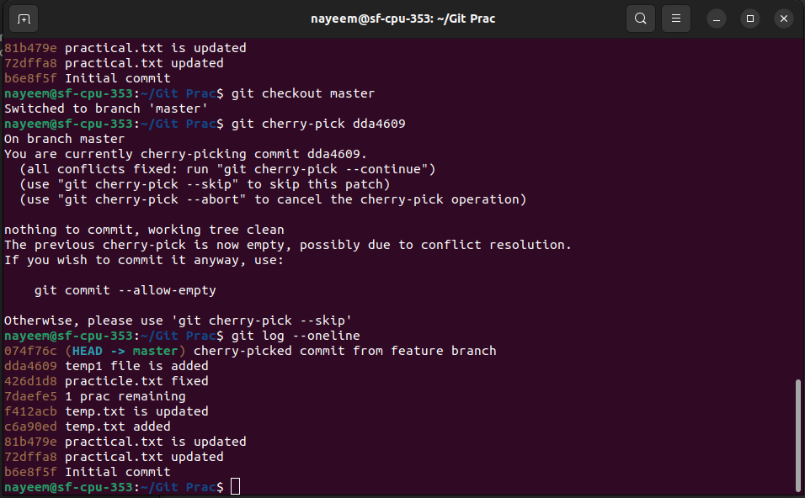

**5.Drop commit**

- Drop commit refer to act of permanently removing commit from repository’s history.

- We can use “git reset --hard <commit hash id>” for that.

- This command will remove all the commits that come after the specified commit and any changes made in those commits will be permanently lost.

