**Name: Dekawadiya Nayeem**

**Sub: MongoDB practical**

1.Batch Create with minimum 100 records in MongoDb (create batch).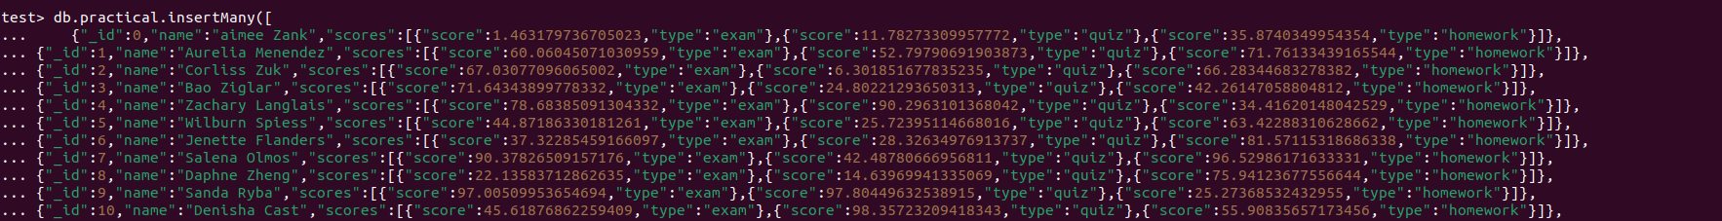

2. Batch Update with minimum 100 records in MongoDB (update batch).





3. Perform indexing on particular 3 fields in MongoDB.



4. Find duplicates using aggregation in MongoDB.



