**Name: Dekawadiya Nayeem**

**Sub: Sql practical**

**Table used:**

EmployeeInfo:

Create table EmployeeInfo (

EmpID serial Primary Key,

EmpFname varchar(12) not null,

EmpLname varchar(12) not null,

Department varchar(12),

Project varchar(5),

Address varchar(20),

DOB date not null,

Gender varchar(1) not null

);

EmployeePosition:  
  
Create table EmployeePosition (

EmpID int primary key,

EmpPosition varchar(15),

DateOfJoining date,

Salary int,

foreign key(EmpID) references EmployeeInfo(EmpID)

);

**Practical:**

1. Write a query to fetch the number of employees working in the department ‘Admin’.

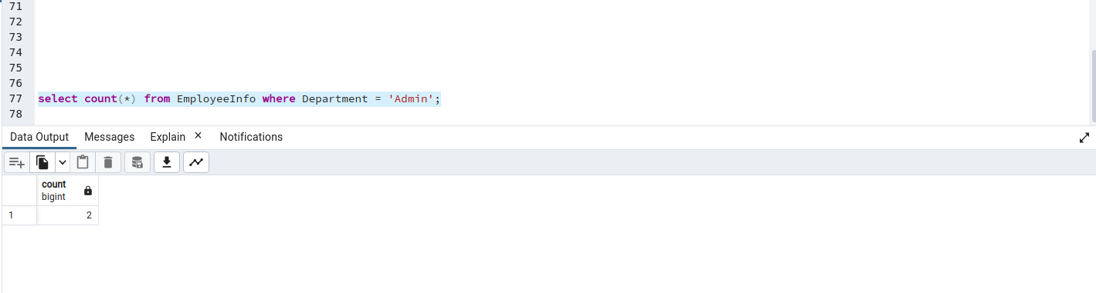

2. Write a query to retrieve the first four characters of EmpLname from the EmployeeInfo table.  
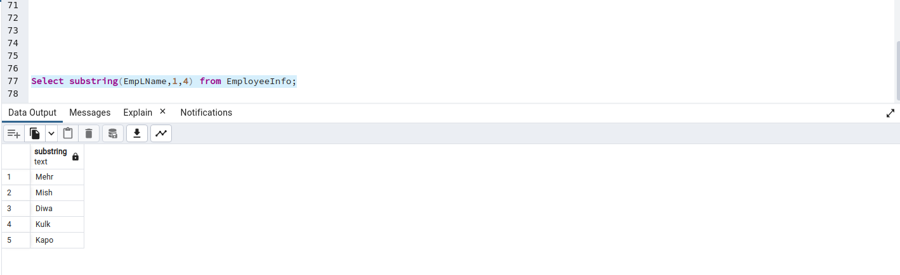

3. Write q query to find all the employees whose salary is between 50000 to 100000.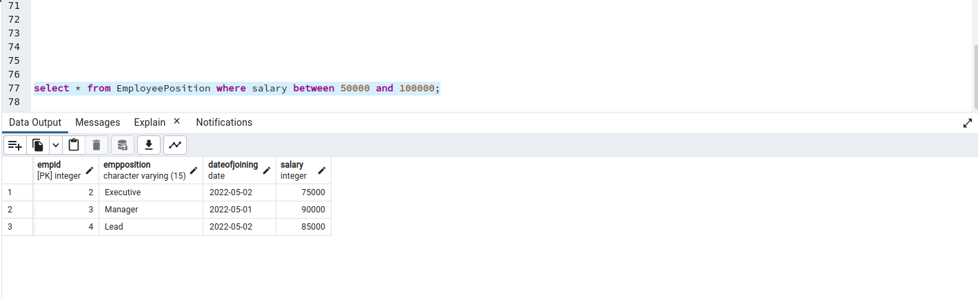

4. Write a query to find the names of employees that begin with ‘S’

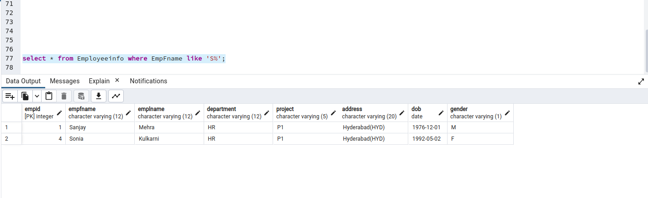

5. Write a query to fetch top N records order by salary. (ex. top 5 records)

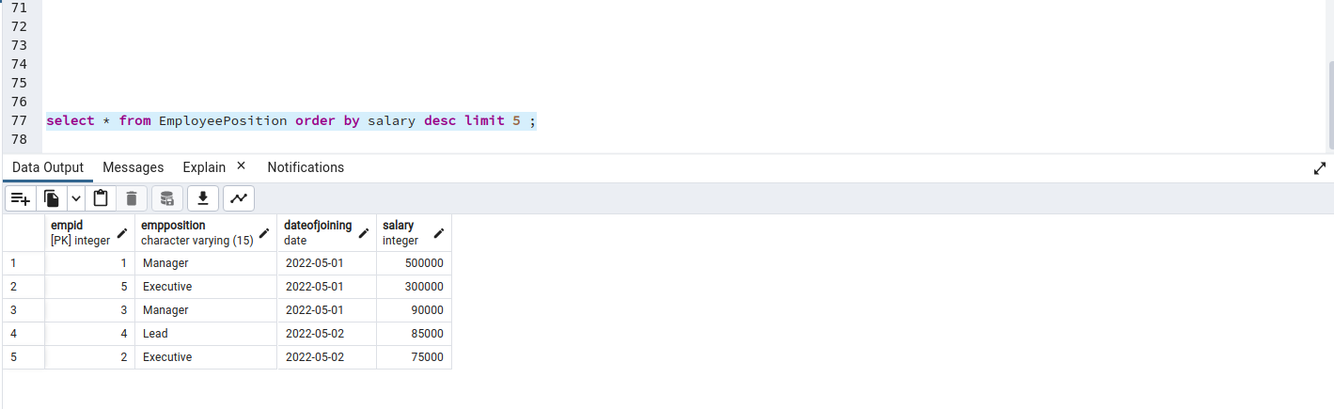

6. Write a query to fetch details of all employees excluding the employees with first names, “Sanjay” and “Sonia” from the EmployeeInfo table.

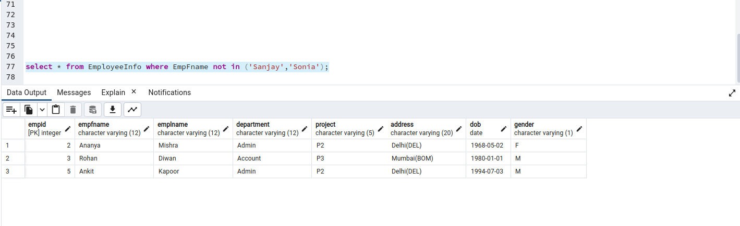

7. Write a query to fetch the department-wise count of employees sorted by department’s count in ascending order.

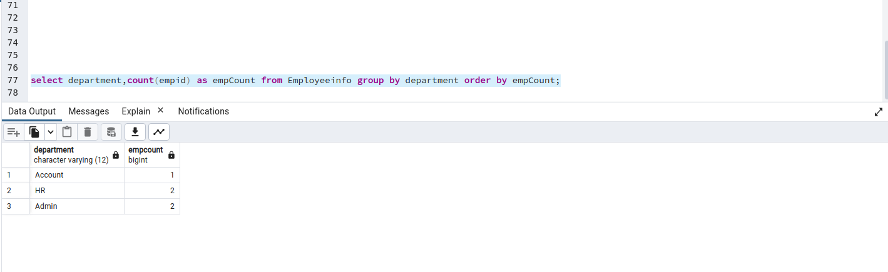

8.1 Create indexing for any particular field and show the difference in data fetching before and after indexing

(Record numbers are small so query optimizer will not use indexing for data retrieve).

Before indexing:  
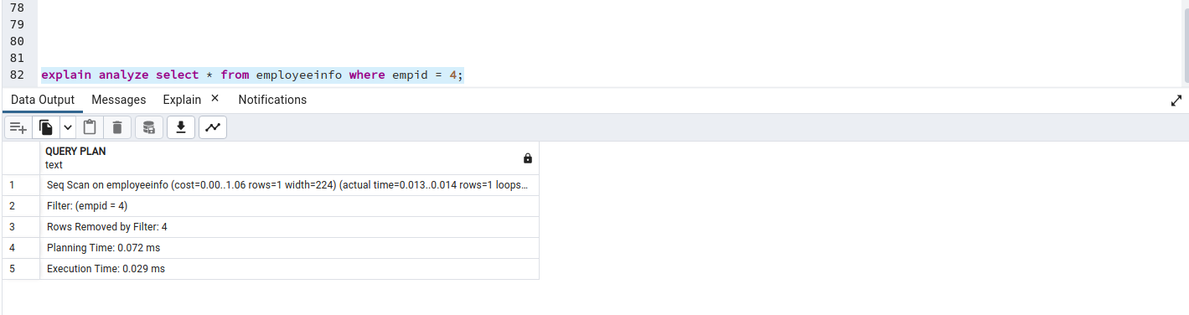

After Indexing:

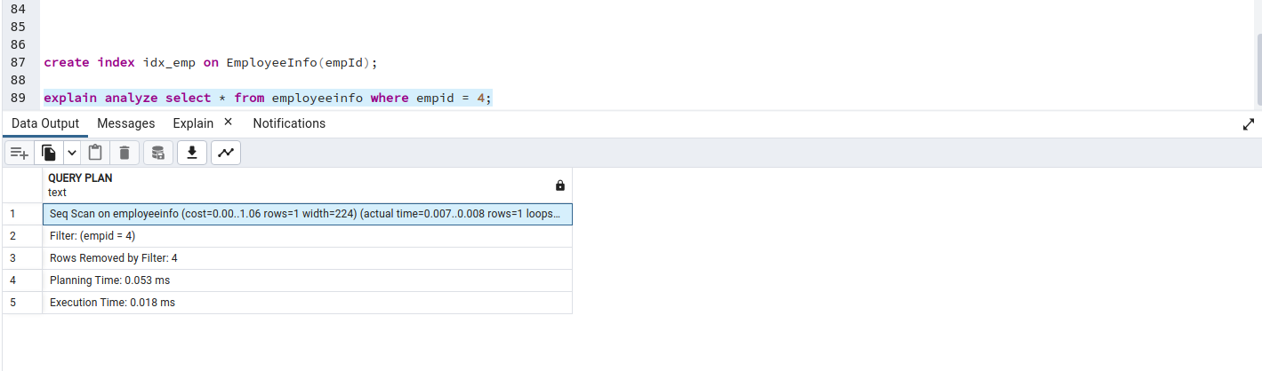

8.2 Create indexing for any particular field and show the difference in data fetching before and after indexing(with imported database : dvdrental)

Before indexing:  
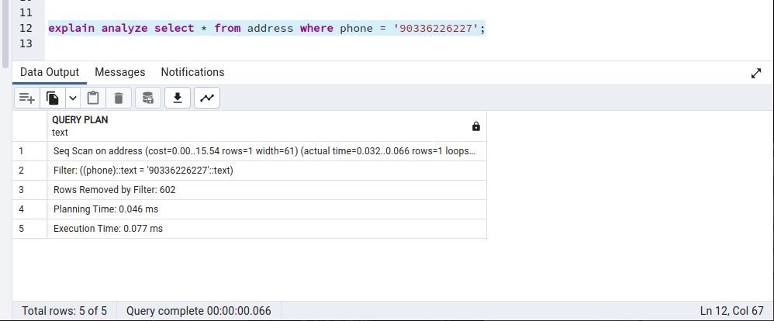

After indexing:

