PES UNIVERSITY, BANGALORE
Department of Computer Science and Engineering
SOFTWARE REQUIREMENTS SPECIFICATION
RAILWAY RESERVATION SYSTEM
Version 1.0
Prepared by Team 12
Parinitha Ramesh
Pranav S S
R Vinay
Dhriti Rajesh
October 2026

Table of Contents
1. Introduction
1.1 Purpose
1.2 Scope
1.3 Definitions, Acronyms, and Abbreviations
1.4 References
1.5 Overview
2. Overall Description
2.1 Product Perspective
2.2 Product Functions
2.3 User Characteristics
2.4 Operating Environment
2.5 Design and Implementation Constraints
2.6 Assumptions and Dependencies
3. Specific Requirements
3.1 External Interface Requirements
3.2 Functional Requirements
3.3 Non-Functional Requirements
3.4 Design Constraints
Analysis Models
Business Rules and Domain Requirements
Other Requirements
Appendix A: Glossary
Appendix B: Field Layouts
Appendix C: Requirement Traceability Matrix

Revision History
Name | Date | Reason For Changes | Version
Team 12 | October 2026 | Initial SRS preparation | 1.0
Team 12 | October 2026 | Reviewed and updated project requirements | 1.0

1. Introduction
1.1 Purpose
This Software Requirements Specification (SRS) defines the requirements for the Railway Reservation System, Version 1.0. The system is an academic software application intended to support railway ticket reservation and cancellation. This document describes the scope, users, interfaces, functional requirements, non-functional requirements, security requirements, constraints, assumptions, and data requirements of the system.
1.2 Scope
The Railway Reservation System will allow users to search for trains, view train and schedule information, check seat availability, book railway tickets, view existing reservations, and cancel reservations. The system will validate user input and maintain reservation information and status. The minimum project scope is limited to the booking and cancellation functions specified in the project statement, together with supporting search and reservation functions.
1.3 Definitions, Acronyms, and Abbreviations
Term | Definition
SRS | Software Requirements Specification
RRS | Railway Reservation System
User/Passenger | Person using the system to search, book, view, or cancel a reservation
Reservation | Record representing a railway ticket booking
Booking | Process of creating a railway reservation
Cancellation | Process of cancelling an existing railway reservation
Reservation Reference | Unique identifier used to identify a reservation
FR | Functional Requirement
NFR | Non-Functional Requirement
RTM | Requirement Traceability Matrix
UI | User Interface
1.4 References
• PES University, Department of Computer Science and Engineering, Software Requirements Specification template.
• PES University, Software Engineering Mini Project Part-1 Deliverables.
• Team 12 project statement: “A railway ticket reservation system with booking and cancellation features.”
1.5 Overview
• Section 1 introduces the system and defines its purpose and scope.
• Section 2 describes the overall system, users, environment, constraints, assumptions, and dependencies.
• Section 3 defines external interfaces and detailed functional and non-functional requirements.
• Appendix A provides a glossary; Appendix B defines data fields; Appendix C provides the Requirement Traceability Matrix.
2. Overall Description
2.1 Product Perspective
The Railway Reservation System is a self-contained academic software application. It accepts travel and passenger information from the user, processes reservation operations, and stores reservation data for later retrieval. The major logical functions are train search, train information, seat availability, booking, reservation viewing, cancellation, validation, and data storage.
2.2 Product Functions
• Search for trains using journey information.
• View train number, train name, source, destination, and schedule information.
• Check seat availability.
• Enter passenger details and book a ticket.
• Generate and display a unique reservation reference for a successful booking.
• View an existing reservation and its current status.
• Cancel an existing reservation.
• Update reservation status and seat availability after successful cancellation.
• Validate user input and display meaningful error messages.
2.3 User Characteristics
The primary user is a passenger with basic computer literacy. The passenger can search for trains, check availability, book tickets, view reservations, and cancel reservations. If administrative functionality is implemented later, an administrator may maintain train and schedule data; administrator functionality is not part of the minimum booking and cancellation scope.
2.4 Operating Environment
• Desktop or laptop computer.
• C or C++ compiler and development environment.
• Windows or Linux operating system.
• Local persistent storage selected by the project team.
2.5 Design and Implementation Constraints
1. The system shall be implemented using C or C++ as specified in the project statement.
2. The implementation shall be suitable for an academic Software Engineering mini-project.
3. User input shall be validated before processing.
4. Reservation, booking, cancellation, and seat-availability information shall remain consistent.
5. The source code shall be modular and maintainable.
2.6 Assumptions and Dependencies
1. Train and schedule information required by the application is available in the system data store.
2. Users provide valid information when making reservations.
3. The required local storage is accessible during system operation.
4. Train and seat information is maintained consistently.
5. The minimum project does not depend on a live railway reservation service unless the team explicitly implements such integration.
6. Payment gateway integration is outside the minimum scope unless implemented by the team.
7. Refund and cancellation-charge policies are not specified by the project statement and shall only be included if defined by the team.
3. Specific Requirements
3.1 External Interface Requirements
3.1.1 User Interfaces
The system shall provide a simple menu-driven or equivalent user interface with options for:
1. Search Train
2. View Train Details
3. Check Seat Availability
4. Book Ticket
5. View Reservation
6. Cancel Ticket
7. Exit
The system shall provide clear prompts, confirmation messages, and error messages for user operations.
3.1.2 Software Interfaces
The system shall use C/C++ standard libraries and the local storage mechanism selected by the project team. Reservation and train information shall be stored and retrieved consistently.
3.1.3 Communications Interfaces
The minimum project implementation does not require external network communication. If network communication is introduced later, the corresponding protocol, security, and data-transfer requirements shall be documented in a revised SRS.
3.1.4 Hardware Interfaces
No specialized hardware interface is required. The system shall operate on a standard desktop or laptop computer capable of running the selected C/C++ development environment.
3.2 Functional Requirements
3.2.1 Train Search
Priority: High.
Stimulus/Response Sequence
1. User enters journey details.
2. System validates search inputs.
3. System searches train data.
4. System displays matching trains or a no-results message.
Functional Requirements
FR-001: The system shall allow the user to enter source and destination stations.
FR-002: The system shall allow the user to enter the required journey date.
FR-003: The system shall display trains matching the supplied search criteria.
FR-004: The system shall display an appropriate message when no matching train is available.
FR-005: The system shall reject incomplete or invalid search inputs.
3.2.2 Train and Schedule Information
Priority: High.
Stimulus/Response Sequence
1. User selects a train.
2. System retrieves train information.
3. System displays the requested train information.
Functional Requirements
FR-006: The system shall display the train number and train name.
FR-007: The system shall display the source and destination stations.
FR-008: The system shall display available departure and arrival information.
FR-009: The system shall display available seat information for the selected train.
3.2.3 Ticket Booking
Priority: High.
Stimulus/Response Sequence
1. User selects a train.
2. System displays booking information.
3. User enters passenger details.
4. System validates information and checks seat availability.
5. System creates the reservation if conditions are satisfied.
6. System generates a reservation reference and displays confirmation.
Functional Requirements
FR-010: The system shall allow the user to select a train for booking.
FR-011: The system shall collect the required passenger details.
FR-012: The system shall validate mandatory passenger information before creating a reservation.
FR-013: The system shall verify seat availability before confirming a booking.
FR-014: The system shall reject a booking request when the required seat is unavailable.
FR-015: The system shall create a unique reservation reference for each successful booking.
FR-016: The system shall store passenger and reservation information after successful booking.
FR-017: The system shall display confirmation details after successful booking.
FR-018: The system shall display an appropriate error message if the booking cannot be completed.
3.2.4 View Reservation
Priority: High.
Stimulus/Response Sequence
1. User enters reservation reference.
2. System validates the reference.
3. System searches stored reservations.
4. System displays reservation details or an error message.
Functional Requirements
FR-019: The system shall allow the user to enter the required reservation reference.
FR-020: The system shall search for the reservation using the supplied reservation information.
FR-021: The system shall display reservation details when a matching reservation is found.
FR-022: The system shall display an appropriate error message when the reservation cannot be found.
FR-023: The system shall display the current reservation status.
3.2.5 Ticket Cancellation
Priority: High.
Stimulus/Response Sequence
1. User selects cancellation.
2. System requests reservation reference.
3. User enters reference.
4. System validates the reservation and displays details.
5. User confirms cancellation.
6. System updates status and applicable seat availability.
7. System displays cancellation confirmation.
Functional Requirements
FR-024: The system shall allow the user to request cancellation of an existing reservation.
FR-025: The system shall require the reservation reference or other required reservation information before processing cancellation.
FR-026: The system shall verify that the specified reservation exists.
FR-027: The system shall display reservation details before final cancellation confirmation.
FR-028: The system shall require user confirmation before completing cancellation.
FR-029: The system shall update the reservation status after successful cancellation.
FR-030: The system shall update corresponding seat availability after successful cancellation where applicable.
FR-031: The system shall reject cancellation when the reservation cannot be identified.
FR-032: The system shall prevent an already cancelled reservation from being cancelled again.
FR-033: The system shall display a cancellation confirmation after successful cancellation.
FR-034: The system shall display an appropriate error message when cancellation cannot be completed.
3.2.6 Input Validation and Error Handling
Priority: High.
Stimulus/Response Sequence
1. User enters data.
2. System validates the data.
3. System processes valid input or displays an error for invalid input.
4. User can correct the input.
Functional Requirements
FR-035: The system shall validate mandatory user inputs before processing an operation.
FR-036: The system shall reject invalid reservation references.
FR-037: The system shall reject invalid or incomplete passenger information.
FR-038: The system shall display a meaningful error message for invalid input.
FR-039: The system shall allow the user to correct invalid input without terminating the complete application.
3.3 Non-Functional Requirements
3.3.1 Performance Requirements
• NFR-001: For normal local operations, the system should respond to user actions within 2 seconds under normal operating conditions.
• NFR-002: Booking and cancellation operations shall complete without unnecessary delay.
• NFR-003: The system shall maintain consistent reservation information after every successful booking or cancellation.
3.3.2 Safety Requirements
• SAF-001: The system shall not control railway operation or railway safety systems.
• SAF-002: The system shall clearly distinguish reservation information from railway operational information.
• SAF-003: The system shall not confirm a reservation when required booking conditions are not satisfied.
3.3.3 Security Requirements
Security Objectives:
• SO-001: Protect reservation and passenger information from unauthorized modification or inappropriate access within the implemented system.
• SO-002: Ensure that reservation operations such as viewing and cancellation are performed only after required reservation information has been validated.
• SO-003: Maintain the integrity and consistency of reservation records during booking and cancellation.
Security Requirements:
• SEC-001: The system shall validate reservation identifiers before allowing reservation-related operations.
• SEC-002: The system shall not allow cancellation when the specified reservation cannot be identified.
• SEC-003: The system shall not expose unnecessary passenger or reservation information in error messages.
• SEC-004: The system shall prevent invalid input from directly modifying reservation records.
• SEC-005: The system shall maintain consistent reservation status after booking and cancellation operations.
3.3.4 Software Quality Attributes
• NFR-004 Usability: The system shall provide clear and understandable menu options and prompts.
• NFR-005 Reliability: The system shall not create duplicate reservation references for separate reservations.
• NFR-006 Data Integrity: The system shall maintain consistent reservation information during booking and cancellation.
• NFR-007 Maintainability: The implementation shall use modular functions for major operations.
• NFR-008 Testability: Major functions such as search, booking, viewing, and cancellation shall be independently testable.
• NFR-009 Robustness: The system shall handle invalid user input without unexpected termination.
• NFR-010 Portability: The implementation should avoid unnecessary dependence on platform-specific features.
3.4 Design Constraints
1. The system shall be implemented using C/C++.
2. The implementation shall follow the requirements specified in this SRS.
3. The system shall use appropriate data structures for trains, passengers, and reservations.
4. The implementation shall maintain consistency between booking, cancellation, and seat availability.
5. The implementation shall provide input validation and error handling.
6. The implementation shall use modular and readable code.
Analysis Models
The primary actor is the User/Passenger. The principal use cases are Search Train, View Train Details, Check Seat Availability, Book Ticket, View Reservation, and Cancel Ticket.
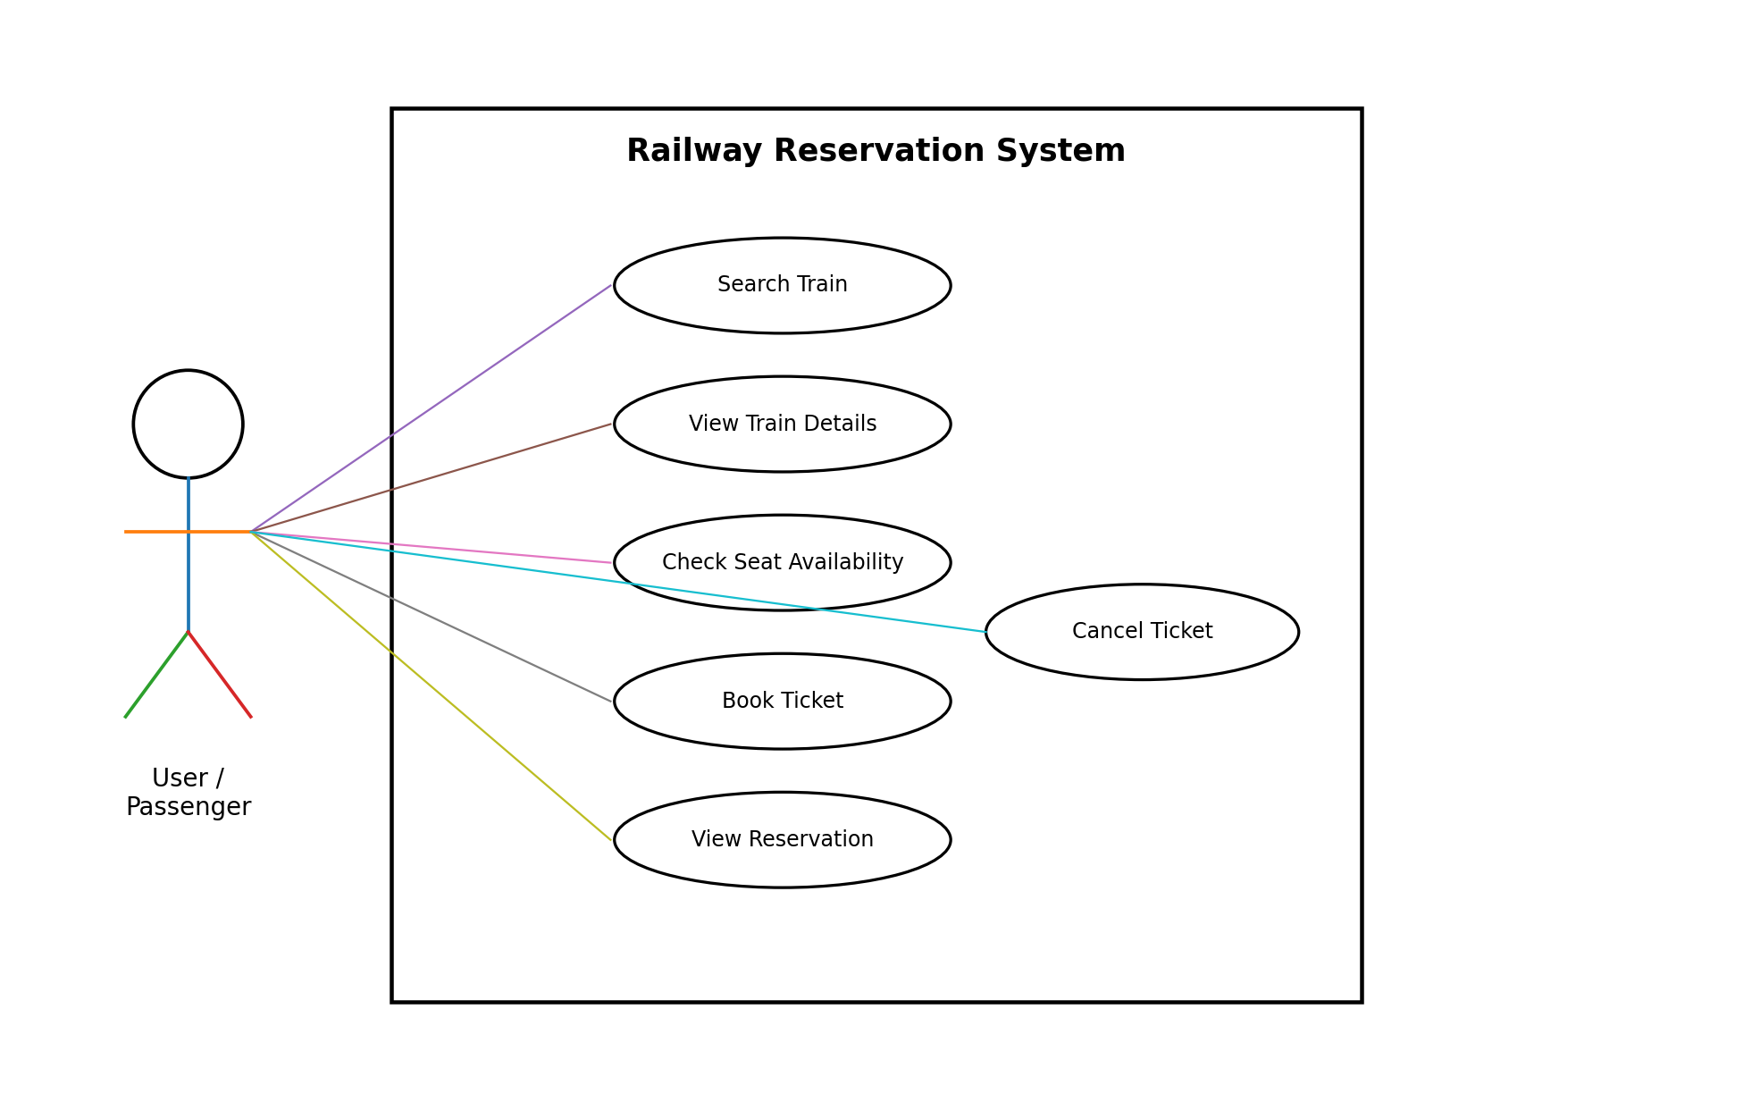
Figure 1: UML Use Case Diagram – Railway Reservation System
Business Rules and Domain Requirements
• BR-001: Each successful reservation shall have a unique reservation reference.
• BR-002: A reservation shall be associated with the selected train and passenger information.
• BR-003: A reservation shall not be confirmed if the required seat availability condition is not satisfied.
• BR-004: A successfully cancelled reservation shall have its status updated accordingly.
• BR-005: A cancelled reservation shall not be processed as an active reservation.
• BR-006: The system shall maintain consistency between reservation status and available seat information.
• BR-007: Cancellation and refund policies, if implemented, shall follow rules defined and approved by the project team.
Other Requirements
• The system shall maintain sufficient data for train identification, passenger information, reservation identification, journey details, seat information, and reservation status.
• Reservation information shall be stored so that it can be retrieved for subsequent operations, subject to the storage mechanism selected by the team.
• The minimum project does not require internationalization or external payment integration.
Appendix A: Glossary
Term | Meaning
Booking | Creation of a railway reservation
Cancellation | Cancellation of an existing railway reservation
Passenger | Person for whom a reservation is created
Reservation Reference | Unique identifier assigned to a reservation
Seat Availability | Number or status of seats available for reservation
Functional Requirement | Requirement describing a function the system must perform
Non-Functional Requirement | Requirement describing a quality or constraint
RTM | Requirement Traceability Matrix
Appendix B: Field Layouts
The following fields represent the minimum data required by the proposed Railway Reservation System.
Field | Length | Data Type | Description | Is Mandatory
Train Number | 10 | Alphanumeric | Unique train identifier | Y
Train Name | 60 | String | Name of train | Y
Source | 60 | String | Starting station | Y
Destination | 60 | String | Destination station | Y
Journey Date | 10 | Date | Date of journey | Y
Departure Time | 8 | Time | Scheduled departure time | Y
Arrival Time | 8 | Time | Scheduled arrival time | Y
Available Seats | 5 | Numeric | Number of available seats | Y
Passenger Name | 60 | String | Passenger name | Y
Age | 3 | Numeric | Passenger age | Y
Gender | 20 | String | Passenger gender | Y
Contact Information | 20 | String | Passenger contact information | N
Reservation Reference | 20 | Alphanumeric | Unique reservation identifier | Y
Seat Information | 10 | Alphanumeric | Allocated seat information | Y
Reservation Status | 20 | String | Current status of reservation | Y
Appendix C: Requirement Traceability Matrix
Architecture, design, code, and test references are marked TBD until the corresponding project artifacts are completed.
Sl. No. | Requirement ID | Brief Description | Architecture Reference | Design Reference | Code File Reference | Test Case ID | System Test Case ID
1 | FR-001 | Enter source and destination | TBD | TBD | TBD | TBD | TBD
2 | FR-003 | Display matching trains | TBD | TBD | TBD | TBD | TBD
3 | FR-010 | Select train for booking | TBD | TBD | TBD | TBD | TBD
4 | FR-013 | Verify seat availability | TBD | TBD | TBD | TBD | TBD
5 | FR-015 | Generate reservation reference | TBD | TBD | TBD | TBD | TBD
6 | FR-019 | Enter reservation reference | TBD | TBD | TBD | TBD | TBD
7 | FR-023 | Display reservation status | TBD | TBD | TBD | TBD | TBD
8 | FR-024 | Request cancellation | TBD | TBD | TBD | TBD | TBD
9 | FR-026 | Verify reservation exists | TBD | TBD | TBD | TBD | TBD
10 | FR-028 | Confirm cancellation | TBD | TBD | TBD | TBD | TBD
11 | FR-029 | Update reservation status | TBD | TBD | TBD | TBD | TBD
12 | FR-030 | Update seat availability | TBD | TBD | TBD | TBD | TBD
13 | SEC-001 | Validate reservation identifier | TBD | TBD | TBD | TBD | TBD
14 | SEC-004 | Prevent invalid data modification | TBD | TBD | TBD | TBD | TBD
15 | NFR-001 | Response time requirement | TBD | TBD | TBD | TBD | TBD

Document status: Draft for Team 12 review before submission.

