PES UNIVERSITY, BANGALORE
Department of Computer Science and Engineering

SOFTWARE ARCHITECTURE AND DESIGN SPECIFICATION
RAILWAY RESERVATION SYSTEM

Version 1.0
Prepared by Team 12
Parinitha Ramesh
Pranav S S
R Vinay
Dhriti Rajesh
October 2026

Document Control
Version | Date | Author | Change Summary
1.1 | October 2026 | Team 12 | Audited architecture/design for Part-1 consistency and traceability

Role | Name | Signature/Date
Team Representative
Project Instructor

1. Introduction

1.1 Purpose
This Software Architecture and Design Specification (SAD) describes the proposed architecture, components, design interactions, interfaces, security considerations, and error-handling approach for the Railway Reservation System, Version 1.0. It translates the requirements defined in the Software Requirements Specification (SRS) into a software structure suitable for implementation in C/C++.

1.2 Scope
The system supports train search, train and schedule information, seat availability, ticket booking, reservation viewing, ticket cancellation, input validation, and reservation data management. The minimum implementation is a local academic application and does not require live railway-service integration or external payment integration.

1.3 Audience
The intended audience includes the project team, software developers, testers, instructors, and reviewers who need to understand the structure and design of the Railway Reservation System.

1.4 Definitions
- SRS – Software Requirements Specification.
- SAD – Software Architecture and Design Specification.
- Reservation Reference – Unique identifier assigned to a successful reservation.
- Passenger – User who searches, books, views, or cancels a reservation.
- UI – User Interface.

2. Document Overview

2.1 How to Use This Document
Section 3 describes the architecture, component responsibilities, selected architecture pattern, technology constraints, requirement traceability, and security architecture. Section 4 describes the detailed design, including sequence diagrams, module interfaces, and error handling.

2.2 Related Documents
- Railway Reservation System – Software Requirements Specification, Version 1.0.
- Software Engineering Mini-Project Deliverables Part-1.
- Software Architecture and Design Specification template supplied for the mini-project.

3. Architecture

3.1 Goals & Constraints
Architecture goals:
- Separate user interaction, business operations, validation, and data management.
- Maintain consistency between reservation status and seat availability.
- Make major functions independently testable and maintainable.
- Support reliable booking and cancellation operations.
Constraints:
- The implementation shall use C or C++.
- The minimum implementation is intended for a local desktop/laptop environment.
- The system uses local storage selected by the project team.
- No live railway-service or payment-gateway integration is required by the minimum scope.

3.2 Stakeholders & Concerns
Stakeholder | Primary Concern
Passenger/User | Simple search, booking, reservation viewing, and cancellation.
Project Team | Modular, readable, maintainable C/C++ implementation.
Tester | Clear interfaces, predictable errors, and traceable requirements.
Instructor/Reviewer | Consistency between SRS, architecture, design, implementation, and testing.

3.3 Component (UML) Diagram
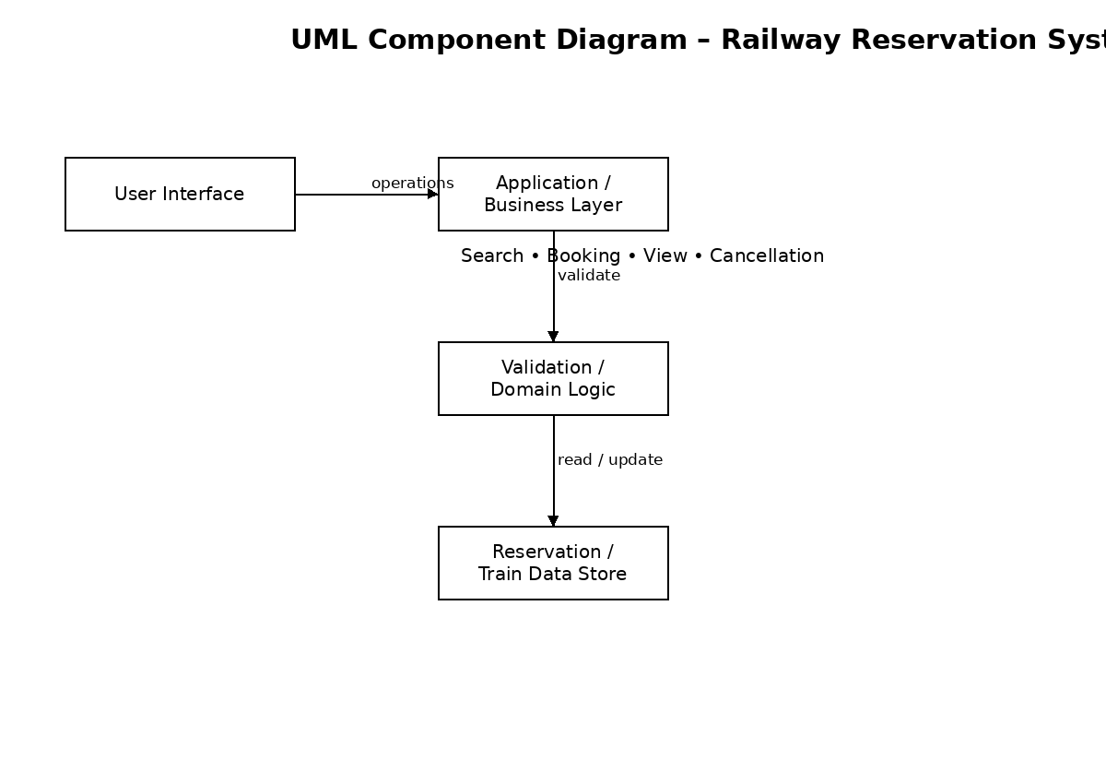
Figure 1: UML Component Diagram – Railway Reservation System

3.4 Component Descriptions
Component | Responsibility
User Interface | Provides the menu-driven interaction, collects user input, displays train/reservation information, and displays confirmations and errors.
Validation / Error Handling | Validates mandatory inputs, reservation references, passenger information, and operation-specific input before processing.
Train Module | Searches train data, provides train and schedule information, and reports seat availability.
Booking Module | Checks availability, creates reservations, generates unique reservation references, and stores booking information.
Cancellation Module | Finds reservations, confirms cancellation, updates reservation status, and triggers the required seat-availability update.
Reservation / Train Data Store | Stores and retrieves train, passenger, reservation, journey, seat, and reservation-status information using the local storage mechanism selected by the team.

3.5 Chosen Architecture Pattern and Rationale
Proposed architecture pattern: Layered Architecture. This is a design decision for the project and is not a separate requirement from the SRS. The component relationships follow presentation → application/business → validation/domain → data management.
The system is organized into a presentation layer, application/business layer, validation and domain logic, and data-management layer. The pattern is appropriate for the academic system because it separates user interaction from reservation processing and storage, supports modular testing, and makes future changes to the storage mechanism less disruptive to the user interface.
- Presentation Layer – menu and user interaction.
- Application/Business Layer – search, booking, viewing, and cancellation operations.
- Validation/Domain Logic – input validation, reservation rules, and consistency checks.
- Data Management Layer – train and reservation data storage/retrieval.

3.6 Technology Stack & Data Stores
- Implementation language: C or C++.
- Execution environment: standard desktop/laptop running Windows or Linux.
- User interface: menu-driven or equivalent local interface.
- Storage: local persistent storage selected by the project team.
- Design/documentation tools: UML diagrams may be prepared using a diagramming tool such as draw.io or PlantUML.

3.7 Risks & Mitigations
Risk | Mitigation
Inconsistent seat count after booking/cancellation | Update reservation status and seat availability as part of the same operation and test both flows.
Invalid user input | Validate input before invoking booking, viewing, or cancellation operations.
Duplicate reservation references | Generate references through a controlled unique-reference function and test uniqueness.
Storage failure or inaccessible data | Check storage access and display an appropriate error rather than silently completing an operation.

3.8 Traceability to Requirements
SRS Requirement | Architecture Component | Reason
FR-001 / FR-003 | Train Module | Accepts search criteria and returns matching trains.
FR-009 / FR-013 | Train Module + Booking Module | Provides and verifies seat availability.
FR-015 / FR-016 | Booking Module + Data Store | Creates a unique reference and stores reservation data.
FR-019 / FR-021 | UI + Data Store | Retrieves and displays an existing reservation.
FR-024 / FR-029 | Cancellation Module + Data Store | Processes cancellation and updates reservation status.
FR-030 | Cancellation Module + Train/Data Store | Updates available seats after successful cancellation.
SEC-001 / SEC-004 | Validation / Error Handling | Validates identifiers and prevents invalid data modification.
NFR-007 / NFR-008 | All modular components | Supports maintainability and independent testing.
FR-020 / FR-021 / FR-023 | User Interface + Data Store | Retrieves reservation by reference and displays details/status.
FR-035 / FR-036 / FR-038 / FR-039 | Validation / Error Handling | Validates inputs and supports correction without termination.
SEC-003 / SEC-005 | Validation / Error Handling + Data Store | Limits error information and preserves reservation/seat consistency.
NFR-001 / NFR-002 / NFR-003 | Application modules + Data Store | Supports response-time and successful-operation consistency.

3.9 Security Architecture
Security architecture is focused on the security objectives and requirements defined in the SRS for the local academic application.
- Reservation identifier validation is performed before reservation-related operations.
- Cancellation is rejected when the reservation cannot be identified.
- Error messages avoid exposing unnecessary passenger or reservation information.
- Invalid input is validated before it can modify reservation records.
- Reservation status and seat availability are kept consistent after booking and cancellation.

4. Design

4.1 Design Overview
The detailed design follows the proposed layered architecture. The UI invokes application operations; the relevant module validates inputs and applies the reservation business rules; the data-management component retrieves or updates persistent data; and the result is returned to the UI for display.

4.2 UML Sequence Diagrams
Sequence Diagram 1 – Ticket Booking
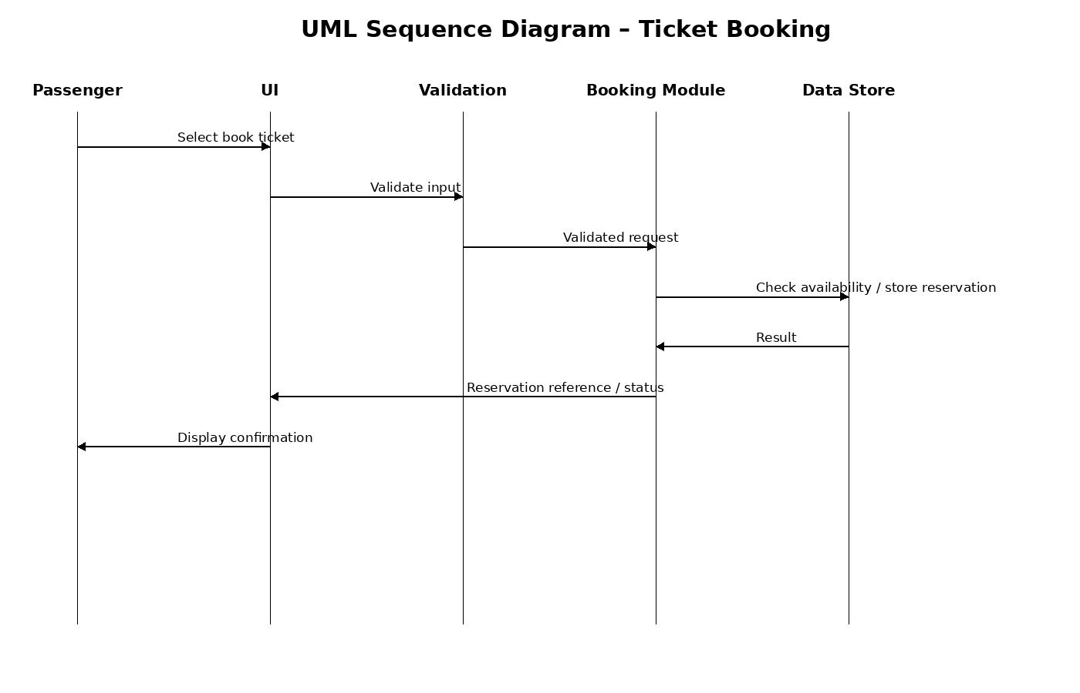
Figure 2: UML Sequence Diagram – Ticket Booking
Sequence Diagram 2 – Ticket Cancellation
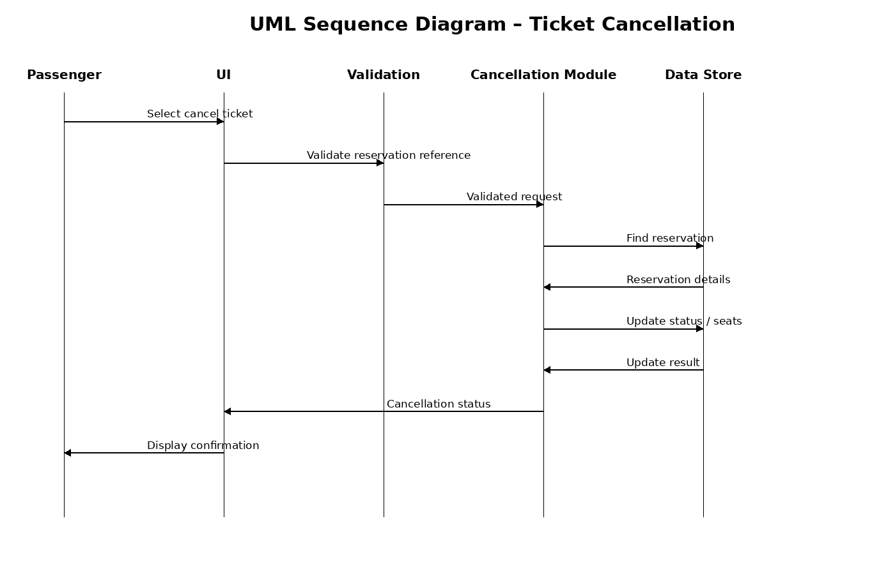
Figure 3: UML Sequence Diagram – Ticket Cancellation

4.3 API / Module Interface Design
Because the minimum project is a local C/C++ application rather than a network service, the term API is treated as module-level function interfaces. The final function signatures may be refined during implementation.
Component | Interface | Input | Output / Result
Train Module | searchTrain(source, destination, date) | Source, destination, journey date | Matching trains or no-results status
Train Module | checkAvailability(trainId, date) | Train identifier, journey date | Available-seat information
Booking Module | bookTicket(trainId, passengerDetails) | Train identifier, passenger details | Reservation reference / booking status
Cancellation Module | cancelTicket(reservationRef) | Reservation reference | Cancellation status and updated availability
Reservation/View Module | viewReservation(reservationRef) | Reservation reference | Reservation details / current status

4.4 Error Handling, Logging & Monitoring
- Invalid search input: reject the request and prompt the user to correct the input.
- No matching train: display a no-results message without terminating the application.
- No available seat: reject the booking and display an appropriate message.
- Invalid reservation reference: reject the operation and display an appropriate error.
- Already cancelled reservation: prevent a second cancellation.
- Storage/data access failure: do not confirm an operation that could not be stored successfully.
- The implementation should avoid storing unnecessary sensitive information in diagnostic output.

4.5 UX Design
- Use clear numbered menu options for major operations.
- Use explicit prompts for source, destination, journey date, passenger details, and reservation reference.
- Display confirmation before final cancellation.
- Display clear success and error messages.
- Allow users to correct invalid input without terminating the complete application.

4.6 Open Issues & Next Steps
- Finalize the exact local storage mechanism and corresponding data structures.
- Implement the modules and interfaces described in this document.
- The Test Plan and planned test cases are now included; execute them after implementation and update results/traceability.
- Update the SRS Requirement Traceability Matrix with final architecture, design, code, and test references.
- Validate the final implementation against the SRS requirements.

5. Appendices

5.1 Glossary
Term | Meaning
Booking | Creation of a railway reservation.
Cancellation | Cancellation of an existing railway reservation.
Passenger | Person for whom a reservation is created.
Reservation Reference | Unique identifier assigned to a reservation.
Seat Availability | Number or status of seats available for reservation.
SRS | Software Requirements Specification.
SAD | Software Architecture and Design Specification.

5.2 References
- PES University, Software Engineering Mini-Project Deliverables Part-1.
- PES University, Software Architecture and Design Specification template.
- Team 12 – Railway Reservation System SRS, Version 1.0.

5.3 Tools
- C/C++ compiler and development environment.
- draw.io or PlantUML for UML diagrams.
- Microsoft Word or equivalent document editor.

