Model Description

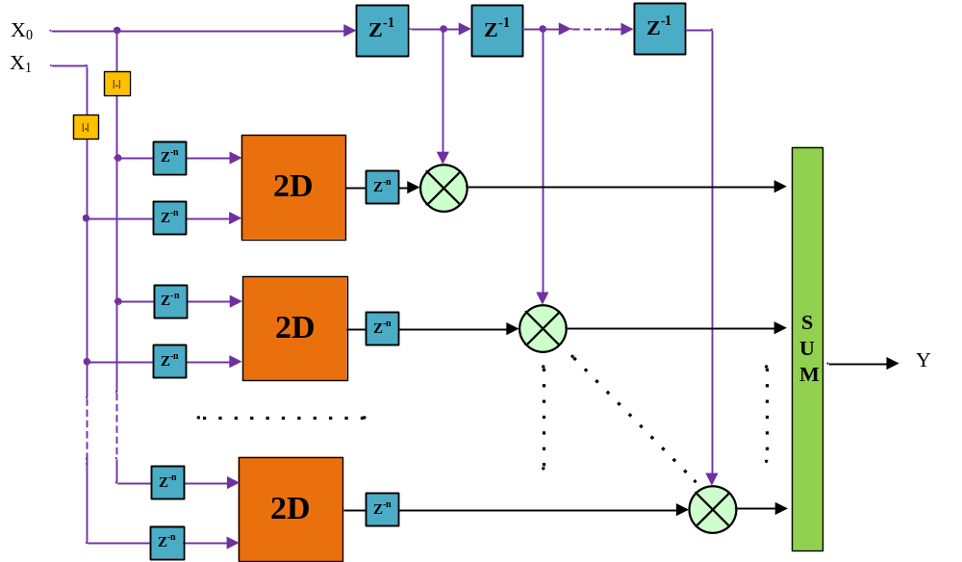

$$y\left(k\right)=\sum_{θ∈[s,u,v,l]}{x_{0}\left(k-s\right)\sum_{n=0}^{N-1}{\sum_{p=0}^{P-1}{c_{n,p}{Basis}_{0}\left(\left|x_{0}\left(k-u-l\right)\right|\right){Basis}_{1}\left(\left|x_{1}\left(k-v-l\right)\right|\right)}}}$$
Where k – discrete time, sample number,
s, u, v ,l – fixed discrete delay defined Model Matrix (structure)
N, P - number of the basis function for each direction i.e. two dimension function here
Basis – Orthogonal basis function like Splines, Chebyshev or Bernstein polynomials or etc.
For example:
PartModel = [0 2 -1 1 2 0 8 3 0 1 1 10 0 -2 2; %s
1 2 0 1 1 0 0 1 1 2 -1 0 2 0 2; %l
-1 -2 -1 0 1 1 4 2 0 -2 0 0 0 -2 -1; %u
0 1 1 0 1 0 0 1 0 0 1 1 0 1 1];%v

N = P = 8;

