21.Design DFA using simulator to accept eve number of a’s.

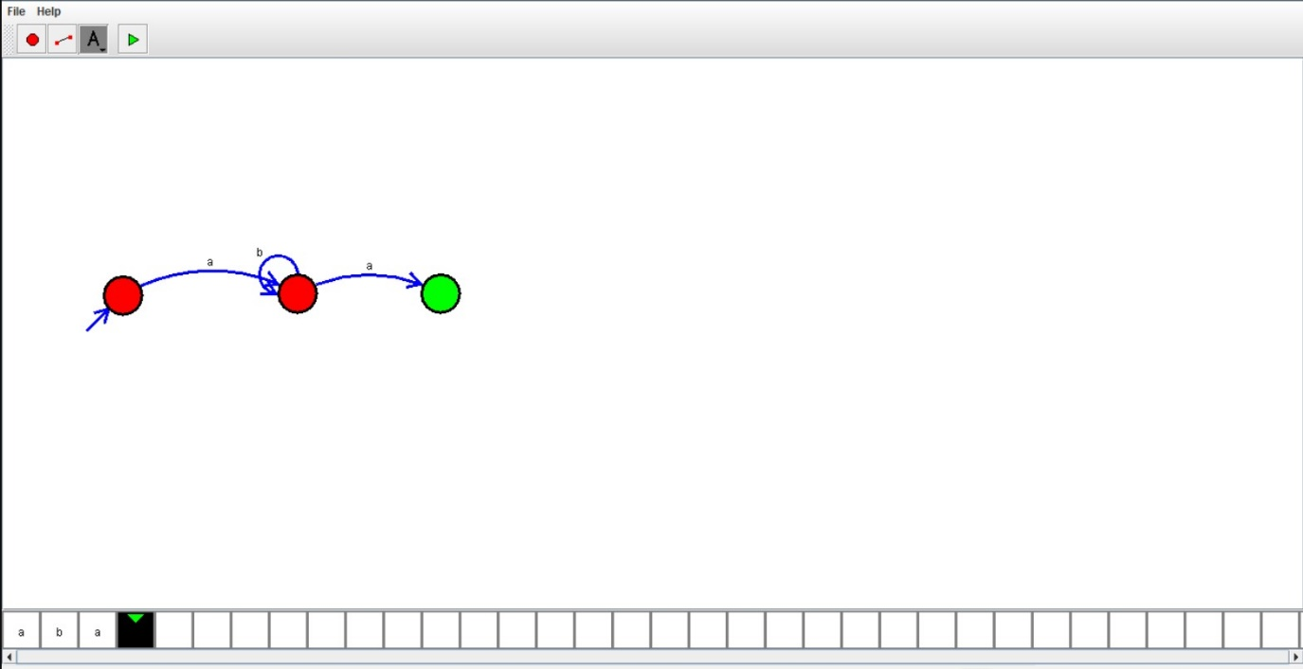

Tuning Machine For Substraction

W=aaa-aa

The Result of the substraction is = a

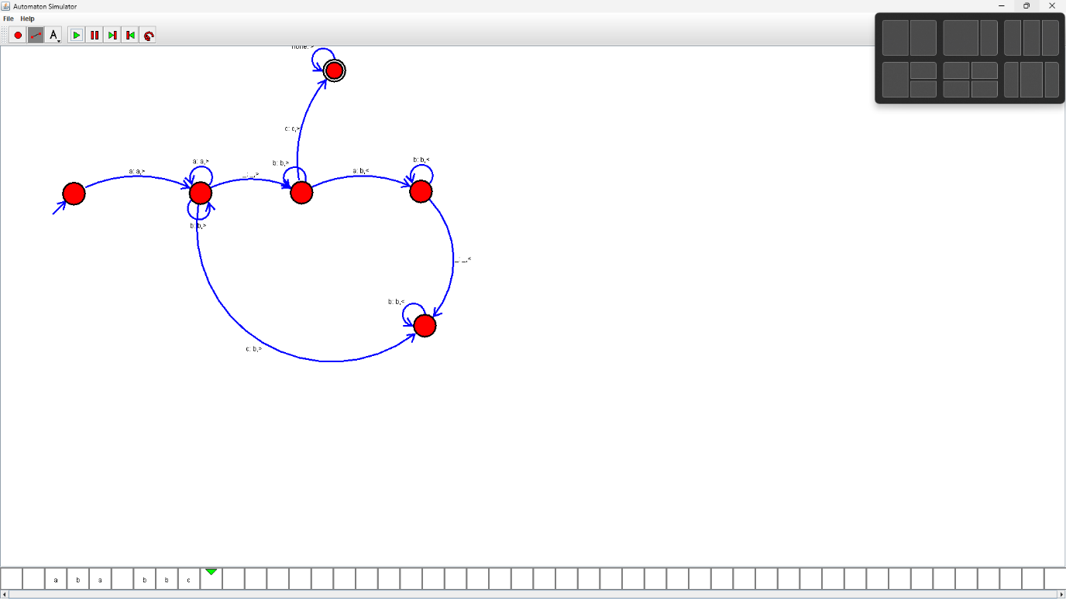

Design TM for the addition of following

W=aa+aaaaa

After Addition of a’s=aaaaaa

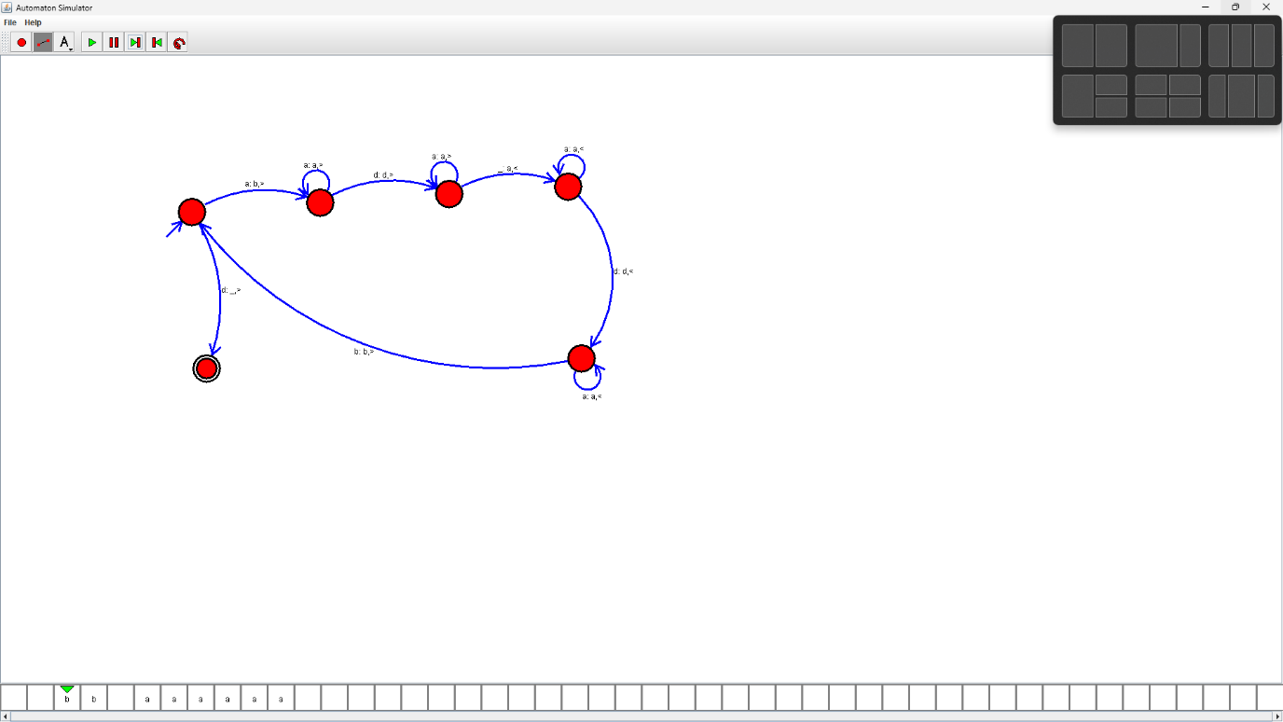

18.Design TM using simulator to accept the input string ww

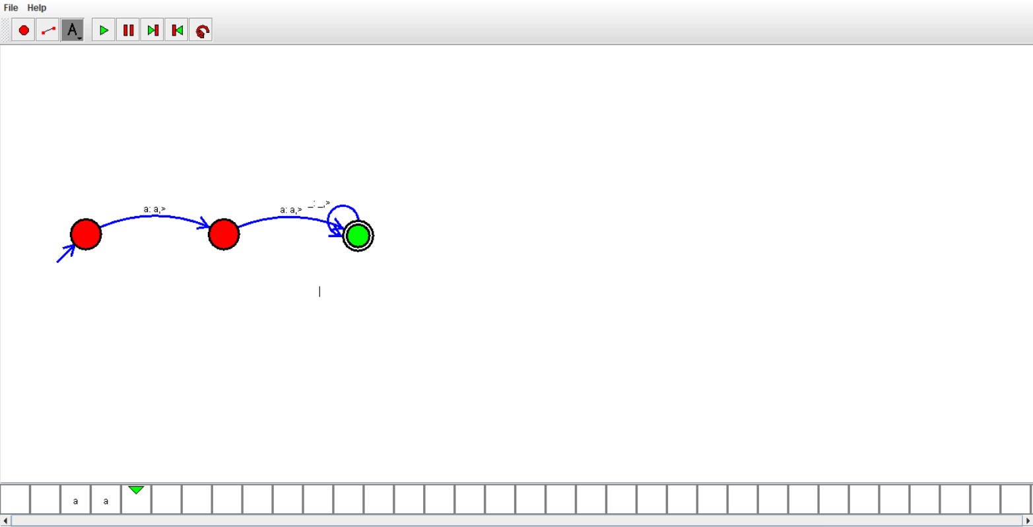

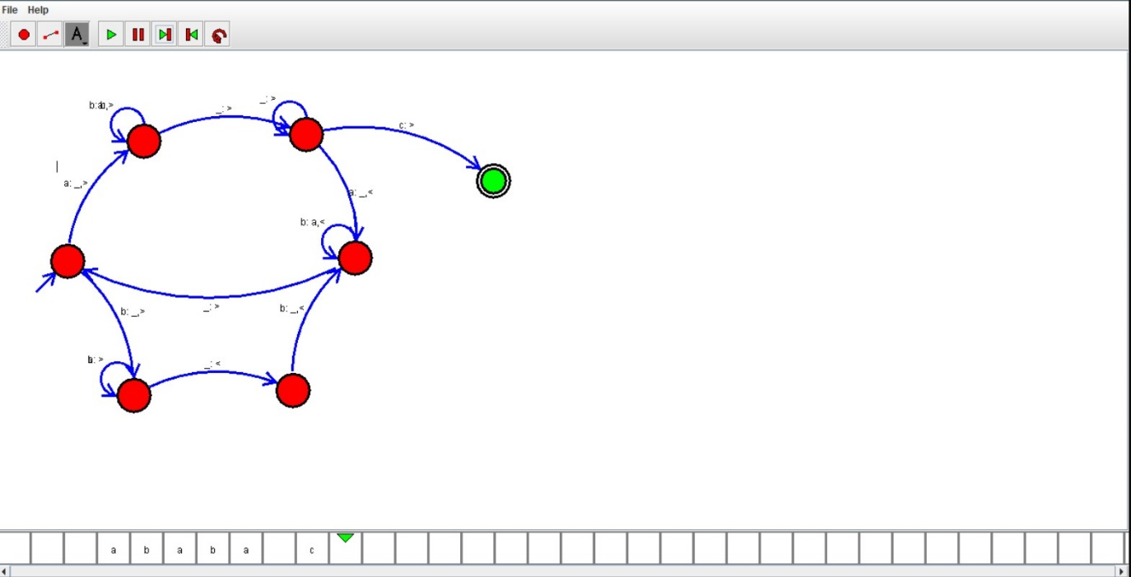

*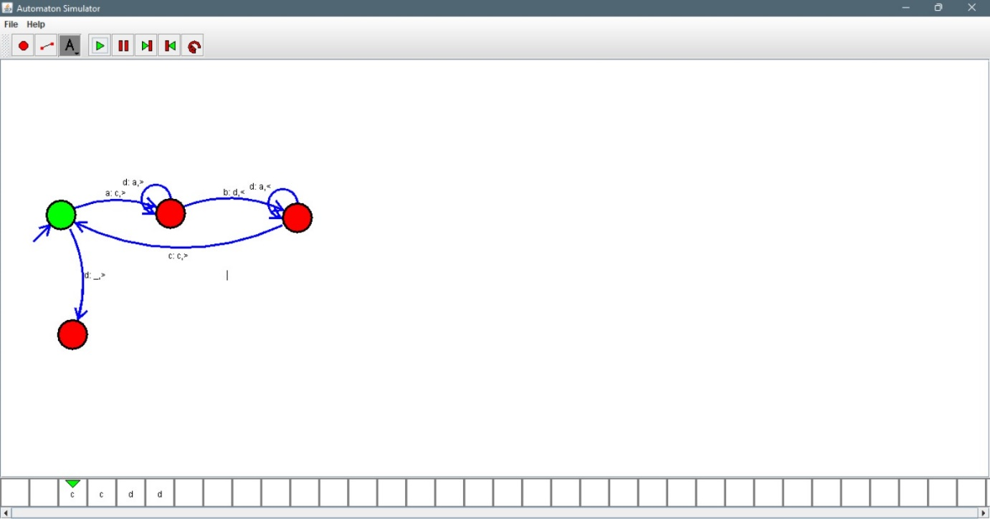*

*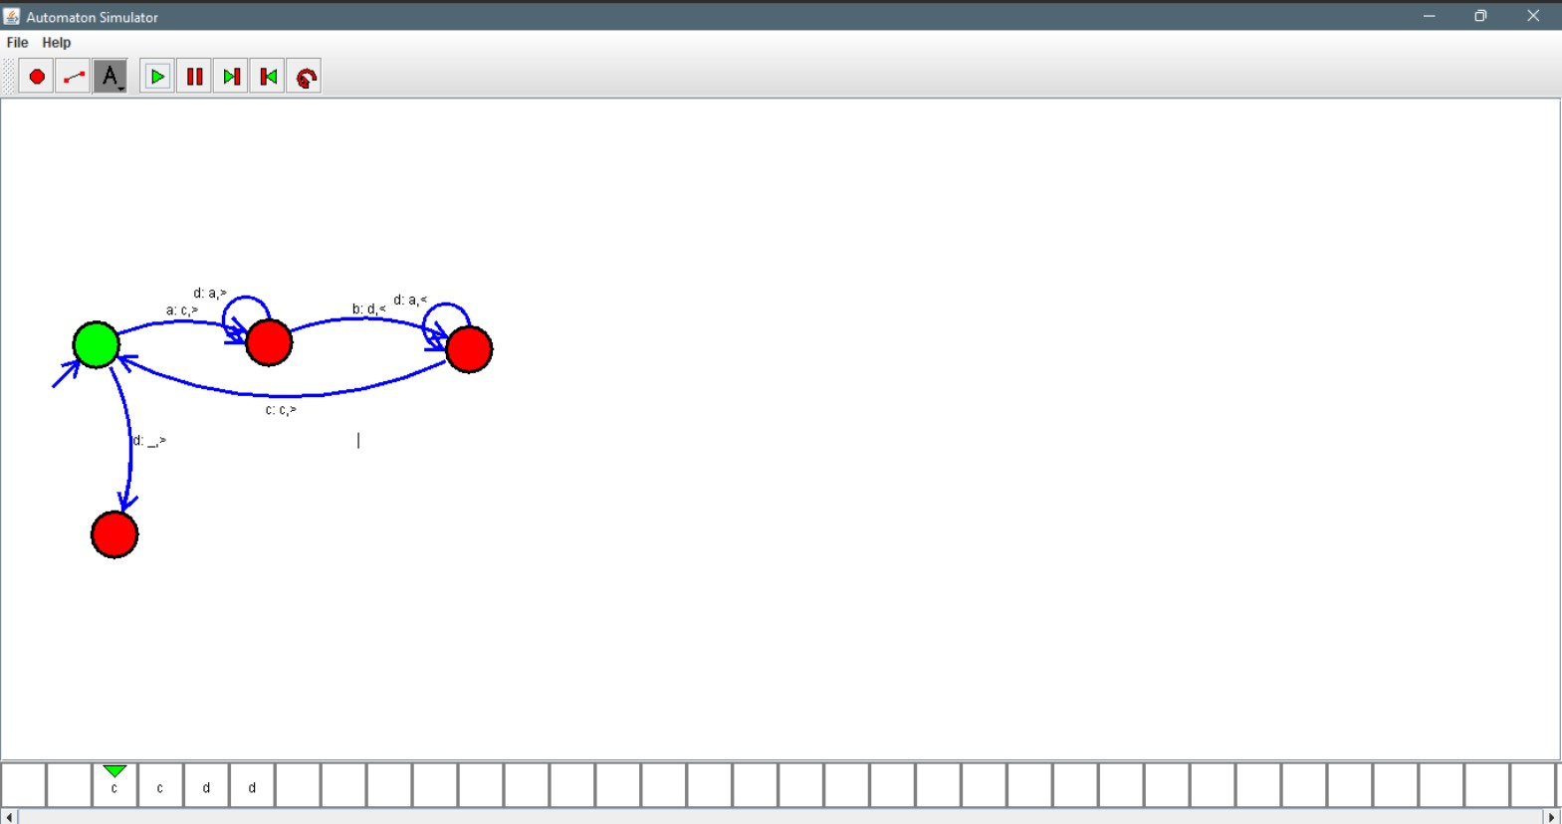*

*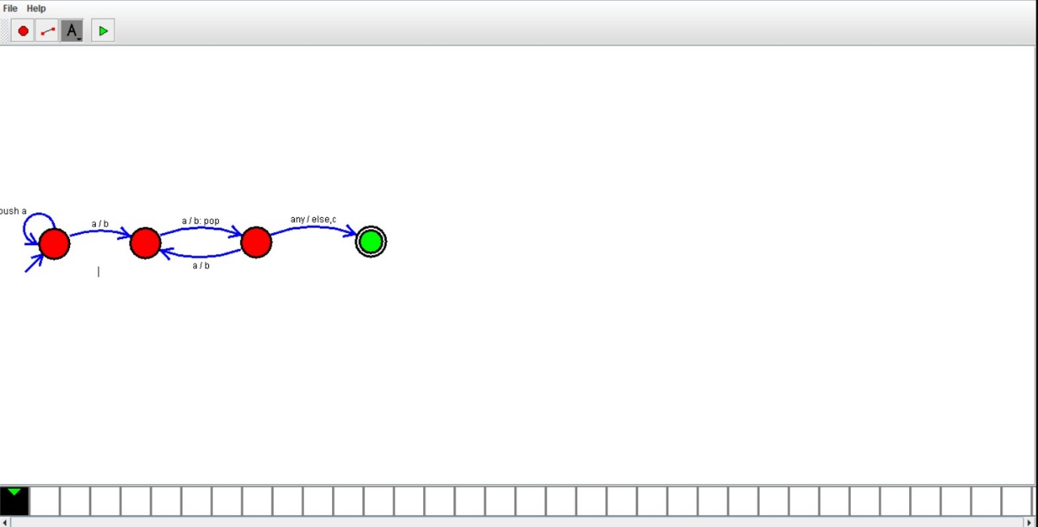*

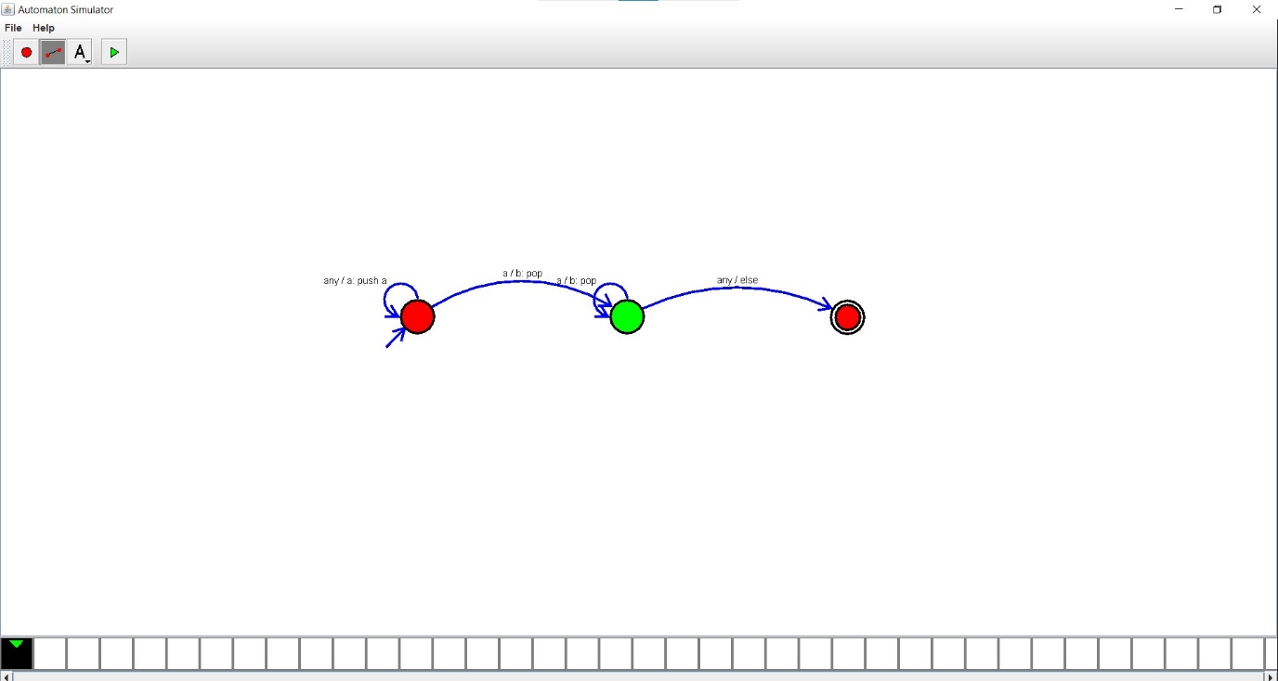

12.Design DFA using simulator to accept the input string “a”,”ac”abd”bac”

