33. Design DFA using simulator to accept the string having ‘abc’ as substring over the set {a,b,c}

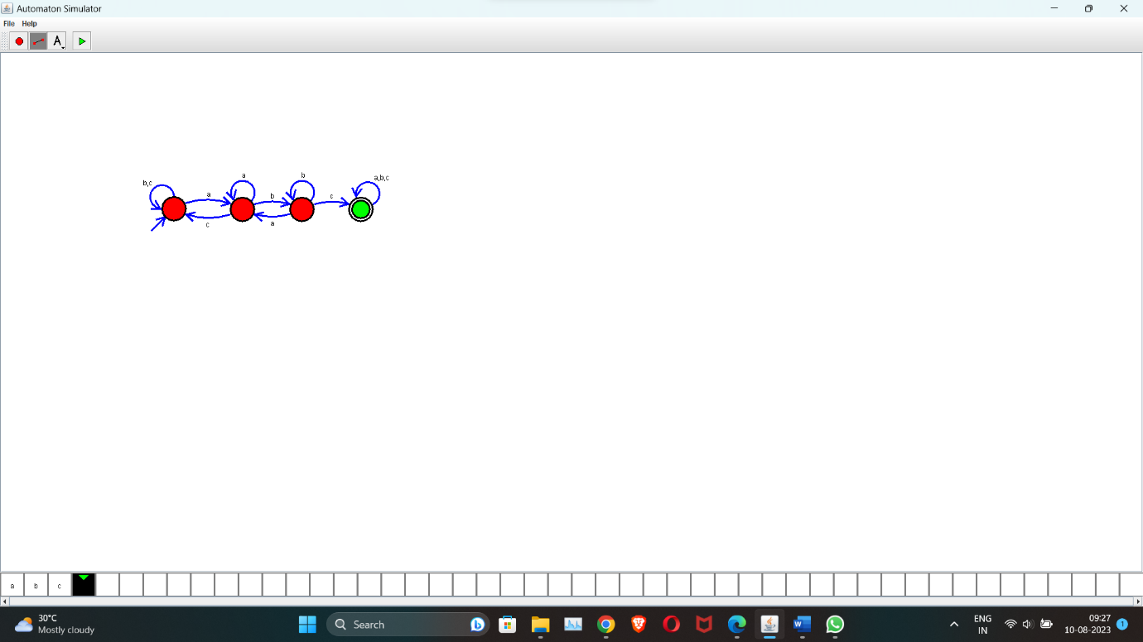

Tuning Machine to Perform String Comparison

W=aba aba

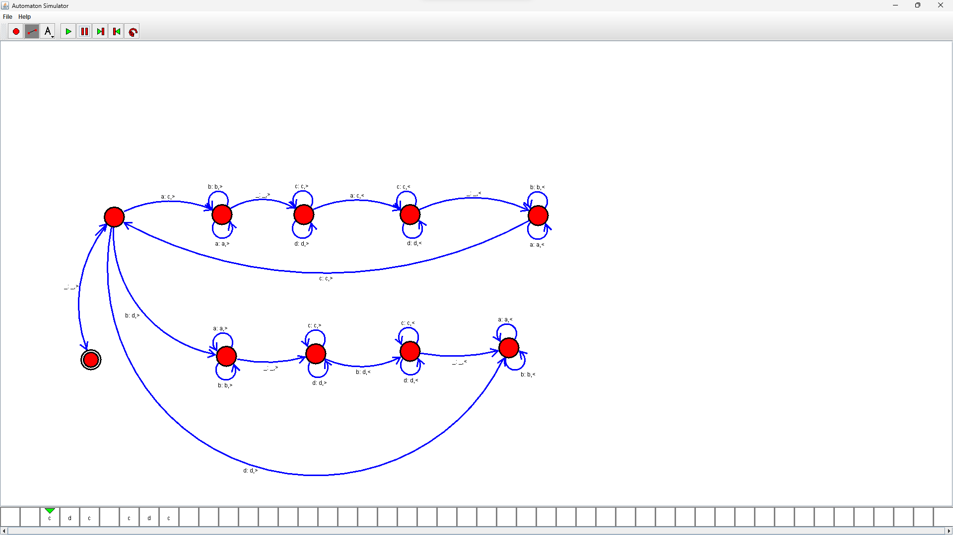

31.Design PDA using simulator to accept the input string anbn

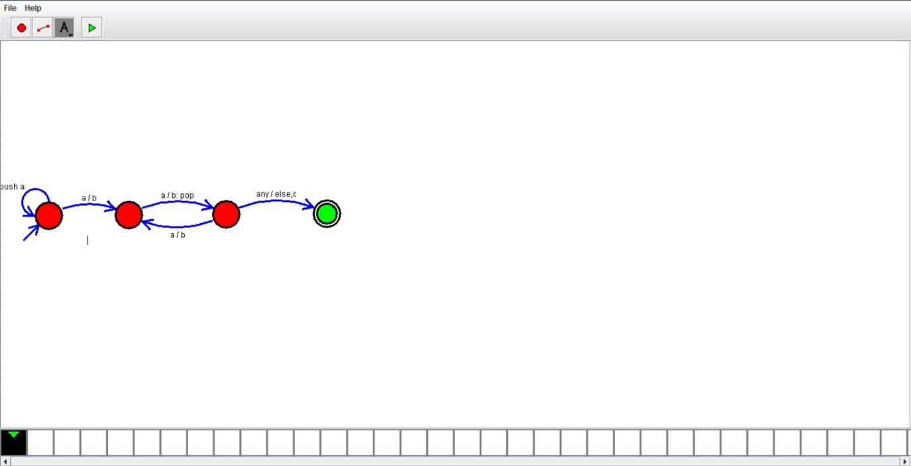

Design DFA tp accept the string bcaaaaaaaaaaaaaaaa,bc and c

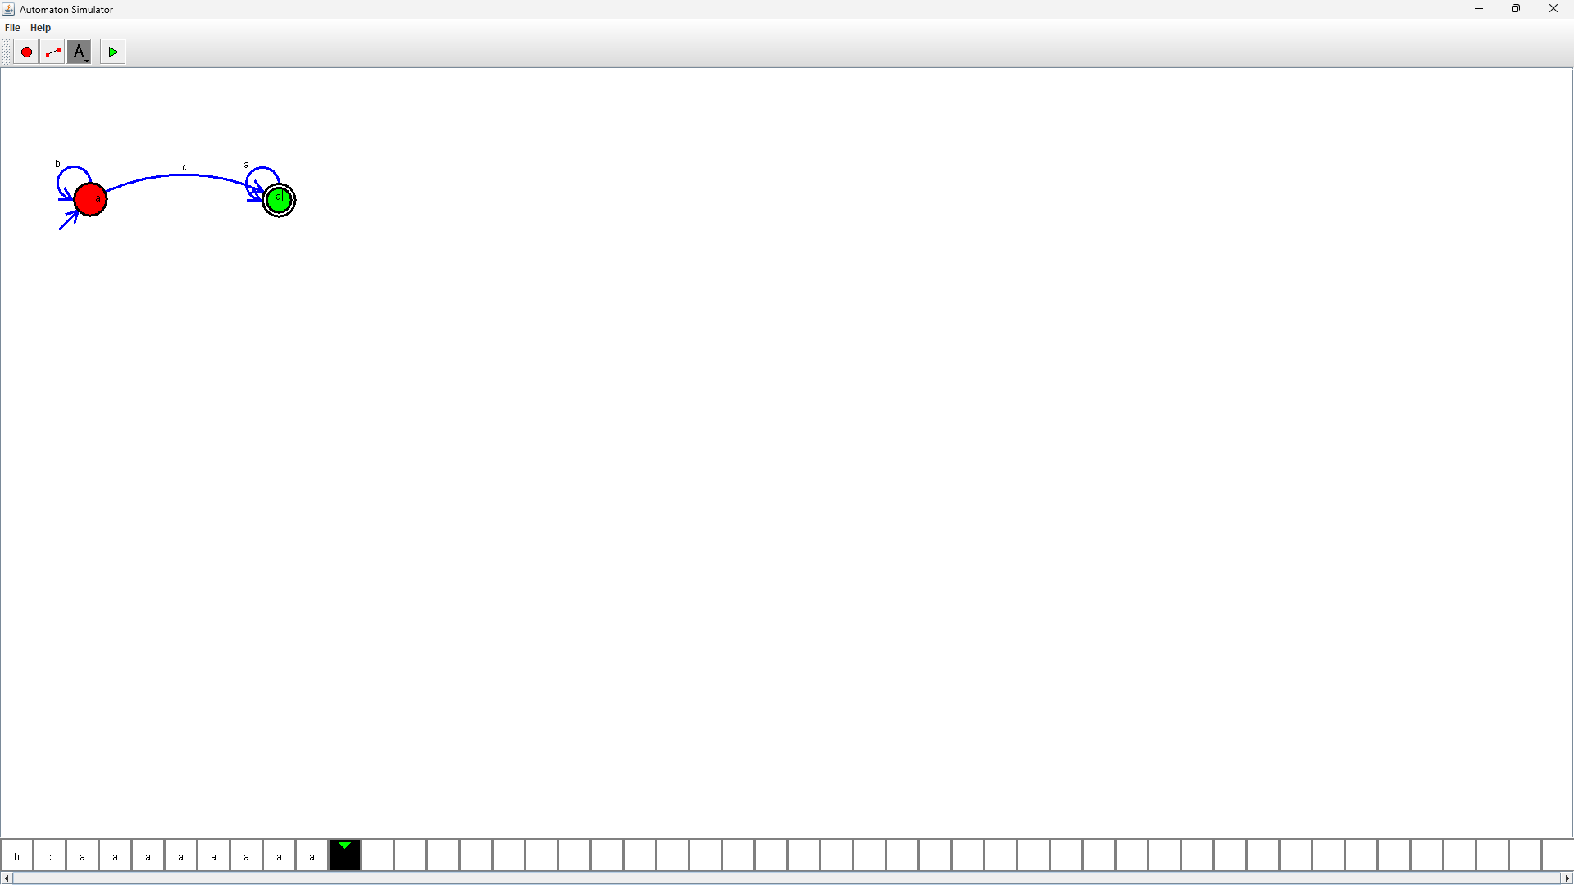

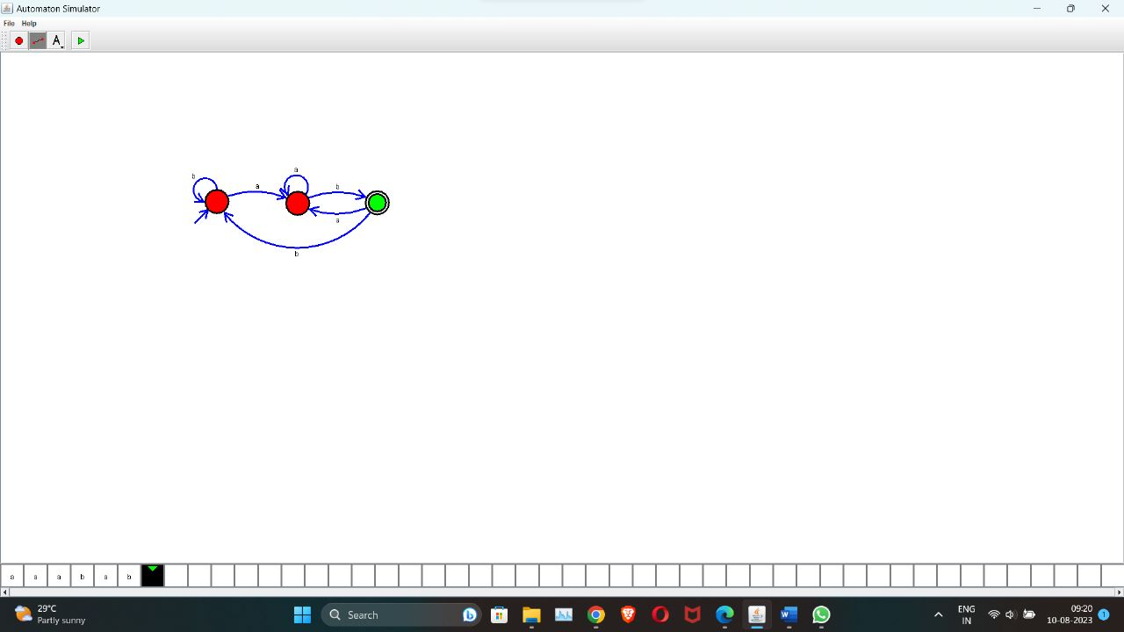

27.Design Tm using simulator to accept the input string wcw

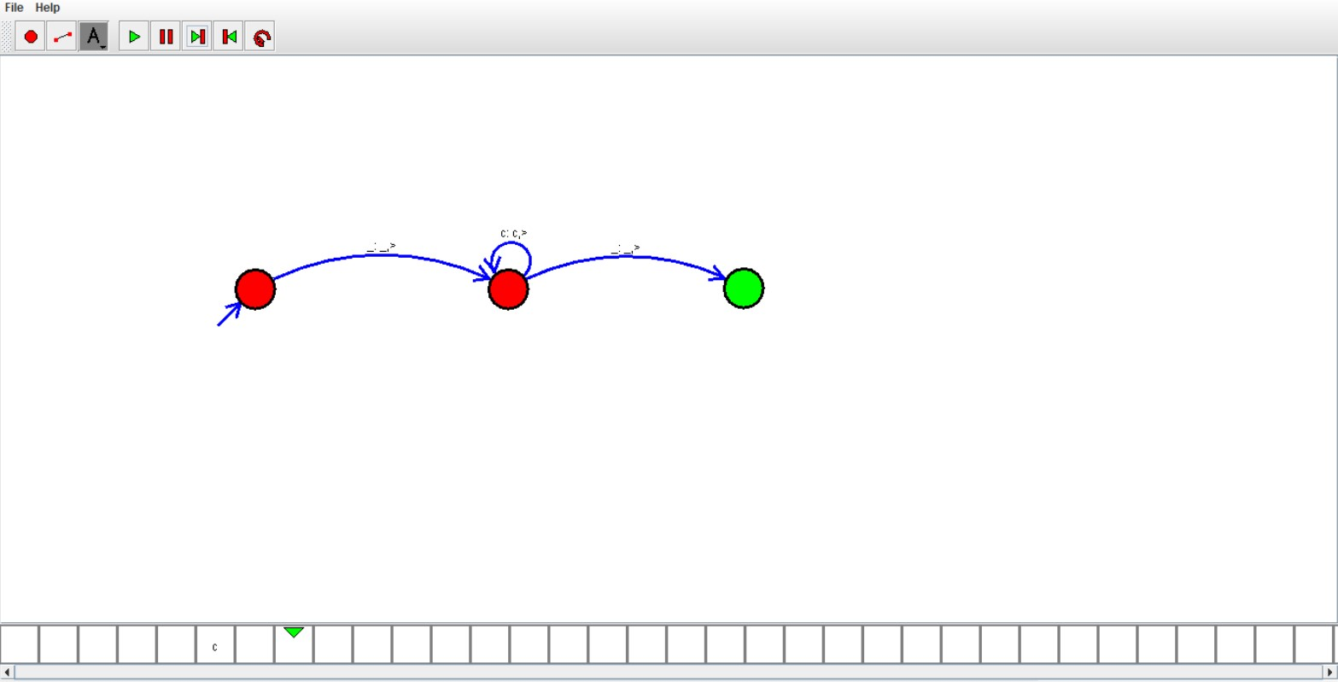

26.Design tm using simulator to accept the string palindrome bbabb

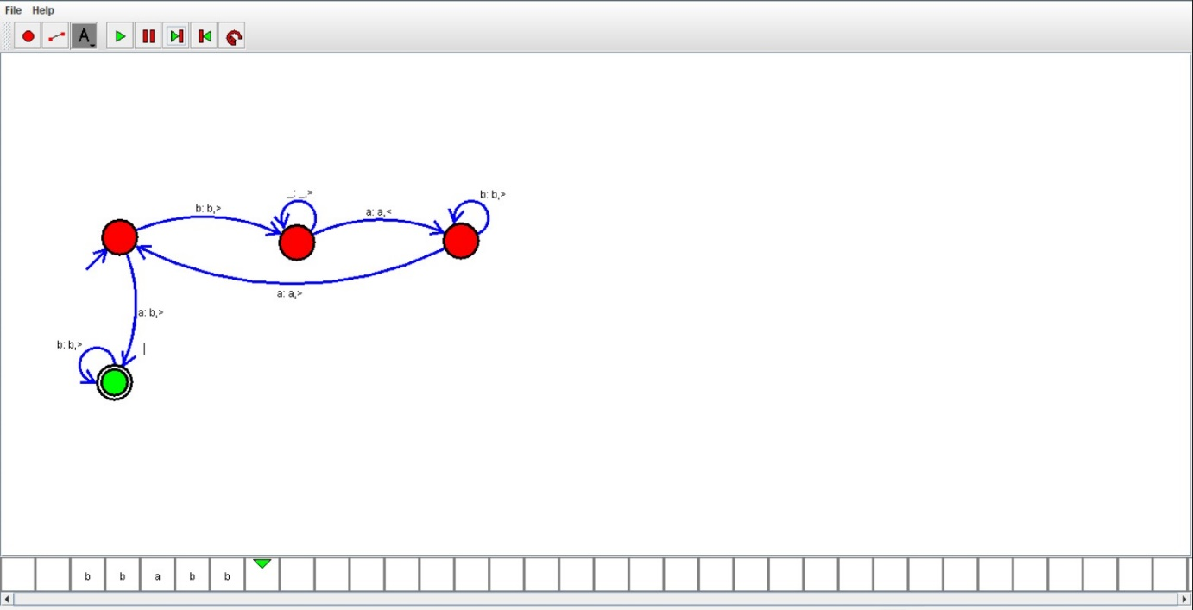

25.Design DFA using simulator to accept the string start with a or b over the set{a,b}

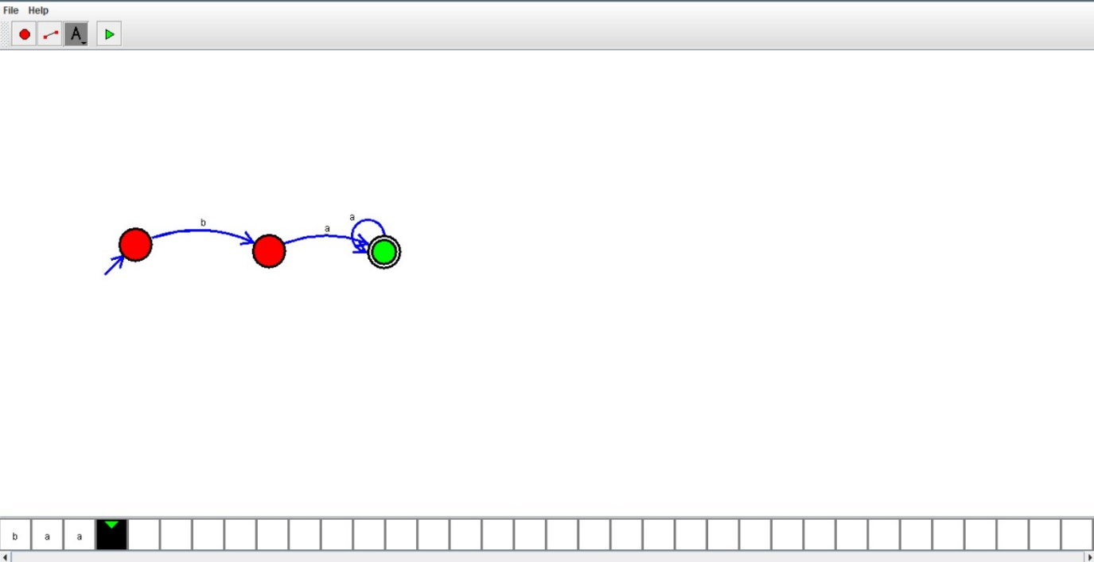

24.Design DFA using simulator to accept the string having ‘ab’ as substring over the set{a,b}

