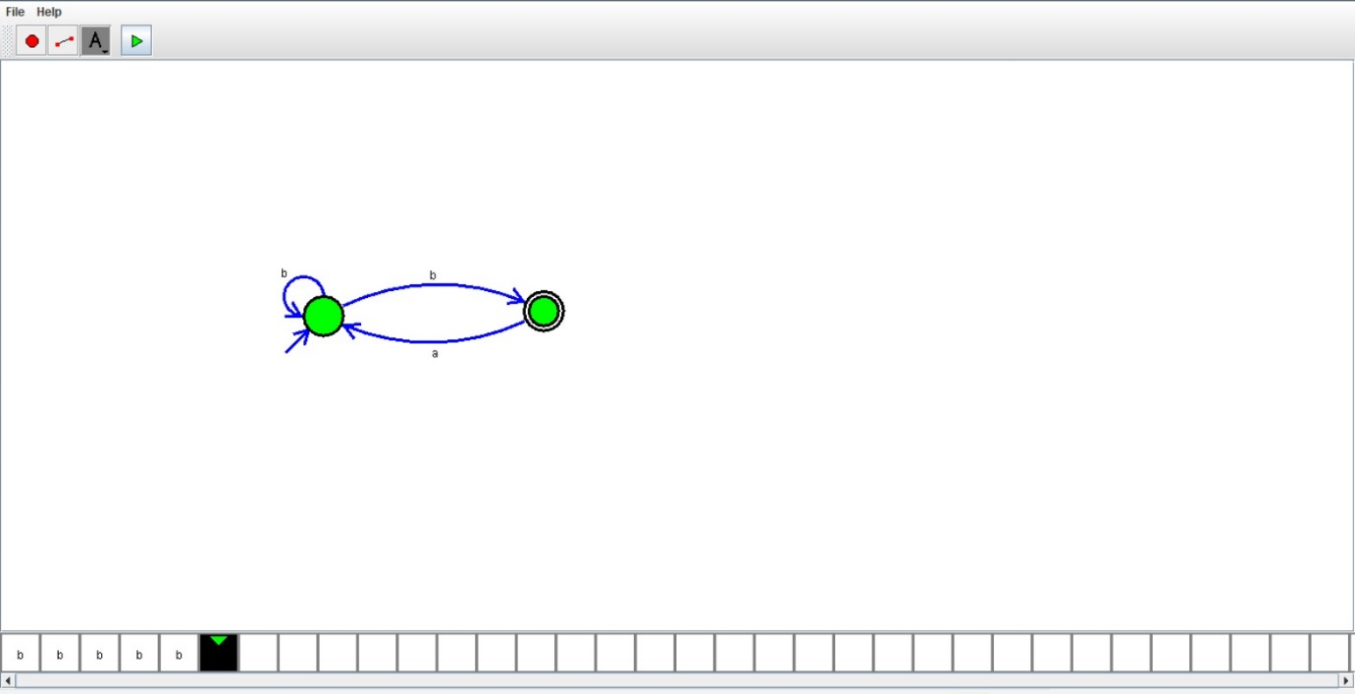

*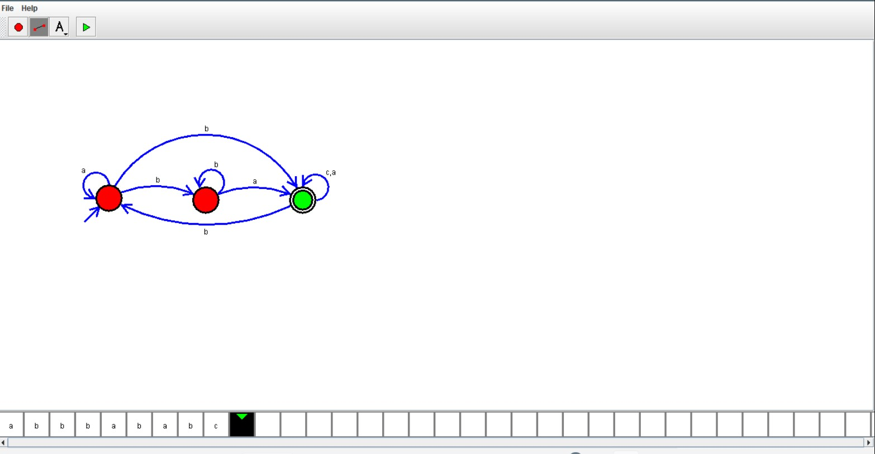*

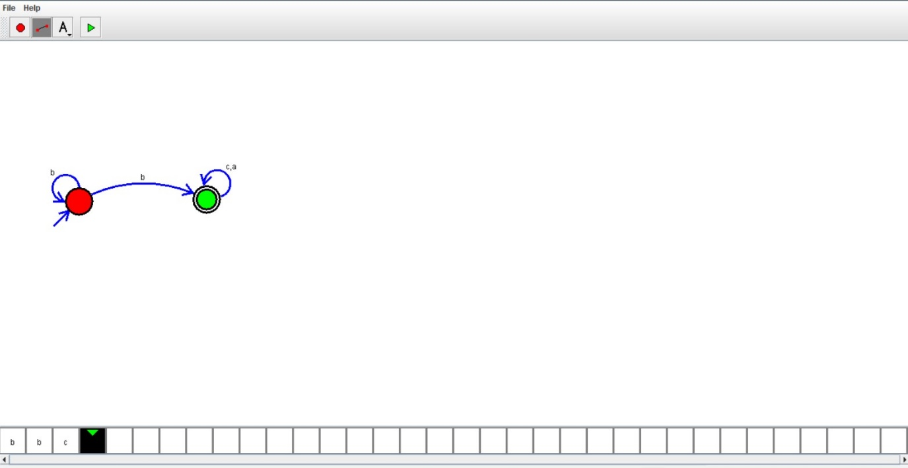

37.Design NFA using simulator to accept the string that start and end with different symbols over the input {a,b}

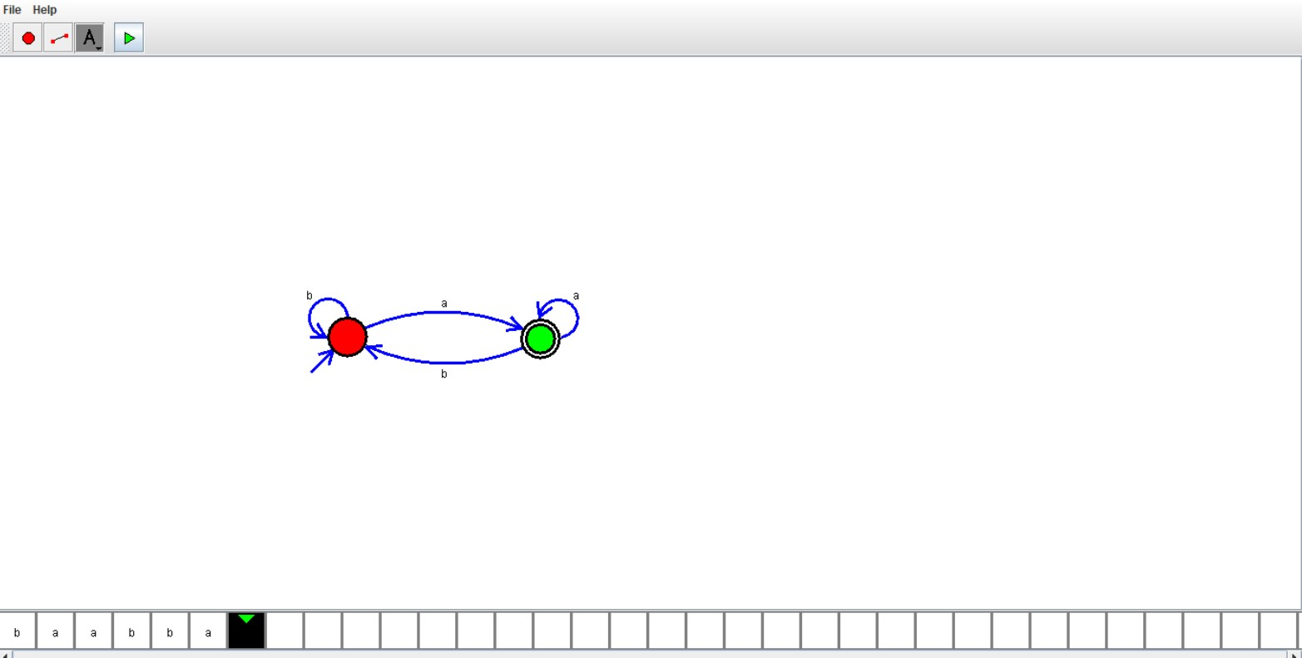

36.Design NFA using simulator to accept the string which start with a and end with b over set {a,b}and check W=abaab is accepted or not

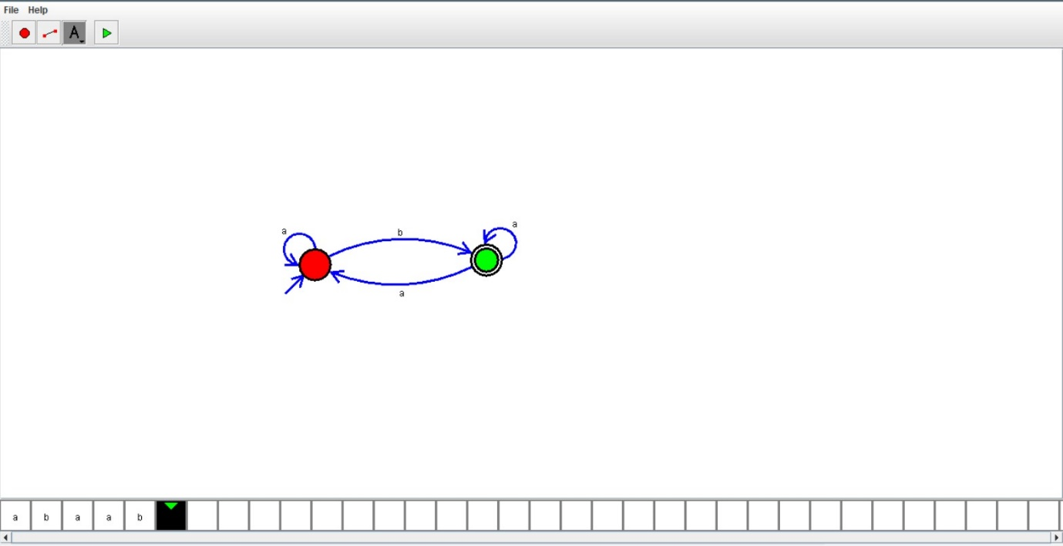

35.Design DFA using simulator to accept the string in which a’s always appear tripled over the input{a,b}

