**Project 2 – Gossip Simulator**

**Group Members: (1) Gurpreet Singh Nagpal (UFID: 0698-9051)**

**(2) Anushri Jain (UFID: 8764-6425)**

**Goal of the Project:**

To determine the convergence of algorithms (Gossip Algorithm and Push-Sum Algorithm) for multiple topologies such as Full Network Toplogy, Line Toplogy, Random2D Topology, 3Dtorus Topology, Honeycomb Topology, RandomHoneycomb Topology.

|  |  |  |  |  |  |  |  |
| --- | --- | --- | --- | --- | --- | --- | --- |
| **GOSSIP ALGORITHM** | | | | | | | |
| **S.No.** |  | **CONVERGENCE TIME (ms)** | | | | | |
|  | **Number of Nodes ->>>** | **50** | **100** | **250** | **500** | **1000** | **2000** |
| 1) | **Full** | 15 | 63 | 236 | 645 | 2600 | 10086 |
| 2) | **Line** | 224 | 490 | 2293 | 9242 | 33879 | 88553 |
| 3) | **Random 2D** | 59 | 186 | 785 | 2344 | 2612 | 9820 |
| 4) | **3Dtorus** | 187 | 363 | 1296 | 1663 | 2778 | 4154 |
| 5) | **Honeycomb** | 141 | 242 | 943 | 2836 | 6477 | 6461 |
| 6) | **HoneycombR** | 79 | 84 | 250 | 409 | 600 | 1053 |

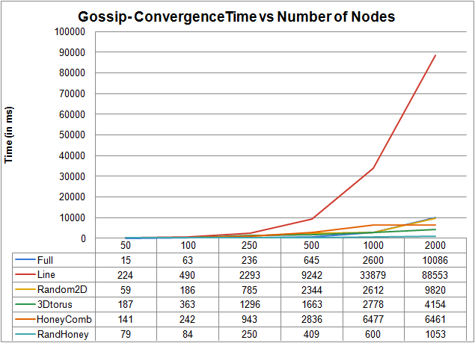

**Practical Observation**: **For Gossip Algorithm:**

The time of convergence for the topologies follows the below order:

Order: *RandHoney < 3Dtorus < Honeycomb < Random 2D < Line < Full*

The following are the fascinating things that we have observed from the above graph and table :

1. Here, RandHoney is the best topology or an efficient one and performs the best among the topologies.
2. After that 3Dtorus is following the RandHoney.
3. Another thing we find that Line topology is an inefficient topology following the Honeycomb topology.
4. The reason behind the line topology for behaving in an inefficient way is that it has only two neighbors, i.e. left and right neighbor.
5. In addition, Full Topology takes maximum time to converge and we can also see that Full Topology and Random2D Topology is behaving in the similar way or takes the same time for convergence.

**Interesting Observation (for Gossip):**

|  |  |  |
| --- | --- | --- |
| **Name of Topology** | **Number of Nodes** | **Convergence Time(ms)** |
| 3Dtorus | 15000 | 86101 |
| **RandHoney** | **15000** | **40938** |

The most fascinating thing that we have observed here is that RandHoney topology converges in 40938 ms (~40 sec) for 15000 nodes following the 3Dtorus topology.

|  |  |  |  |  |  |  |
| --- | --- | --- | --- | --- | --- | --- |
| **PUSH-SUM ALGORITHM** | | | | | | |
| **S.No.** |  | **CONVERGENCE TIME (ms)** | | | | |
|  | **Number of Nodes ->>>** | **50** | **100** | **250** | **500** | **1000** |
| 1) | **Full** | 172 | 453 | 1552 | 6197 | 27161 |
| 2) | **Line** | 1818 | 3766 | 10547 | 20250 | 33374 |
| 3) | **Random 2D** | 281 | 422 | 1595 | 5915 | 24413 |
| 4) | **3Dtorus** | 305 | 468 | 2148 | 3524 | 6852 |
| 5) | **Honeycomb** | 974 | 3786 | 9073 | 20375 | 50323 |
| 6) | **HoneycombR** | 2652 | 4411 | 14422 | 32672 | 50416 |

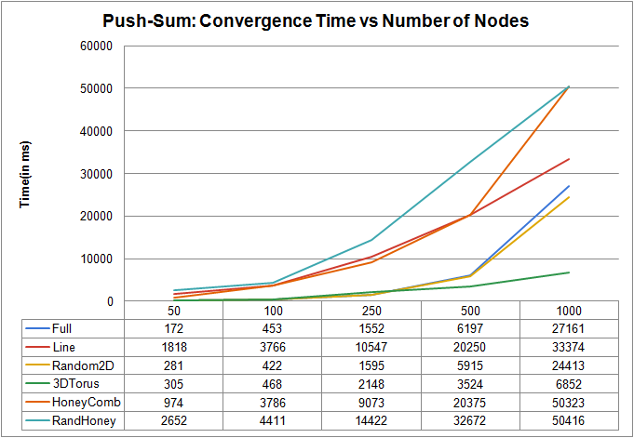

**Practical Observation: For Push-Sum Algorithm:**

Order: *3Dtorus < Random2D < Full < Line < Honeycomb < RandHoney*

1. Here, we observe that RandHoney takes the maximum time to converge and is performing in an inefficient way or the worst topology following the HoneyComb topology.
2. Random2D topology and Full topology is behaving in the same way or takes almost same time to converge.
3. Among these topologies, 3Dtorus topology is the best one and takes only 6852 ms (~6.8 sec) to converge and this is really an interesting finding.
4. For this algorithm, RandHoney converges faster than the HoneyComb following the Line topology.

**Interesting Observations:**

1. The most fascinating thing that we have observed here is that **3dtorus topology: Push-Sum Algorithm**) converges in **394297 ms (~394 sec)** for **10648** nodes.
2. 3Dtorus topology is performing significantly well in both the algorithms