***DASHBOARD PROJECT UPDATES***

**Last week's assigned task was to research and understand the concepts of sign-in authentication, particularly focusing on Google and GitHub authentication.**

**I successfully completed this task during the week.**

**Currently I am working on assessment pages .**

1.LOGIN PAGE :

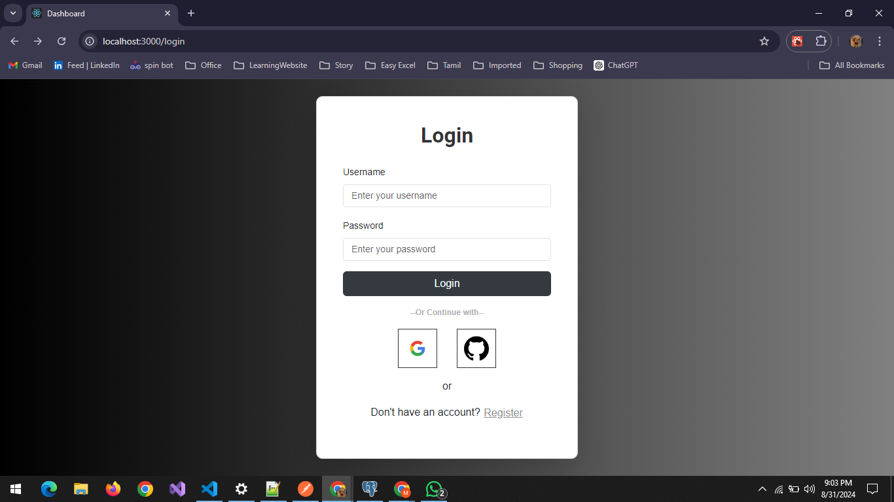

2.PROJECT PAGE:

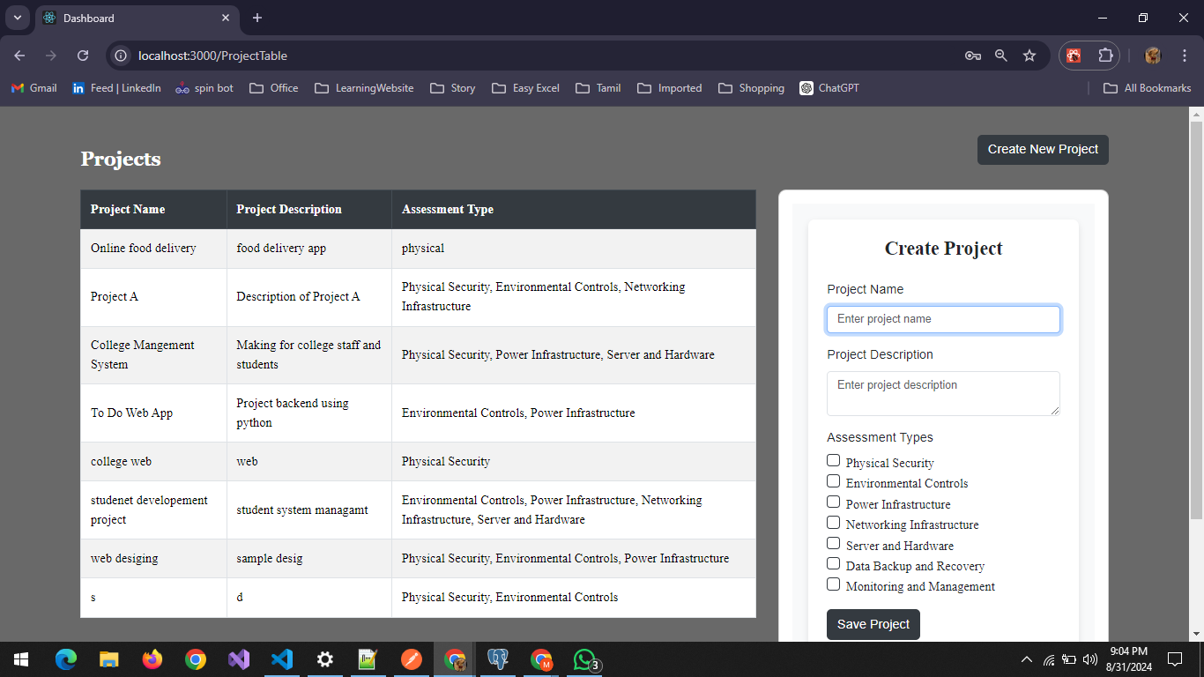

3.DASHBOARD PAGE :

