Driver Drowsiness Detection System Using Raspberry Pi

**D.ANAND1, J.V.K.Vishwapoojitha2, M.Sarumathy3, R.Vaishaly4**

1Assistant Professor, Department of Electronics and Communication Engineering,

234Final Year Students, Department of Electronics and Communication Engineering,

K.L.N. College of Engineering. Email: [anand.duraiswamy@gmail.com](mailto:anand.duraiswamy@gmail.com)

# Abstract—: A countless number of people drive on the highway day and night. People traveling long-distance suffer from lack of sleep. Because of which it turns out to be extremely risky to drive while feeling drowsy. Most of mishaps occur because of the sleepiness of the driver. As per an exhaustive examination, there are more than 500,000 mishaps in India alone every year. Furthermore, driver fatigue is a factor in almost 60 percent of these accidents. In this paper, we provide a real-time monitoring system that makes use of face / eye and yawn identification and image processing algorithm. The job of picture handling is to perceive the substance of the driver and afterward separates the picture of the eyes of the driver for identification of sluggishness. The Haar face detection algorithm takes captured frames of image as input and then the detected face as output. It can be concluded this approach is a low cost and effective solution to reduce the number of accidents due to driver's Drowsiness to increase the transportation safety. Driver sleepiness recognition is a vehicle security innovation which prevents accidents when the driver is getting drowsy.

**Keywords: Drowsiness, Face detection, Open Cv, Haar cascade**

# INTRODUCTION

Drowsy driving is one of the major causes behind fatal road accidents One of the new review shows that one out of five street mishaps are brought about by tired driving which is generally around 21% of street mishaps, and this rate is expanding consistently according to worldwide status report on street wellbeing 2015, in light of the information from 180 unique nations. This certainly highlights

the fact that across the world the total numbers of road traffic deaths are very high due to driver’s drowsiness. Driver fatigue, drive drunk and imprudence are approaching as significant purposes for such street road accidents. Many lives and families are getting impacted because of this across different nations. Constant sluggish driving recognition is one of the most outstanding conceivable significant that can be carried out to help drivers to make them mindful of tired driving circumstances. Such driver behavioral state detection system can help in catching the driver drowsy conditions early and can possibly avoid mishaps. With this paper, we are introducing procedure to recognize driver tiredness utilizing of Open CV, raspberry pi and image processing. Several studies have shown various possible techniques that can detect the driver drowsiness. Such driver sleepiness recognition can be estimated utilizing physiological measures, visual measure and execution measure. Among these physiological measure and visual measure can give more exact outcomes. Physiological measure incorporates mind waves, pulse, beat rate estimations and these requires some kind of actual association with the driver, for example, interfacing anode to the driver body. In any case, this prompts discomfortable driving circumstances. In any case, visual measure should be possible without actual association.

Ocular measure to detect driver eye condition and possible vision based on eye closure is well suited for real world driving conditions, since it can distinguish the eyes open/shut state utilizing a camera. In Real Time Driver Drowsiness System using Image Processing, capturing drivers eye state using computer vision based drowsiness detection systems have been done by analyzing the interval of eye closure and developing an algorithm to detect the driver’s drowsiness in advance and to warn the driver by in vehicles alarm. This section motivates how face is distinguished and how eye discovery is performed for auto application and their recognition is essential for evaluating driver tiredness.

# Raspberry Pi 3:

The Raspberry Pi is a negligible cost, MasterCard assessed PC that plugs into a PC screen or television, and usages a standard control center and mouse. A fit little device enables people, things being what they are, to examine figuring, and to sort out some way to program in vernaculars like Scratch and Python.

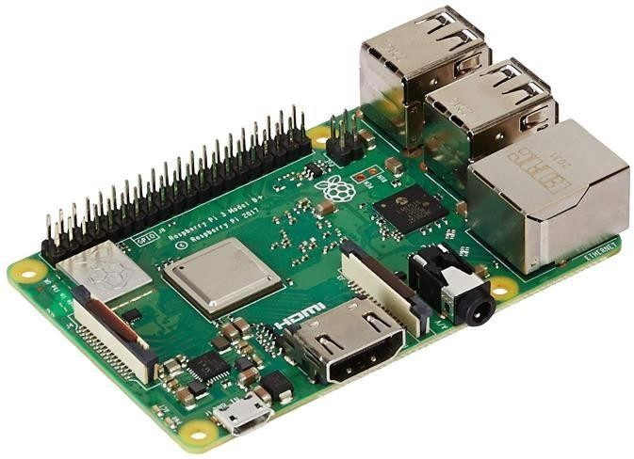

# Camera module:

The flex interface inserts into the connector stamped CAMERA on the Raspberry Pi, which is arranged between the Ethernet and HDMI ports. The connection ought to be inserted with the silver contacts going up against the HDMI port. To open the connector, pull the tabs on the most elevated mark of the connector upwards, then, towards the Ethernet port. The flex interface should be installed steadily into the connector, with care taken not to turn the flex at too extraordinary a point. To close the connector, push the top piece of the connector towards the HDMI port and down, while holding the flex interface.  
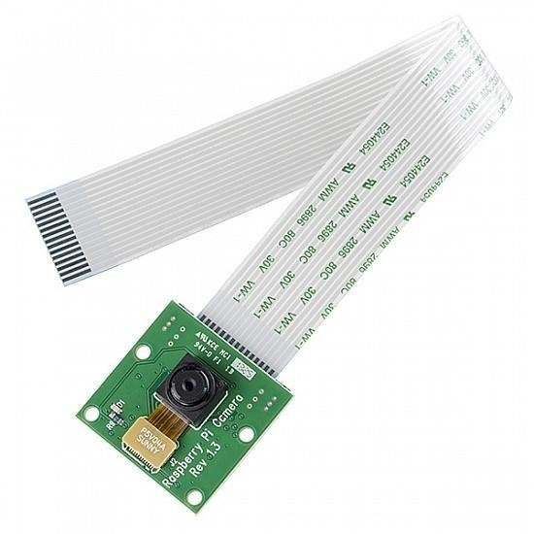

# Buzzer:

There are two main types of buzzer: active and passive buzzer. A *passive* buzzer emits a tone when a voltage is applied across it. It also requires a specific signal to generate a variety of tones. The *active* buzzers are a lot simpler to use, so these are covered here. Connecting a buzzer an active buzzer connecting like an LED, But as they are a little more robust, you won’t be needing a resistor toprotect them.

# II.SYSTEM ARCHITECTUR: The architecture of the system consists of various phases.



Driver

Camera



camera

Eyes and Mouth status

analyzing

Facial

Processing

Eye and Mouth variable

storage

Drowsy status detection

Drowsy

detected

Alarm Ringing

Real time capturing

# Camera:

This is the underlying phase of the framework. An arrangement is made and streamlined for current user. Successful head location of the driver is the key stage. [4] Assuming the driver's head is effectively found, it turns out to be not difficult to deal with the picture and helps in distinguishing the present status of driver.  
**Face Detection:**

The proposed framework will begin by catching the video approaches individually. OpenCV offers broad help for handling live recordings. The framework will distinguish the face in the casing picture for each edge. This framework utilizes Viola-Jones object finder which is an AI approach for visual item location (Paul Viola, 2004 and Paul Viola, 2001). This is accomplished by utilizing the Haar calculation for face discovery. Haar overflow is a notable vigorous element based calculation that can identify the face picture

proficiently. With the utilization of purposes of fountain of stages, Haar calculation ready to eliminate the up-and-comers that are non - face. What's more, each stage comprises of mix of various Haar highlights and every single element is characterized by a Haar include classifier. The inbuilt OpenCV xml "haarcascade_frontalface_alt2.xml" record is utilized to look and distinguish the face in individual casings. This document contains various elements of the face and built by utilizing various positive and negative examples. First burden the outpouring record then pass the gained casing to an edge discovery capability, which recognizes every one of the potential objects of various sizes in the casing. Since the essence of the driver involves a huge piece of the picture, rather than distinguishing objects of every conceivable size, indicate the edge identifier to recognize just objects of a specific size for example for face area. Then, the result the edge locator is put away and this result is contrasted with the outpouring record with recognize the face in the casing. The result of this module is an edge with face recognized in it. Just weakness in Haar calculation is that it can't extrapolate and doesn't work suitably when the face isn't before the camera pivot. When the face recognition capability has identified the essence of the driver, the eyes identification capability attempts to identify the driver's eyes.

# Eye Detection:

Once the face detection function has recognized the essence of the driver, the eyes discovery capability attempts to identify the vehicle driver's eyes. After face identification track down eye district by considering eyes are available just in upper piece of the face and from top edge of the face, remove eyes Locale of Interest (return for money invested) by trimming mouth and hair, we mark it the locale of premium. By taking into account the district of revenue it is feasible to lessen how much handling required and furthermore accelerates the handling for getting precise eyes. After the district of interest is denoted, the edge identification procedure is applied exclusively on the area of interest. Then, at that point, look for eyes in return on initial capital investment; Round Hough Change is utilized here to track down state of eyes (Rhody Chester, 2005). The principal benefit of the Hough change strategy is that it is liberal to holes in highlight limit portrayals and is somewhat unaffected by picture clamor, in contrast to edge identifiers. The OpenCV capability Hough Circles () is utilized to distinguish circles in an eye picture. CHT guarantee that at most two eyes found. With the eye discovery method we might have the option to identify the open condition of eyes.  
**Drowsy Detection:**

Subsequent to getting eyes the calculation then counts the quantity of open eyes structure each edge and decides the sleepiness. On the off chance that the standards are fulfilled, the driver is supposed to be sluggish. The ringer associated with the framework performs activities to address the driver unusual way of behaving. For this framework, the eye and the face classifiers are required. The HARR Classifier Outpouring records worked in there with the Open CV contains various classifiers for the face and eye detection."haarcascade_frontalface_alt2.xml"and capability "Houghcircles ()" is utilized to look and identify the face followed by individual edges. The face location and open eye identification have been done on each edge of the driver's caught facial picture. The variable Eyes complete is doled out to store the quantity of open eyes tracked down in each casing. A variable will store the quantity of progressive edges in which the eyes viewed as shut with the qualities like 0, 1, 2, 3… and so on. At first, this variable is set to 0.When both the eyes are open, and afterward Sluggish count will be 0. Sluggish count will increment when Eyes absolute < 2. For an eye squint, Sleepy count esteem is raised by 1. Assuming the eye flickers in multiple edges, for example variable count is more noteworthy than or equivalent to 4, then the condition for sluggishness is met and an alert will be motioned at ongoing. For this framework, the face and eye classifiers are required. The HARR Classifier Fountain records inbuilt on OpenCV incorporate various classifiers for the face recognition and the eyes location. The inbuilt OpenCV xml "haarcascade_frontalface_alt2.xml" is utilized to look and identify the face in individual edges.  
  
 **III. PROPOSED METHOD:**

The all out framework is isolated into Preparing the dataset, Testing, and sending prepared to alarm the driver Getting ready:

a) Initialize LBPH face recognizer.

b) Get appearances and IDs from the informational collection coordinator to set up the LBPH face recognizer.

c) Save the pre-arranged data as a XML or YAML report. Load Haar classifier, LBPH face recognizer, and arranged data from XML or YAML record.  
a) Capture the picture from the camera,

b) Convert it into grayscale,

c) Detect the face in it and

d) Predict the face utilizing the above recognize Raspberry Pi's control center either by utilizing SSH on a PC or by utilizing Keyboard and mouse with the showcase gadget like a TV associated with Pi. The calculation, first and foremost, needs a ton of positive pictures and negative pictures to prepare the Haar overflows classifier. Positive pictures are pictures with clear faces though bad pictures are those with no appearances.

**Haar Cascades:**

Every part is tended to as a single worth gained from the qualification between the measures of pixels in the white square shape from how much all pixels in obscurity square shape. All different likely sizes and region of the classifier are used for determining a ton of components. As the amount of classifiers fabricates the calculating estimations seem to consume the greater part of the day. To avoid this, we use the possibility of Necessary Picture. In Picture Handling, a Basic picture is a data structure that is an additional district table and computation for quickly and really making a measure of values in a rectangular cross section subset. A fundamental picture is deduced by using the condition.  
Haar Outpouring depends on the idea of elements which are proposed by Paul Viola and Michael Jones in their paper "Quick Item Location utilizing a Helped Fountain of Straightforward Highlights" in 2001. It is an AI based approach where an outpouring capability is prepared from a great deal of positive and negative pictures. Recognizing objects from a picture or a video can be utilized. This calculation includes four phases:

a) Haar Feature Selection

b) Creating Integral Images

c) Adaboost Training

d) Cascading Classifiers

**I. IMPLEMENTATION OF THE SYSTEM**

**A. Capturing the image**

The camera module is set where people go into the regular timetable and video is taken inside a distance under 5 meters. A camera is used for taking video which contains various configurations from which any of the lodgings can be used for standing up to demand and wandering the participation.  
**B. Detecting Faces:**

Picking an effective computation for face certification or affirmation is key in this proposed work. There are different face area computations accessible in OpenCV, for instance, Eigenfaces, Fisher appearances, and Neighborhood Double Example Histograms. Taking into account the assumptions for the continuous confirmation estimation which has been picked is the Haar Fountain Calculation for face acknowledgment and assertion. It is accessible in the OpenCV source library  
**C. Face Recognition:**

The framework goes into examination stage subsequent to finding the driver's head, eyes and mouth appropriately in Video caught through camera. This video is preprocessed involving different Picture Handling procedures for sluggishness location. Different procedures associated with Picture Handling are Obscuring, RGB to HSV Transformation, HSV Thresholding Mass Identification. In obscuring stage, the recently caught video is disintegrated into pixels which fans out and gets blended into encompassing pixels. This got picture comprises of a few remarkable highlights which can be best communicated and portrayed utilizing HSV design. So the RGB picture design is changed over utilizing HSV design. At the point when the pixel variety range is assorted, thresholding in HSV is exceptionally helpful for disengaging video includes that can't be accomplished by RGB thresholding. So HSV thresholding is completed. After video thresholding mass recognition strategy is executed which targets recognizing locales of picture that vary in properties like brilliance or variety when contrasted with encompassing districts. Driver's head development is observed utilizing camera which is then dissected utilizing Focus of Gravity to distinguish the driver's state. For identifying assuming the driver is utilized which is put directly before the driver's face.  
**A. Alert Stage:**

The framework actuates the caution and alarms the driver if he/she is found in strange driving state for example being sluggish Then the caution can be a signal (or) sound.

**Blockdiagram:  
  
  
  
**Output :**

1. *Face recognition*

1. *Eye detection*

1. *Yarn detection:*

**CONCLUSION & FUTURE SCOPE:**

The driver irregularity checking framework created is fit for recognizing tiredness, tanked and careless way of behaving of driver in a brief time frame. The Sleepiness Discovery Framework created in view of eye conclusion of the driver can separate typical eye squint and tiredness and identify the sluggishness while driving. The proposed framework can forestall the mishaps because of the tiredness while driving. The framework functions admirably even in the event of drivers wearing exhibitions and, surprisingly, under low light circumstances on the off chance that the camera conveys improved yield. Data about the head and eyes position is acquired through different self-created picture handling calculations. During the observing, the framework can choose if the eyes are opened or shut. At the point when the eyes have been shut for a really long time, an admonition signal is given. Handling makes a decision about the driver's readiness level based on nonstop eye terminations. In future it can implement drowsiness detection system in aircraft in order to alert pilot.

• The alcoholic sensor is also used for drunk drivers

• In future it can implement drowsiness detection system in schools and colleges to alert the staffs to find the drowsy student in a class

**REFERENCE**:

[1]. KouzaniA, HeF, SammutK. Fractalface representation and recognition. IEEE Int Conf Syst Man Cybern 1997;2.http://dx.doi.org/10.1109/ICSMC.1 997.638231

[2]. Viola, P., & Jones, M. (2001). Rapid object detection using a boosted cascade of simple features. In Computer Vision and Pattern Recognition, 2001. CVPR 2001. Proceedings of the 2001 IEEE Computer Society Conference on (Vol.1,pp.I-511).IEEE

[3]. Bagus G. Pratama, IgiArdiyanto, Teguh B. Adji, A Review on Driver Drowsiness Based on Image, Bio-Signal, and Driver Behavior, IEEE, July 2017. [4]. E. Vural, M. Cetin, A. Ercil, G. Littlewort, M. Bartlett, and J. Movellan, "Drowsy driver detection through facial movement analysis," in International Workshop on Human-Computer Interaction, 2007, pp. 6- 18: Springer. [5]. P.Thiffault and J. Bergeron, "Monotony of road environment and driver fatigue: a simulator study," Accident Analysis & Prevention, vol. 35, no. 3, pp. 381-391, 2003.

[6]. “Drowsy Driving,” National Highway Traffic Safety Administration (NHTSA), 01-Feb-2018.[Online].

[7].FACES ALGORITHM”, ARPN Journal of Engineering and Applied SciencesVOL.11,NO.13

[8].Rafael C. Gonzalez. 2009. Digital Image Processing. Pearson Education India.

[9]. Kyong Hee Lee, Whui Kim, Hyun Kyun Choi, Byung Tae Jan. A Study on Feature Extraction Methods Used to Estimate a Drivers Level of Drowsiness, IEEE, February 2019.   
[10]. Fouzia, Roopalakshmi R, Jayantkumar A Rathod, Ashwitha S, Supriya K, Driver Drowsiness Detection System Based on Visual Features. , IEEE, April 2018