`

INTELLIGENT BASED TEMPERATURE SURVEILLANCE FOR INDOOR SYSTEM

### A PROJECT REPORT

***Submitted by***

# ARUN RAJA K B (910618106008) DEERAJ SHARMA H (910618106012)

**MOKESH BABU N G U (910618106020)**

***in partial fulfilment for the award of the degree of***

# BACHELOR OF ENGINEERING

**IN**

### ELECTRONICS AND COMMUNICATION ENGINEERING

**K.L.N. COLLEGE OF ENGINEERING, POTTAPALAYAM**

# ANNA UNIVERSITY::CHENNAI 600 025

### MAY 2022

`

ANNA UNIVERSITY :: CHENNAI 600 025

# BONAFIDE CERTIFICATE

### Certified that this project report “INTELLIGENT BASED TEMPERATURE SURVEILLANCE FOR INDOORSYSTEM

**”** is the bonafide work of **“ ARUN RAJA KB(910618106008), DEERAJ SHARMA H(910618106012), MOKESH BABU NGU(910618106020)”**

carried out the project work under my supervision.

### SIGNATURE SIGNATURE

**Dr. V. KejalakshmiM.E.,Ph.D. Mrs.R.PAVITHRA ., M.E.,**

### HEAD OFTHEDEPARTMENT SUPERVISOR ASSISTANTPROFESSOR

Department of Electronics and Department of Electronics and

Communication Engineering, Communication Engineering,

K.L.N. College of Engineering, K.L.N. College of Engineering,

Pottapalayam, Pottapalayam,

Sivagangai –630612 Sivagangai – 630612

Submitted for the project Vice-Voce examination held on ...........................

INTERNALEXAMINER EXTERNALEXAMINER

`

# ACKNOWLEDGEMENT

First and foremost we thank and praise the almighty god for his guidance and protection throughout the course of our study. It is worth to quote that “Behind every successful efforts there lays contribution from numerous sources irrespective of their magnitude”. At this juncture we take this opportunity to express our sincere and whole hearted thanks to all.

We extend our gratitude to our college President, **Er.K.N.K.KARTHIK**,

K.L.N. College of Engineering for making us march towards the glory of success.

We extend our sincere thanks to our college Secretary and Correspondent **Dr. K.N.K.GANESH**, K.L.N. College of Engineering, for the motivation throughout the academic works.

We express our thanks to our principal **Dr. A.V.RAMPRASAD**, for his kind cooperation and then keen interest by which our project ends in no vain.

We would like to express our gratefulness to our beloved Head of the Department, **Dr.V.KEJALAKSHMI M.E., Ph.D.,** and Project Co-ordinator **Mrs.R.PAVITHRA AP(Sr.Gr)/ECE** for her invaluable guidance and encouragement for completing this project work.

We express our deep gratitude to our project guide **Mrs.R.PAVITHRA M.E,** Assistant Professor, Department of Electronics and Communication Engineering, who greatly supported us, and helped us to complete this project successfully.

Last but not least, we also thank our parents, all staffs in our department and friends who have given a lot of motivation, valuable suggestions and helped us to complete the project in time.

Finally, we thank each and every one who helped us to do this project.

`

**ABSTRACT**

In this digitalized world, ventures, different organizations as well as instructive associations are utilizing individual distinguishing proof methodology like RFID, unique mark, and so on. Out of this multitude of systems face acknowledgment is generally proficient one. It saves time. A camera is fundamental prerequisite for this task. Assuming an individual goes into in a room, camera takes a preview and with the further pre- handling like face editing the face data set is gathered to perceive the essences of an individual. At first the framework is prepared with faces which are known as data set. Then, at that point, it contrasts the picture and dataset and assuming it matches, it will straightforwardly store into any capacity gadget with separate individual's name and ID. OpenCV calculation is utilized with picture handling system. We measure the internal heat level of every individual utilizing MLX90614

`

### TABLE OF CONTENTS

|  |  |  |
| --- | --- | --- |
| **CHAPTER NO** | **CONTENTS** | **PAGE**  **NO** |
|  | **ABSTRACT** | iv |
|  | **LIST OF FIGURES** | ix |
|  | **LIST OF FIGURES** | xi |
| **1** | **INTRODUCTION** | 1 |
|  | 1.1 SYSTEM | 1 |
|  | 1.2 EMBEDDED SYSTEM | 1 |
|  | 1.3 COMPONENTSOF  EMBEDDEDSYSTEM | 1 |
|  | 1.4 HISTORY OF EMBEDDED  OPERATING SYSTEMS | 2 |
|  | 1.5 CHARACTERISTICS OF AN  EMBEDDED SYSTEM | 3 |
|  | 1.6 BASIC STRUCTURE OF AN  EMBEDDED SYSTEM | 4 |
|  | 1.7 WORKING OF EMBEDDED  SYSTEM | 5 |
|  | 1.8 FUTURE TRENDS IN  EMBEDDED SYSTEMS | 6 |
|  | 1.9 APPLICATIONOF  EMBEDDEDSYSTEM | 6 |
| **2** | **LITERATURE SURVEY** | 8 |
|  | 2.1 KNOWLEDGE BASED METHODS | 8 |
|  | 2.2 FEATURE-INVARIANT METHODS | 9 |

`

|  |  |  |
| --- | --- | --- |
|  | 2.3 TEMPLATE MATCHING METHODS | 9 |
|  | 2.4 APPEARANCE-BASED METHODS | 10 |
| **3** | **INTELLIGENT BASED TEMPERATURE SURVEILLANCE FOR INDOOR SYSTEM** | 13 |
|  | 3.1 INTRODUCTION | 13 |
|  | * 1. OPEN CV   2. ALGORITHM | 13 |
|  | 3.3.1 HAAR CASCADE | 15 |
|  | 3.4 DEVELOPMENT OF AN AUTOMATED BODY TEMPERATURE DETECTION PLATFORM FOR FACE RECOGNITION IN CATTLE WITH YOLO V3-TINY DEEP LEARNING AND INFRARED THERMAL IMAGING | 17 |
|  | 3.5 HUMAN FACE RECOGNITION AND TEMPERATURE MEASUREMENT BASED ON DEEP LEARNING FOR COVID-19 QUARANTINE CHECKPOINT | 18 |
|  |  | 19 |
|  | 3.6 DESIGN OF CAMPUS HEALTH INFORMATION SYSTEM USING FACE RECOGNITION AND BODY  TEMPERATURE DETECTION |  |

|  |  |  |
| --- | --- | --- |
|  | 3.7 ATTENDANCE SYSTEM  BASED ON FACE RECOGNITION, | 20 |
| FACE MASK AND BODY |  |
| TEMPERATURE DETECTION ON |  |
| RASPBERRY PI |  |
| 3.8 NON-CONTACT |  |
| TEMPERATURE DETECTION, |  |
| FACE MASK DETECTION, AND  ATTENDANCE UPDATION | 21 |
| SYSTEM USING FACIAL |  |
| RECOGNITION TECHNIQUE |  |
| 3.9 PATIENT MONITORING |  |
| SYSTEM USING COMPUTER |  |
| VISION FOR EMOTIONAL |  |
| RECOGNITION AND VITAL SIGNS |  |
| DETECTION |  |
| **4** | **EXISTING SYSTEM** | 23 |

`

|  |  |  |
| --- | --- | --- |
| **5** | **PROPOSED SYSTEM** | 24 |
|  | 5.1 DESCRIPTION | 24 |
|  | 5.2 BLOCK DIAGRAM OF  PROPOSED SYSTEM | 26 |
|  | 5.3 CIRCUIT DIAGRAM | 27 |
|  | 5.4 PROJECT SETUP | 28 |
| **6** | **HARDWARE DESCRIPTION** | 32 |
|  | 6.1 RASPBERRY Pi | 32 |
|  | 6.2 MODELS | 33 |
|  | 6.3 RASPBERRY PI 4 MODEL B | 34 |
|  | 6.3.1 BOARD CONNECTORS | 35 |
|  | 6.3.2FEATURES | 36 |
|  | 6.4 SPECIFICATIONS | 37 |
|  | 6.5 PI CAMERA | 38 |
|  | 6.5.1 CAMERA COMPONENTS | 39 |
|  | 6.5.2 Features of raspberry pi 5mp camera module with cable | 41 |
|  | 6.6 MLX90614 THERMAL IMAGING CAMERA | 42 |
|  | 6.6.1 MLX90614 PINS | 43 |
|  | 6.6.2 MLX90614 APPLICATIONS | 43 |
|  | 6.6.3 MLX90614 FEATURES | 44 |

`

|  |  |  |
| --- | --- | --- |
| **7** | **DATABASE** | 45 |
|  | 7.1Introduction to MySQL | 45 |
|  | 7.1.2 Architecture | 45 |
|  | 7.1.3 Features | 46 |
|  | 7.1.4 Performance | 47 |
|  | 7.1.5 High Availability and Throughput | 47 |
|  | 7.1.6 Compliance to ACID | 47 |
|  | 7.1.7 Leveraging SQL functionality | 47 |
|  | * + 1. Security     2. Summary | 48 |
|  | 7.2 JDBC | 49 |
|  | 7.2.1 How JDBC works | 49 |
|  | 7.3 JDBC’s architecture | 50 |
|  | * 1. JDBC drivers   2. Created database code 7.6JDBC   7.7 About the code | 51 |
| **8** | **CONCLUSION AND FUTURE WORK** | 54 |
|  | 8.1 CONCLUSION | 54 |
|  | 8.2 FUTURE WORK | 55 |
| **9** | **REFERENCES** | 56 |

LIST OF TABLE(S)

|  |  |  |
| --- | --- | --- |
| **TABLE No** | **TABLE NAME** | **PAGE**  **NO** |
| 6.3.1 | Board Connectors | 35 |
| **6.5 b)** | **MLX90614 pinout** |  |

`

### LIST OF FIGURES

|  |  |  |
| --- | --- | --- |
| 38**FIGURE**  **NO** | **FIGURE NAME** | **PAGE**  **NO** |
| 1.3 | Components of Embedded system | 2 |
| 1.5 | Block diagram of Embedded system | 4 |
| 1.6 | Basic Structure of Embedded System | 5 |
| 3.3 | Facial recognition on an iPhone X | 16 |
| 3.3 a) | Haar line features | 17 |
| 3.3 b) | Binary calculation | 17 |
| 5.2 | Circuit Diagram | 27 |
| 5.2 a) | Pi camera | 28 |
| 5.2 b) | Raspberry pi 4 model B | 28 |
| 5.2 c) | Thermal imaging camera MLX90614 | 29 |
| 5.2 d) | Raspberry pi connected with all sensors | 30 |
| 5.2 e) | Whole Setup | 30 |
| 5.2 f) | Face recognition | 31 |
| 5.2 g) | Database | 31 |
| 6.1 | RASPBERRY PI 4 MODEL B | 34 |
| 6.3 b) | Raspberry Pi 4 Pin Configuration | 35 |

|  |  |  |
| --- | --- | --- |
| 6.4 a) | Pi Camera | 38 |
| 6.4 b) | Pi Camera Flow Diagram | 38 |
| 6.5 a) | MLX90614 | 42 |
| 6.5 b) | MLX90614 pinout. | 43 |
| 7.1.2 | Architecture | 45 |
| 7.1.9 | Survey | 48 |
| 7.2 | JDBC | 49 |
| 7.3 | JDBC API | 50 |

`

### LIST OF ABBREVIATIONS

|  |  |  |
| --- | --- | --- |
| **S NO** | **ACRONYM** | **ABBREVIATION** |
| 1 | **IoT** | Internet of Things |
| 2 | **FPGA** | Field Programmable Gate Arrays |
| 3 | **NICHD** | The National Institute of Child Health and Human  Development SBCU Special Baby Care Units |
| 4 | **VR** | Virtual Reality |
| 5 | **AR** | Augmented Reality |
| 6 | **GPU** | Graphical Processing Unit |
| 7 | **SpO2** | Oxygen Saturation |
| 8 | **IoT-BBMS** | Internet of Things Based Baby Monitoring System for  Smart Cradle |
| 9 | **NodeMCU** | Node Microcontroller Unit |
| 10 | **MQTT** | Message Queuing Telemetry Transport |
| 11 | **WIFI** | Wireless Fidelity |
| 12 | **GSM** | Global System for Mobile Communications |
| 13 | **DC** | Direct Current |
| 14 | **SMEs** | Small and Medium Enterprises |
| 15 | **LCD** | Liquid Crystal Display |
| 17 | **RTOS** | Real Time Operating system |
| 18 | **ROM** | Read Only Memory |
| 19 | **HW/SW** | Hardware/Software |
| 20 | **ASIP** | Application Specific Instruction Set Processor |
| 21 | **IO** | Input-Output |

`

|  |  |  |
| --- | --- | --- |
| 22 | **A-D** | Analog to Digital |
| 23 | **D-A** | Digital to Analog |
| 24 | **PIR Sensor** | Passive InfraRed Sensor |
| 25 | **MIC** | Microphone |
| 26 | **UWB** | Ultra Wide Band |
| 27 | **AI** | Artificial Intelligence |
| 28 | **CPU** | Central Processing Unit |
| 29 | **RAM** | Random Access Memory |
| 30 | **GPIO** | General Purpose Input/Output |
| 31 | **TV** | Television |
| 32 | **HDMI** | High Definition Multimedia Interface |
| 33 | **MIPI** | Mobile Industry Processor Interface |
| 34 | **DSI** | Display Serial Interface |
| 35 | **SDIO** | Secure Digital Input Output |
| 36 | **ARM** | Acorn RISC Machine |
| 37 | **RISC** | Reduced-instruction-set Computing |
| 38 | **PXE** | Preboot Execution Environment |
| 39 | **SD Card** | Card Secure Digital Card |
| 40 | **IR** | InfraRed |
| 41 | **MP** | Megapixel |
| 42 | **CCTV** | Closed-Circuit Television |
| 43 | **ADC** | Analog to Digital Converter |
| 44 | **DC** | Direct Current |
| 45 | **PCB** | Printed Circuit Board |
| 46 | **VCC** | Voltage Common Collector |
| 47 | **GND** | Ground |
| 48 | **DO** | Digital Value Output |
| 49 | **AO** | Analog Value Output |

`

|  |  |  |
| --- | --- | --- |
| 50 | **DB** | Decibel |
| 51 | **PWM** | Pulse width modulation |
| 52 | **TTL** | Transistor–transistor logic |

### CHAPTER 1 INTRODUCTION

* 1. **SYSTEM:**

A system is an arrangement in which all its unit assemblies work together according to a set of rules. It can also be defined as a way of working, organizing or doing one or many tasks according to a fixed plan. For example, a watch is a time displaying system. Its components follow a set of rules to show time. If one of its parts fails, the watch will stop working. So we can say, in a system, all its subcomponents depend on each other.

### EMBEDDED SYSTEM:

As its name suggests, Embedded means something that is attached to another thing. An embedded system can be thought of as a computer hardware system having software embedded in it. An embedded system can be an independent system or it can be a part of a large system. An embedded system is a microcontroller or microprocessor based system which is designed to perform a specific task. For example, a fire alarm is an embedded system; it will sense onlysmoke.

### COMPONENTS OFEMBEDDED SYSTEM:

An embedded system has three components:

* + - It hashardware.
    - It has applicationsoftware.
    - It has a Real Time Operating system (RTOS) that supervises the application software and provides a mechanism to let the processor run a process as per scheduling by following a plan to control the latencies. RTOS defines the way the system works. It sets the rules duringthe

execution of the application program. A small scale embedded system may not have RTOS.

So we can define an embedded system as a Microcontroller based, software driven, reliable, real-time control system.

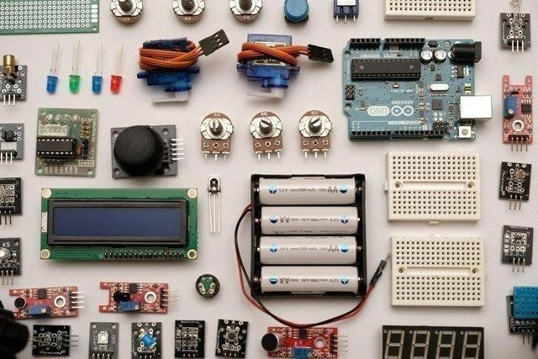

### Figure 1.3 Components of Embedded system

* 1. **HISTORY OF EMBEDDED OPERATINGSYSTEMS**

The first modern, real-time embedded computing system was the Apollo Guidance Computer, developed in the 1960s by Dr. Charles Stark Draper at the Massachusetts Institute of Technology for the Apollo Program. The Apollo Guidance Computer was designed to collect data automatically and provide mission-critical calculations for the Apollo Command Module and Lunar Module.

In 1971, Intel released the first commercially available microprocessor unit -- the Intel 4004 -- an early microprocessor that still required support chips and external memory; in 1978 the National Engineering Manufacturers Association released a standard for programmable microcontrollers, improving the embedded system design; and by the early 1980s, memory, input and output system components had been integrated into the same chip as the processor, forming a microcontroller.

The microcontroller-based embedded system would go on to be incorporated into every aspect of consumers’ daily lives, from credit card readers and cell phones, to traffic lights and thermostats.

.

### CHARACTERISTICS OF AN EMBEDDEDSYSTEM:

* + - **Single-functioned** – An embedded system usually performs a specialized operation and does the same repeatedly. For example: A pager always functions as apager.
    - **Tightly constrained** − All computing systems have constraints on design metrics, but those on an embedded system can be especially tight. Design metrics is a measure of an implementation's features such as its cost, size, power, and performance. It must be of a size to fit on a single chip, must perform fast enough to process data in real time and consume minimum power to extend batterylife.
    - **Reactive and Real time** − Many embedded systems must continually react to changes in the system's environment and must compute certain results in real time without any delay. Consider an example of a car cruise controller; it continually monitors and reacts to speed and brake sensors. It must compute acceleration or de-accelerations repeatedly within a limited time; a delayed computation can result in failure to control the car.
    - **Microprocessors based** − It must be microprocessor or microcontroller based.
    - **Memory**− It must have a memory, as its software usually embeds in ROM. It does not need any secondary memories in thecomputer.
    - **Connected**− It must have connected peripherals to connect input and output devices.
    - **HW-SW systems** − Software is used for more features and flexibility. Hardware is used for performance andsecurity.

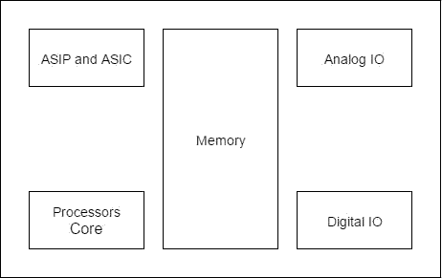

### Figure 1.5 Block diagram of Embedded system

**Advantages:**

* + - EasilyCustomizable
    - Low powerconsumption
    - Lowcost
    - Enhanced performance

### Disadvantages:

* + - High developmenteffort
    - Larger time tomarket

### BASIC STRUCTURE OF AN EMBEDDEDSYSTEM:

The following illustration shows the basic structure of an embedded system

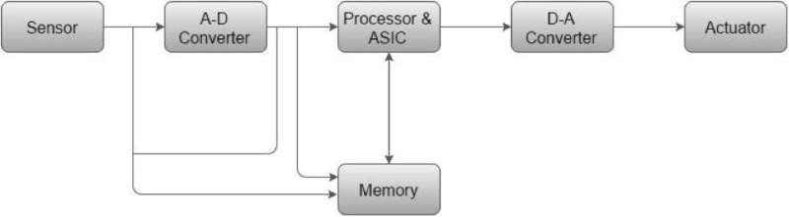

### Figure1.6 Basic Structure of Embedded System

* + - **Sensor**− It measures the physical quantity and converts it to an electrical signal which can be read by an observer or by any electronic instrument like an A2D converter. A sensor stores the measured quantity to the memory.
    - **A-D Converter** − An analog-to-digital converter converts the analog signal sent by the sensor into a digitalsignal.
    - **Processor & ASICs** − Processors process the data to measure the output and store it to thememory.
    - **D-A Converter** − A digital-to-analog converter converts the digital data fed by the processor to analogdata
    - **Actuator** − An actuator compares the output given by the D-A Converter to the actual (expected) output stored in it and stores the approvedoutput.

### WORKING OF EMBEDDEDSYSTEM

Embedded systems are managed by microcontrollers or digital signal processors (DSP), application-specific integrated circuits (ASIC), field-programmable gate arrays (FPGA), [GPU technology](https://www.omnisci.com/accelerated-analytics-explained), and gate arrays. These processing systems are

integrated with components dedicated to handling electric and/or mechanical interfacing.

Embedded systems programming instructions, referred to as firmware, are stored in read-only memory or flash memory chips, running with limited computer hardware resources. Embedded systems connect with the outside world through peripherals, linking input and outputdevices.

### FUTURE TRENDS IN EMBEDDEDSYSTEMS

The industry for embedded systems is expected to continue growing rapidly, driven by the continued development of Artificial Intelligence (AI), Virtual Reality (VR) and Augmented Reality (AR), machine learning , deep learning, and the Internet of Things(IoT). The cognitive embedded system will be at the heart of such trends as: reduced energy consumption, improved security for embedded devices, cloud connectivity and mesh networking, deep learning applications, and visualization tools with real time data.

According to a 2018 report published by QYResearch, the global market for the embedded systems industry was valued at $68.9 billion in 2017 and is expected to rise to $105.7 billion by the end of 2025.

### APPLICATION OF EMBEDDEDSYSTEM

1. **Telecommunications**
   * Telephoneswitches
   * Cellphones
   * Routers

### Consumerelectronics

* + MP3 Players
  + Televisionsets
  + Digitalcameras

### Householdappliances

* + Microwaveovens
  + Washingmachines
  + Dishwashers

### Transportationsystems

* + Avionics
  + Automobiles
  + Electricvehicles,
  + Hybridvehicles

### Medical equipments

* + MRI
  + CTScan

### CHAPTER 2 LITERATURE SURVEY

**REVIEW OF FACE RECOGNITION METHODS**

Face recognition methods divided into categories Knowledge-based methods

Feature-invariant methods Template matching methods Appearance-based methods

### KNOWLEDGE-BASED METHODS:

Knowledge-based methods are encoding our knowledge of human faces. These are rule-based methods. They try to capture our knowledge of faces, and translate them into a set of rules. It’s easy to guess some simple rules. For example, a face usually has two symmetric eyes, and the eye area is darker than the cheeks. Facial features could be the distance between eyes or the color intensity difference between the eye area and the lower zone. The big problem with these methods is the difficulty in building an appropriate set of rules. There could be many false positives if the rules were too general. On the other hand, there could be many false negatives if the rules were too detailed. A solution is to build hierarchical knowledge-based methods to overcome these problems. These methods show themselves efficient with simple inputs. But, what happens if a man is wearing glasses? There are other features that can deal with that problem. For example, there are

algorithms that detect face-like textures or the color of human skin.

### DRAWBACKS:

* + - difficulty in building an appropriate set of rules
    - false positives if the rules were too general
    - false negatives if the rules were too detailed
    - hierarchical knowledge-based methods used for this but it detect face based on textures or the color of human skin

### FEATURE-INVARIANT METHODS:

Feature-invariant methods that try to find invariant features of a face despite its angle or position. Facial recognition utilizes distinctive features of the faceincluding: distinct micro elements like: Mouth, Nose, Eye, Cheekbones, Chin, Lips, Forehead, Ears, Upper outlines of the eye sockets, the areas surrounding the cheekbones, the sides of the mouth, and the location of the nose and eyes. The distance between the eyes, the length of the nose and the angle of the jaw.

### DRAWBACK:

* **Facial expression**

### TEMPLATE MATCHING METHODS:

These algorithms compare input images with stored patterns of faces or features. Template matching methods try to define a face as a function. One can try to find a standard template of all the faces. Different features can be defined independently. For example, a face can be divided into eyes, face contour, nose and mouth. Also a face model can be built by edges. But these methods are limited to faces that are frontal. A face can also be represented as a shape. Other templates use the relation between face

regions in terms of brightness and darkness. These standard patterns are compared to the input images to detect faces. This approach is simple to implement, but it’s insufficient for face detection. It cannot achieve good results with variations in pose, scale and shape.

### DRAWBACKS:

* + - Limited to faces that are frontal.
    - A face can also be represented as a shape.
    - Other templates use the relation between face regions in terms of brightness and darkness.
    - This approach is simple to implement, but it‟s insufficient for face detection.
    - It cannot achieve good results with variations in pose, scale and shape.

### APPEARANCE-BASED METHODS:

A template matching method whose pattern database is learnt from a set of training images. In general, appearance-based methods rely on techniques from statistical analysis and machine learning to find the relevant characteristics of face images.

Principal Component Analysis (PCA) is well-organized method for face recognition. It is one of the most usable methods for a face image. It is used to reduce the dimensionality of the image and also holds some of the variations in the image data. It is projecting face image data into a feature space that covers the significant variations among known facial images. Those significant features are known as “Eigen faces”, because they are the eigenvectors or Principal Component of the set of faces. That is not necessary to correspond to the features such as eyes, ears, and noses. The projection operation characterizes an individual face by a weighted sum of the Eigen faces features. So to recognize a particular face, it is necessary only to compare these weights to those individuals. The Eigen Object Recognizer class

applies PCA on each image, the results of which will be an array of Eigen values. To

perform PCA several steps are undertaken:

Stage 1: Subtract the Mean of the data from each variable (our adjusted data) Stage 2: Calculate and form a covariance Matrix

Stage 3: Calculate Eigenvectors and Eigenvalues from the covariance Matrix Stage 4: Chose a Feature Vector (a fancy name for a matrix of vectors)

Stage 5: Multiply the transposed Feature Vectors by the transposed adjusted data

### DRAWBACKS:

* Different head pose
* Different alignment
* Different facial expression

### Distribution based Methods – LDA Algorithm

LDA also known as Fisher‟s Discriminant Analysis, is another dimensionality reduction technique. It is an example of a class specific method i.e. LDA maximizes the between – class scattering matrix measure while minimizes the within – class scatter matrix measure, which make it more reliable for classification. Lih-Heng Chan proposed a framework of facial biometric was designed based on two subspace methods i.e., Principal Component Analysis (PCA) and Linear Discriminant Analysis (LDA). First, PCA is used for dimension reduction, where original face images are projected into lower- dimensional face representations. Second, LDA was proposed to provide a solution of better discriminant. Both PCA and LDA features were presented to Euclidean distance measurement which is conveniently used as a benchmark. LDA-based methods outperform PCA for both face identification and verification. Fisher faces are one the most successfully widely used method for face recognition. It is based on appearance method. In 1930 Fisher developed linear/fisher discriminant analysis for face recognition which shows successful result in face recognition process. The disadvantage of LDA is that within the

class the scatter matrix is always single, since the number of pixels in images is larger than the number of images so it can increase detection of error rate if there is a variation in pose and lighting condition within same images. So to overcome this problem many algorithms has been proposed. Because the fisher faces technique uses the advantage of within-class information so it minimizes the variation within class, so the problem with variations in the same images such as lighting variations can be overcome

### DRAWBACKS:

* + The face to classify must be in the DB .
  + Can’t work well with high dimension.

### CHAPTER -3

**INTELLIGENT BASED TEMPERATURE SURVEILLANCE FOR INDOOR SYSTEM**

### INTRODUCTION:

The advanced participation machine is manual. It burns through a lot of time each for teachers and understudies. The showing hour for the understudies is expanded assuming that participation is taken by this face acknowledgment framework. There are in any case opportunities for intermediaries with inside the grandness while participation is taken physically. Manual participation consistently a have a worth of human mistake. Face is the indispensable conspicuous proof for any human. So robotizing the participation framework will development the efficiency of the greatness. To make it to be had for every stage we have chosen the Raspberry pi three for face location and acknowledgment. A Webcam is joined to the Raspberry Pi module. Face character isolates faces from non-faces and individuals faces that might be seen. In this framework wecan take the participation utilizing face acknowledgment which perceives the essence of every understudy during the class.

The framework gives elements like location of faces, extraction of highlights, and identification of extricated highlights and investigation of understudy's participation. The precision in identifying and perceiving appearances will be more because of purpose of bigger number of highlights (shape, variety, LBP, wavelet, Auto connection, and so forth) Of the face.

### OPENCV:

OpenCV (Open Source Computer Vision Library) is an open source computer vision and machine learning software library. OpenCV was built to provide a common infrastructure for computer vision applications and to accelerate the use of machine perception in the commercial products. Being a BSD-licensed

product, OpenCV makes it easy for businesses to utilize and modify the code.

The library has more than 2500 optimized algorithms, which includes a comprehensive set of both classic and state-of-the-art computer vision and machine learning algorithms. These algorithms can be used to detect and recognize fa ces, identify objects, classify human actions in videos, track camera movements, track moving objects, extract 3D models of objects, produce 3D point clouds from stereo cameras, stitch images together to produce a high resolution image of an entire scene, find similar images from an image database, remove red eyes from images taken using flash, follow eye movements, recognize scenery and establish markers to overlay it with augmented reality, etc. OpenCV has more than 47 thousand people of user community and estimated number of downloads exceeding 18 million. The library is used extensively in companies, research groups and by governmental bodies.

Along with well-established companies like Google, Yahoo, Microsoft, Intel, IBM, Sony, Honda, Toyota that employ the library, there are many startups such as Applied Minds, VideoSurf, and Zeitera, that make extensive use of OpenCV. OpenCV’s deployed uses span the range from stitching streetview images together, detecting intrusions in surveillance video in Israel, monitoring mine equipment in China, helping robots navigate and pick up objects at Willow Garage, detection of swimming pool drowning accidents in Europe, running interactive art in Spain and New York, checking runways for debris in Turkey, inspecting labels on products in factories around the world on to rapid face detection in Japan.

It has C++, Python, Java and MATLAB interfaces and supports Windows, Linux, Android and Mac OS. OpenCV leans mostly towards real-time vision applications and takes advantage of MMX and SSE instructions when available. A full-featured CUDAand OpenCL interfaces are being actively developed right now. There are over 500 algorithms and about 10 times as many functions that compose or support those algorithms. OpenCV is written natively in C++ and has a templated interface that works seamlessly with STL containers.

# ALGORITHM:

### HAAR Cascade

A widely popular subject with a huge range of applications. Modern day Smart phones and Laptops come with in-built face detection softwares, which can authenticate the identity of the user. There are numerous apps that can capture, detect and process a face in real time, can identify the age and the gender of the user, and also can apply some really cool filters. The list is not limited to these mobile apps, as Face Detection also has a wide range of applications in Surveillance, Security and Biometrics as well. But the origin of its Success stories dates back to *2001*, when *Viola and Jones* proposed the first ever Object Detection Framework for Real Time Face Detection in Video Footage.

You see facial recognition everywhere, from the security camera in the front porch of your house to your sensor on your iPhone X. But how exactly does facial recognition work to classify faces, considering the large number of features as input and the striki ng similarities between humans?

Enter Haar classifiers, classifiers that were used in the first real-time face detector. A Haar classifier, or a Haar cascade classifier, is a machine learning object detection program that identifies objects in an image and video

A detailed description of Haar classifiers can be seen in Paul Viola and Michael Jones’s paper “Rapid Object Detection using a Boosted Cascade of Simple Features”

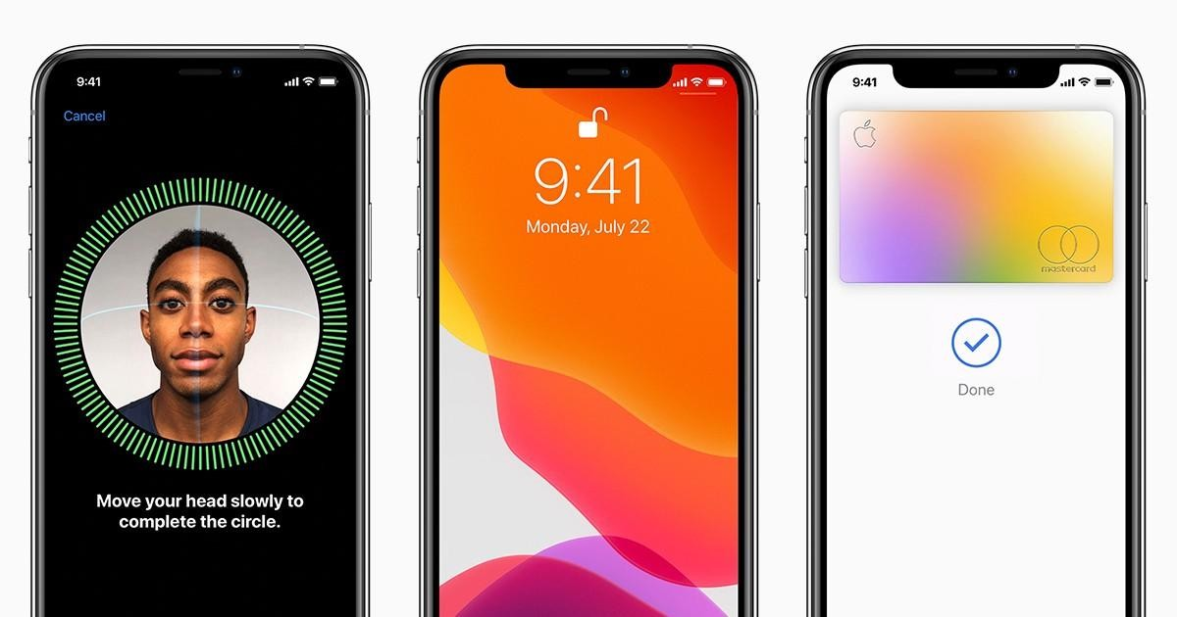

Figure 3.3 Facial recognition on an iPhone X

So what is Haar Cascade? It is an Object Detection Algorithm used to identify faces in an image or a real time video. The algorithm uses edge or line detection features proposed by Viola and Jones in their research paper “Rapid Object Detection using a Boosted Cascade of Simple Features” published in 2001. The algorithm is given a lot of positive images consisting of faces, and a lot of negative images not consisting of any face to train on them.

### FEATURES:

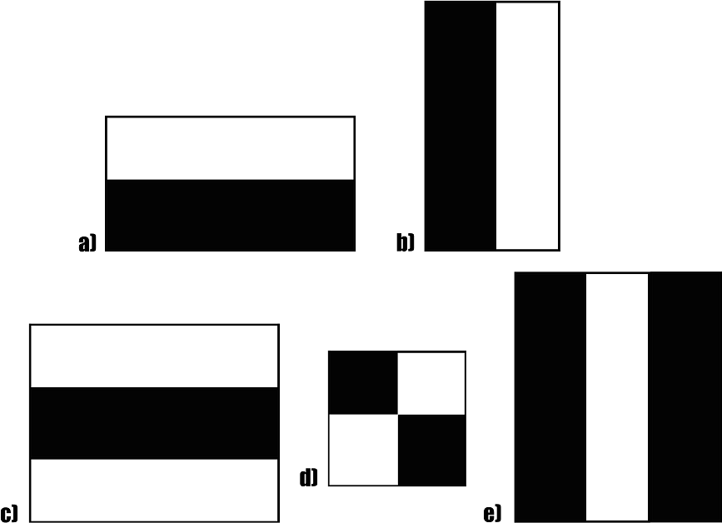

Figure 3.3 a) 7

The first contribution to the research was the introduction of the haar features shown above. This feature on the image makes it easy to find out the edges or the lines in the image, or to pick areas where there is a sudden change in the intensities of the pixels.

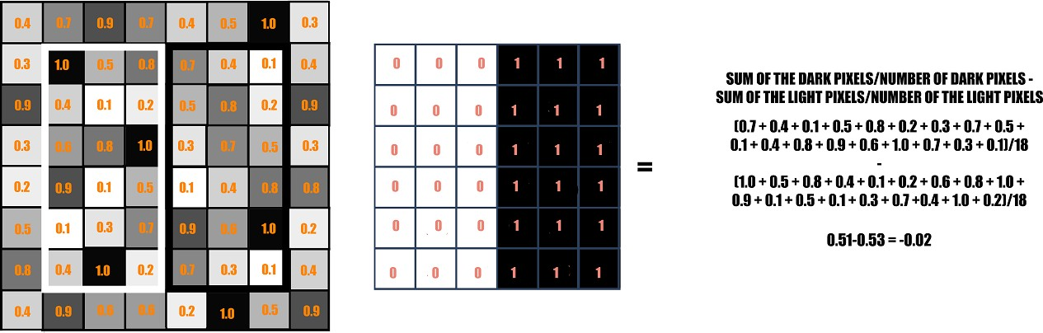

Figure 3.3 b) Binary calculation

Fig. The rectangle on the left is a sample representation of an image with pixel values 0.0 to 1.0. The rectangle at the center is a haar kernel which has all the light pixels on the left and all the dark pixels on the right.

### DEVELOPMENT OF AN AUTOMATED BODY TEMPERATURE DETECTION PLATFORM FOR FACE RECOGNITION IN CATTLE WITH YOLO V3-TINY DEEP LEARNING AND INFRARED THERMAL IMAGING

This study developed an automated temperature measurement and monitoring platform for dairy cattle. The platform used the YOLO V3-tiny (you only look once, YOLO) deep learning algorithm to identify and classify dairy cattle images. The system included a total of three layers of YOLO V3-tiny identification: (1) dairy cow body; (2) individual number (identity, ID); (3) thermal image of eye socket identification. We recorded each cow’s individual number and body temperature data after the three layers of identification, and carried out long-term body temperature tracking. The average prediction score of the recognition rate was 96%, and the accuracy was 90.0%. The thermal image of eye socket recognition rate was

>99%. The area under the receiver operating characteristic curves (AUC) index of the prediction model was 0.813 (0.717–0.910). This showed that the model had excellent predictive ability. This system provides a rapid and convenient temperature measurement solution for ranchers. The improvement in dairy cattle image recognition can be optimized by collecting more image data. In the future, this platform is expected to replace the traditional solution of intrusive radio-frequency identification for individual recognition.

### HUMAN FACE RECOGNITION AND TEMPERATURE MEASUREMENT BASED ON DEEP LEARNING FOR COVID-19 QUARANTINE CHECKPOINT

The human temperature measurement system has been widely applying in hospitals and public areas during the widespread Covid-19 pandemic. However, the current systems in the quarantine checkpoint are only capable of measuring

the human temperature; however, it can not combine with the identification of

facial recognition, human temperature information, and wearing mask detection.

In addition, in the hospitals as well as the public areas such as schools, libraries,

train stations, airports, etc. facial recognition of employees combined with

temperature measurement and masking will save the time check and update

employee status immediately. This study proposes a method that combines body

temperature measurement, facial recognition, and masking based on deep

learning. Furthermore, the proposed method adds the ability to prevent spoofing

between a real face and face-in-image recognition. A depth camera is used in

the proposed system to measure and calculate the length between the human's

face and camera to approach the best accuracy of facial recognition and anti-

spoofing. Moreover, a low-cost thermal camera measures the human body

temperature. The methodology and algorithm for the human face and body

temperature recognition are validated through the experimental results.

### DESIGN OF CAMPUS HEALTH INFORMATION SYSTEM USING FACE RECOGNITION AND BODY TEMPERATURE DETECTION

Proposed by Hanlin Wu in IEEE. Currently under the epidemic crisis of COVID-19, campus epidemic prevention has become a hot topic, and temperature detecting equipment has become a necessity in public spaces. However, temperature detection systems that are widely sold on the market are relatively simple and cannot recognize personal identity. Besides, they cannot record individual temperature changes, and they are still inadequate in terms of managing personal health information. In this study, we proposed a system that can meet the needs of campus epidemic prevention called CHIS (Campus Health Information System). In CHIS, an infrared sensor is used for temperature detection and combined with face recognition. The body temperature is recorded while face recognition is performed, and the faceID and the collected

real-time body temperature aretransmitted to the cloud for viewing and

managing by the school. The data will be managed centrally in the cloud and will be cleaned during daily processing. In the end, the student’s health data history will be stored only in their personal Pod (Personal online datastore), a decentralized personal cloud data model that prevents the risk of large-scale data leakage due to centralized management. The combination of body temperature detection and face recognition avoids substituting the presence of a real person with photos or pictures, which further enhances security. It also reduces the risk of infection prompted by human detection, which increases safety.

### ATTENDANCE SYSTEM BASED ON FACE RECOGNITION, FACE MASK AND BODY TEMPERATURE DETECTION ON RASPBERRY PI

Handayani Saptaji Winahyu Proposed at IEEE. The world is currently experiencing a COVID-19 pandemic which has caused many deaths. Then, one of COVID-19 early detection can be done through wearing a face mask and detecting body temperature when entering a room. The purpose of this research is to create an attendance system capable to recognize face, face mask, and measure body temperature. The data was tested against three types of Raspberry Pi (Pi 3B, Pi 4-4Gb, and Pi 4-8Gb). Each type of Raspberry Pi was tested using three metric combinations of different encoding methods and object classification, namely Method 1 - Haar Cascade and LBPH, Method 2 - Haar Cascade, and Tensorflow, Method 3 - MTCNN and Tensorflow. The test results obtained Method 1: FPS 15, accuracy rate 60%, CPU temperature 58°C, Method 2: FPS 4, accuracy rate 90%, CPU temperature 65°C, Method 3: FPS 2, accuracy rate 95%, CPU temperature 68°C. Basedon the benchmarks and scoring, it can be concluded that the most optimal attendance system based on face recognition, mask, and body temperature detection is a system with a Raspberry Pi 4-4Gb and Method 1-Haar Cascade and LBPH. For next

development, this attendance system needs to be further improved in security and accuracy without increasing CPU load.

### NON-CONTACT TEMPERATURE DETECTION, FACE MASK DETECTION, AND ATTENDANCE UPDATION SYSTEM USING FACIAL RECOGNITION TECHNIQUE

As communities are suffering from the COVID-19 pandemic, cross- contamination of the virus between the employees is a huge risk factor. To mark the attendance of individual employees, the swiping cards or biometrics are normally in use. This can be an easy medium for the exchange of infection which leads to a widespread of the virus. Adding to this factor, not wearing a mask also contributes to the viral spread. This can be avoided using non-contact temperature assessment device. As a part of an initial inspection at entry points, this can be used to identify people who may have elevated temperatures which is indication of a possibility of a person who may have contracted the COVID- 19 infection. While the device dispenses sanitizer on arrival, this is developed to replace the current method of manual temperature scanning that exposes front line workers directly to possibly infected persons during examination. Apart from detecting the temperature, the system also uses HOG algorithm for face recognition and updates the employee attendance. This rules out the spread of virus through swipe of card or biometrics. The system also detects if the employee is wearing a mask and ensures that COVID protocol of essential masking is guaranteed. If the employee has an elevated temperature then, the employee is referred to the on-campus physician, the appointment for which is automatically made using the system generated SMS for preliminary evaluation. If the employee needs further evaluation the physician updates the same in the database for processing medical leave.

### PATIENT MONITORING SYSTEM USING COMPUTER VISION FOR EMOTIONAL RECOGNITION AND VITAL SIGNS DETECTION

Patient monitoring is a pivotal part of the healthcare system nowadays, either at hospitals or at home. Critical patients require to be monitored consistently and less human involvement, 24 hours a day to enable them to get medical assistance in the moment of need. However, these types of services are only available in private hospitals. Typically, there is a small number of patients in private hospitals, especially from the higher socio-economic backgrounds. Conversely, in public hospital, a huge number of patients require medical attention due to the imbalance between staff to patient ratio. The patient monitoring system is restricted when they are asleep or unconscious due to incapability to call for assistance during an emergency. This may delay the treatment as the medical staff are unaware of the patients' condition, hence resulting fatality. This work proposes a smart integrated patient monitoring system that automatically detects patient's emotional state and heartbeat levels through face recognition algorithms, heartbeat and temperature sensors. A Raspberry Pi and NodeMCU are used as client nodes to collect the patient data. These data are then transmitted to an IoT cloud for realtime visualization. Through this monitoring system, critical patients can get immediate attention without the requirement of the staff being present there 24 hours a day. This system offers a faster response from medical staff to provide treatment in critical times.

### CHAPTER-4 EXISTING SYSTEM

Face recognition, as one of the most successful applications of image analysis, has recently gained significant attention. It is due to availability of feasible technologies, including mobile solutions. Research in automatic face recognition has been conducted since the 1960s, but the problem is still largely unsolved. Last decade has provided significant progress in this area owing to advances in face modelling and analysis techniques. Although systems have been developed for face detection and tracking, reliable face recognition still offers a great challenge to computer vision and pattern recognition researchers. There are several reasons for recent increased interest in face recognition, including rising public concern for security, the need for identity verification in the digital world, face analysis and modelling techniques in multimedia data management and computer entertainment.

### CHAPTER-5 PROPOSED SYSTEM

**5.1 DESCRIPTION :**

The total system is separated into 3 modules-Face detection and recognition, Database creation, Temperature monitoring

# Face detection and recognition

The camera module is set where individuals go into the everyday schedule and video is taken inside a distance under 5 meters. A camera is utilized for taking video which contains different formats from which any of the housings can be utilized for confronting insistence and venturing the cooperation.

Picking a successful calculation for face affirmation or acknowledgment is fundamental in this proposed work. There are various face location calculations available in OpenCV, for example, Eigenfaces, Fisher appearances, and Neighborhood Binary Pattern Histograms. Considering the expectations for the ongoing affirmation a calculation which has been chosen is the Haar Cascade Algorithm for face recognition and affirmation. It is available in the OpenCV source library.

**Database creation**

* + As a biometric procedure has been decided for us, it is huge for enrolment of every person whose interest should be taken. Here the face of every individual is caught and taken care of in a sensible data set that incorporates the name of an individual and different capabilities like an exceptional ID number. Here various tests are taken for a solitary individual with various lighting conditions
  + MYSQL is chosen as a database as relational DB will be much suited for the data being stored and for faster retrieval and storage.Java Database Connector connects java with a MySQL database. Separate schemas are created in a single database for logging and registering purposes. from the database can be fetched using a Data Access Object class and is returned as a JSON response to display in the frontend.
  + MYSQL queries are written in the form of Prepared Statements rather than directly allowing access to the database to avoid any form of injection attacks. Details such as Name, Temperature, in-time, and out-time are stored in DB MYSQL is chosen as database as relational DB will be much suited for the data being stored and for faster retrieval and storage. Separate schemas are created in a single database for logging and registering purpose. MYSQL queries are written in the form of Prepared Statements rather than directly allowing access to database to avoid any form of injection attacks. Details such as Name, Temperature, in-time, out-time are stored in DB.

## Temperature monitoring

Inside the examination module, the face acknowledgment handle is done. At the point when a face is recognized by the camera, it checks the contrasting upsides of the ongoing clear face with values set aside inside the record. On the occasion that the qualities are a direction, then the face is perceived and the title related to that face is shown what's more, with the assistance of the MLX90614 sensor internal heat level is detected.

### BLOCK DIAGRAM OF PROPOSEDSYSTEM:

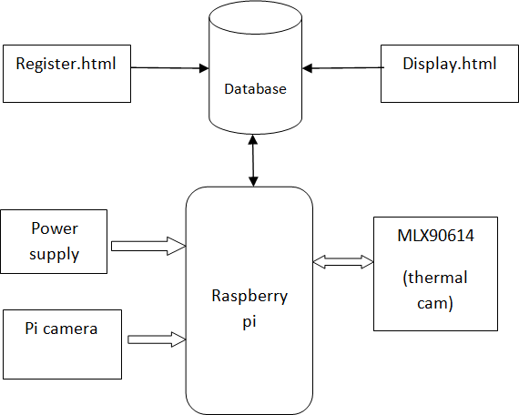

**Figure 5.1 Block Diagram of Proposed System**

### CIRCUITDIAGRAM

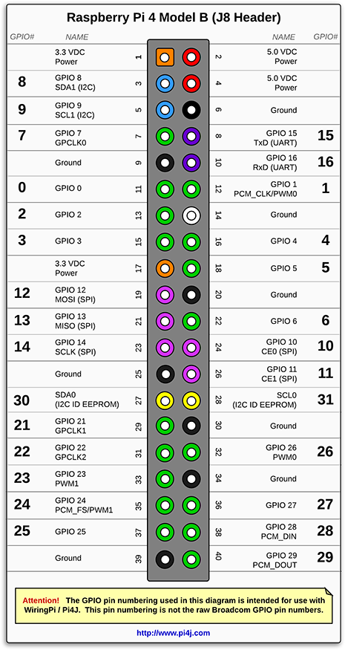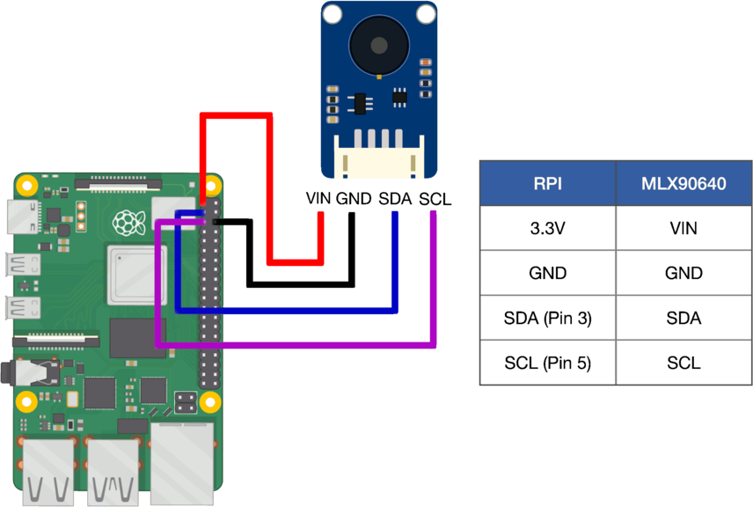

**Figure 5.2 Circuit Diagram**

### 5.2PROJECT SETUP:

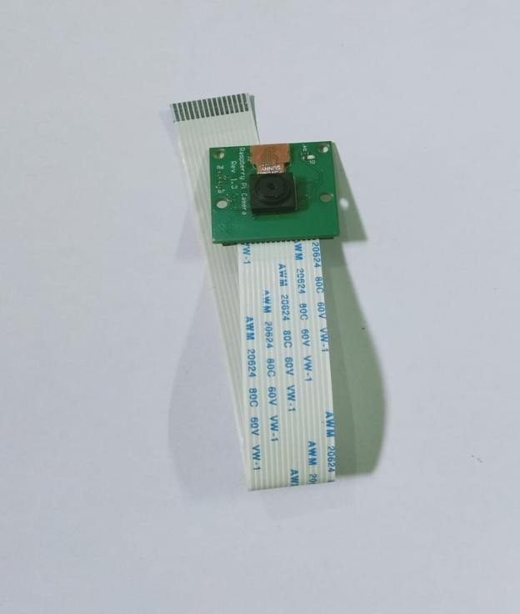

**Figure 5.2 a) Pi camera**

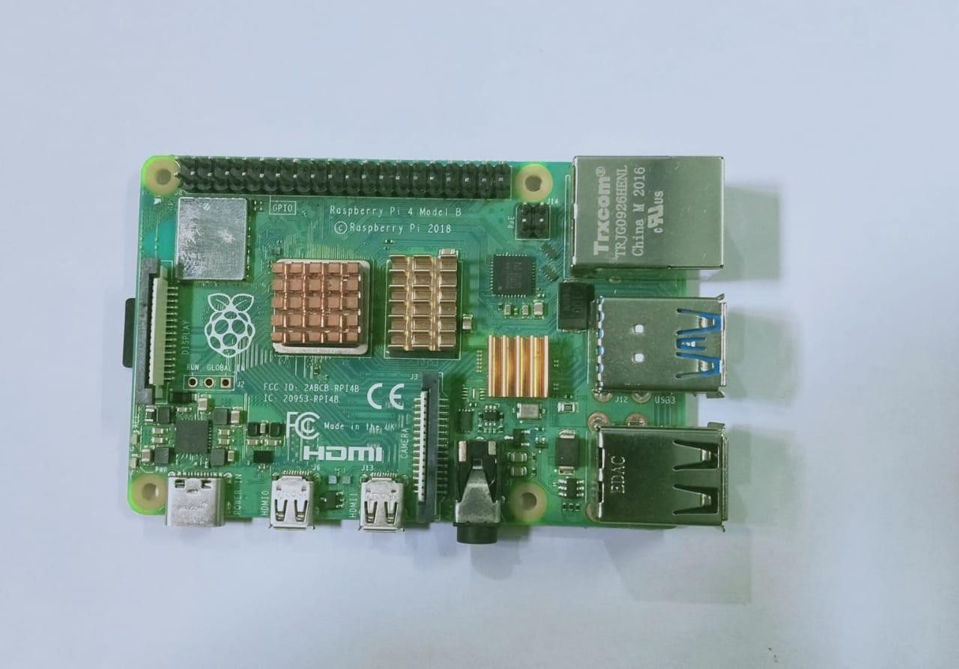

### Figure 5.2 b) Raspberry pi 4 model B

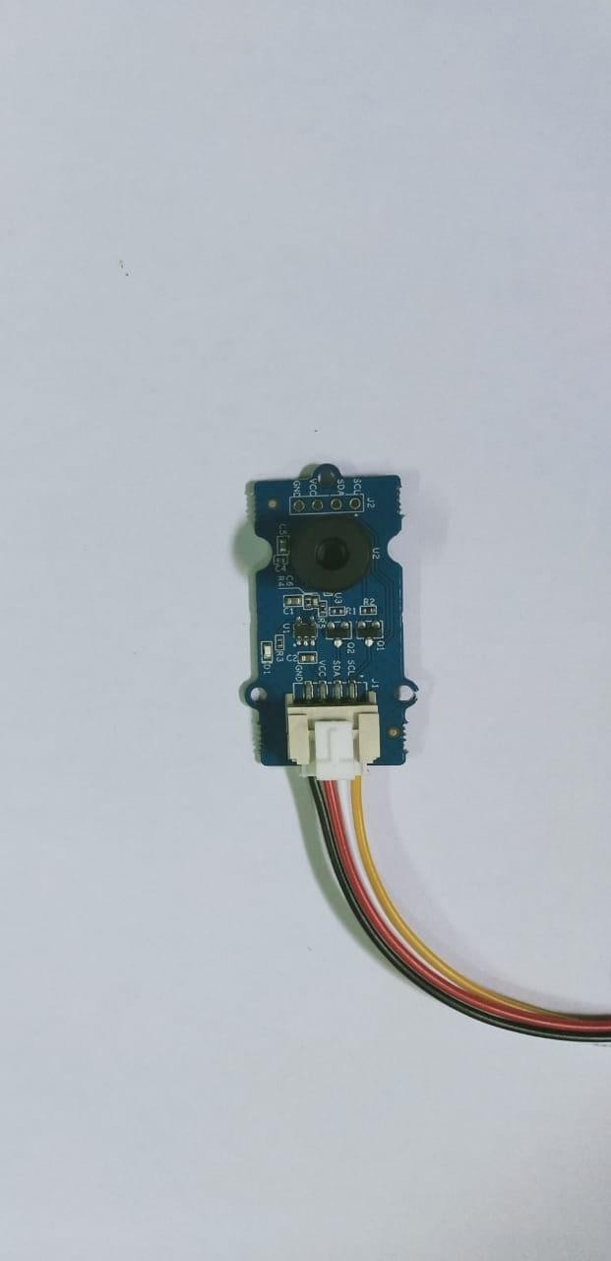

**Figure 5.2 c) Thermal imaging camera MLX90614**

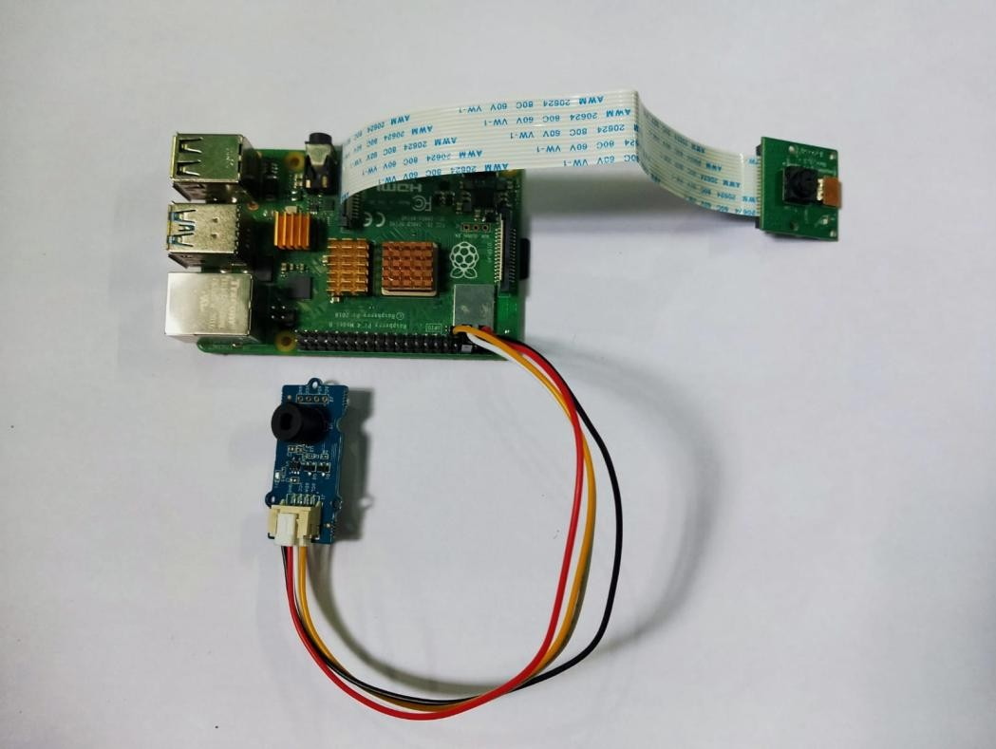

### Figure 5.2 d) Raspberry pi connected with all sensors

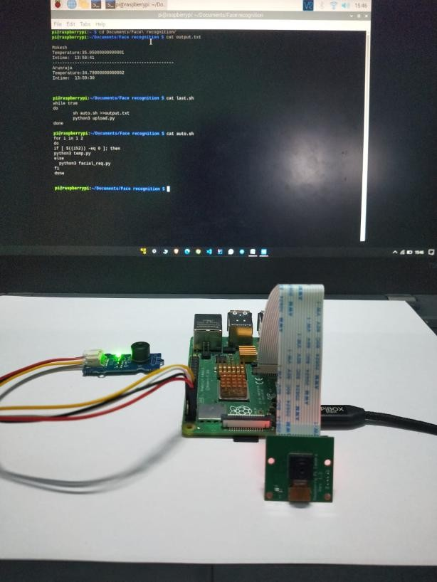

**Figure 5.2 e) Whole setup**

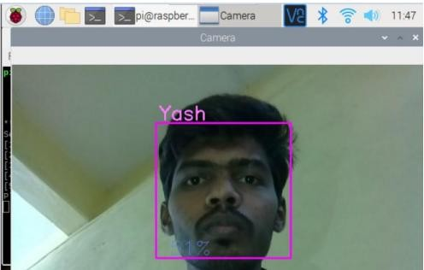

### Figure 5.2 f) Face recognition

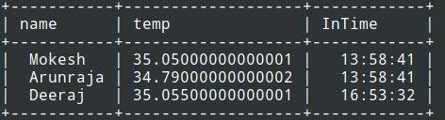

**Figure 5.2 g) Database**

### CHAPTER-6 HARDWARE DESCRIPTION

* 1. **RASPBERRYPI:**

Raspberry Pi is the name of a series of single-board computers made by the Raspberry Pi Foundation, a UK charity that aims to educate people in computing and create easier access to computing education.

The Raspberry Pi launched in 2012, and there have been several iterations and variations released since then. The original Pi had a single-core 700MHz CPU and just 256MB RAM, and the latest model has a quad-core 1.4GHz CPU with 1GB RAM. The main price point for Raspberry Pi has always been $35 and all models have been $35 or less, including the Pi Zero, which costs just $5.

All over the world, people use Raspberry Pi to learn programming skills, build hardware projects, do home automation, and even use them in industrial applications.

The Raspberry Pi is a low cost, credit-card sized computer that plugs into a computer monitor or TV, and uses a standard keyboard and mouse. It is a capable little device that enables people of all ages to explore computing, and to learn how to program in languages like Scratch and Python. It’s capable of doing everything you’d expect a desktop computer to do, from browsing the internet and playing high-definition video, to making spreadsheets, word- processing, and playinggames.

The Raspberry Pi is a very cheap computer that runs Linux, but it also provides a set of GPIO (general purpose input/output) pins that allow you to control electronic components for physical computing and explore the Internet of Things(IoT).

### MODELS:

There have been three generations of Raspberry Pi: Pi 1, Pi 2, and Pi 3, and there has generally been a Model A and a Model B of most generations. Model A is a cheaper variant and tends to have reduced RAM and ports like USB and Ethernet. The Pi Zero is a spinoff of the original (Pi 1) generation, made even smaller and cheaper.

Model (release date) Pi 1 Model B(2012) Pi 1 Model A(2013) Pi 1 Model B+(2014) Pi 1 Model A+(2014) Pi 2 Model B (2015)

Pi Zero (2015)

Pi 3 Model B (2016) Pi Zero W (2017)

Pi 3 Model B+(2018) Pi 3 Model A+(2019) Pi 4 Model B(2019)

### RASPBERRY PI 4 MODEL B

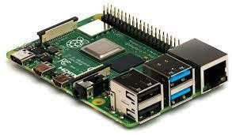

**Figure 6.3 a) RASPBERRY PI 4 MODEL B**

Raspberry Pi 4 Model B is the latest product in the popular Raspberry Pi range of computers. It offers ground-breaking increases in processor speed, multimedia performance, memory, and connectivity compared to the prior-generation Raspberry Pi 3 Model B+, while retaining backwards compatibility and similar power consumption. For the end user, Raspberry Pi 4 Model B provides desktop performance comparable to entry-level x86 PC systems.

This product’s key features include a high-performance 64-bit quad-core processor, dual-display support at resolutions up to 4K via a pair of micro-HDMI ports, hardware video decode at up to 4Kp60, up to 8GB of RAM, dual-band 2.4/5.0 GHz wireless LAN, Bluetooth 5.0, Gigabit Ethernet, USB 3.0, and PoE capability (via a separate PoE HAT add-on).

The dual-band wireless LAN and Bluetooth have modular compliance certification, allowing the board to be designed into end products with significantly reduced compliance testing, improving both cost and time to market.

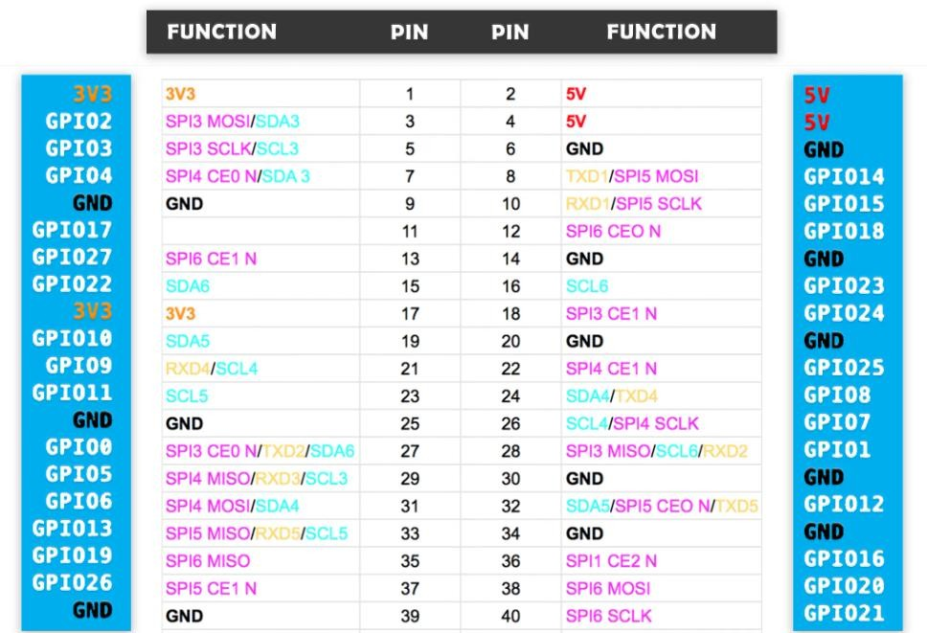

### Figure 6.3b) Raspberry Pi 4 Pin Configuration

* + 1. **Board connectors:**

|  |  |
| --- | --- |
| **Name** | **Description** |
| **Ethernet** | Base T Ethernet Socket |
| **USB** | 2.0 (Four sockets) |
| **Audio Output** | 3.5mm Jack and HDMI |
| **Video output** | HDMI |
| **Camera Connector** | 15-pin MIPI Camera Serial Interface (CSI-2) |
| **Display Connector** | Display Serial Interface (DSI) 15 way flat flex cable connector with two data lanes and a clock lane. |
| **Memory Card Slot** | Push/Pull Micro SDIO |

### Features:

* 1.4GHz 64-bit quad core ARMCortex-A-53CPU
* Gigabit Ethernet(over USB)
* Dual-band Wifi andBluetooth
* Power-over-Ethernet (PoE)pins
* Improved PXE and USBbooting
* Improved thermalmanagement

This is a big update to the existing Pi 4, including a re-spin of the BCM2837 CPU (running faster at 1.4GHz), new dual-band wireless connectivity (so you can connect to both 2.4- and 5-GHz WiFi networks), better thermal control, and more. As always, you'll need an up-to-date Raspbian SD card, but the new model is backwards-compatible with all previous models and runs the same operating systems andprograms.

### Specifications:

* + - * Color: White + Green OR White +Blue
      * Infrared Sensor with Control CircuitBoard
      * The Sensitivity and Holding Time Can beAdjusted
      * Working Voltage Range: DC 4.5V-20V
      * Current Drain:<60uA
      * Detection Range:<140°
      * Voltage Output: High/Low level Signal: 3.3V TTLoutput
      * Detection Distance: 3 to 7m (can beadjusted)
      * Delay Time: 5 to 200s (Can be Adjusted, Default 5s +/-3%)
      * Blockade time: 2.5s (Default)
      * Work temperature:-20-+80°C
      * Dimension: 3.2cm x 2.4cm x 1.8cm(Approx)
      * Sensitive Setting: Turn to Right, Distance Increases (About 7M); Turn to Left, Distance Reduce (About3M)
      * Time Setting: Turn to Right, Time Increases (About 200S); Turn to Left, Time Reduce (About5S).

### Pi CAMERA

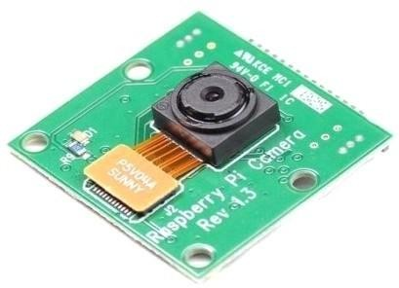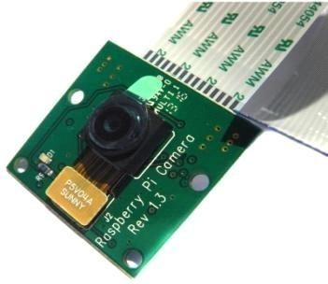

**Figure 6.4 a) Pi Camera**

Camera, in photography, device for recording an image of an object on a light-sensitive surface; it is essentially a light-tight box with an aperture to admit light focused onto a sensitized film orplate.

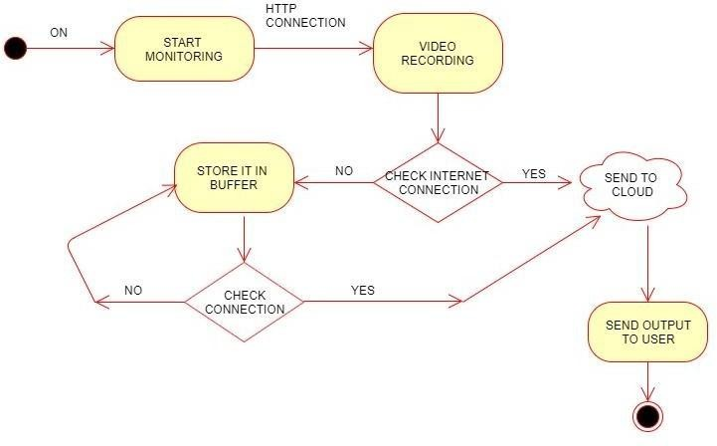

### Figure 6.4 b) Pi Camera Flow Diagram

* + 1. **Camera components:**

1. The camera box, which holds and protects the sensitive film from all light except that entering through thelens;
2. Film, on which the image is recorded, a light-sensitive strip usually wound on a spool, either manually or automatically, as successive pictures aretaken;
3. The light control, consisting of an aperture or diaphragm and a shutter, both oftenadjustable;
4. The lens , which focuses the light rays from the subject onto the film, creating the image, and which is usually adjustable by moving forward or back, changing the focus;and
5. The viewing system, which may be separate from the lens system (usually above it) or may operate through it by means of amirror.

Note that there are actually two versions of this camera module. The simpler and cheaper one is shown in Fig - and it is the one we use in thisproject.

The 5MP Raspberry Pi 3 Model B Camera Module with Cable equips flexible cable for attaching with Raspberry Pi 3 Model B. The 5MP camera module is perfect for small Raspberry Pi projects which have very little space allowance just boot up the latest version of Raspbian

The high-definition 5MP camera delivers outstanding photos but can also shoot video, ideal for drones or a CCTV project. The lightweight camera module allows for it to be used in more practical roles, such as a hidden camera or even a camera for a Pi-phone, forexample.

This Raspberry Pi Camera Module is a custom designed add-on for Raspberry Pi. It attaches to Raspberry Pi by way of one of the two small sockets on the

board upper surface. This interface uses the dedicated CSI interface, which was designed especially for interfacing to cameras. The CSI bus is capable of extremely high data rates, and it exclusively carries pixel data.

The board itself is tiny, at around 25mm x 23mm x 8mm. It also weighs just over 3g, making it perfect for mobile or other applications where size and weight are important. It connects to Raspberry Pi by way of a short flexible ribbon cable. The camera connects to the BCM2835 processor on the Pi via the CSI bus, a higher bandwidth link which carries pixel data from the camera back to the processor. This bus travels along the ribbon cable that attaches the camera board to thePi.

The sensor itself has a native resolution of 5 megapixels and has a fixed focus lens onboard. In terms of still images, the camera is capable of 2592 x 1944 pixel static images, and also supports 1080p30, 720p60 and 640x480p60/90 video.

No adapters required,this camera will plug directly into the Raspberry Pi 3 Model B camera port.

### Features of raspberry pi 5mp camera module withcable:

* + - * Fully Compatible with Both the Model A, Model B and Model B+ RaspberryPi
      * 5MP Omnivision5647 CameraModule
      * Still Picture Resolution: 2592 x1944
      * Video: Supports 1080p @ 30fps, 720p @ 60fps and 640x480p 60/90 Recording
      * 15-pin MIPI Camera Serial Interface - Plugs Directly into the Raspberry PiBoard
      * Size: 20 x 25 x9mm
      * Weight3g

### MLX90614 THERMAL IMAGING CAMERA:

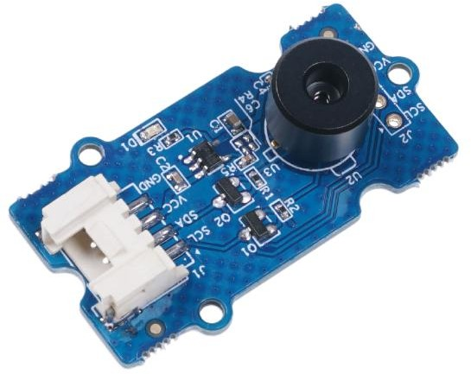

**FIGURE 6.5 a) MLX90614**

The key feature of the MLX90614 is that it is a high-precision, contactless IR temperature sensor. It can therefore be used in industries to measure the temperature of moving objects, such as a rotating motor shaft. Due to its high accuracy and precision, it is also used in a wide range of commercial, health and household applications such as room temperature monitoring, body temperature measurement, etc.

The MLX90614 sensor can measure the temperature of an object without any physical contact with it. This is made possible by a law called the Stefan-Boltzmann Law, which states that all objects and living beings emit IR Energy and that the intensity of that emitted IR energy is directly proportional to the temperature of that object or living being. The MLX90614 sensor therefore calculates the temperature of the object by measuring the amount of IR energy emitted from it.

### MLX90614 PINS:

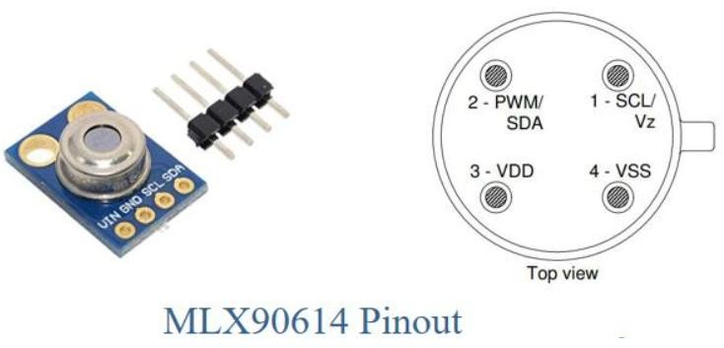

**Figure 6.5 b) MLX90614 pinout**

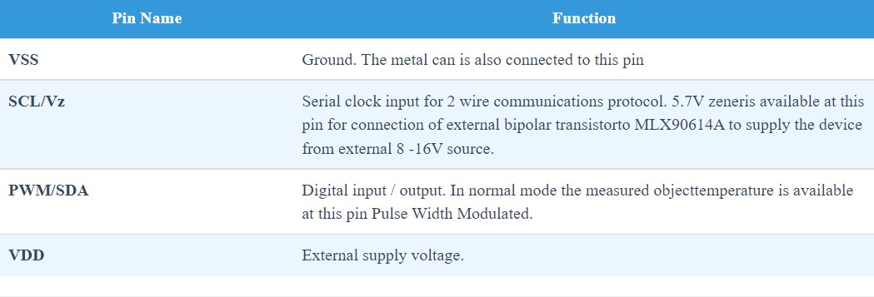

### MLX90614APPLICATIONS:

* High precision non-contact temperature measurements
* Thermal Comfort sensor for Mobile Air Conditioning control system
* Temperature sensing element for residential, commercial and industrial building air conditioning
* Automotive blind angle detection
* Industrial temperature control of moving parts
* Temperature control in printers and copiers
* Home appliances with temperature control
* Healthcare
* Livestock monitoring.

### MLX90614 FEATURES:

* Small size, low cost
* Easy to integrate
* Factory calibrated in wide temperature range: -40 to 125 ˚C for sensor temperature and -70 to 380 ˚C for object temperature
* High accuracy of 0.5°C over wide temperature range (0..+50°C for both Ta and To
* High (medical) accuracy calibration optional
* Measurement resolution of 0.02°C
* Single and dual zone versions
* SMBus compatible digital interface
* Customizable PWM output for continuous reading
* Available in 3V and 5V versions
* Simple adaptation for 8 to 16V applications.

### CHAPTER-7

**DATABASE**

### Introduction to MySQL:

One of the numerous important aspects for the smooth functioning of a website or a web app is the strength of its database. How well the DB handles critical high- volume traffic, is there a data recovery mechanism in case of system failures, advanced functionalities, etc. are some of the parameters that define the working of a DB.

We will look at an introduction to the MySQL database (an RDBMS) and go through its architecture and various features that make it the best choice with regards to developing web apps or websites.

## Architecture:

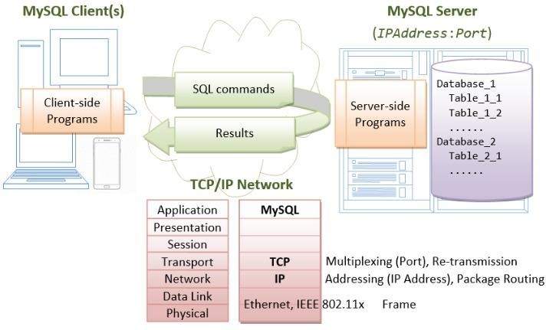

Figure 7.1.2 Architecture

MySQL, initially developed by MySQL AB, now backed by Oracle, is a relational database management system (RDBMS), based on the client-server model.

Data is distributed in a tabular form (in different tables) using rows and columns. Tables are connected to each other via joins (relations).

SQL (Structured Query Language) is used as a mode of communication between the client and the server. All advanced functions of the SQL, like triggers, stored procedures, etc. can be used as part of querying.MySQL is a multi-platform DB that can run on various operating systems like Windows, Linux, Unix, Mac etc. It is an open-source DB written in C and C++ but uses SQL as the language to communicate within the DB, and it supports various data types, namely Character-string, Numeric, Bit-string, Date & Time, Boolean, and Timestamp.MySQL is the most widely used DB, along with PHP, to build websites, and popular examples of them include Facebook, WordPress, Drupal, etc. It is also compatible with other programming languages like Ruby, Python, Perl, etc.

### Features:

Developers are swearing by MySQL because of its wide range of features and benefits and are giving their systems an introduction to MySQL by migrating from previous db to mysql

### Performance:

As mentioned above, the performance of a DB, while maintaining an enormous amount of data, is a significant parameter it is judged upon. MySQL provides high performance in such critical situations without compromising on data since it stores data on multiple engines like InnoDB, ISAM, CSV, etc. It offers faster loading because of its memory caching and indexing methodologies.

### High Availability and Throughput:

One of the major advantages of MySQL is the availability of the MySQL cluster servers that facilitate auto-sharing, wherein data is distributed across several servers. In this way, data is well-balanced and always accessible even during high-traffic situations.

In the event of any crash or system failure, data can be replicated onto secondary servers from the primary servers, thereby providing instant backup and recovery.

### Compliance to ACID:

MySQL is fully compliant to ACID (Atomicity, Consistency, Isolation, Durability), which means it guarantees reliable transaction processing and data accuracy even during adverse circumstances.

### Leveraging SQL functionality:

Having SQL as its primary language for database interaction, MySQL supports the use of advanced SQL components like views, stored procedures, triggers, functions, etc. for enhanced application development. Perhaps this is one of the most powerful features of MySQL.

### Security:

MySQL provides robust security mechanisms like user account authorization, password encryptions, etc., which make it the most secure and reliable RDBMS.

### Summary:

The below survey shows the most popular databases

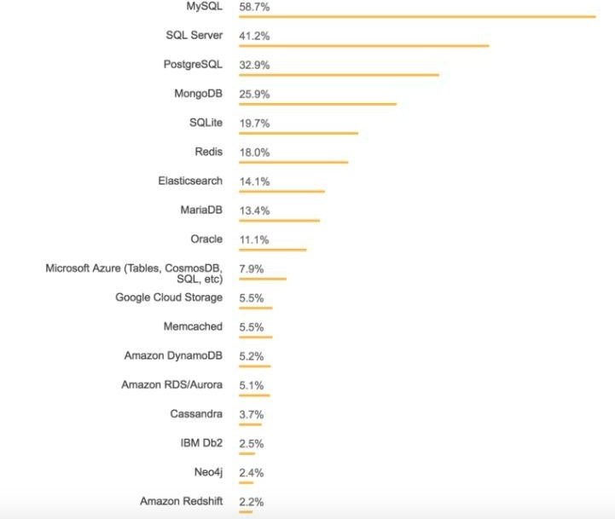

Figure 7.1.9 Survey

### JDBC (Java Database Connectivity):

Java API that manages connecting to a database, issuing queries and commands, and handling result sets obtained from the database. Released as part of JDK 1.1 in 1997, JDBC was one of the earliest libraries developed for the Java language.

JDBC was initially conceived as a client-side API, enabling a Java client to interact with a data source. That changed with JDBC 2.0, which included an optional package supporting server-side JDBC connections. Every new JDBC release since then has featured updates to both the client-side package (java.sql) and the server- side package (javax.sql). JDBC 4.3, the most current version as of this writing, was released as part of Java SE 9 in September 2017 as JSR 221.

### How JDBC works:

As a developer, you can use JDBC to interact with a database from within a Java program. JDBC acts as a bridge from your code to the database.

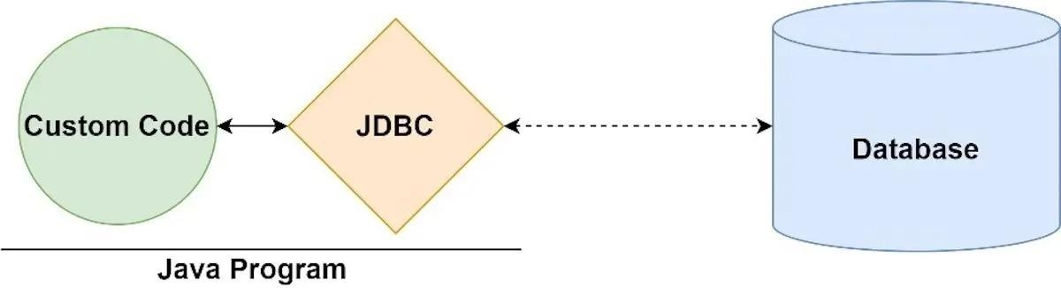

Figure 7.2.1JDBC

### 7.2.3 JDBC vs. ODBC:

Before JDBC, developers used Open Database Connectivity (ODBC), a language- agnostic standard approach to accessing a relational database management system, or RDBMS. In some ways, JDBC takes its inspiration from ODBC. The difference is that JDBC is Java-specific, offering a programming-level interface that handles the mechanics of Java applications communicating with a database.

### JDBC’s architecture:

The JDBC interface consists of two layers:

* The JDBC API supports communication between the Java application and the JDBC manager.
* The JDBC driver supports communication between the JDBC manager and the database driver.

The JDBC API and JDBC driver have been refined extensively over the years, resulting in a feature-rich, performing, and reliable library.

JDBC is the common API that your application code interacts with. Beneath that is the JDBC-compliant driver for the database you are using.

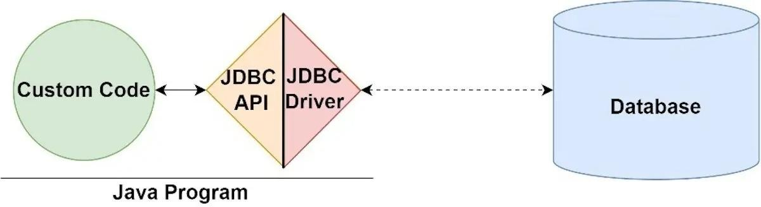

Figure 7.3 JDBC API

### JDBC drivers:

As an application programmer, you don’t need to immediately be concerned with the implementation of the driver you use, so long as it is secure and official. However, it is useful to be aware that there are four JDBC driver types:

* JDBC-ODBC bridge driver: A thin Java layer that uses an ODBC driver under the hood.
* Native API driver: Provides an interface from Java to the native database client.
* Middleware driver: A universal interface (“middleware”) between Java and the RDBMS’s vendor-specific protocol.
* Pure Java driver: A driver that implements the vendor-specific protocol directly in Java.

### Created database code:

import java.io.*;

import java.util.ArrayList;

import javax.servlet.ServletException; import javax.servlet.annotation.WebServlet; import javax.servlet.http.HttpServlet;

import javax.servlet.http.HttpServletRequest; import javax.servlet.http.HttpServletResponse;

@WebServlet("/ReadFIle")

public class ReadFIle extends HttpServlet {

protected void service(final HttpServletRequest request, final HttpServletResponse response) throws IOException {

this.read(request, response);

}

protected ArrayList read(final HttpServletRequest request, final HttpServletResponse response) throws IOException {

ArrayList<String> arr = new ArrayList<>(); File file = new File("/yourdirectory/sample.txt");

BufferedReader br = new BufferedReader(new FileReader(file));

String st;

while ((st = br.readLine()) != null) arr.add(st);

for(int i=0; i<arr.size(); i+=4) {

System.out.println(arr.get(i) + " " + arr.get(i+1) + " " + arr.get(i+2)); LoginDAO.insert(arr.get(i).substring(arr.get(i).lastIndexOf(":") + 1),

arr.get(i+1).substring(arr.get(i+1).lastIndexOf(":") + 1),

arr.get(2).substring(arr.get(i+2).indexOf(":") + 1));

}

return arr;

}

}

### JDBC:

import java.util.ArrayList; import java.sql.SQLException; import java.sql.ResultSet;

import java.sql.PreparedStatement; import java.sql.Connection;

import java.sql.DriverManager; import com.mysql.jdbc.Driver;

public class LoginDAO

{

static String url;

static String username; static String password;

static {

LoginDAO.url = "jdbc:mysql://localhost:3306/finalproject"; LoginDAO.username = "root";

LoginDAO.password = "";

}

public static void insert(final String a, final String b, final String c, final String d)

{

try {

Class.forName("com.mysql.cj.jdbc.Driver");

final Connection con = DriverManager.getConnection(LoginDAO.url,

LoginDAO.username, LoginDAO.password);

final PreparedStatement st = con.prepareStatement("INSERT INTO register VALUES(?, ?, ?, ?);");

st.setString(1, a); st.setString(2, b); st.setString(3, c); st.setString(4, d); st.executeUpdate();

}

catch (Exception e) { e.printStackTrace();

}

}

}

### About the code:

* Fetches file hosted in Firebase and stores it in our local system.
* Reads file stored in local machine and iterates through whole file. Data iterated will be stored in a List.
* ArrayList is then passed to a Data Access Object.
* Using JDBC data retreived from List is stored in database using Prepared Statements.

### CHAPTER-8 CONCLUSION AND FUTURE WORK

* 1. **CONCLUSION:**

In this system we have implemented the face recognition and temperature detection. It spares time and exertion. The total framework is executed with OpenCV and raspberry pi. This system shows the use of facial recognition and detection method for the person to identify and storing temperature. The result of the test appears the discovery and Acknowledgment portion. This strategy can moreover distinguish numerous faces and can be effortlessly utilized in a classroom. At that point the identified faces are at that point confirmed with confront database. The accuracy of confront acknowledgment is nearly more than 90%. Face verification, also often referred to as face authentication, is about validating an identity based on the image of a face by checking against an existing database. Face authentication involves comparing an input image only with the image that belongs to the identity the person claims to be. In other words, the system will only compare your face to one picture, not the whole database.

In Covid19 situation body temperature sensing is important in terms of student’s safety, so temperature sensing is done. This system can also be implemented in hospitals. In the last few years, some hospitals started to use facial recognition systems to make patient processing easier. The system matches the right patient to their records, thereby preventing record duplicates or record oversight.Another area where facial recognition is used, is emergency situations.

.

### FUTURE WORK:

We are planning to add a finger impression framework to the model to distinguish people with their biometrics, on the off chance that they face acknowledgment bombs we can involve this for improved results and it will make an exceptional id. Robotizing these undertakings assists associations with setting aside time and cash, with added face acknowledgment and temperature observing highlights.

### CHAPTER-9

**REFERENCES**

* + 1. Viola, P., & Jones, M. (2001). Rapid object detection using a boosted cascade of simple features. In Computer Vision and Pattern Recognition, 2001. CVPR 2001. Proceedings of the 2001 IEEE Computer Society Conference on (Vol. 1, pp. I-511). IEEE
    2. Priya Pasumarti1, P. Purna Sekhar2 “Classroom Attendance Using Face Detection and Raspberry-Pi” International Research Journal of Engineering and Technology (IRJET), Volume: 05 Issue: 03
    3. Sarath Chandu Gaddam1, N. V. K. Ramesh2 and Hema dhanekula3,” FACE RECOGNITION BASED ATTENDANCE MANAGEMENT SYSTEM WITH RASPBERRY PI 2 USING EIGEN
    4. FACES ALGORITHM”, ARPN Journal of Engineering and Applied Sciences VOL. 11, NO. 13
    5. Kiran Kumar.R, Mekala.S M.E,” Face Recognition Attendance System using Raspberry Pi”,International Journal of Pure and Applied MathematicsVolume 118 No.20 2018, 3061-3065
    6. G. T.S.Lim Fac., Ayer Keroh, Malaysia S. C. Sim ; M. M. Mansor. 2009. RFID based attendance system Industrial Electronics and Applications. ISIEA 2009. IEEE Symposium on (Vol. 2)
    7. Quan-Xi, Li Gang M. 2012. An Efficient Automatic Attendance System Using Fingerprint Reconstruction Technique IJCSIS International Journal of Computer Science and Information Security.
    8. U. Eze peter; Owerri Nigeria; C.K.A. JoeUzuegbu; Laz Uzoechi; F.K. 2013. Opera biometric based attendance system with remote real time

monitoring tertaryinstitutions in developing countries emerging and sustainable technologies for power and ICT in a developing society NIGERCON, IEEE

* + 1. “Very Low Resolution Face Recognition Problem” Wilman W. W. Zou, Student Member, IEEE, and Pong C. Yuen, Senior Member, IEEE, IEEE TRANSACTIONS ON IMAGE PROCESSING, VOL. 21, NO. 1, JANUARY 2012
    2. Face Recognition using Neural Networks, P.Latha, Dr.L.Ganesan & Dr.S.Annadurai, Signal Processing: An International Journal (SPIJ) Volume

(3) : Issue (5)