Hikyu Bank V6
  - LCNC + AI iBPM Assignment Report
Saltcorn 1.6.2 • Flowable 7.1.0 • Real local supervised classification
Prepared from the V5 archive supplied in this task. Evidence date: 3 November 2026.
Validated local functional demonstrator. Human workflow tests use separate accounts operated by one person. Full V5 equivalence, real-person acceptance and public hosting are not claimed.
Verified scope | Actual evidence
Uploaded V5 baseline | 93 backend tests, five frontend test-file executions, 14 startup tests; new-account browser smoke
Live V6 human workflow | 8 LCNC E2E checks + 10 resilience/security checks
Native banking reconstruction | 14 live banking checks + 5 protected CSV checks
AI and task failures | 3 controlled AI-fault E2E checks + actual accelerated human-task timer escalation
Artifacts | Native LCNC application pack, executable BPMN, source, safe evidence and setup guide

The short reflection is a separate 166-word appendix. The full report is intentionally longer than 200 words.

Hikyu Bank V6 — LCNC and AI iBPM Assignment Report
Status: Working local V6 demonstrator with a tested LCNC–AI–human workflow. This is not a claim of complete V5 feature equivalence, public hosting, production banking readiness, or real multi-person testing.
Evidence date: 3 November 2026. Source boundary: Only the uploaded Hikyu-Bank-Project-V5.zip, this task's instructions, official sources inspected during this task, and newly generated synthetic data. No old deployment, account, database destination or earlier test result was used. A private environment file in the archive was preserved but not loaded. All 651 extracted archive files were checked unchanged.

Step 1 — Select and set up an LCNC platform
The original instruction selected Bubble. The user subsequently authorized switching to another editable LCNC platform. The final platform is Saltcorn 1.6.2, installed from the official npm package under a locked dependency manifest. Its official repository describes an open-source no-code database application builder with views, layouts, datatypes and actions; its license is MIT. The native editor, PostgreSQL-backed data, page definitions, reusable views and application actions run in this task's new environment.
Bubble pricing/API pages could not be retrieved through the environment policy. No Bubble project editing, preview, live release, upgrade or trial occurred. Exact current Bubble plan entitlements therefore remain unverified and are superseded by the platform-change instruction.
Budibase was evaluated first. Its official deployment images exhausted the managed Docker vfs storage during application-container creation. The failed task-created deployment and its unused images were removed. Saltcorn was chosen after successful installation and actual editing/data/workflow verification, rather than claiming the failed Budibase deployment worked.
The selected combination uses free self-hosted software and existing task compute. Hosting, operations, backups and any future public domain remain separate costs. No permanent free public hosting is claimed, no paid module was purchased, and no external AI subscription is required. The local service is a self-hosted deployment, not a publicly reachable website. No environment version was published by the agent.

Step 2 — Reconstruct the V5 components
The uploaded V5 uses Spring Boot 3.5.16, Java 17 compilation, native JavaScript modules, PostgreSQL and Flyway migrations V1–V8. V6 assignment numbering is independent of SQL migration numbering. The archive's previously generated binaries/results were not trusted: a clean working copy excluded private environment files and build outputs, then compiled and tested against a newly created database.
Fresh baseline validation passed 93 backend tests, five frontend test-file executions and 14 startup tests. A newly registered synthetic V5 account passed a real browser login/code/PIN flow and loaded six routes. The rendered desktop interface has horizontal navy navigation; the source <aside> tag was not mistaken for a visible desktop sidebar.
The LCNC application contains eight native pages, native data definitions and reusable views. Its page layouts can be edited in Saltcorn; custom reusable view/action extensions supply security-sensitive business behavior. The build used the platform SDK/CLI and browser validation, not an invented manual drag-and-drop experience. See the detailed mapping (V5_to_LCNC_Mapping.md).
Implemented and tested financial components include owned account cards, persistent transactions, exact integer-cent amounts, own-account transfers, peer payments, debit/credit purchases, credit repayment, saved demo billers, bill payment, card locking, budgets and CSV statements. The native action implementation serializes users/accounts in PostgreSQL transactions, stores idempotency hashes, binds simulated authorization codes to sessions and request fingerprints, and writes linked ledger legs. PINs use salted scrypt hashes; no PIN is returned by a financial action. Direct user writes to financial and workflow state fields are restricted.
V5 UUIDs and Saltcorn integer row IDs are separate identifiers. Synthetic source_v5_id values are explicitly separate from native IDs; no claim is made that real V5 records were migrated. The normalized V5 notification-recipient and financial-event tables are represented using owned notification rows and a unified event table. This is a documented representation change, not byte-identical schema migration.
Parity gaps: Native email/password sign-in replaces V5 username/password plus simulated login MFA; payment code/PIN checks are implemented separately. Full original registration/profile/security/session-management behavior, all alert scheduling/preferences, the original financial assistant, complete transaction filtering/pagination/detail behavior, account-opening behavior and complete mobile/layout equivalence have not been fully ported and verified. These remain incomplete, not silently marked passed.

Development experience
V5 expresses constraints and transactions in Java/SQL, with Maven compilation and JUnit tests. Saltcorn exposes tables, fields, ownership and page/view metadata directly and provides a live editor and native export pack. These generated views made the data structure visible quickly. Exact monetary behavior, authorization-code binding and transaction atomicity still required a coded extension and real database tests; a visual sequence of row updates would not have preserved the guarantees. CLI changes required reloading the application to refresh process-local metadata. Debugging included a real SQL keyword collision and a test harness CSRF-source issue, both corrected and retested. Configuration export aids version review, but no time-saving percentage or measured productivity gain is claimed.

Step 3 — Compare and select an AI iBPM platform
Platform_Comparison.md (Platform_Comparison.md) compares Flowable Open Source and n8n Community, using inspected official repository documentation. Criteria cover task assignment, human review, modeling, automation, state, audit, exceptions, AI, integration, licensing and hosting.
Flowable 7.1.0 was selected after the actual Saltcorn → runtime AI → service-agent/reviewer handoff → persisted Saltcorn writeback chain passed. Its Apache 2.0 engine provides executable BPMN, human tasks, gateway branches, timers and history. This implementation adds AI through a real service delegate; it does not claim that the open-source engine includes a hosted generative-AI entitlement. The n8n comparison found documented AI human-review support and indefinite Community self-hosting, but also Community limits on projects, sharing and governance. n8n was researched, not executed.

Step 4 — Implement a multi-participant workflow
Business case: Transaction Support Review, derived from V5's actual owned transaction history and card/payment features. It adds support handling without changing a settled transaction or making a real credit decision.
Participant | Task | Handoff
Requester | Select an owned transaction; describe a synthetic issue; supply missing information if returned | Service agent
Service agent | Review the runtime AI category and transaction context; continue, return or reject | Independent reviewer or requester
Reviewer | Independently complete or reject the proposed handling | Final result
Supervisor | Handle an overdue review | Final result

The executable definition is implementation/workflow/src/main/resources/transaction-support.bpmn20.xml. The deployment binds the AI service delegate, stage-version listener and final-state listener. Real task history records assignees. Candidate groups alone are not treated as sufficient authorization: the service checks the authenticated role, business-record ownership, active task and expected version. The agent and final reviewer must be different identities.
Process/architecture diagram: see the Markdown report for the editable Mermaid definition. Main flow: requester → runtime AI → service agent → independent reviewer → persisted LCNC outcome; exceptions route to manual triage or supervisor.
Uniform displayed states are SUBMITTED, MANUAL_TRIAGE, SERVICE_REVIEW, RETURNED, REVIEWER_REVIEW, ESCALATED, COMPLETED and REJECTED. Integration errors are separate synchronization metadata, not a fabricated successful business state. Return goes back to classification; final states cannot be overwritten by late non-final projections. The normal reviewer deadline is 24 hours. A controlled two-second test deadline caused a real timer expiry and persisted escalation; no claim is made that a 24-hour wait was observed.
All role testing was performed by one operator using separate newly created accounts/browser contexts. Actual participation by different people remains Not tested.

Step 5 — Integrate the LCNC application and workflow
Process/architecture diagram: see the Markdown report for the editable Mermaid definition. Main flow: requester → runtime AI → service agent → independent reviewer → persisted LCNC outcome; exceptions route to manual triage or supervisor.
implementation/openapi.yaml documents process submission, status retrieval and task decisions. The LCNC server creates the business row first and submits its stable business_id; Flowable returns process_instance_id. AI, stage, sequence, timestamp and comments are projected into that same LCNC row. Browser refresh reads persisted data. The LCNC owns the business record and financial ledger; Flowable owns execution/tasks/timers/history. Its status response is a projection, not a competing banking database.
Generated role tokens and native account passwords are stored only in the task's private directory and server process configuration. Browsers receive native session cookies and CSRF protection, not workflow service tokens. Submitted text is data, never executable instructions. Errors use explicit HTTP statuses. Duplicate requests with unchanged content return the original record/process; changed content under the same key returns conflict. Task versions reject duplicate/late decisions. Correlation checks reject another process/business ID pairing.
A persistent database record precedes network submission. A background reconciliation worker uses exponential backoff (capped at 60 seconds) after failures and reads durable engine state after service recovery. Real tests stopped the API, restarted it, imposed a temporary PostgreSQL callback constraint, removed that constraint and observed automatic convergence. This is polling/reconciliation integration, not a claimed external webhook deployment. Polling and loopback HTTP are local-demo choices; a public deployment needs HTTPS, managed secrets, authentication hardening and hosting configuration.

Actual AI implementation
The task uses a trained multinomial Naive Bayes text classifier, not mock output and not an LLM. Its three bounded labels are card_access, payment_tracking and general_support, with unclassified for entirely unknown tokens. Training uses 24 synthetic sentences. All six small synthetic holdout examples were classified as expected; this is not a production accuracy estimate or calibrated confidence guarantee.
The BPMN service task actually starts the Python classifier during execution, supplies only the description over standard input, validates its JSON schema/labels/confidence/model metadata and persists input/output evidence. No names, PINs, passwords, account balances or demographic fields are needed by the model. Every output requires human review; the model cannot approve or move funds.
Actual failure-mechanism tests used explicitly labeled controlled process fixtures for timeout, malformed output and process failure. All three reached MANUAL_TRIAGE through the live LCNC/engine chain. These fixtures are failure tests, not successful AI outputs. Normal classification was restored afterward.

Step 6 — Reflect, evaluate and govern
V6_Reflection.md (V6_Reflection.md) provides the required short English reflection. V6_Test_Results.md (V6_Test_Results.md) separates baseline tests, real LCNC/engine integration, fault injection, role simulation, unresolved parity and unrun real-person/public-hosting checks. V6_Requirements_Coverage.md (V6_Requirements_Coverage.md) maps every requirement group to evidence.
The system uses synthetic data, record ownership, minimal model input, server-side credentials, human review, bounded classification, task history, idempotency and monotonic state versions. Remaining concerns include weak generalization from a tiny training set, uncalibrated confidence, incomplete V5 authentication parity, code-extension maintenance, loopback-only HTTP and untested production load. The local demo is not suitable for real banking or automated credit decisions.

Official sources and artifacts
Official-source URLs, inspected snapshots, version/commit records, unavailable pricing-page observations and research date are in Platform_Comparison.md (Platform_Comparison.md). Saltcorn README/license/package metadata, Flowable README/license, and the pinned n8n official documentation are retained in research/. The native LCNC configuration export is Saltcorn_V6_Application_Pack.json (Saltcorn_V6_Application_Pack.json); it contains definitions, not account passwords or business rows. Setup, restoration prerequisites and demo steps are in V6_Setup_and_Demo_Guide.md (V6_Setup_and_Demo_Guide.md).

Appendix A — Actual Platform and Test Evidence
All figures below are direct screenshots of the installed platform or its persisted application records. They were captured during this task. Screenshots illustrate specific observations; the accompanying logs/JSON contain the actual test assertions. No account password, PIN or workflow token is shown.
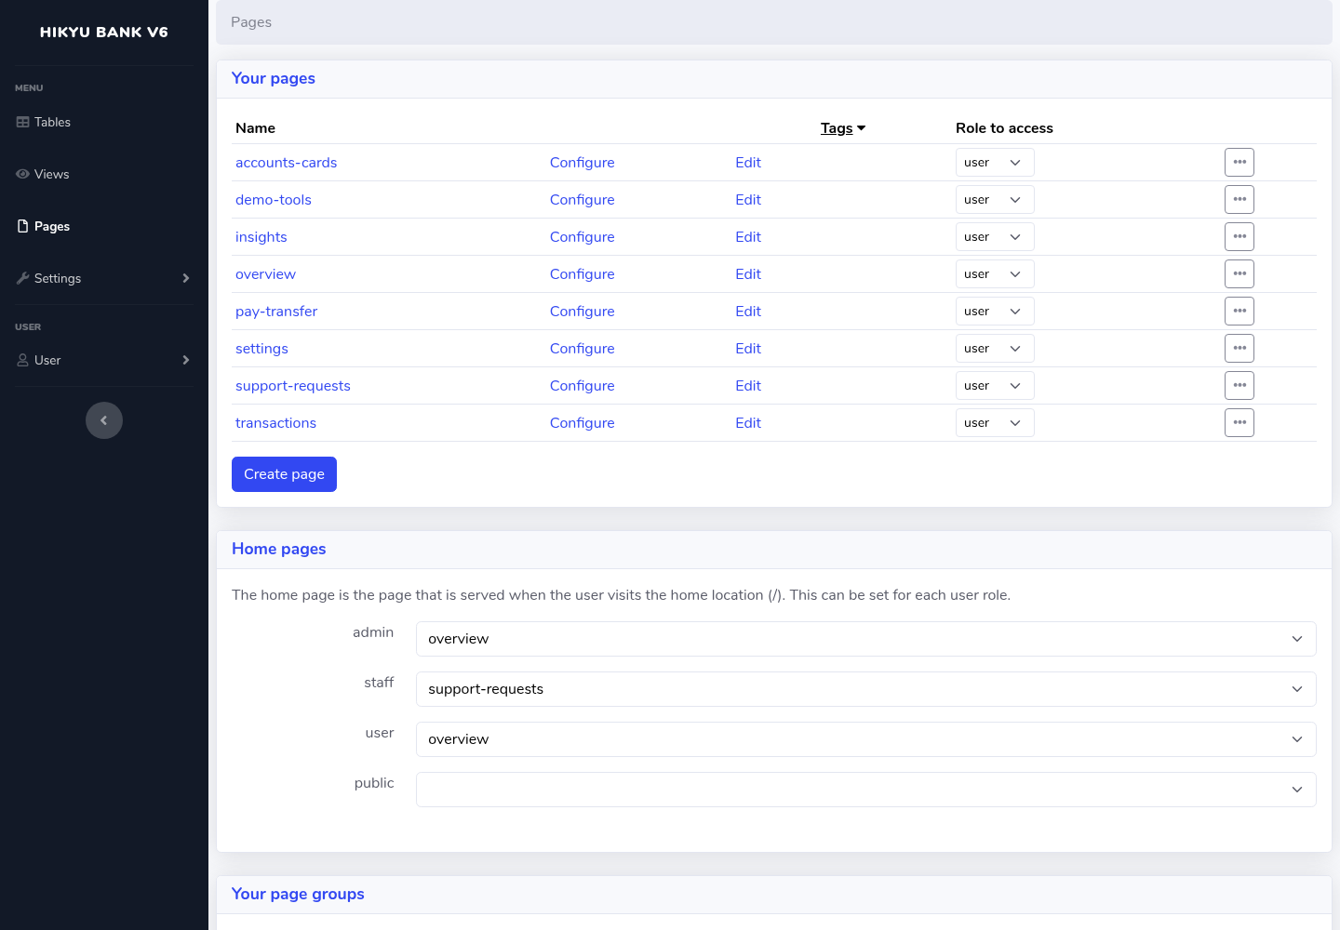
Figure 1. Actual Saltcorn native page editor: eight V6 pages and role-based home-page configuration. This is a configuration/editability observation, not an E2E pass by itself.

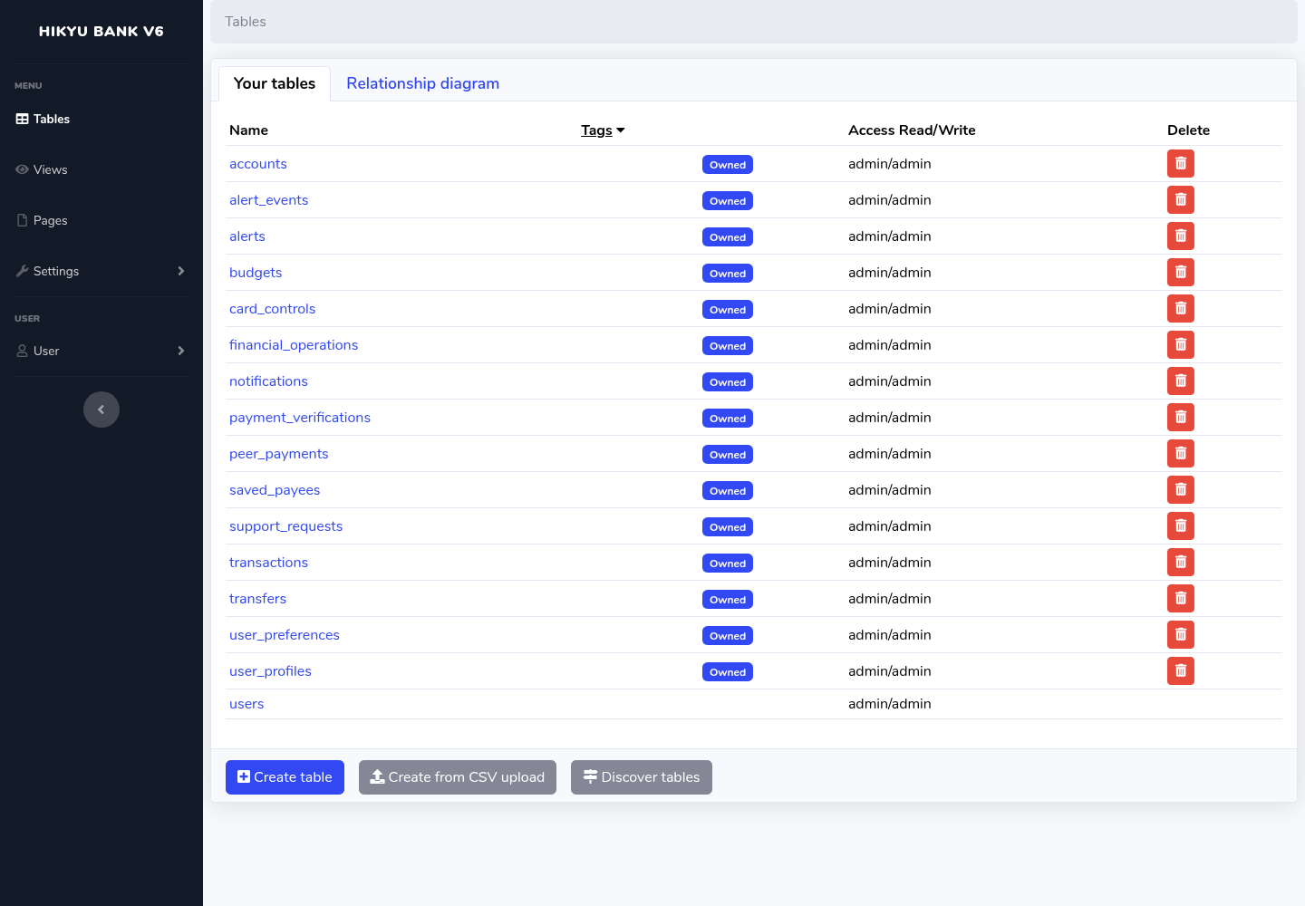
Figure 2. Actual native data editor: domain tables with ownership, plus the platform user table. Financial/workflow write protection is additionally verified by negative tests.

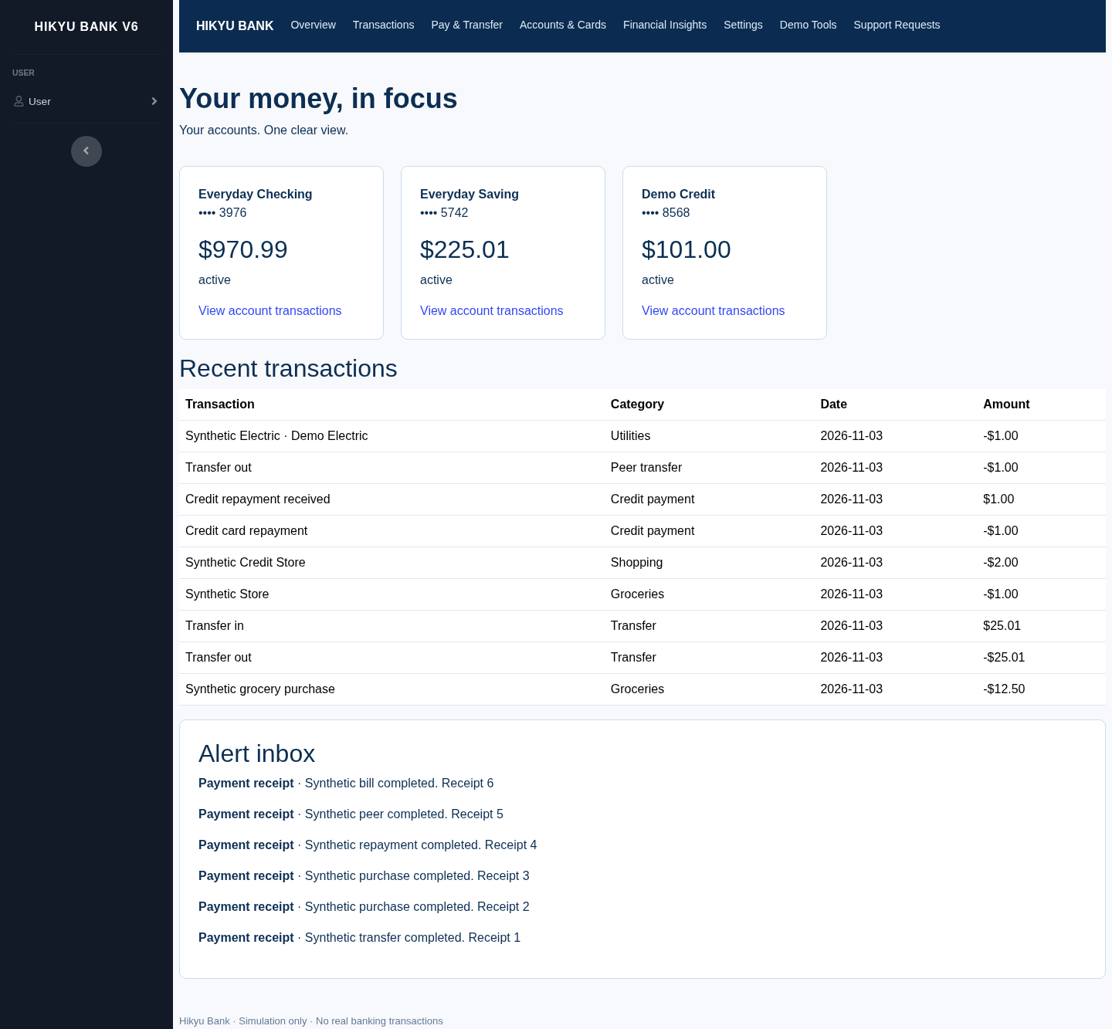
Figure 3. Real LCNC account cards and owned database-backed values after financial scenario checks. Evidence: lcnc-banking-tests.json. All values are synthetic.

The following three figures concern the same actual business record: v6-413e151e-7d5e-481f-9e2e-18a2f9d2b678. The different sessions are role simulation, not different people.
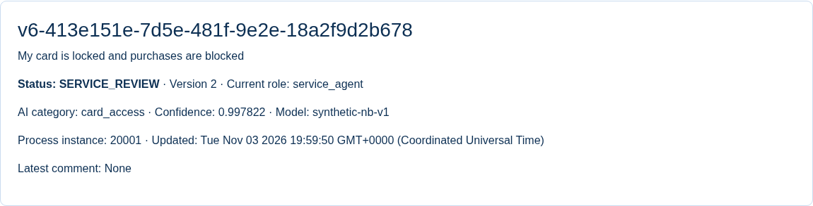
Figure 4. Persisted submission after the real local classifier ran: category, confidence, model version, service-review stage and engine instance are visible.
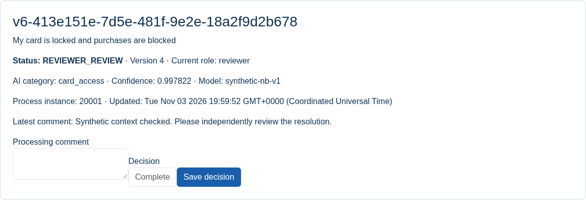
Figure 5. Same record handed from service agent to independent reviewer. A reviewer decision/comment is required; AI does not approve.
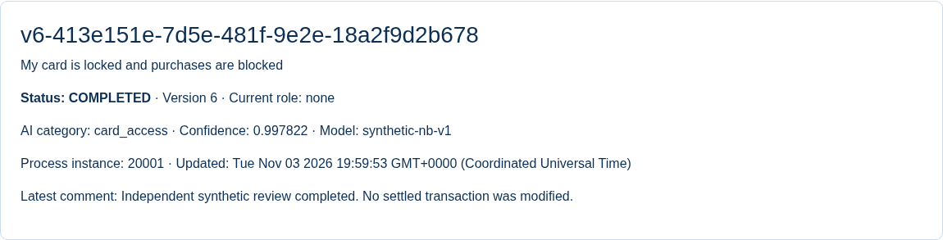
Figure 6. Same record after reviewer completion and requester refresh: COMPLETED, a later version, persisted processing comment and the same process instance.

Appendix B — Test Results and Boundaries

Live LCNC E2E
Scenario | Actual result
LCNC native submission and real runtime AI | Pass
Service agent hands task to reviewer | Pass
Final status written to the same LCNC row and retained after refresh | Pass
Duplicate submission uses same persisted business record | Pass
Conflicting duplicate submission rejected | Pass
Blank required input rejected server-side | Pass
Cross-user transaction reference rejected; other user cannot see business record | Pass
Unauthorized role decision rejected | Pass

Recovery/security
Scenario | Actual result
Real LCNC return, requester resubmission and rejection | Pass
Incorrect role and stale decision versions rejected on live LCNC path | Pass
Native field permissions block direct user status tampering | Pass
Late non-final projection cannot overwrite a final LCNC record | Pass
Actual stopped workflow API leaves durable submitted record with pending retry | Pass
Automatic retry recovers after actual workflow API restart | Pass
Actual PostgreSQL callback constraint failure preserves committed engine task | Pass
Automatic status writeback recovers after real database write failure | Pass
LCNC process restart retains same business ID, engine ID, final state and version | Pass
Browser refresh after LCNC restart shows recovered final state | Pass

Native banking
Scenario | Actual result
Own-account transfer atomically updates balances and two balanced ledger legs | Pass
Financial idempotency prevents duplicate debit | Pass
Changed financial payload conflicts with existing request key | Pass
Insufficient funds causes no balance mutation | Pass
Wrong code attempt is counted and does not consume authorization | Pass
Locked debit card rejects purchase; unlocking permits the authorized purchase | Pass
Credit purchase increases outstanding debt within limit | Pass
Credit repayment reduces deposit and debt with linked balanced legs | Pass
PIN and code authorized peer payment credits the other synthetic user | Pass
Saved biller and simulated bill payment persist | Pass
Owned monthly category budget is stored | Pass
Cross-user financial account mutation rejected | Pass
Zero, negative, overprecision, nonfinite and excessive amounts rejected | Pass
Formatted account cards and persisted budget results render in real browser | Pass

CSV
Scenario | Actual result
Real LCNC CSV endpoint exports inclusive UTC date data | Pass
CSV text formula injection is neutralized | Pass
Other user transaction is excluded from export | Pass
Blank, invalid and excessive statement date ranges rejected | Pass
CSV export rejects a foreign account | Pass

AI timeout, invalid output and subprocess failure were controlled fault injection through the live LCNC/engine path; all reached MANUAL_TRIAGE. The human-review timer was an actual expiry with a controlled PT2S test deadline; normal PT24H configuration was restored. These tests are not successful AI outputs or a 24-hour observation.
Not fully implemented/verified: original V5 login MFA, full registration/profile/security/session workflows, original assistant and complete scheduled alerts, full transaction UI and mobile parity. Real different-person testing, public hosting and separate-install restoration remain unverified. See V6_Test_Results.md for the complete scope and evidence index.

Appendix C — Reflection (166 words)
Rebuilding Hikyu Bank showed that low-code tooling can make data and workflow structure easier to inspect, but it does not automatically preserve banking safeguards. Native pages and owned records were useful foundations. Exact money handling, authorization-code binding and durable state synchronization still required explicit code and tests.
The local classifier added a visible category during each support request, giving reviewers a starting point without deciding the outcome. This demonstrated runtime AI integration, but the small synthetic training set cannot justify claims about production accuracy or measured efficiency gains. High confidence from this model should not be confused with reliable financial judgment.
Automation also moved responsibility into less visible components. Duplicate handling, failed callbacks and overdue tasks needed durable records and recovery paths. Human review, minimal model input and separate role checks helped limit harm, while real fault tests made those safeguards observable. I would retain these controls even if they make the process slower, and complete authentication parity and independent participant testing before extending the demonstration.

Appendix D — Delivery and Setup
The V6 ZIP combines the clean V5 source baseline and all new LCNC/workflow/model/test source, documentation, native application export and actual evidence. Start with README.md and V6_Setup_and_Demo_Guide.md. Private configuration, secrets, databases, dependency folders and old compiled outputs are excluded. The report is not a claim of a public deployment.

