Pros and Cons of different method

|  |  |  |  |
| --- | --- | --- | --- |
|  | Manual | Semi-Auto | Auto (Hand-Guiding) |
| Pros | 1. Less calculation and able to see if the robot hitting obstacle 2. Customize action to be performed 3. When environment is changed, manual control provides fast way to reach the intended position. | 1. Using IK/FK, precise position can be calculated and transformed to motor angle and position 2. Can perform the same repeatable motion with rospy/scripts when programmed with calculated points | 1. Less calculation and able to see if the robot hitting obstacle  2. Customize action to be performed |
| Cons | 1. In lagging environment, robot may not be going to intended position 2. It is hard to repeat the same position | 1. Calculation involved if no software aid. Tuning may be required. 2. With Software aid, IK unresolvable situation can take place. 3. Orientation may need to be taken into account to reduce IK unresolvable case. 4. Program change is required when environment changed. | 1. In lagging environment, robot may not be going to intended position  2. When environment changed, the repeated position may hit into obstacle.  3. Re-train is always needed when environment changes. |

**Appendix**

Teleop

Step 1: Press “h” to increase motor 1 angle until reaching top of object

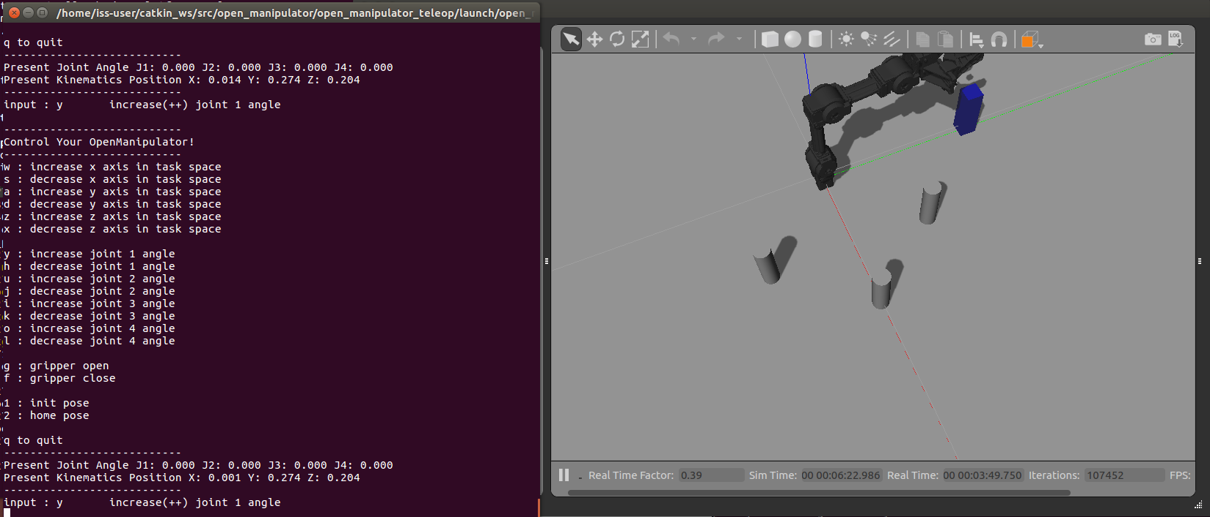

Step 2: Press “u”,“x” and “I” consecutively after pressing “g” to open gripper. Close Gripper “f” at the pick up position

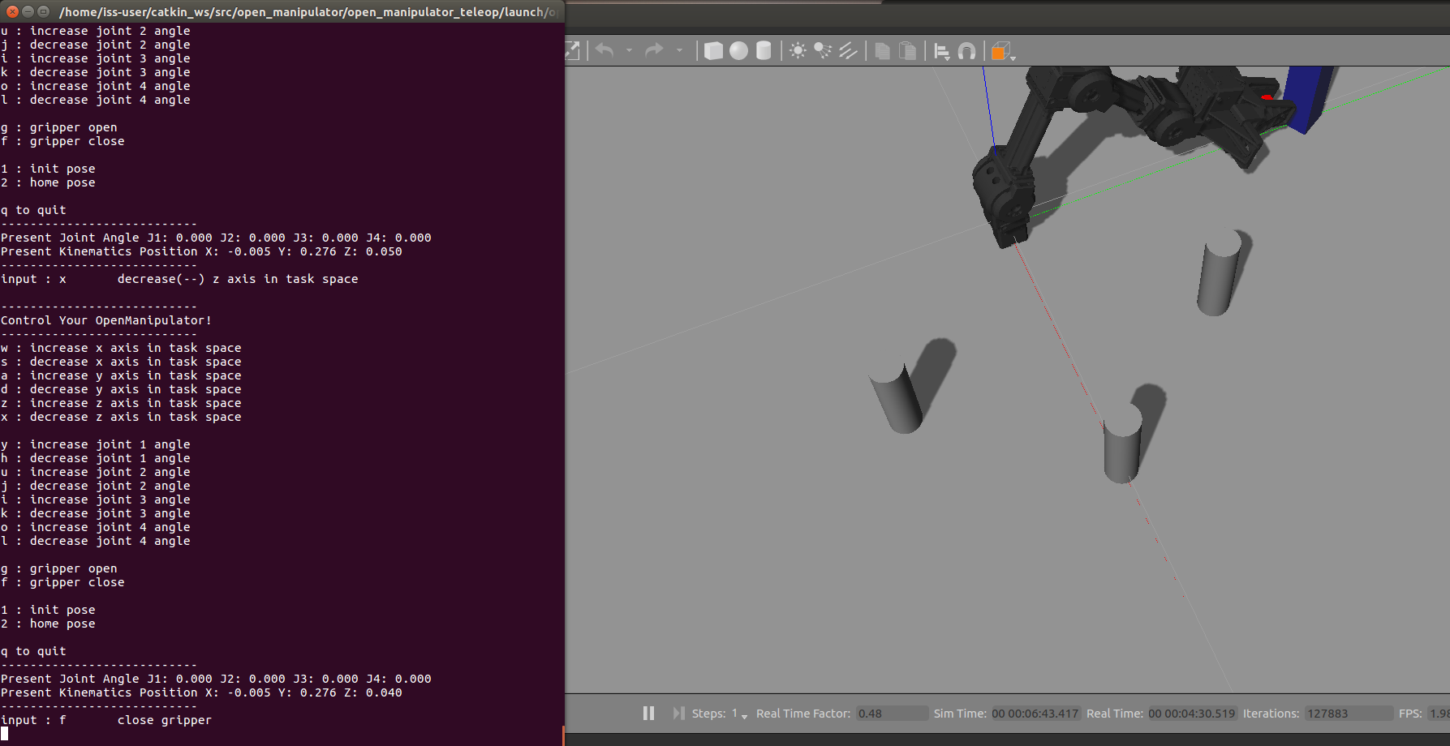

Step 3: Lift up the object by pressing “j”,”k”,”l”

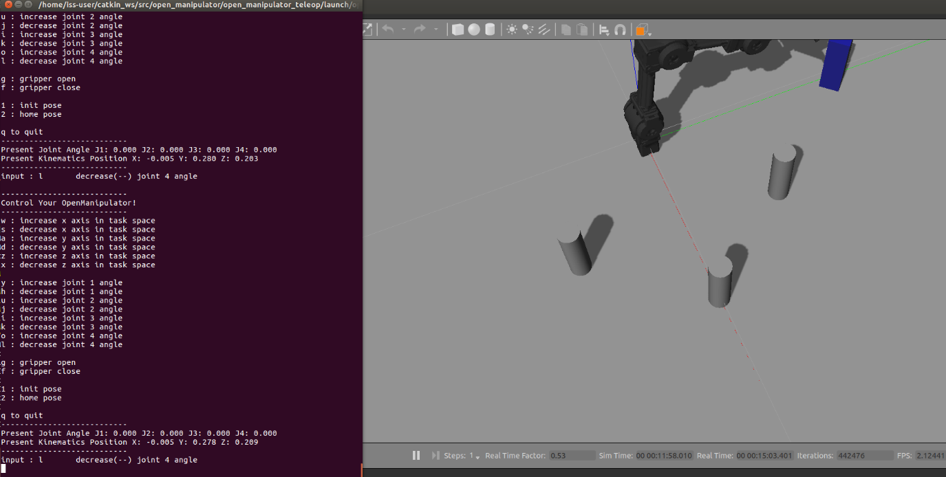

Step 4: Goes to top of Drop position by pressing “h”

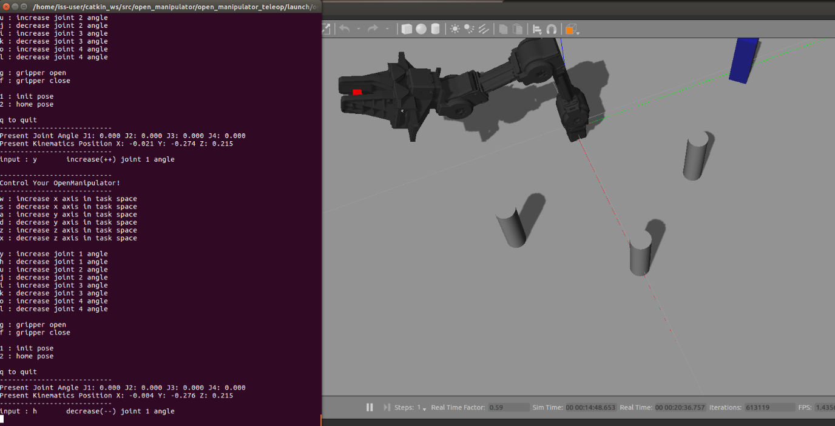

Step 5: Press “u”,”I””x” until reaching destination x,y,z position and open gripper “g”

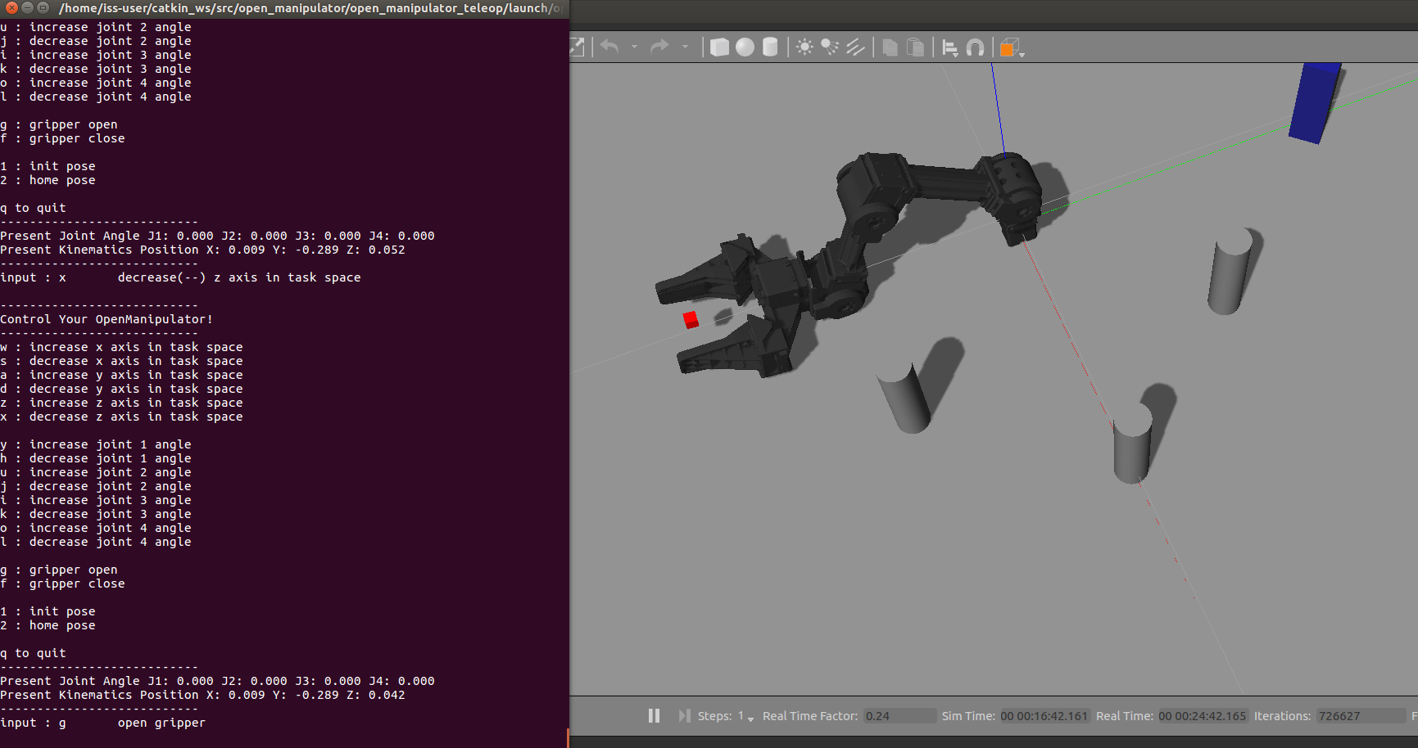

Step 6: repeat step 4, step 3, step 2, step 3 step 4, step 5.

Rospy

Using Forward kinematics to control the joint. The code is included in workshop_method2.py

