MTech(IS)
Intelligent Process Automation
Project Report

INTELLIGENT TEMPERATURE SCREENING SYSTEM

Team Members
CAO LIANG – A0012884E
GENG LIANGYU – A0195278M
HAN DONGCHOU FRANCIS – A0195414A
ONG BOON PING – A0195172B
TAN CHIN GEE – A0195296M

1.0 EXECUTIVE SUMMARY

2.0 PROBLEM DESCRIPTION
As of 3rd April 2020, the number of novel coronavirus (covid19) cases has exceeded 1000 in Singapore. Covid19 is a pandemic that has swiftly evolved from a localized public health emergency in China to a global crisis in a matter of a few months. The threat of this pandemic has forced governments around the world to take unprecedented drastic measures to control the spread of the virus. The daily taking of one’s temperature has become one of the defining measures implemented by the authority during the last few months.

A temperature higher than 37.5 degree Celsius (i.e., having a fever) is one of the clinical symptoms associated with being infected with covid19. Therefore the action of temperature taking is now a standard practice among businesses locally. The process of taking a person’s temperature typically required one or more staffs to man the temperature screening station. The number of staff deployed to perform this task will depend on the size of the human traffic and the temperature sensor that is employed. A temperature screening station equipped with an infrared-red temperature sensor hooked to a monitor can be manned with fewer staffs than one using a hand-held forehead thermometer.

Placing staff to man temperature screening station either displaces staff from performing their normal duty or add additional work onto staff. Manned temperature screening station also exposes the staff to the risk of being infected with covid19 through their frequent contacts with other people. This is a situation that is both an ineffective use of manpower and risky to the health of staff. A better solution can be achieve through enhancing the process of temperature screening using the technology of Intelligent Process Automation (IPA) and Robotic Process Automation (RPA).

The team analyzed the temperature screening process employed by our respective organizations and discussed what the ideal situation could be like after employing IPA and RPA. The “as is” diagram is a typical flow of the processes of temperature screening (Figure 1).
3.0 BUSINESS PROCESS MAPPING

The temperature screening process typically comprises the following five groups of people:
- Employee
- Receptionist
- Manager
- Recipients
- Authority

The receptionist of the organization begins the process by updating the list of employees who are serving Stay Home Notice (SHN). This list is the blacklist record. The receptionist is tasked with identifying blacklisted employees and temperature screening at the entrance to the building.

The employee will present himself/herself to the receptionist for identification and temperature taking before entering the building. The receptionist will raise an alert through email to the managers, recipients and authority when the employee has a temperature higher than 37.5 degree Celsius or is blacklisted.

Figure 1. “as is” diagram of the temperature screening processes
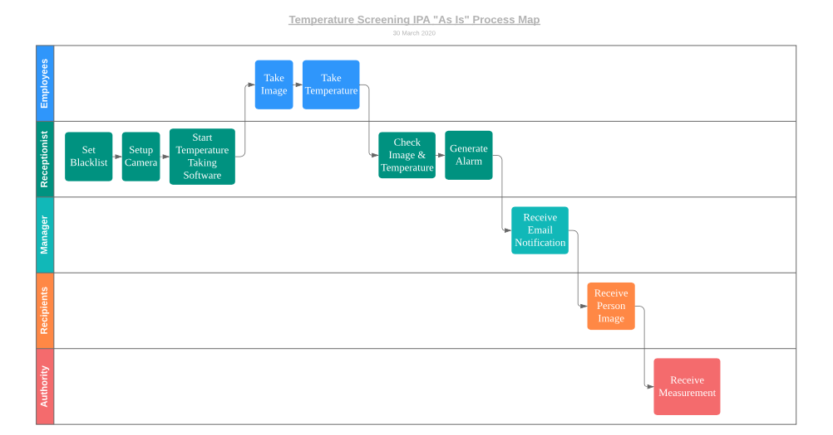
4.0 SOLUTION
Our solution uses RPA and IPA to automate close to half of the repetitive processes and reduces the bulk of the work on the receptionist. The system structure comprises of a UiPath RPA application that operates in tandem with Python scripts that perform face recognition of employees and rule-based retrieval of information from employee records (see Figure 2).

Figure 2. Overview of the System Structure
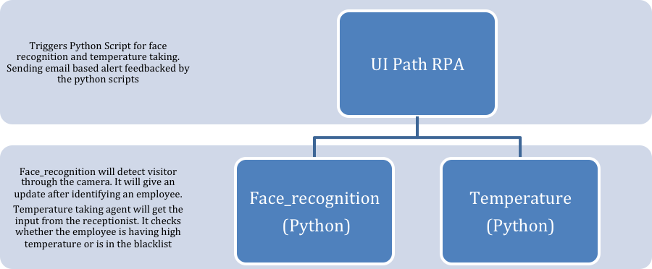

The process of temperature screening using our system is display in Figure 3. When an employee is presented to the camera, the UiPath application triggers the face recognition python script, face_recognize.py that updates the image_login csv file. The UiPath application also triggers the temperature python script, temperature.py to read the temperature of the employee that is inputted by the receptionist. The UiPath application takes the information from the image_login csv file and the blacklist csv file to generate the alert csv file that records the change in employee’s temperature. The UiPath application takes the changes from the alert csv file and sends an email to management if the employee is either having a fever or is blacklisted.

Figure 3. “to be” diagram of the temperature screening processes
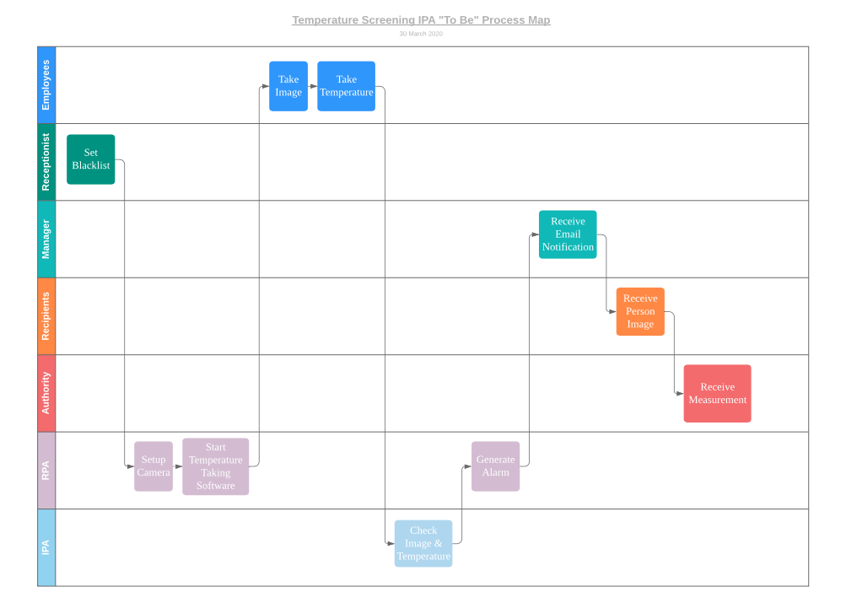
Components of the System

1. Folder of the Photos of Employee’s Faces: The system uses these photos to perform face recognition.

2. face_recognize.py: The IPA component of the system. This python script performs the task of face recognition powered by the Dlib based face_recognition Python library. The code takes a real-time video stream and uses Dlib to convert images into HoG array to find the face area. It applies a 128-bit array encoding on each face. The cosine distance between the video-stream faces’ encoded array and the known encoded employee faces will determine the similarity of faces.

The recognized face will be recorded to image_login csv file with timestamp. Image will also be recorded in PC with date-stamp and name on the jpg filename. The image_login csv file is initialized with all known employees given a value of 99999 that represents non-detection at the onset. However, a date-stamp will replace the initial 99999 value once a face is recognized.

3. temperature.py: The receptionist uses this simple python script to read in employee’s temperature through keyboard input. The script checks against the blacklist csv file to determine whether the employee was blacklisted and forbidden from entering the company. A detected blacklisted employee is recorded in the alert csv file. A employee with a temperature higher than 37.5 degree Celsius is also recorded in the alert csv file. However, temperature will not be checked for blacklisted employees.

4. UiPath RPA: This application automates the starting of the camera and temperature taking of the employees through the keyboard control feature during startup. After startup, the face_recognize and temperature script will be constantly running. Hence, the RPA is observing the alert csv file in an infinite loop. The RPA will send email if the employee triggered alert = 1 (i.e., having a temperature higher than 37.5 degree Celsius) or alert = 2 (i.e., blacklisted employee). The email message contains the name and temperature of the employee for alert = 1, or the blacklisted employee for alert = 2. Emails are sent through SMTP method using a Gmail account.

Outputs of the System

System Alert Output
1. Name: A string object. The system outputs the name of the identified employees that is stored in the records.

2. Alerts: A numerical value that is either 1 or 2. The system generates an alert of 1 when it detects an employee with fever, or generates an alert of 2 when it detects an employee on the blacklist. An employee on the blacklist is forbidden from entering the company. A value of 99999 indicates that an employee is not presented to the camera.

3. Temperature: A float value rounded to one decimal place. The system outputs the temperature reading that is keyed into the system by the receptionist.

Blacklist Records
1. Name: A string object. The name of the blacklisted employee that is stored in the records.

2. Blacklisted: A Boolean value. A value of 1 indicates that an employee is blacklisted, and a value of 0 indicates otherwise.

Config File – Emails
1. Name: A string object. The name of the email sender and recipients tied to an email account.

2. Role: A string object. The name of the role of the sender and recipients tied to an email account.

3. EmailAddress: A string object. The email addresses of the email sender and recipients.

4. Password: A string object. The password of the sender email account.

5. EmailServerAddress: A string object. The location of the sender email server.

6. EmailServerPort: A string object. The port used by the sender email account.

5.0 CONCLUSION

APPENDIX A. USER MANUAL

APPENDIX B. EXAMPLE SYSTEM INPUT & OUTPUT

