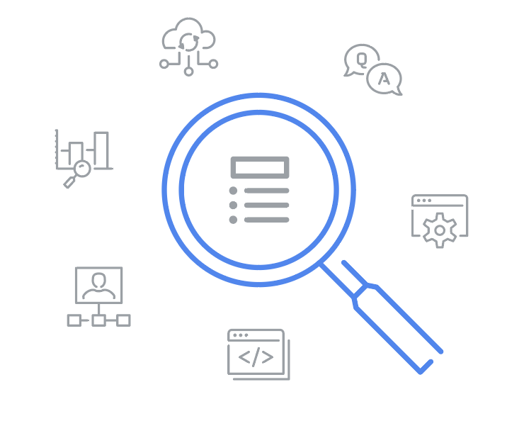
Glossary

IT Automation with Python

Terms and definitions from Course 1

A
Automation: The process of replacing a manual step with one that happens automatically

B
Break: A way to exit out of a loop before the loop's condition is false
Built-in functions: Functions that exist within Python and can be called directly

C
Client-side scripting language: Primarily for web programming; the scripts are transferred from a web server to the end-user’s internet browser, then executed in the browser
Code editors: Tools to provide features, including syntax highlighting, automatic indentation, error checking, and autocompletion

Comments: Notes to yourself and/or other programmers to make the purpose of the code clear
Computer program: A step-by-step list of instructions that a computer follows to reach an intended goal
Control statements: Programming constructs that direct the flow of execution of a program by allowing you to make decisions, repeat actions, or choose between different code paths based on specific conditions

D
Data types: Classes of data (e.g., string, int, float, Boolean, etc.), which include the properties and behaviors of instances of the data type (variables)
Dictionaries: A data type used to organize elements into collections, taking the form of pairs of keys and values

E
Explicit conversion: This occurs when code is written to manually convert one data type to another using a data type conversion function
Expression: A combination of numbers, symbols, or other values that produce a result when evaluated

F
For loop: This executes a block of code for a specified number of iterations or over a collection of items
Functions: A reusable block of code that performs a specific task

I
IDE: A software application that provides comprehensive facilities for software development

Implicit conversion: This occurs when the Python interpreter automatically converts one data type to another
Infinite loop: A sequence that is missing a method for exiting the loop, causing the loop to run forever
Interpreter: The program that reads and executes code
Input: Information that is provided to a program by the end user
Iterators: Variables that allow you to loop through a collection one item at a time

L
List comprehensions: Create new lists based on sequences or ranges
Logic errors: Errors in code that prevent it from running correctly
Logical operators: Operators used to combine or manipulate boolean values (True or False) to create complex conditions for decision-making
Loop: A sequence that makes the computer do repetitive tasks

M
Machine language: Lowest-level computer language. It communicates directly with computing machines in binary code (ones and zeros)

O
Object-oriented programming language: Most coding elements are considered to be objects with configurable properties

Output: the end result of a task performed by a function or computer program

P
Parameter (argument): A value passed into a function for use within the function, controlling the behavior of the CSV reader and writer
Pass: A placeholder statement which is used when the syntax requires a statement, but you don't want to execute any code or command
Platform-specific scripting language: Language used by system administrators on those specific platforms
Programming: The process of writing a program to behave in different ways
Programming code: A set of written computer instructions, guided by rules, using a computer programming language

Programming languages: Language with syntax and semantics to write computer programs

Python: A general purpose programming language
Python interpreter: Program that reads and executes Python code by translating Python code into computer instructions

R
Recursion: The repeated application of the same procedure to a smaller problem
Refactoring: When a code is updated to be more self-documenting and clarify the intent
Return value: This is the value or variable returned as the end result of a function

S
Script: Often used to automate specific tasks
Semantics: The intended meaning or effect of statements, or collections of words, in both human and computer languages
String: A data type used to represent a piece of text. sequences of characters and are immutable
Syntax: The rules for how each statements are constructed in both human and computer languages

T
Tuples: Sequences of elements of any type that are immutable, written parentheses instead of square brackets

V
Variables: These are used to temporarily store changeable values in programming code

W
While loop: This is used when a segment of code needs to execute repeatedly while a condition is true

