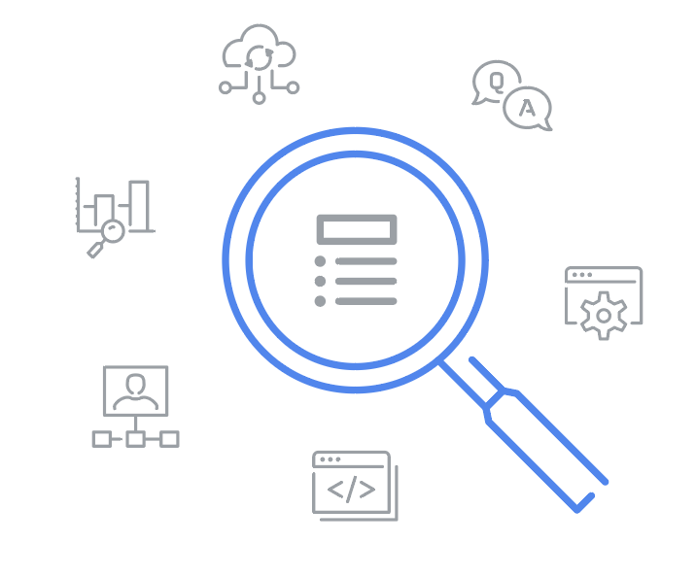
Glossary

IT Automation with Python

Terms and definitions from Course 5

A
A/B testing: A way to compare two versions of something to find out which version performs better

Artifact: A byproduct of the software development process that can be accessed and used, an item produced during programming

Automatic scaling: This service uses metrics to automatically increase or decrease the capacity of the system

Autoscaling: Allows the service to increase or reduce capacity as needed, while the service owner only pays for the cost of the machines that are in use at any given time

C
Capacity: How much the service can deliver

Cold data: Accessed infrequently and stored in cold storage

Configuration management: Automation technique that manages the configuration of computers at scale

Containers: Applications that are packaged together with their configuration and dependencies

Container registry: A storage location for container images, organized for efficient access

Container repository: A container registry that manages container images

Content Delivery Networks (CDN): A network of physical hosts that are geographically located as close to the end users as possible

Continuous delivery: Any changes to the software are tested and then deployed to users and servers as soon as they are verified

Continuous deployment: Automates the deployment of code to production

Continuous integration: Constantly adding updates and improvements to software

D
DevOps: Describes the steps of the software development lifecycle beyond writing code, the union between the development team and the operations team

DevSecOps: Adding security testing and protection to the software development lifecycle

Disk image: A snapshot of a virtual machine’s disk at a given point in time

Docker: An open-source tool used to build, deploy, run, update, and manage containers

Domain-Specific Language (DSL): A programming language that's more limited in scope

E
Ephemeral storage: Storage used for instances that are temporary and only need to keep local data while they’re running

F
Facts: Variables that represent the characteristics of the system

H
Hot data: Accessed frequently and stored in hot storage

Hybrid cloud: A mixture of both public and private clouds

I
Input/Output Operations Per Second (IOPS): Measures how many reads or writes you can do in one second, no matter how much data you're accessing

Infrastructure as a Service (or IaaS): When a Cloud provider supplies only the bare-bones computing experience

K
Kubernetes: An open-source platform that gives programmers the power to orchestrate containers

L
Load balancer: Ensures that each node receives a balanced number of requests

M
Manual scaling: Changes are controlled by humans instead of software

Multi-cloud: A mixture of public and/or private clouds across vendors

O
Object storage: Storage where objects are placed and retrieved into a storage bucket

Orchestration: The automated configuration and coordination of complex IT systems and services

P
Persistent storage: Storage used for instances that are long lived and need to keep data across reboots and upgrades

Platform as a Service (or PaaS): When a Cloud provider offers a preconfigured platform to the customer

Pod: A group of one or more containers that are scheduled and run together

Private cloud: When your company owns the services and the rest of your infrastructure

Production: The software is pushed out to the end users from a cloud server

Public cloud: The cloud services provided to you by a third party

Puppet: The current industry standard for configuration management, also known as the client

Puppet master: Known as the Puppet server

R
Rate limits: Prevent one service from overloading the whole system

Reference images: Store the contents of a machine in a reusable format

Registry: A place where containers or artifacts are stored and organized

S
Software as a Service (or SaaS): When a Cloud provider delivers an entire application or program to the customer

Staging: A strategic DevOps approach where we specify the build steps and tests

Sticky sessions: All requests from the same client always go to the same backend server

T
Templating: The process of capturing all of the system configuration to let us create VMs in a repeatable way

Throughput: The amount of data that you can read and write in a given amount of time

U
Utilization limits: Cap the total amount of a certain resource that you can provision

