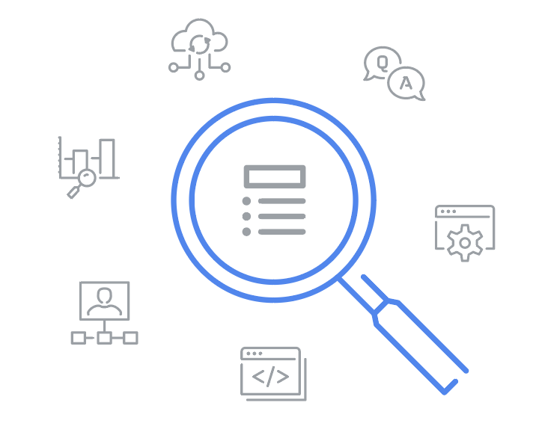
Glossary

IT Automation with Python

Terms and definitions from Course 6

A
API endpoint: The part of the program that listens on the network for API calls

D
Data serialization: The process of taking an in-memory data structure, like a Python object, and turning it into something that can be stored on disk or transmitted across a network

Distributed systems: Also referred to as distributed computing or distributed databases, utilize different nodes to interact and synchronize over a shared network

Docstrings: Documentation that lives alongside the code

E
Error budgets: Represented as the maximum amount of time that a program is able to fail without violating an agreement

F
Flask: A Python library that makes it easier to create web applications and REST web services

J
JSON: A data-interchange format used in RESTful APIs to facilitate communication between clients and servers

N
NALSD (Non-Abstract Large System Design): A discipline and process introduced by Google, primarily aimed at empowering site reliability engineers (SREs) to assess, design, and evaluate large-scale systems

Naming conventions: Functions, classes and methods with naming conventions to understand what to expect from them

R
REST (Representational State Transfer): Every request carries all the parameters and data needed for the server to satisfy that request

RESTful APIs: Rely on the HTTP protocol, can be further secured using HTTPS, and API endpoints can authenticate users via authorization tokens, API keys, or other security mechanisms

REST architecture: An architectural style for designing networked applications and web services

Richardson Maturity Model (RMM): A framework that categorizes and describes different levels of implementation for RESTful APIs based on their adherence to the six constraints

S
Service-level agreements (SLAs): An agreement between a vendor and its clients or users that can be legally binding

Service-level objectives (SLOs): A specific and measurable target that defines the level of performance, reliability, or quality a service should consistently deliver

W
Web application: An application that you interact with over HTTP

