EID | HSCW | LiveWt | Yield | P8 Fat | Rib Fat | Image
951 000330197853 | 313 | 572 | 54.8 | 18 | 12 | 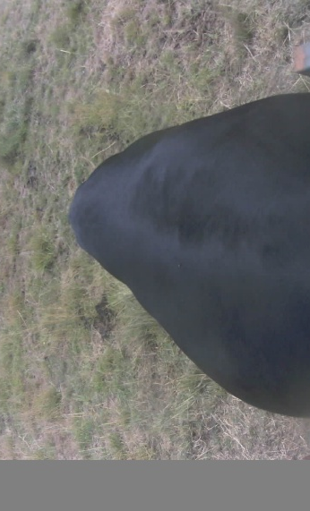
991 006000385835 | 296 | 542 | 54.6 | 15 | 10 | 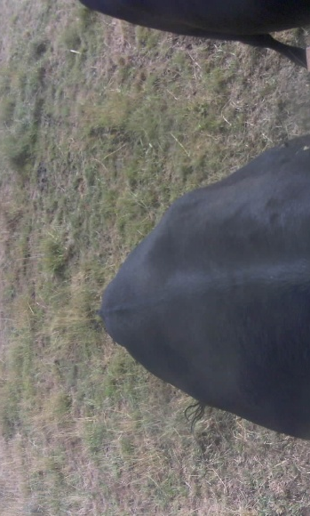
982 123811808596 | 312 | 574 | 54.4 | 13 | 5 | 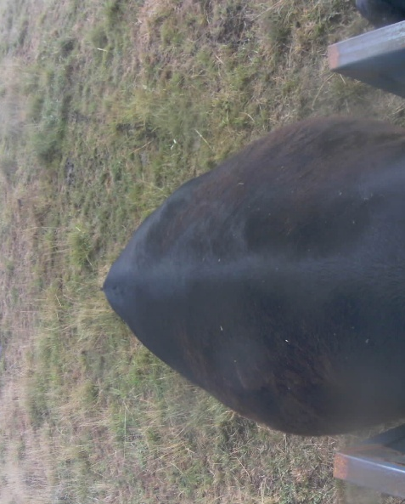
982 123811808411 | 283 | 549 | 51.6 | 15 | 8 | 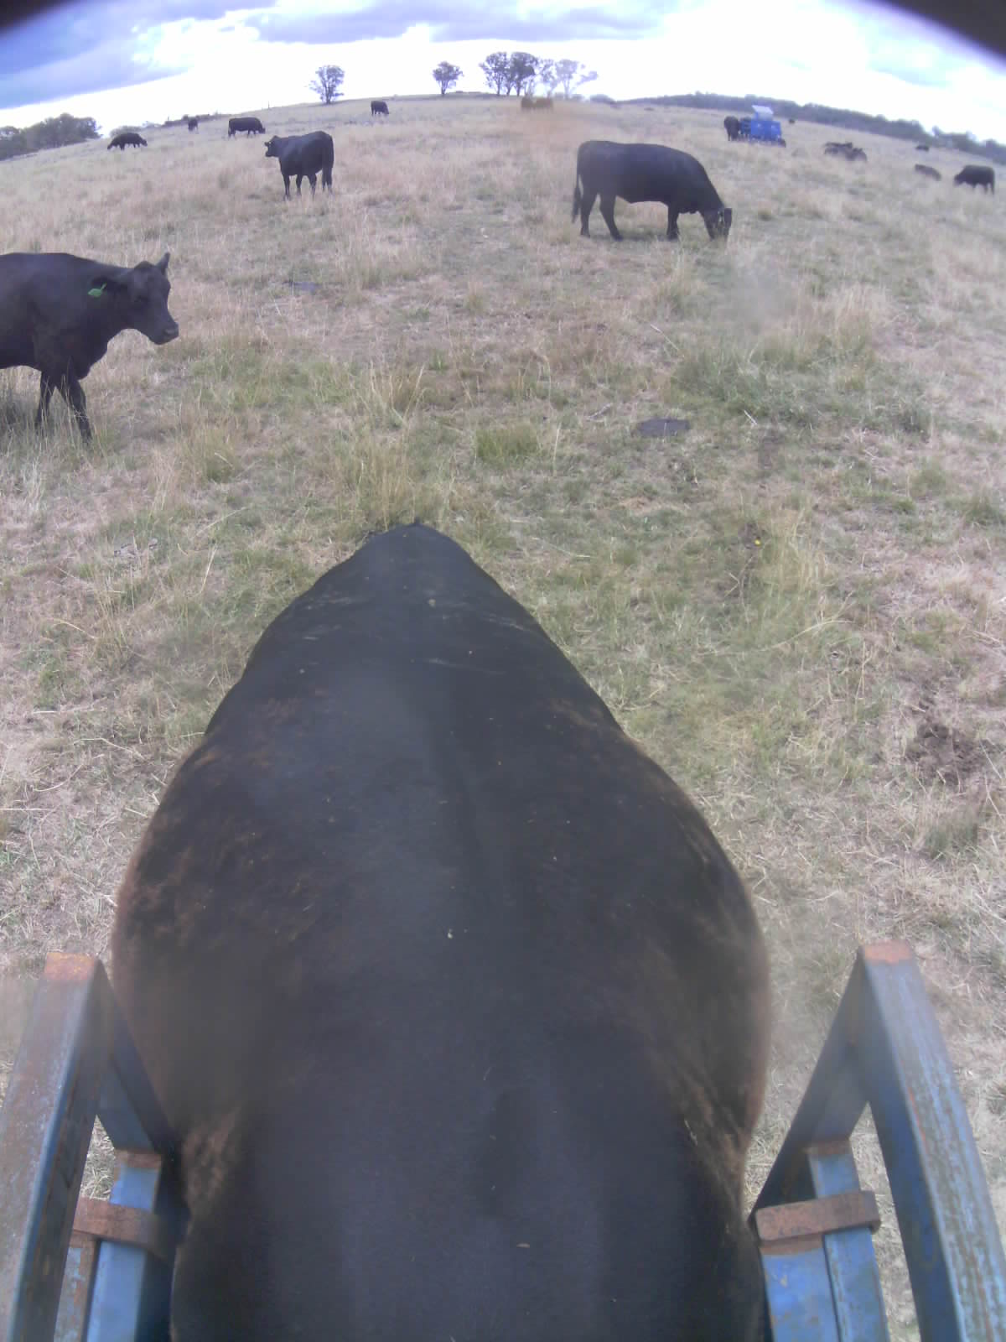
982 123811808447 | 304 | 549 | 55.3 | 16 | 7 | 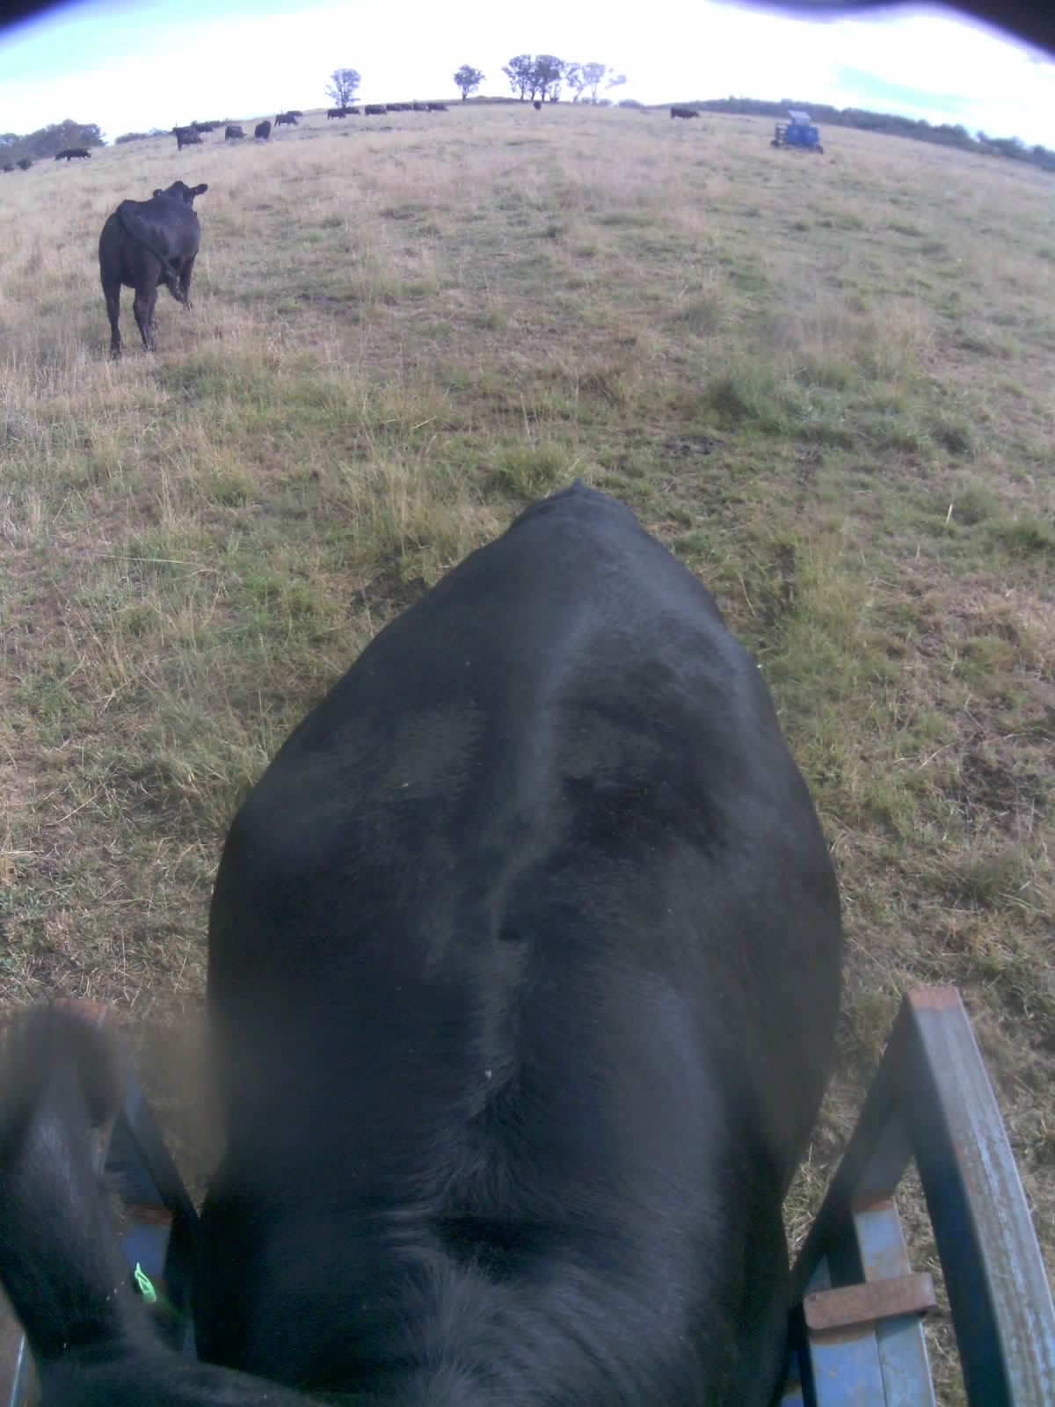
982 123822846905 | 310 | 566 | 54.7 | 9 | 8 | 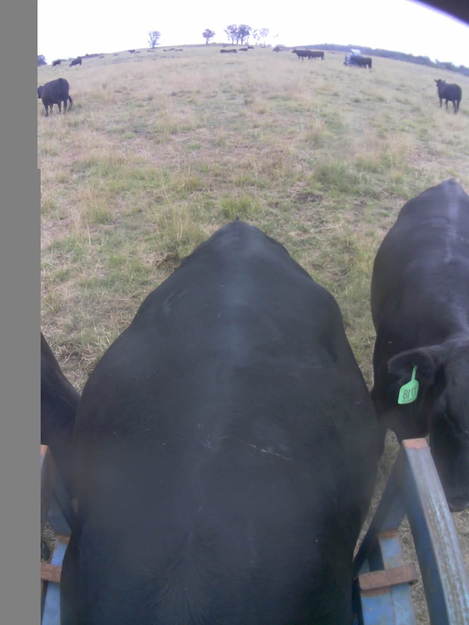
982 123825202316 | 307 | 553 | 55.5 | 10 | 12 | 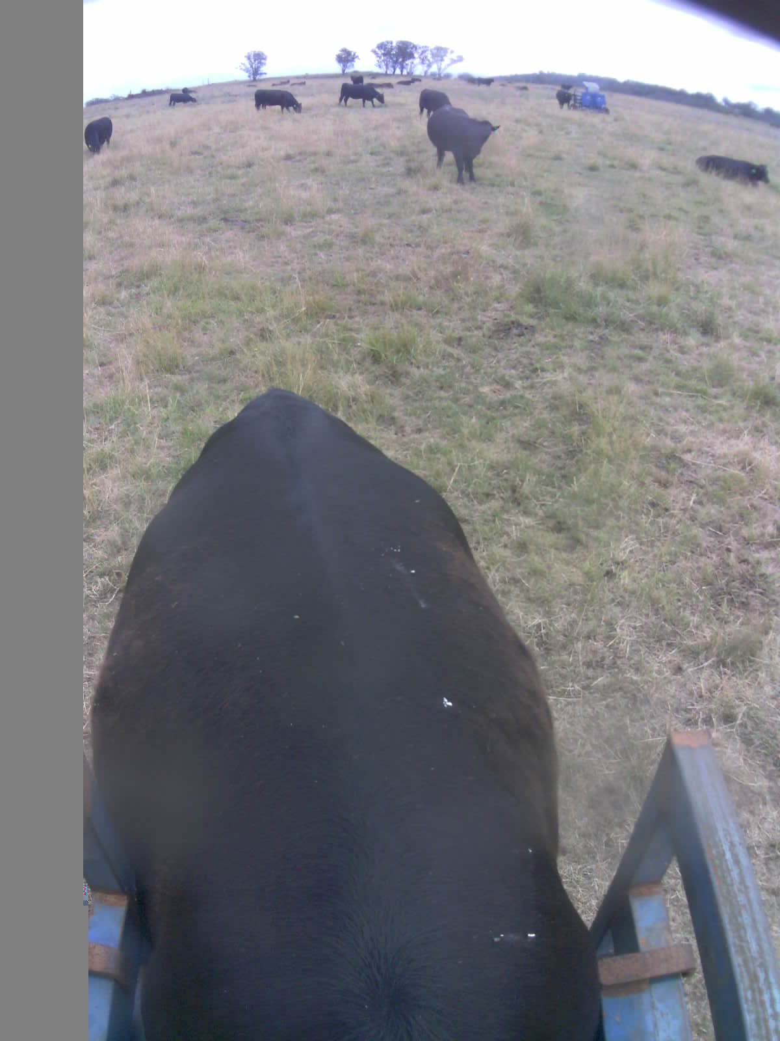
982 123825202530 | 298 | 568 | 52.4 | 8 | 5 | 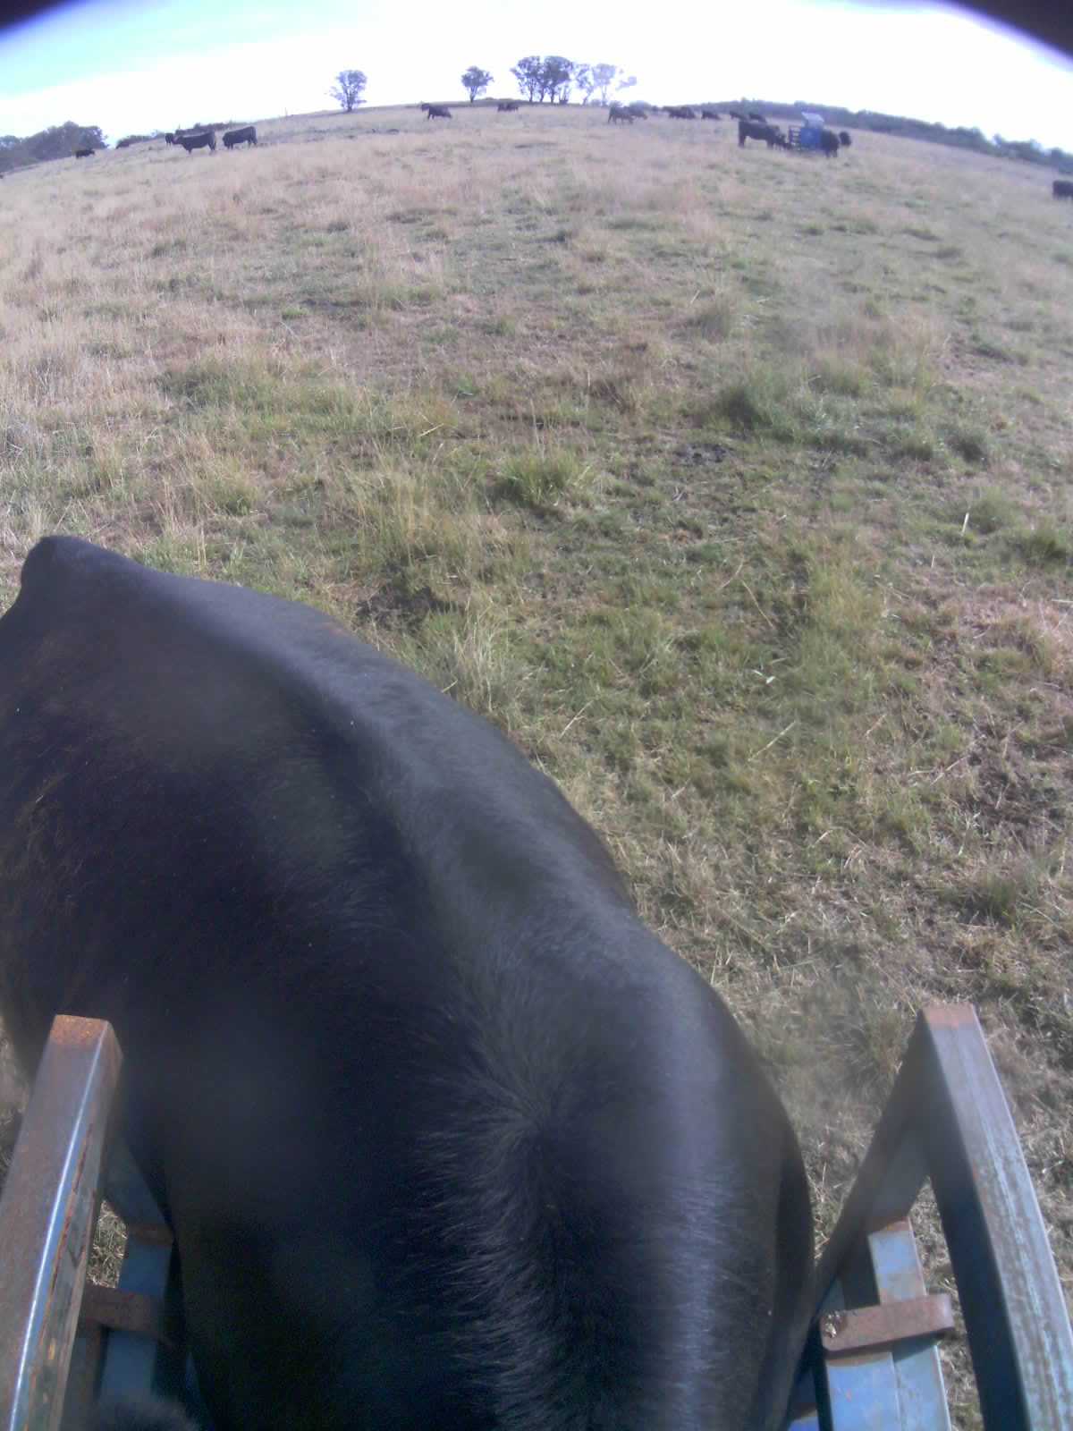
982 123811808038 | 286 | 538 | 53.2 | 15 | 5 | 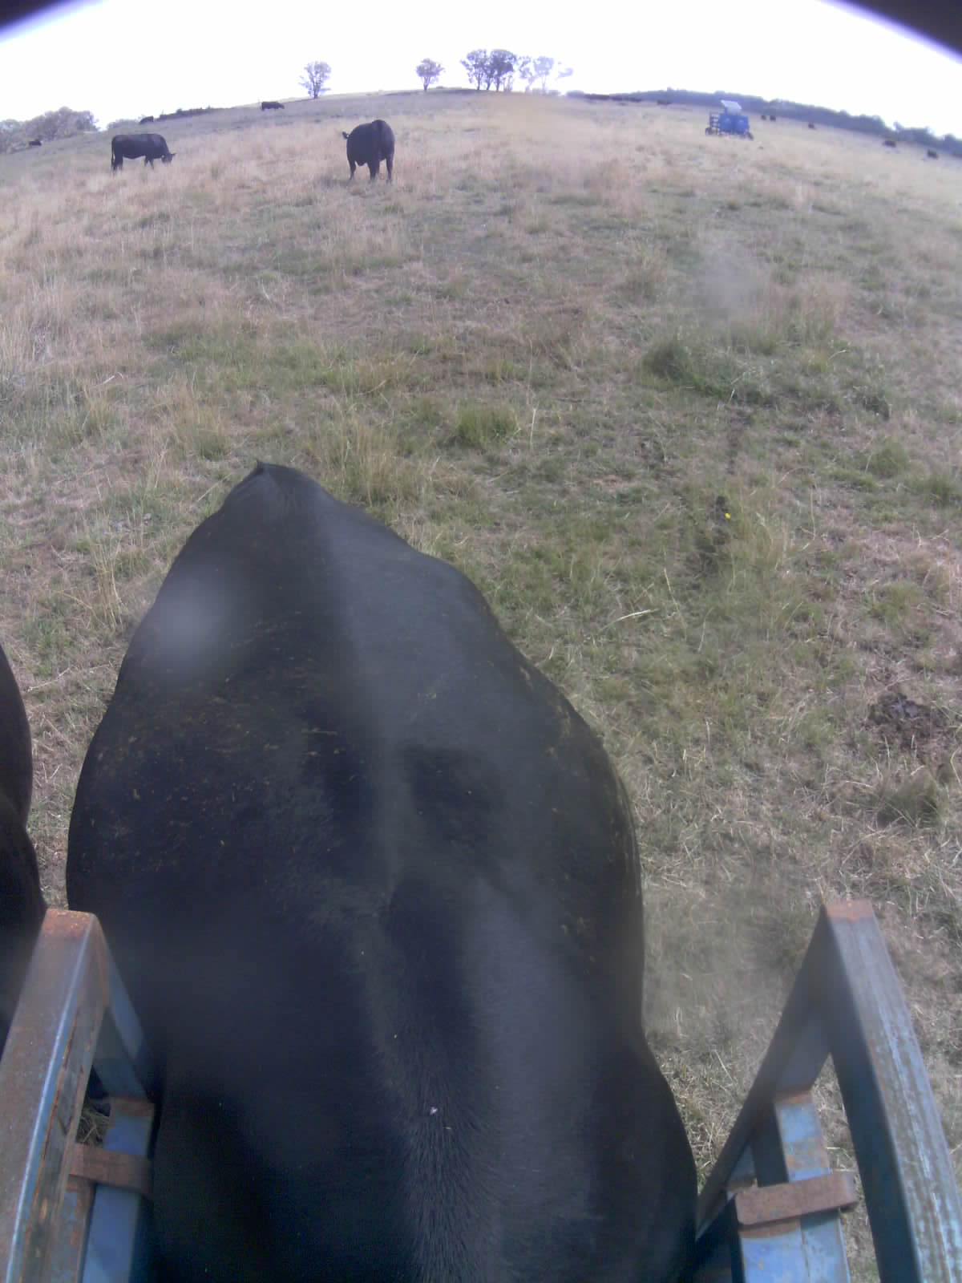
982 123811808156 | 292 | 542 | 53.9 | 18 | 7 | 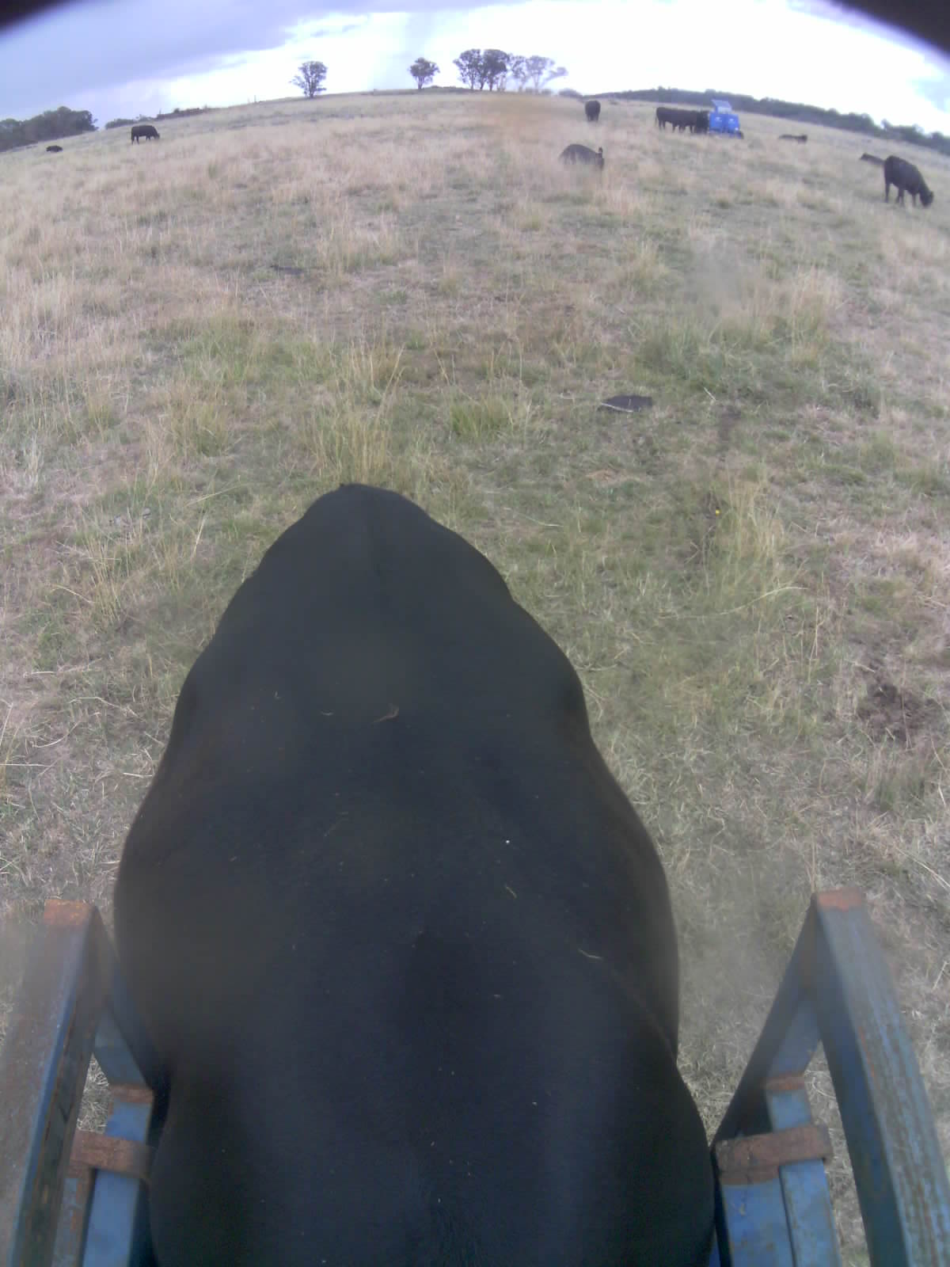
982 123811808288 | 285 | 555 | 51.4 | 14 | 5 | 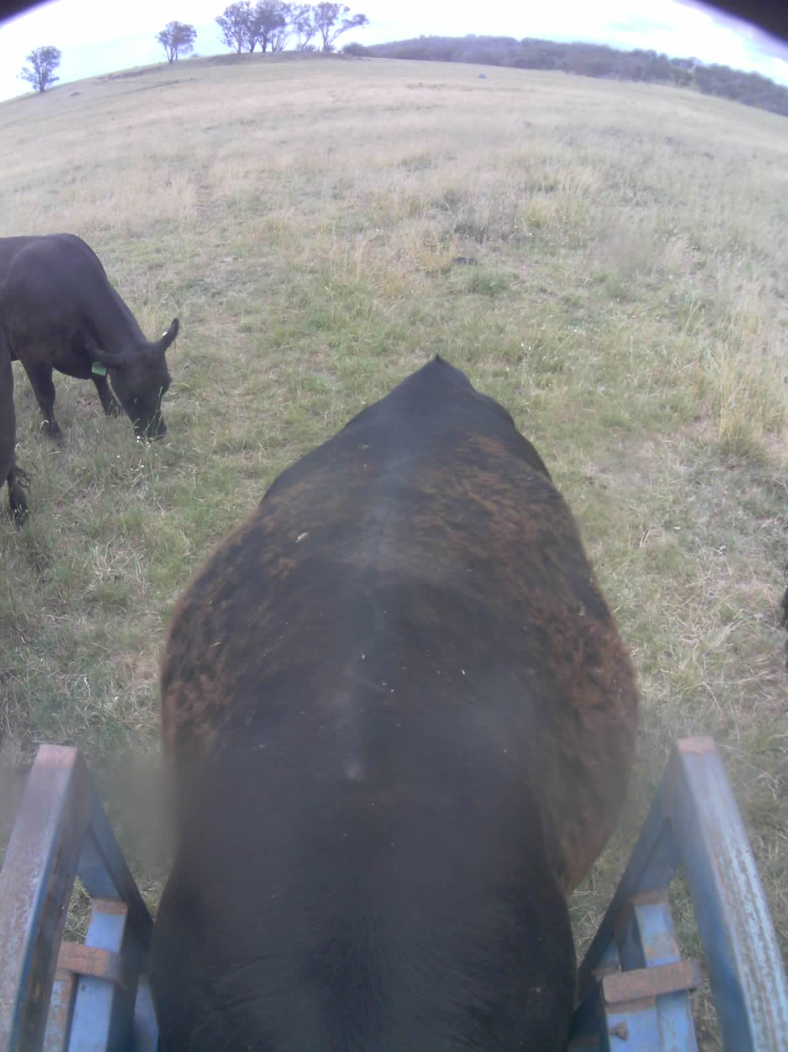
982 123811808673 | 300 | 549 | 54.7 | 9 | 5 | 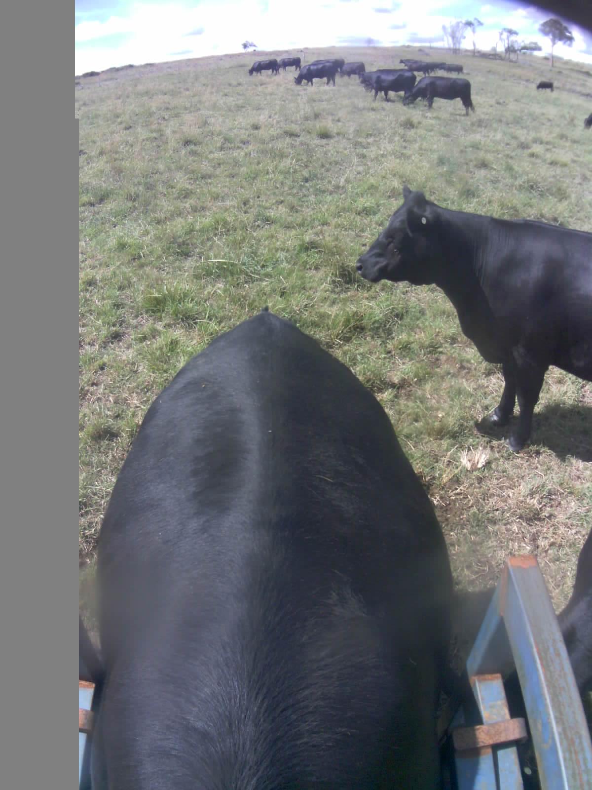
982 123811808697 | 287 | 568 | 50.6 | 8 | 5 | 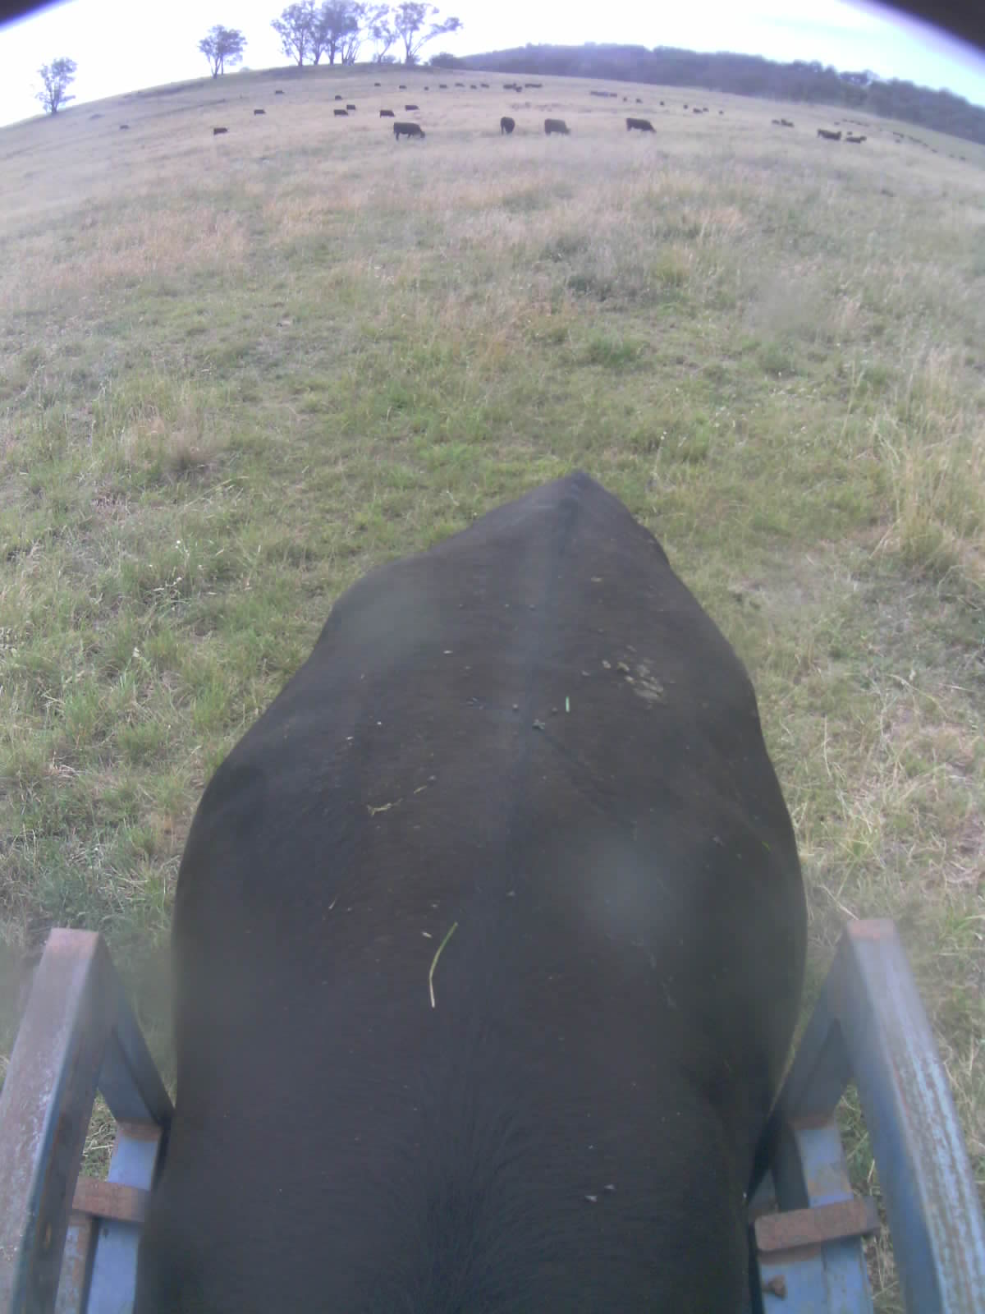
982 123811808731 | 265 | 523 | 50.6 | 13 | 5 | 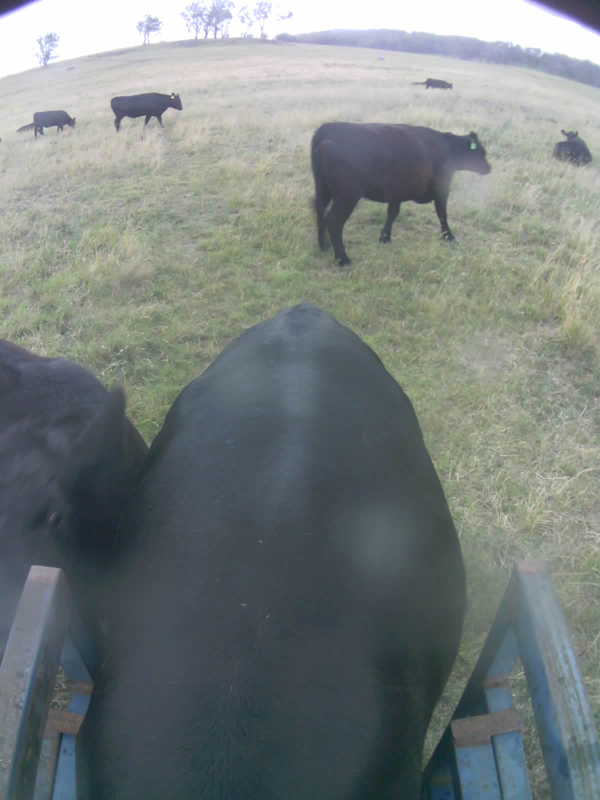
982 123825202163 | 297 | 553 | 53.8 | 11 | 8 | 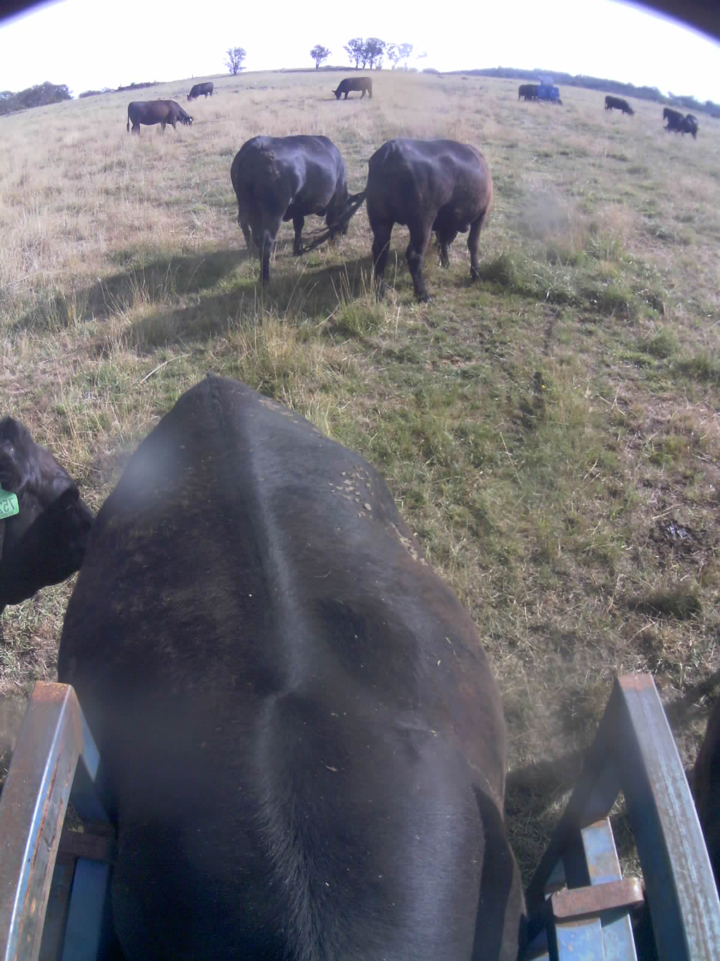
982 123825202539 | 291 | 566 | 51.4 | 18 | 5 | 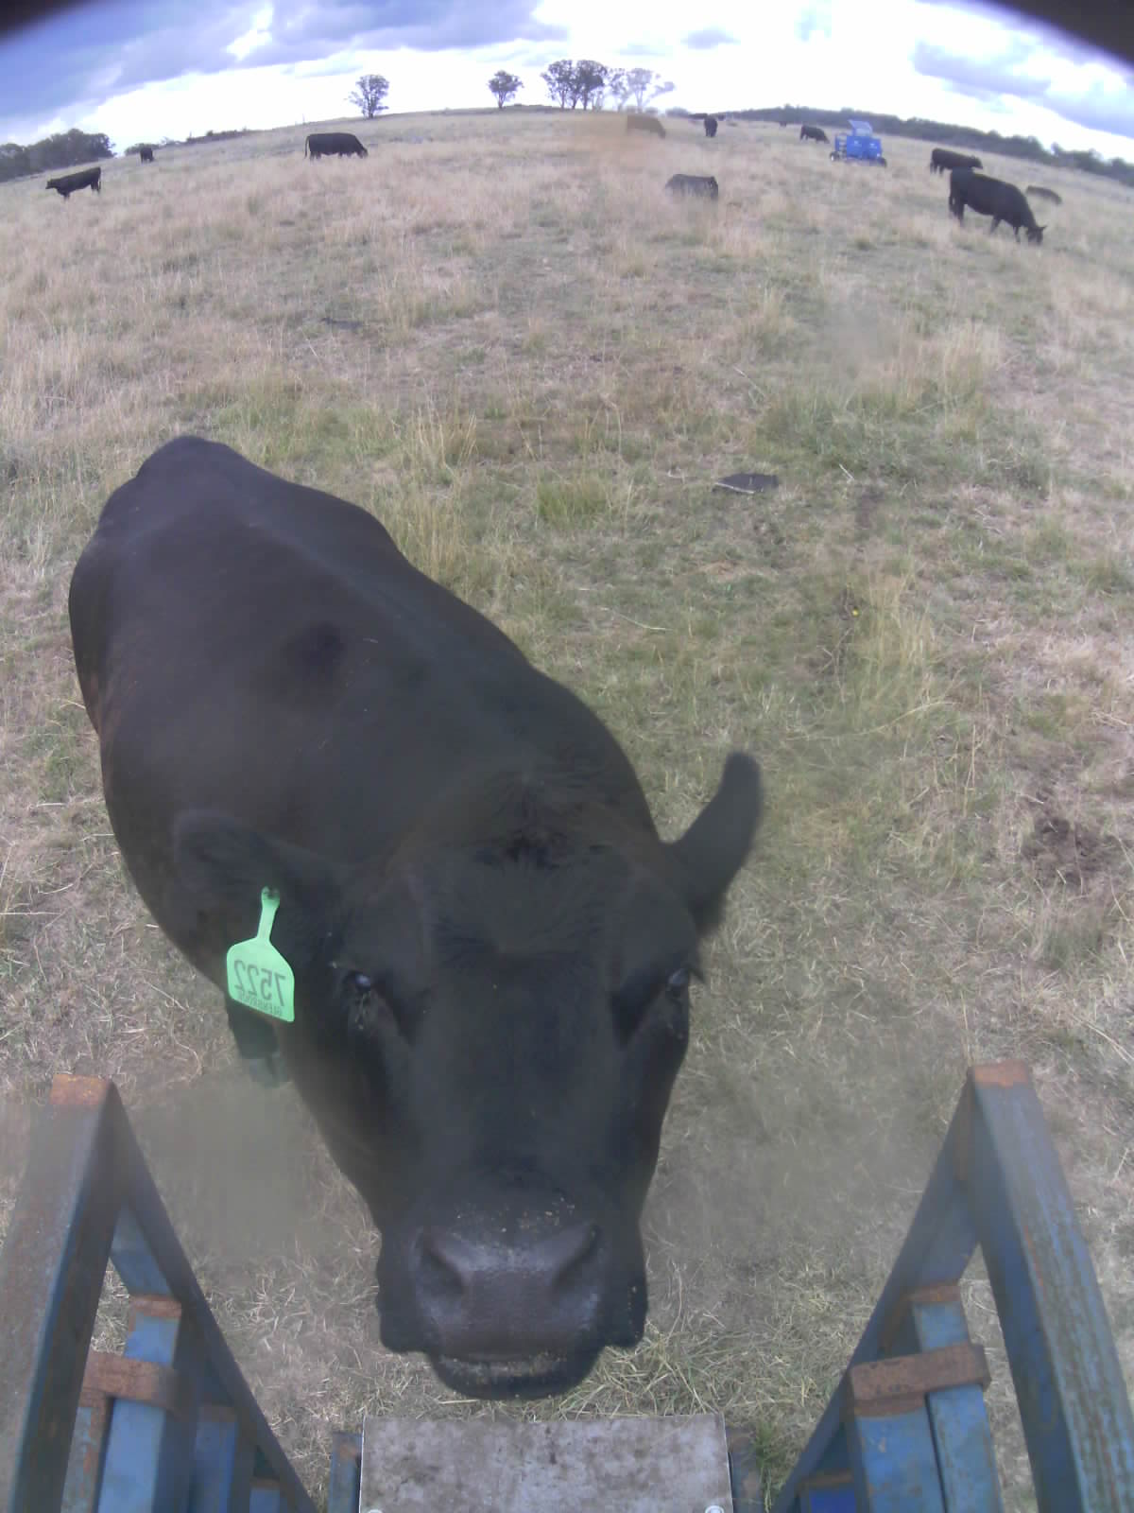
982 123811808023 | 300 | 553 | 54.2 | 15 | 8 | 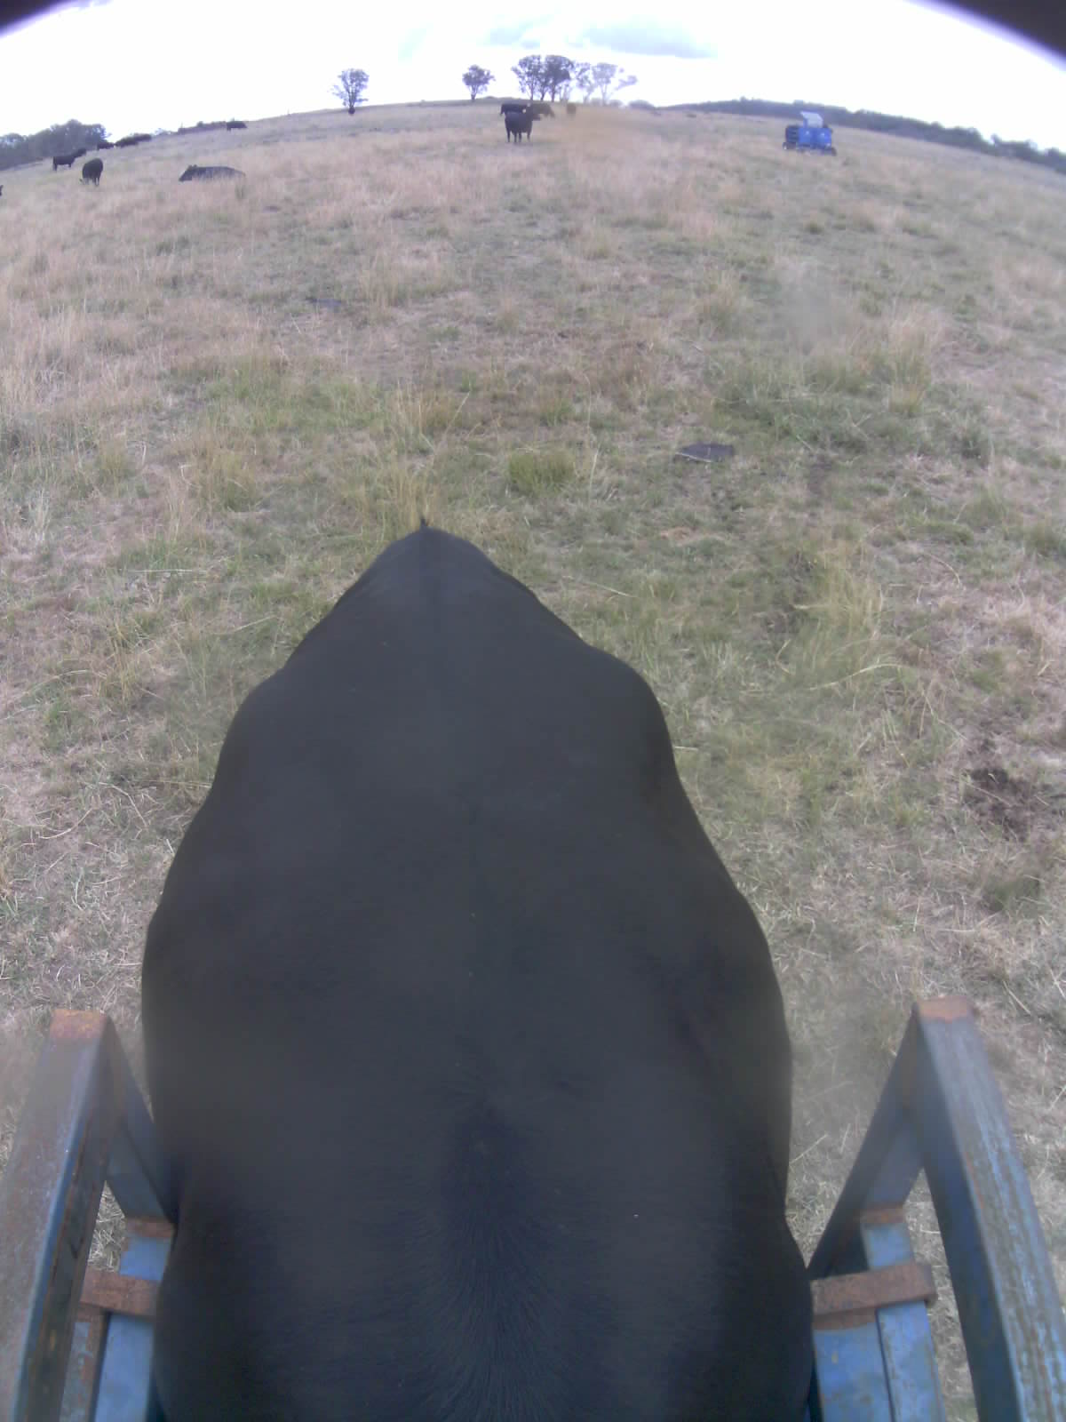
982 123811808300 | 314 | 553 | 56.8 | 16 | 8 | 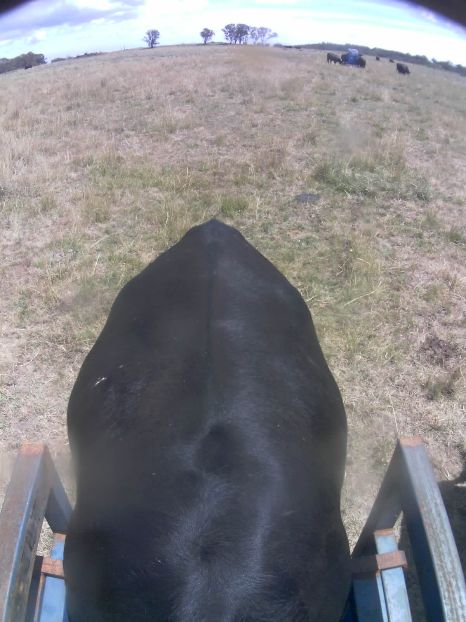
982 123811808356 | 294 | 526 | 54.9 | 18 | 8 | 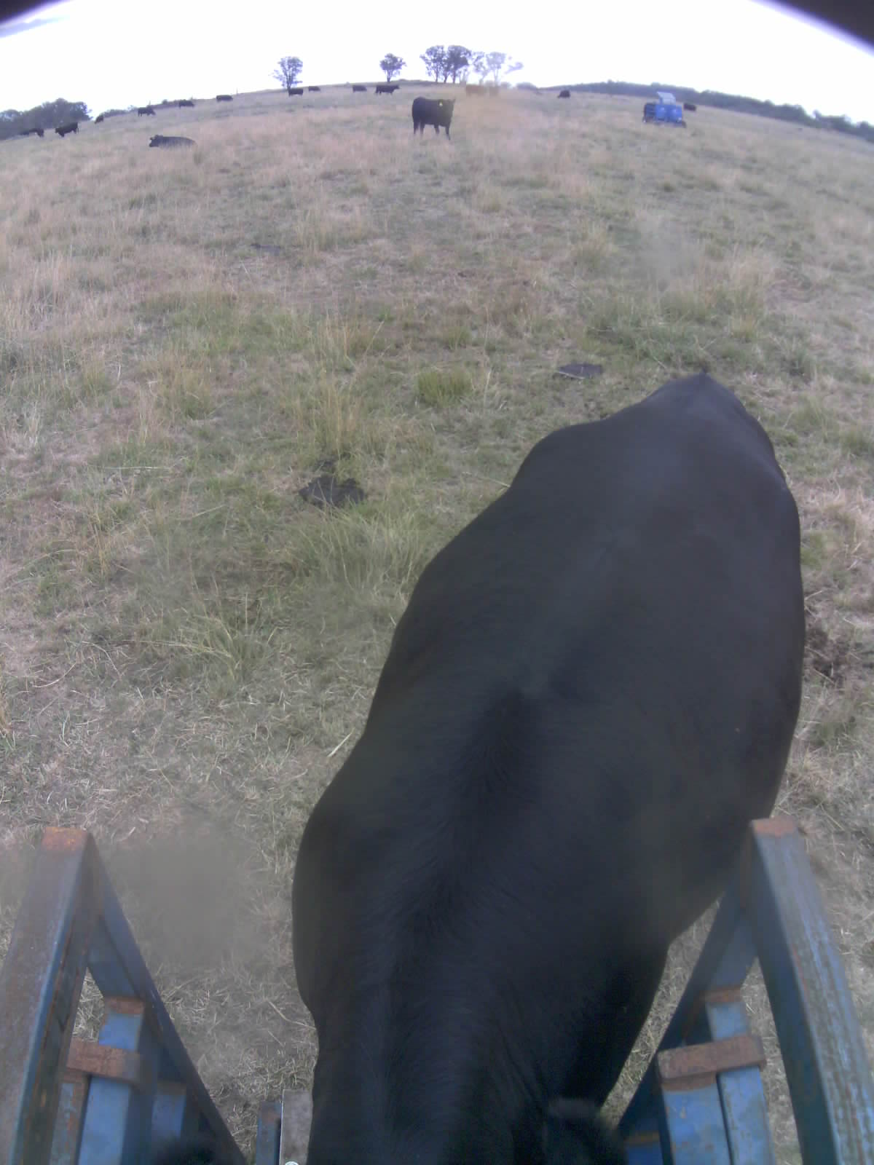
982 123811808713 | 305 | 559 | 54.6 | 11 | 7 | 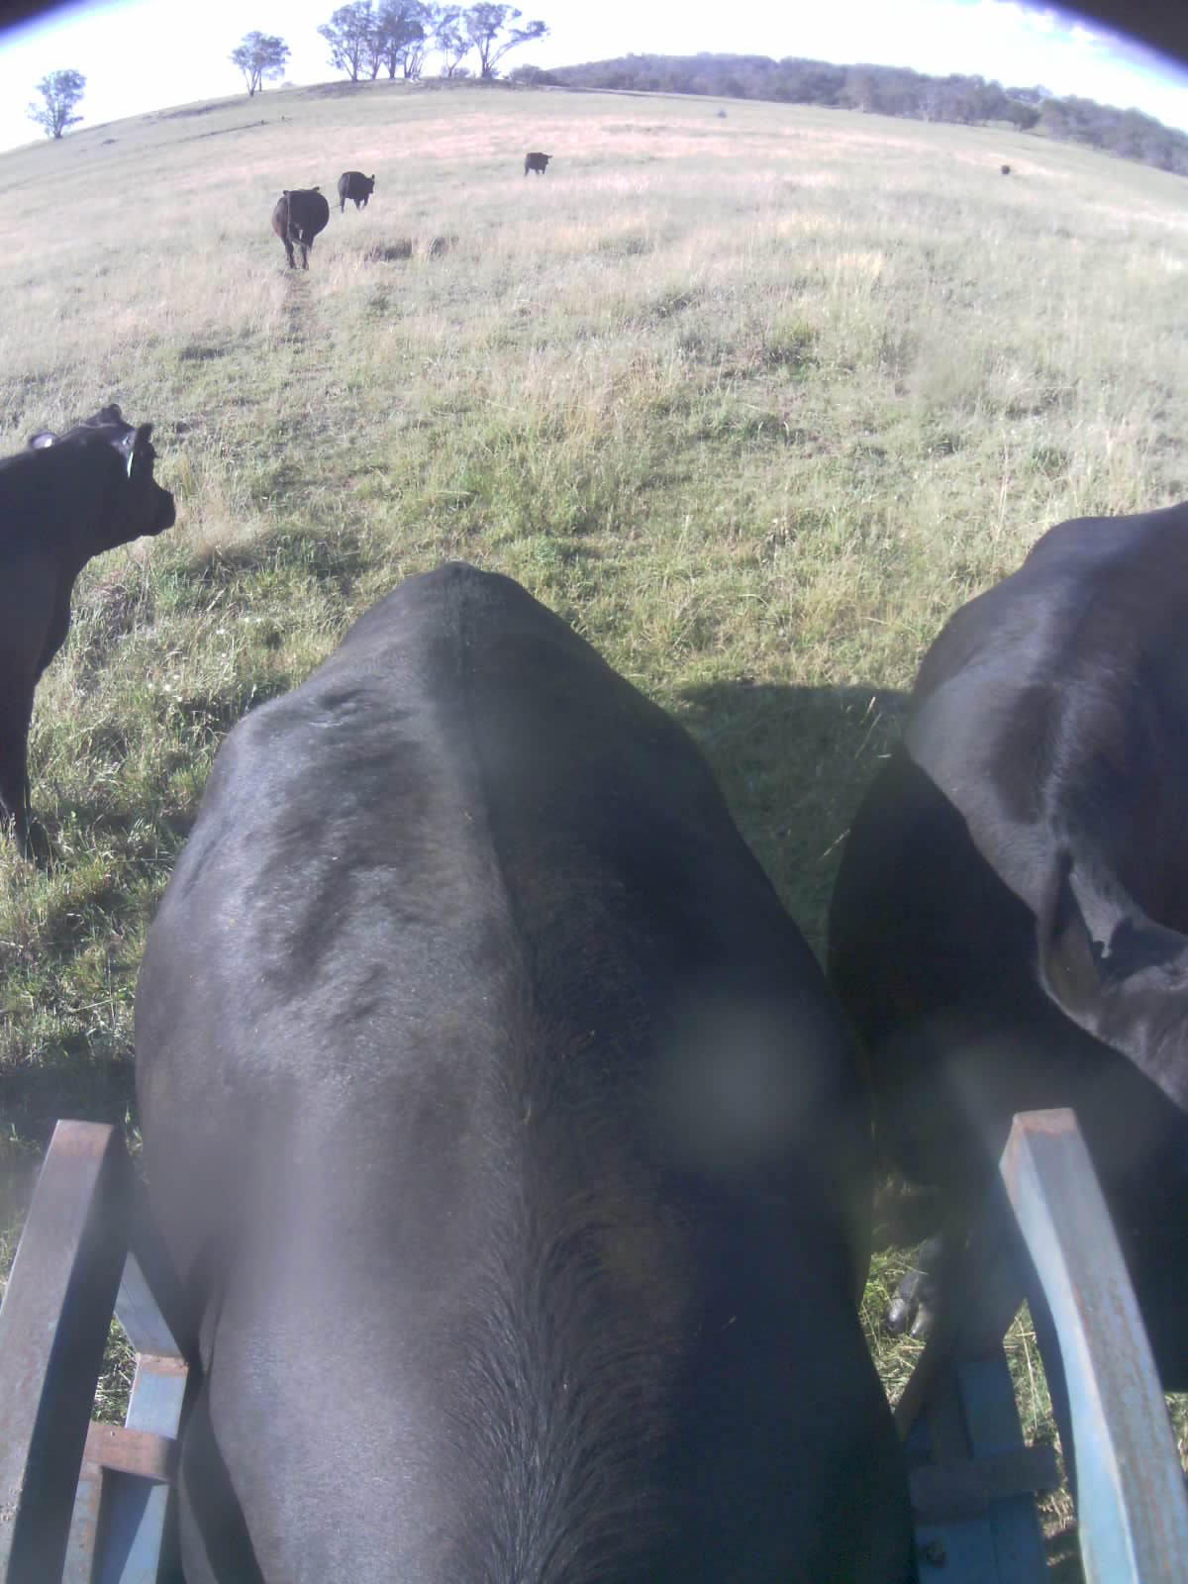
982 123825202338 | 292 | 543 | 53.7 | 16 | 13 | 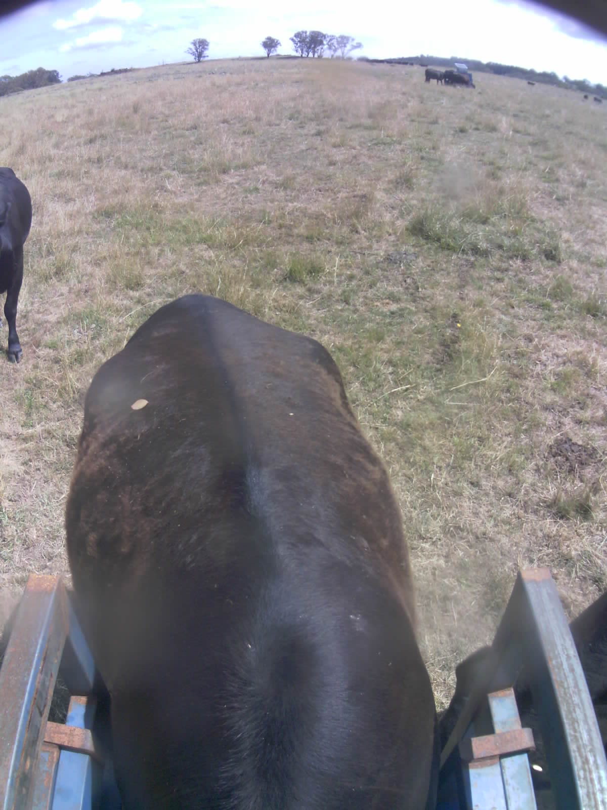
982 123826780248 | 289 | 536 | 54.0 | 16 | 13 | 